CHAPTER I

INTRODUCTION

This chapter consists of background, problem statement, significance, and focus of the research. Each of those points will be discussed in turn in the following.
- Background
Learning process is a process which consists of planning, teaching, activities of learning and evaluation. Learning could be defined as an interaction between learners and teachers. This process is begun by the planning of learning. There should be a planning before conducting the activities of teaching and learning. In this first step, the objectives of learning and the activities are prepared or designed by the teachers. After planning the objectives and the activities, the process moves to teaching and learning activities to acquire knowledge. The last step is evaluation. It is important to determine the success or failure of the goal.
Tyler cited in Arikunto (2002) stated that evaluation is a process of determining the extend to which the educational objectives are actually being achieved. In contrast, Davis (2010) explained that evaluation answers the question “How?”. It answers the questions about how well the project or learning is working, how the person knows that value is being/has added, how valid the assessment measures are and how effective the intervention strategies are.
The other term usually used, related to evaluation, is assessment. Assessment is an activity to assess or measure the students’ achievement. It includes the collecting information as well. Davis (2010) said that assessment answers the question “What?”. It answers the questions about what is being learned by the students, the impact being made by instruction, what is working, what is not working, what can students do and what is the faculty accomplishing.
There are many kinds of assessments used in learning process such as paper and pencil assessment, product assessment, self assessment, performance assessment, attitude assessment, portfolio assessment, performance assessment andproject assessment. Those kinds of assessment use a particular technique in collecting information. The technique based on learning standards and basic competencies. Basic competency is assessed based on achievement indicators of learning outcomes, that consists of threeaspects, namely cognitive, affective, and psychomotoric.
An effective assessment is an assessment which can cover three aspects of learning namely cognitive, affective and psychomotoric. It should be considered since most of the teachers assess students only on cognitive aspects like students’ ability to memorize. The students are not taught to learn, but tend to practice in answering questions. As a result, students cannot experience and use the knowledge in their daily life. Mostly, the schools apply the assessment only for the cognitive aspect. The teachers always give the students an assignment in written form, for example fill in the blank and rearange the sentences. Especially in one of Indonesian curriculum, there was called as Lembar Kerja Siswa (LKS) or students’ worksheets. It is a book which is full of questions. Each student has to complete those questions in one semester and he/she can work on it as a homework. Those assignment potentially make the students cheat other students’ assignment.
Harris and McCann (1994) told that one of the fundamental reasons for assessment often does not feed back into the learning and teaching process is the kind of feedback is expressed only by a grade or mark. The grade classifies students, but does not give real help but telling students what their specific problems are and by making suggestion to overcome them. On the other hand, Harris and McCann (1994) stated that assessment has got to a continuous process going on at a different level.
Based on the pre-observation conducted on May 2014, the researcher found that the assessment of the students in SMA Negeri 2 Bantaeng was expressed only by a grade. In this school, the teacher gave some assignments in the form of filling in the blank, rearanging the sentences and answering questions about the text. Those assignments were conducted out of the school. Then, in the next meeting the students submitted their assignments without any feedback from the teacher. This assessment wass more like paper and pencil assessment but researcher had an information that the teacher would assign the students to do a project.
Related to what Harris and McCain (1994) explained, the researcher found one interesting assessment called project assessment. Syamsudduha (2012) said that project assessment is assessment of assignment that must be completed by students in particular period of time. The assignment is an investigation form beginning from collecting, organizing, evaluating, until presenting the data. On the other point of view, keputusan menteri (Kepmen) No.53/4/2001 tentang Pedoman Penyusunan Standar Pelayanan Minimal Penyelenggaraan Persekolahan Bidang Pendidikan Dasar dan Menengah (DIKDASMEN) or ministerial decree guidelines for the implementation of minimum service standards schooling elementary and secondary education stated that project assessment is an accumulation of tasks which involves some competencies and should be accomplished by the learners. Through this assessment, the researcher predicts that project assessment can cover the feedback which the students need.
Recently, the researcher observed that this school sometimes assigns students for “Tugas Besar”. It refers to the project in which the students should complete the assignment in a period of time. The researcher concluded this tugas besar is more like project work that is related to project assessment.
In order to investigate other assessment of language learning, the researcher believes that a research is worth conducting to observe how the other assessment applied and what is the students’ perception about the project work that they work on in this assessment. The researcher is interested in investigating and exploring this assessment in the afforedmention school under the title An Exploration on Project Assessment of Students’ Productive Skills (A Study of First Grade Students of Senior High School).

- Problem Statement
As mentioned, an assessment has got to a continuous process going on at a different level. Unfortunately, some assessments often do not feed back into the learning and teaching process because those assessments are expressed by a grade. Project assessment has several steps to do by the students and an investigation can be conducted related to these steps. How it runs, how it functions and how it gives the feedback to the students. Related to these research problems, the researcher formulates the research questions based on the three aspects mentioned above. They can be seen as follows:
- How do the teachers manage the assessment?
- What is the students’ perception to project work?

- Objective of the Research

Based on the research problems above, the researcher formulates the objectives of the research as follows:
- Explaining the process of project assessment.
- Finding out the students’ perception to project work.

- Significance of the Research
The findings of this research are expected to be theoretically and practically beneficial contributor to the field of foreign language assessment. Theoretically, the findings of this research are expected to give reference to the teachers, educational practitioners, students and other stakeholders in educational field about project assessment. On the other hand, practically, this research can give a contribution to the assessment of teaching and learning English as a foreign language in Indonesia. It helps the teachers to assess the students not only from the cognitive aspect, but also other aspects of learning.

- Scope of the Research

The focus of this research is language testing related to project assessment. This assessment assesses the productive skills which focuses on speaking ability. The other focus of this research is students’ perception to the application of this assessment.

CHAPTER II

REVIEW OF RELATED LITERATURE

This chapter deals with some previous pertinent ideas which included assessment, project assessment, productive skills and students’ perception.

- Review of Related Study

Arikunto (2013) described that some lessons can apply project assessment namely science and socials. This project would be better if it is applied to the students who are in the second or third grade in junior high school and the high school level. Arikunto (2013) gives some examples in his book. In science, students can investigate the advantage of the leaf of a particular plant to consume while in socials, teacher can assign students to investigate why villagers like to work together instead of working individually.

Nastu (2009) informed that students in a South Texas classroom had taken on the role of employees at Clean Water Tech, a fictional U.S. company that produces water filtration technology, and were poring over the economic indicators of various unnamed countries, trying to decide into which nation the company should expand. This activity is mentioned as project assessment as well in the field of technology.

The researcher notices from two aforementioned studies above that mostly project assessment is applied in the field of science, socials and technology. The researcher finds this study challenging because project assessment in this study is applied in language learning.

- Some Pertinent Ideas
- Evaluation

Tyler cited in Arikunto (2002) stated evaluation is a process of determining the extend to which the educational objectives are actually being achieved while Davis (2010) explained that evaluation answers the question “How?”. It answers the questions about how well the project or learning is working, how the person knows that value is/has being added, how valid the assessment measures are and how effective the intervention strategies are.

Evaluation can be associated with test or without test. Genesee and Upshur (1996) explored that evaluation with tests can be conducted in some ways namely testing, objectives-referenced testing, choosing and devising test task, assembling and scoring test, interpreting test scores, standardized tests and summary and integration. Some ways for evaluation without tests are observation in the classroom, portfolios and conferences, journals, questionnaire and interviews.

Those aforementioned ways above can help the teachers evaluate the class to determine the useful information for making decisions. As Genesee and Upshur (1996) stated that there are four aspects of evaluation that should be considered. Those are purpose of evaluating, collecting information, interpreting information and decisions making. A decision made because of an evaluation, while evaluation itself, as explained by Nation and Macalister (2009), tries to answer the question “Is this a good course?” They further explained that the term “good” course could be one that: attracts a lot of students, makes a lot of money, satisfies the learners, satisfies the teachers, satisfies the sponsors, helps learners gain high scores in an external test, results in a lot of learning, applies state-of-the art knowledge about language teaching and learning, is held in high regard by the local or international community and follows accepted principles of curriculum design.

Genesee and Upshur (1996) explained that evaluation is a process that results in decisions about instruction, students or both. There are two steps in making decision as they explained namely (1) identify the purpose for evaluation and (2) collect the information pertinent to these decisions. Genesee and Upshur emphasize that this aspect of the evaluation is referred to as assessment. Similarly, Nation and Macalister (2009) mentioned that assessment itself is one of the sources of information that can contribute to the evaluation of a course.
- Assessment

Harris and McCann (1994) stated that it is very important to make a clear distinction between assessment and evaluation. As teachers, when carrying out assessment, they have to measure the performance of their students and the progress they make. They also need to diagnose the problems they have and provide the learners with useful feedback. Evaluation, on the other hand, involves looking at all the factors that influence all the learning process, such as syllabus objectives, course design, materials, methodology, teacher performance and assessment.

Brown (2001) pointed out that assessment itself is an on-going process that encompasses a much wider domain (than a test). Moreover, whenever a student responds to a question, offers a comment or tries out a new word or structure, the teacher subconsciously makes an assessment of the student’s performance. Assessment is different with a test. It is an instrument of procedure designed to elicit performance from learners with the purpose of measuring their attainment of specified criteria. Tests are almost always identifiable time periods in a curriculum when learners muster all their faculties to offer peak performance, knowing that their responses are being measured and evaluated: tests can be useful devices among other procedures and tasks designed to assess students.

Assessment has got to be a continuous process going on at a different level. Harris and McCann (1994) explained that one of the fundamental reasons for assessment often does not feed back into the learning and teaching process is the kind of feedback that is expressed only by a grade or mark. The grade classifies students but does not give any real contribution by telling students what their specific problems are and by making suggestion to overcome them.

Brown (2001) divided assessment into two types, namely informal and formal assessment. The former is assessing students in the process of forming their competencies and skills in order to help them continue that growth process. It implies the observation of the process of learning, as opposed the product. The latter is exercises or experiences specifically designed to tap into a storehouse of skills and knowledge, usually within a relatively short time limit. They are systematic, planned sampling techniques constructed to give teacher and student an appraisal of student achievement.

Brown (2004) mentioned the kinds of the aforementioned assessment. They are:
- Informal assessment consists of:
- Unplanned observation and general feedback
- Planned classroom activities in which students perform tasks but do not receive final grade on performance. It can be seen in think-pair-share, dialogues, essay or journal writing, note-taking and group or partner work.
- Formal assessment consists of the activities in class that the teacher gives to students for which they receive graded feedback. The activities are:
- Tests
- Rubric-scored assignment:
- Writing portfolio
- Presentation
- Journal entries
- Notes
- Performance
- Posters
- Projects

The other assessments are called formative and summative assessment. Brown (2004) defined formative assessment as daily classroom assessment used to plan for modify and improve instruction. Feedback in this assessment helps the teacher and the students make plans to improve language competence in the future. Informal assessment, as mentioned above, should be formative. It aims at improving a student’s competence and performance.

Summative assessment measures and summarizes what a student has learned over a given period of time: unit tests, mid-term exams, final exams, entrance exams, and professional language tests.

Current issues in classroom testing are traditional and authentic assessment. The characteristics of traditional assessment can be seen as follows:
- One-shot, standardized exams
- Time, multiple-choice format
- De-contextualized test items
- Scores are feedback
- Norm-referenced scores
- One correct answer
- Summative
- Oriented to product
- Non-interactive
- Extrinsic motivation

The characteristics of authentic assessment are:
- Continuous long-term assessment
- Untimed, free response
- Contextualized communicative task
- Individualized feedback
- Criterion-reference scores
- Formative
- Oriented to process
- Interactive performance
- Intrinsic motivation
- Project Assessment
- The Definition of Project Assessment
There are some definitions of project assessment. One of the definitions is stated by Syamsudduha (2012). He said that project assessment is assessment of assignment that must be completed by students in particular period of time. The assignment is an investigation form beginning from collecting, organizing, evaluating, until presenting the data. The other definition can be found in keputusan menteri (Kepmen) No.53/4/2001 tentang Pedoman Penyusunan Standar Pelayanan Minimal Penyelenggaraan Persekolahan Bidang Pendidikan Dasar dan Menengah (DIKDASMEN) or ministerial decree guidelines for the implementation of minimum service standards schooling elementary and secondary education as follows:
- Accumulation of tasks which involves some competencies and should be accomplished by the learners.
- A learning model which is adopted to measure and assess the cumulative achievement of competencies.
- Assessment model which is expected to be professional.
- Scope of activities: making proposals, preparation, execution (process) and the culminating activity (presentation, testing, and exhibition).
- The Functions of Project Assessment
Project assessment is as a measurement of students’ achievement. It has the other functions as follows:
- To measure the competence and capability of the students if they have achieved the expected goal.
- To determine the kind of action for the goal which is not achieved.
- To rank the students especially for the their succeed of achieving the goals.
- To give the information about the applying strategy especially for the strength and the weakness of that strategy.
- To plan or to design the procedures for reforming the lesson plan and to decide the source of material.
- The Implementation of Project Assessment
In implementing project assessment, there are some aspects should be considered. Mia (2012) explained three things that should be considered in project assessment.
- Management capability, the students are given a chance to choose a certain topic that is not too wide so the information received is more explicit, and freedom to think over about data collection schedule and written report.
- Relevance, knowledge and skill at relevance learning with project based task, so it can be an evidence.
- Authenticity, consider the source of data that can be achieved so the data are authentic.
The project can be applied in all disciplines. The implementation should follow five steps. Mia (2012) explained them as follows:
- Deciding the theme of the project
This first step should follow some indicators. It has to involve a general idea and is still original, it is important and interesting, it describes a complex problem, it reflects some related ideas, it gives priority to the problem solving.
- Deciding the learning context
This step should follow six indicators. The questions in the project should ask about the problem in a real life, it gives a priority to the students’ authority, it conducts an inquiry in the social context, students are able to manage their time effectively and efficiently, students are learning with self control and it stimulates the works professionally.
- Planning the activities
The planning activities include reading, research, observation, interview, recording, internet access and visiting the related places.
- Processing the activities
The indicators of this step are designing the scetch, describing the analysis, counting, generalizing and developing the prototype.
- Applying of the activities for finishing the project
There are 6 activities for this step. They are trying to do the project based on the scecth, evaluating the obtaining result, revising the obtaining result, recycling the other project and clasifying the best result.
- Scoring system of project assessment
Project assessment consists of score achieved from some steps; planning, data collection, processing data, and report. In scoring each step, the ranges from 1 to 3. Score 1 is the lowest score and score 3 is the highest score. The following table is the example of scoring proposed by Syamsudduha (2012).
Table 2.1. Example of Criteria and Score of Project Assessment
Aspect | Criteria and score
 | 1 | 2 | 3
Planning | If consist of objective, topic, background, research area, respondent, complete question list. | If consist of objective, topic, background, research area, respondents, questions list less complete. | If consist of objective, topic, background, research area, respondents,  list ofquestionsin complete.
Collecting data | If all of thequestions list can be done andthe data is recordedneatly and completely. | If all of thequestions list can bedone, butthe datais notrecordedneatly andcompletely. | If questions list cannot be done all and thedata is not recorded neatly.
Processing Data | If the discussion ofthe data in line withthe researchobjectives | If the discussion of data describes the research objective incompletely | If the report do not consist of the discussion ofdata
Report | If the systematic of writingcorrect, containssuggestions, use communicativelanguage. | If the systematic ofwritingcorrect, consist of suggestions, but language used is lesscommunicative | If the writingis less systematic, language used is less communicative language,contains lesscontains
Syamsudduha (2012)

- Format of Project Assessment
There are some formats of project assessment. In this paper, the following is a kind of project assessment formats.
Lesson : ................................
Project Name : ................................
Allocation : ................................
Teacher : ................................
Group : .............................
Class : ............................
No. | Aspect | Score (1-3)
1. | Planning:  - Preparation  - Tittle
2. | Process:  - Writing system  - Accuracy of the data/information  - Quantity of data sources  - Data analysis  - Conclusion
3. | Report of project:  - Performance  - Presentation
 | Total Score

Haryati (2013:53)
- Project Work
Project assessment tends to use project work. This kind of assessment is conducted because it has some significances. Haryati (2013:53) explored about project work. It can be seen in the following explanations.
  - Project work is a part of the most standard learning process. It is pedagogic and meaningful.
  - It gives an opportunity for the learners to express completely their competence.
  - It is more efficient and produces an economical product.
  - It produces a value of competence which they can take responsibility of it.
Some language educators have described project work. Stoller in Richards and Renandya (2001) mentioned some educators who described project work. They are Carter and Thomas (1986), Ferragatti and Carminati (1984), Fried-Booth (1982, 1986), Haines (1989), Legutke (1984, 1985), Legutke and Thiel (1983), Papandreou (1994), Sheppard and Stoller (1995) and Ward (1988). They have different perspective about project work but mostly, Stoller (1995) stated that those educators have similar opinion as follows:
    - Project work focuses on content learning rather than on specific language targets. Real-world subject matter and topics of interest to students can become central to project.
    - Project work is student centered, though the teacher plays a major role in offering support and guidance throughout the process.
    - Project work is cooperative rather than competitive. Students can work on their own, in the small groups, or as a class to complete a project, sharing resources, ideas, and expertise along the way.
    - Project work leads to the authentic integration of skills and processing of information from varied sources, mirroring real-life tasks.
    - Project work culminates in an end product (e.g., an oral presentation, a poster session, a bulletin-board display, a report, or a stage performance) that can be shared with others, giving the project a real purpose. The value of the project, however, lies not just in the final product but in the process and product orientation, and provides students with opportunities to focus on fluency and accuracy at different project-work stages.
    - Project work is potentially motivating, stimulating, empowering and challenging. It usually results in building student confidence, self-esteem and autonomy as well as improving students’ language skills, content learning and cognitive abilities.

Sheppard and Stoller Richards and Renandya (2002) proposed some steps to do the project work. The following figure is the steps.
Step 1
Agree on a theme for the project

Step 2
Determine the final outcome

Step 3
Structure the project

Step 4
Prepare students for the language demands of Step 5

Step 5
Gather information

Step 6
Prepare students for the language demands of step

Step 7
Compile and analyze information

Step 8
Prepare students for the language demands of Step 9

Step 9
Present final product

Step 10
Evaluate the project

Figure 2.1. Steps of Project Work

- Project-Based Learning and Project Assessment

The term that is always associated with project assessment is project-based learning. It is generally accepted because both of the terms use the term “project”. The clear understanding of both project-based learning and project assessment can be achieved by delving into the definition to each term. By referring to each term, there is a widespread confusion whether project-based learning and project assessment have similarity.
Mansoor et. al (1997) stated that project-based learning is a collaborative approach to teaching and learning in which learners are placed in situation where they use authentic language to accomplish particular objectives. As part of the process, learners plan, work on complex tasks and assess their performance and progress. A project is designed around issues, questions or needs identified by the learners. Similarly, Mos and Van Duzer in Simpson (2011) said that project-based learning is an instructional approach that contextualizes learning by presenting learners with problems to solve or products to develop.
Moreover, the other point of view comes from Yam and Rossini (2010). They describe that Project-Based Learning (PBL) is a student-centred instructional approach used to promote active and deep learning by involving students in investigating real-world issues in a collaborative environment. In accordance to this, Solomon in Simpson (2011) explained that project-based learning is a process of learning that students are responsible for in their own education. Students work collaboratively to solve problems that are authentic, curriculum-based and often interdisciplinary. Boud and Feletti as cited in Simpson (2011) added that in project-based learning the students construct plans to find their own answers, create solution and later share the information or solution with their peers. The other expert namely Rousova (2008) stated that project based learning applied project method which organizes lesson topics as a series of projects or complete task that would be attractive for a pupil through its concrete goal.
Based on the theories above, it can be stated that project-based learning is an approach whereas project assessment (based on subtopic point D above) is a kind of assessment. It means that the relation between approach and assessment is an assessment can be applied in a particular approach. Further explanation can be seen in Mansoor et. al (1997) who stated that in PBL, students can be assessed through peer assessment, self assessment and rubric assessment. Tamim and Michael (2013) stated that teachers mainly used rubrics to assess students in project-based learning. Berge et. al in Simpson (2011) described as well that assessment of PBL can be different and challenging. Students in PBL are assessed by various assessments, for instance, traditional pencil and paper assessment, performance-based assessment and portfolio assessment. Hellstrom, D et. al (2009) explained that in project-based learning, students have been assessed in a variety of ways. Those ways can be self-assessment, peer-assessment, co-assessment, portfolio assessment, performance assessment and reflective journals.
- Productive Skills

There are four main skills in learning and teaching language; they are listening, speaking, reading and writing. Jabu (2008) explained that speaking and listening are said to relate to language expressed through the aural medium and reading and writing are said to relate to language expressed through the visual medium. The terms aural and visual refer to productive and receptive in which they are the way language is manifested.

Based on the reference above, speaking skill is a productive skill since it is expressed through the aural medium. Even though it is a productive skill, someone still needs receptive skill. Widdowson cited in Jabu (2008) described that the act of communication through speaking is commonly performed in face-to-face interaction and occurs as part of dialogue or other forms of verbal exchange. What is said, therefore, is dependent on an understanding of what else has been said, whether by the speaker or the interlocutor, in the interaction. Jabu (2008) further explained that speaking as an instance of use is part of a reciprocal exchange which both reception and production play a part.

Clark and Clark (1977) formulated the definition of speaking. They stated that speaking fundamentally an instrument act. Speakers talk in order to have some effect on their listeners. They assert things to change their state of knowledge. They ask them questions to get them to provide information. They request thing to get them to do thing for them. While Florez in Udin (2013) defines speaking as an interactive process of constructing meaning that involves producing, receiving and processing information.

Luoma (2004) stated speaking skill is an important part of the curriculum in language teaching and this makes them an important object of assessment as well. Luoma (2004) divided seven types of speaking task; they are description, narrative, instruction, comparison, explanation, justification, prediction and decision. Speaking task in this case has been explained by Bachman and Palmer in Luoma (2004). They defined language use tasks in very similar terms. To modify their definition slightly for the specific context of speaking, speaking tasks can be seen as activities that involve speakers in using language for the purpose of achieving a particular goal or objective in a particular speaking situation. The emphasis in this definition is on goal-oriented language use, and it is appropriate for test tasks as well as events or ‘tasks’ outside testing situations.

Related to the assessment, Harris and McCann (1994) described that informal assessment is particularly for speaking as many teachers have practical difficulties in organizing oral tests. On the other case, Brown (2004) pointed out two kinds of assessment namely formal and informal assessment in which project assessment is included in formal assessment.
- Perception

Smith (2008) stated that many individuals perceive learning as how they learned. As times change, so do people. Children now are facing struggles never faced by children before. As their experiences change, so do their perceptions of education and the way of they perceive education to benefit them. If they are presented with information believed to be important, but they cannot relate it to their personal lives, then we lose them. Understanding learning as if effects each individual is imperative. We are losing too many of our youth to society, while they try to make it on their own.

On the other hand, Richard (2002: 427) defined perception as the recognition and understanding of events, objects and stimuli through the use of senses (sight, hearing, touch, etc). This term can be found as well on Oxford dictionary. The word perception means the ability to see, hear or become aware of something through their senses. The other definition in this dictionary is the way in which something is regarded, understood or interpreted. Walgito (1991) had different definition but still related to the previous one. He defined perception as the last process of observation which is started by the process of sensing in which the process of stimuli is received by the senses then continued by the process of attention then directed to the brain that will make the individual realizes about something.

Several definitions above indicate that perception is recognition, understanding, and awareness of something and mostly through the use of senses. On the other point of view, all human beings including students have senses, related to this theory, it can be stated that students will possibly have a perception about teacher, teaching and learning process, applied teaching method and assessment. This is supported by Notebaert (2009) who stated that students have perceptions of a variety of components of the learning environment including teacher effectiveness, workload and assessment.

Schunk & Meece (2009) divided students’ perception into two types, as follows:
- Outcome Expectations
Outcome expectations are beliefs about anticipated outcomes of actions. People select actions they believe will be successful and attend to models who they think will teach them valued skills. Outcome expectations sustain behaviors over long periods when people believe their actions will eventually produce desired outcomes.
- Perceived Self-efficacy
Perceived self-efficacy refers to judgments of one’s capabilities to organize and implement actions necessary to attain designated performance levels. Self-efficacy can influence choice of activities, effort expended, and persistence.
Students’ perception is affected by many factors such as motivation, language acquisition, metacognitive process, and psychological aspect. Students’ perception typically are assessed through questionnaires or interviews in which the students are presented with items asking about their beliefs and they judge each item using a numerical scale or respond to it verbally.

CHAPTER III

RESEARCH METHODOLOGY

This chapter deals with research method and design, research setting, research instrument, procedure of collecting data and technique of data analysis.

- Research Design
This research applies qualitative design and called as an exploratory method. It means that the qualitative study comes first and is typically as an “exploratory” study (Gay, et.al., 2006). The qualitative method employed descriptive method, is applied to find out how the project assessment runs and functions and find out the students’ perception of project assessment.

- Operational Definition
This research mainly discussed about project assessment which is one kind of assessments. Project assessment is an assessment of assignment that is given to the students and they should finish it in a period of time. Assessment itself is an on-going process that leads a much wider domain that is not merely a test, for example, a student responds to a question, offers a comment, and just to name a few. In this regard, the teacher subconsciously performs an assessment. Other term related to this topic is evaluation. Such process is undergone to determine to how far the educational objectives are actually being perceived. Hence, evaluation is wider than assessment and project assessment is a part of assessment.

- Research Setting
The research took place in SMA Negeri 2 Bantaeng in the 2014/2015 academic year. The researcher chose this school because this school applied project assessment while other school in this city did not apply it. The students and the teacher of this school were the subjects of this research. Purposive sampling technique was applied in this research. It had only one class as a sample of research namely the students who are the first grader. Purposive sampling was applied because only one teacher assigned the students to do project work. The researcher determined directly the sample to the class which applied it. The total number of this class is 30 students. The other subject is the English teacher of this class. The research observed the teacher who assessed the students.

- Research Instrument
This research applied two research instruments. They were direct observation and interview. The direct obsevation was employed to find out how the application, process and functions of project assessment. The second instrument was interview intended to find the students’ perception of project work.

- Procedures of Collecting Data
In collecting the data, the researcher carried out the following procedure:
- Direct Observation
In this direct observation, the researcher made a to-do list for the students project. In general, the researcher focused on how the students plan the data, collect the data, process the data and report the data. In this observation, the researcher was an external observer. In this regard, the researcher did not involve in the students project work and only observed the kinds of activity that the students had performed.
- Interview
The researcher interviewed the students in term of their perceptions of project work. The combination of semi-structured, unstructured and structured interview was conducted as it was suggested by Gay et. al (2006). In conducting the interview, the researcher spoke in English and/or Indonesian depending on the respondent which was being interviewed.

- Data Analysis
Interactive model of Huberman and Miles (1994) was applied in data analysis. Huberman and Miles (1994) explained that interactive model has three stages: (1) data reduction, (2) data display and (3) conclusion drawing and verification.
Data reduction refers to omitting irrelevant data and taking the needed data. In data display, the reseacher organized and compressed the information from the data reduction. Lastly, conclusion was drawn and verified referring to the interpretation of the researcher about the data and the conclusion.

- Research Data Validity
The research did some techniques which was examined the data validity. It was conducted to obtain a valid data. The techniques are:
- Negotiations
Haryanto (1998) explained that one of the characteristics of qualitative research is research results should be negotiated with the informants. Negotiations can be referred as one way to be taken in order to check the validity of the data.
- Persistence Observation
The observation was conducted continuously by checking the all of the data which have been collected. The observation conducted was in the classroom and out of the classroom.
- TriaRengulation
Moleong (2009) emphasizes four kinds of triangulation methods that may be used in qualitative research called source triangulation, methods triangulation, researcher triangulation, and theory triangulation. This research will only apply one of the triangulation methods, triangulation of data sources.The researcher evaluates the results by checking the perception that comes from the respondent, if there are some unclear statements the researcher asks the respondent feedback.
- The Adequacy of Reference
Authentic photographs, documents, and recordings are the form used to see the experience. Those are to prove the valid data.

CHAPTER IV

FINDINGS AND DISCUSSION
This chapter deals with the findings of the research and discussion of research findings. It covers the description of the result of the data analysis. The discussion session further explains and gives interpretation of the findings.

- Findings
This part shows the findings of the research to answer the problem statements. As mentioned in the first chapter, the problem statements are about how the teachers manage the assessment, the assessment focuses on project assessment, and students’ perception of project assessment and project work. The research was conducted for five meetings. Those meetings covered all the needed data. Starting on the explanation of the project by the teacher to the report of the project that the researcher observed directly. At the end of the meeting, the researcher interviewed six groups of students (30 students) to figure out their perceptions about the project.
- Teacher’s management of Assessment
Based on the obtained data, the researcher found that the teacher managed the assessment starting on the students’ preparation to the report of project. Regarding to the students’ assignment, there were three aspects which teacher assessed namely planning, process and report. Teacher managed the assessment of preparation into two parts called preparation and deciding the title. Aspects of process consisted of getting information, writing, analyzing data and concluding. Teacher assessed only three parts of this aspect. She did not assess the writing part. The last assessed aspect was report of project. It had presentation, retelling, telling experience and performance.
This assignment took a week to finish. The teacher assessed the students since the first day until the last day. Teacher managed it systematically. She told the students what they should do with the assignment which was in a form of project.
The given project was to find out the question in the movie. The teacher thought that the movie was interesting because the movie would excite the students to think while watching. They needed to watch the movie with their own group. In the presentation, the students should retell the movie, explain the question that all characters in the movie tried to figure out, tell the class what their favorite scene and the last part is tell the class about the moral message of the movie.
The researcher observed the teacher during the assessment process of students’ project. She used observation checklist to identify the activities of the teacher in assessing students based on the theory of project assessment. The following table performs the observation checklist.

Table 4.1. Teacher’s Management
Meeting | Grouping | Explaining | Consultation | Assessing
 |  |  |  | Planning |  | Process |  |  |  | Report of Project
 |  |  |  | Preparation | Title | Getting Information | Writing | Analyzing Data | Concluding | Presentation | Retelling | Telling ExperiencExperience | Performance
First | √ | √ | - | √ | √ |  | -
Second |  |  | - |  |  | √ | - | √
Third |  |  | - |  |  |  | - | √ | √
Forth |  |  | - |  |  |  | - |  | √
Fifth |  |  | - |  |  |  | - |  |  | √ | √ | √ | √

The table above indicates that teacher had six steps in managing the class to give a project to the students. They are grouping, explaining, consultation, planning, process and report of project. The last three steps involve in assessment steps. Each step in assessing process has some aspects. Planning has two aspects namely preparation and title, process has four aspects namely getting information, writing, analyzing data and concluding, and report of project has two aspects called presentation and performance. In the research, the researcher noticed that retelling and telling experience are presentation.
At the first meeting, the teacher explained what the students need to do with the project. The project was about a movie. The teacher explained that ideally the students had to write a review about the movie but she did not tell the students to do so because the teacher wanted to focus on the speaking ability. Before giving a project, the teacher grouped the students into six groups based on the students’ seat (See appendix 4). Then, the teacher explained what the students should do. It can be seen in the following picture.
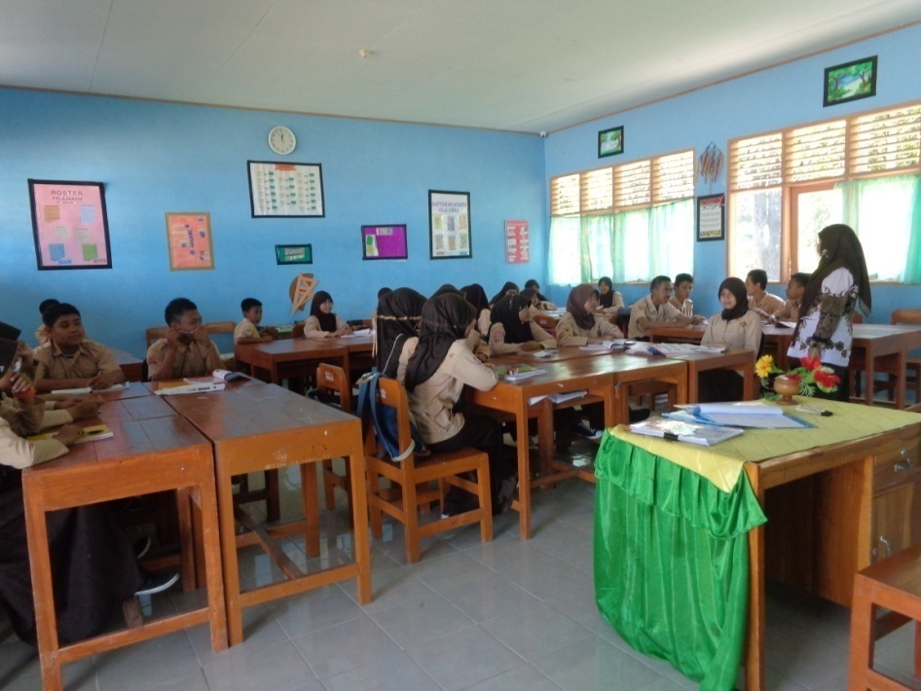
Picture.1 Grouping and Explaining

The researcher noticed that the given project does not result any concrete product. The only product is the movie review orally through presentation in front of the class. The way of assessing the students is starting on the planning at the first meeting to the report of project at the fifth meeting. The assessment was conducted twice in the classroom and three times out of the classroom.
The first meeting, after grouping and explaining, the teacher let the students to prepare the project and decide the title. She assessed directly the preparation and title. The criteria in assessing planning aspect based on Syamsudduha (2012).
The next meeting, students did their project out of class. The teacher still ran the class, giving material to the students while out of class the students had an assignment called a project. The project took two weeks before presentation. The teacher could assess the students even out of class because they chose to work on the project in “Lintas Minat” time (Lintas minat is a kind of extracurricular in that school). In this second meeting, the teacher assessed the two aspects called getting information and analyzing the data. Those activities can be seen as follows.
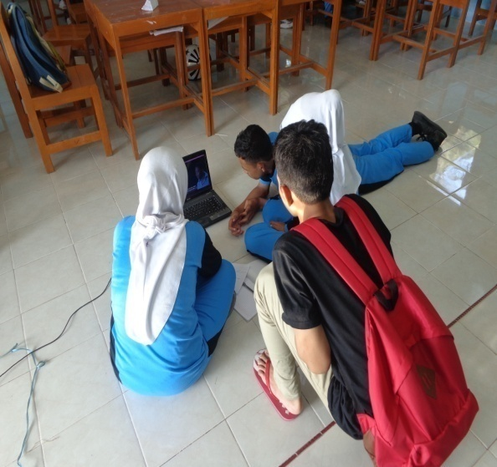
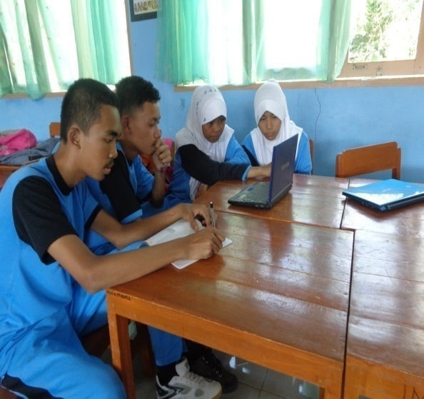
Picture 2. Analyzing Data Picture 3. Getting Information

Those pictures above were about the students get information through the movie and analyzing the data. The process of assessing the analyzing the data can be seen when the students watching the movie the teacher came to them and asked who they think the winner is in the movie. The teacher asked what the student were guessing and their reasons why they said so. They should speak English in analyzing the data together.
The next aspect assessed was concluding. It was still conducted out of class. The teacher assessed how the students took the conclusion. The teacher followed the students’ discussion in the small group and noticed the argumentation of students about why they concluded so.
In the last meeting, the students should present their result of their activities during the process in the class. The teacher assessed the students’ presentation, retelling, telling experience and performance. As mentioned above, the students were divided into six groups. Each group consists of five students. In the report of project, students divided themselves to do different things. One student told about the overview of the project, one student retold the movie, one student told their favorite scene and why they liked it, one student told about their critic of the movie and the last students told about the message of the movie. The teacher assessed the whole performance of presentation both individually and in a group. The member’s performance could affect the group score from the teacher. The students’ presentation performs below.
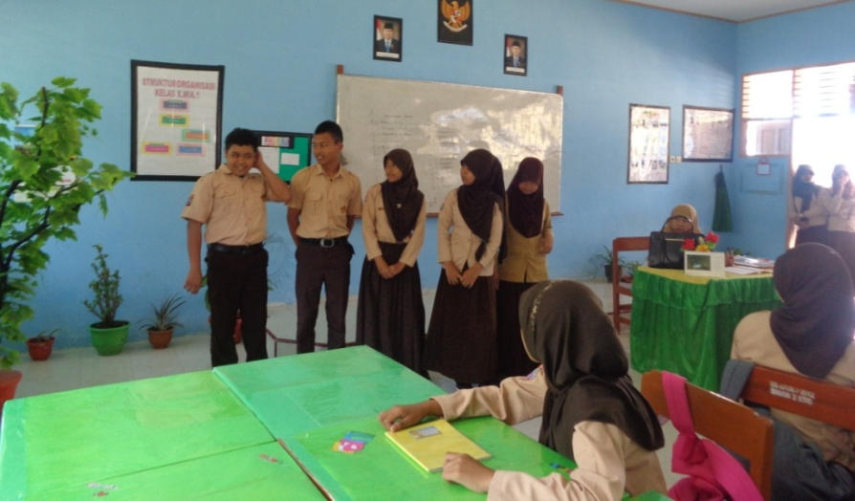
Picture 4. Students’ Presentation

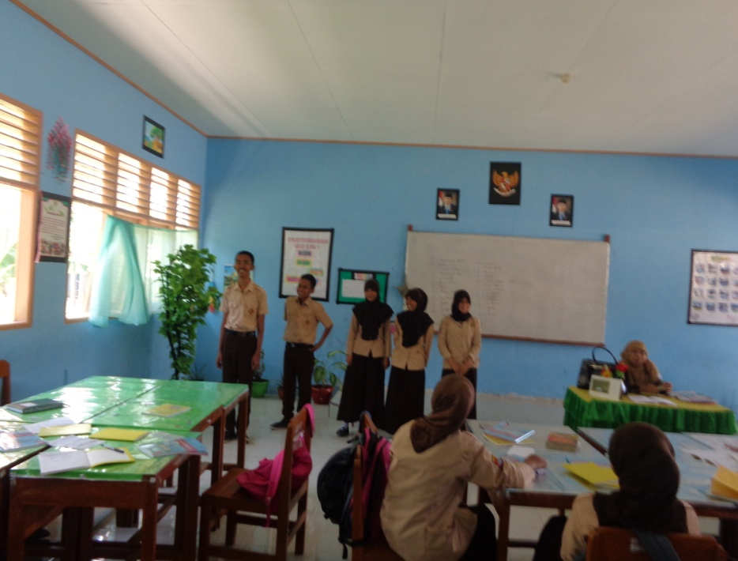
Picture 5. Students’ Presentation

Pictures above performed that all the members in one group came together at the same time in front of the class. They spoke one by one based on their job in their group. Five of them must speak in front of the class because they have responsibility to do so. Teacher assessed the students while they had the presentations.
Based on the assessment sheet (See appendix 3), teacher did not assess one aspect called writing aspect, in this project. As mentioned in the previous discussion, it is because the teacher wanted to focus on the speaking ability. The teacher would probably give them another project which focuses on the writing ability.
- Students Perception of Project Work
Project assessment is identical with project work. The teacher should give the assignment in the form of project work to assess the students. This part discusses about students’ perception of project work as their assignment. As mentioned in the problem statement, this study tried to find out the students’ perception of project work. The perception refers to what students think about project work and the effect of project work for them.
Based on the result of interview, the researcher finds that project work is helping, interesting, exciting, fun and different than other assignments. Some students thought that project work wasted their time because they should work on the project for many days but most of the students thought it does not waste time at all. The following table performs the result of students’ interview.
Table 4.2. Students’ Perception to the Project Work
No. | Students’ Perception | Stated by  (Group)
1 | Project work is helping | 1,2,3,4,5,6
2 | Project Work is interesting | 1,2,4
3 | Project Work is motivating | 1
4 | Project Work is exciting | 2,3
5 | Project Work is different from other assignments. | 2, 3, 4, 5
6 | Project Work does not waste the time | 2, 3, 4, 5

Based on the table above, most students perceived that project work is interesting, different from other assignments and does not waste the time. Other perceptions are motivating and exciting. One group of students stated that project work is motivating and two groups stated that project work is different from other assignments.
- Project Work is Helping
The appearing opinion is project work can help the students. Students assumed that project work helps them to know how to compete and take responsibility. This assumption can be found in the extract below:
R: Apa pendapat kalian tentang tugas proyek?
What do you think about project work?
Ss: Suka karena membantu .. untuk mengetahui dalam .. berkompetisi dan bertanggung jawab.
I like it because it helps to know how to compete and take responsibility.
(Interview of group 5 number 6)
The extract above shows that students were serious to work on the assignment because they realized that it helped them to take responsibility of it. The students realized as well that they competed with other groups in a good way.
The other opinion which indicates that project work is helping can be seen as follows:
R: Apa pendapat kalian tentang tugas proyek?
What do you think about project work?
Ss: Kita bisa memecahkan sebuah masalah.
We can solve the given problem.
(Interview of group 6 number 6)
The researcher categorizes the extract above as “helping” because the students stated that through project work, they could learn to solve a problem. This project stimulated the students to work together and discuss the given problem then try to solve it.
The similar perception can be seen in the following extract:
R: Apa manfaat tugas proyek untuk kalian?
What is the advantage of project work for you?
Ss: Manfaatnya eee… cukup banyak, karena kita bisa eee… mengetahui kosakata yang belum pernah… yang belum kami ketahui dan juga kita bisa bekerja sama untuk eee… memecahkan masalah itu.
The adavantage…eee… a lot of advantages, we can eee… know words that we do not know and we can work together as well to solve a problem.
(Interview of group 1 number 11)
The extract above is also categorized as “helping” because the students perceived that the advantageous of project work is to help the students knowing new words, to encourage them to solve problems and to work together. This perception is more or less same as the previous extract.
The following extract is the other interview which indicates project work is helping.
R: Apa manfaatnya?
What are the advantages of project work?
Ss: Melatih belajar berbahasa Inggris
Practicing English
Ss: Melatih bagaimana cara membagi teman .. dalam presentasi bahasa Inggris nanti.
To know how to divide friends in English presentation
R: Supaya bisa kerja kelompok.
We can work in a group
(Interview of group 2 number 8)

The extract above implies that project work can help the students creatively. It can be seen when the students stated that “we can solve the given problem”. It indicates that students work seriously on the assignment (project work). The project work helps the students as well to acquire new words, to practice their English and to work together which means they can help each other through the project.
The similar opinion found in interview of group 3 and 6. Students assumed the same thing as the previous extract. Their perception can be found as follows:
R: Menurut kalian, apa manfaat tugas proyek?
In your point of view, what is the advantage of project work?
Ss: Bisa memecahkan soal
We can solve the given problem.
Ss: Bisa bekerja sama
We can work together.
Ss: Lebih teliti
We are more accurate
(Interview of group 3 number 8)
The other question that can identify the perception of the students is “what is the advantage of project work?” The students’ answers are more or less same as the previous one. Project work can help them work more accurately. It helps them to think together in solving the given problem. This perception is supported by the following perception from different group.
R: Menurut kalian, tugas proyek mampu membantu kalian berpikir kreatif?
Do you think project work can help you think creatively?
Ss: Mampu karena .. lebih banyak berbahasa Inggris jadi mengasah otak.
Yes, it can, because we speak more English so we can sharpen our intelligences.
(Interview of group 6 number 12)
The extract above reflects students’ perception of project assessment which can help students to solve the given problem. It was mentioned as well in the previous extracts. The other appearing opinion says that project work help the students think accurately and help the students speak more in English. It proves that project work help the students.
The researcher asked the students in some different ways to figure out the students’ perception. It can be seen as follows:
R: Apa pengaruhnya dalam kemampuan kalian?
What is the effect of project work to you?
Ss: Bisa bicara, terutama menceritakan kembali.
I can speak especially for retelling.
(Interview of group 3 number 15)
The researcher asked about the effect of project work to the students. The answer of this question can tell that project work is helping as well. Students explain that they can speak more English especially in “retelling” session. The similar perception comes to group 4. They stated the similar thing as the extract above.
R: Tugas proyek, menurut kalian mempengaruhi kemampuan kalian?
Do you think, project work affects your ability?
Ss: Mempengaruhi lebih baik karena eee…disuruh menjelaskan movie itu.
Yes, it does better because eee…we were told to explain the movie.
(Interview of group 4 number 7)
The students perceived that project work affected their speaking ability. They explained that it affected better because they should explain the movie in front of the class so they were serious to prepare it. This students’ statement proved that project work is helping.
The other group told their perception about project work is group 6. They had the same perception as group 4 about “project work is helping”.
R: Apakah ada pengaruhnya terhadap kemampuan bicara?
Does project work give an effect to your speaking ability?
Ss: Ada, karena dilatih untuk menceritakan ulang
Yes, it does. We are trained to retell.
Ss: Menjawab pertanyaan tentang movie
Answer questions about the movie
(Interview of group 6 number 8)
Ss: Karena ada presentasinya
Because it has a presentation
Ss: Menyimpulkan cerita
Sum up the story
Ss: Lebih banyak bicaranya.
We speak more
(Interview of group 6 number 14)

Those extracts indicate that project work is helping because it has an effect. Students stated that they can speak because the project has some parts called retelling, explaining, answering question, presenting the result and summing up the story. Through the project work, the teacher trained the students to speak and they experienced the effect to be better.
- Project Work is Interesting
Students perceive that project work is interesting. The results of interview prove that it is interesting. The students perceive it so because project work does not make the students bored and mostly the students like it. It can be seen in the following extract.
R: Apa pendapat kalian tentang tugas proyek?
What do you think about the project work?
Ss: Menurut saya, tugas proyek yang baru ini cukup .. menarik karena tidak bikin bosan karena ada movie bukan cuma buku yang dipake untuk belajar.
I think, the project work was interesting enough because it did not make us bored, we used a movie to learn not only book.
(Interview of group 1 number 7)
This extract shows that project work is interesting because it does not make the students bored. They informed that mostly they got a book to learn English but in project work, they used a movie as media and reference of project. Using a movie as a media and making them into the project is something new for them.
Group 4 stated their perception about project work in a following extract.
R: Apa pendapat kalian tentang tugas proyek?
What do you think about project work?
Ss: Suka
I like it
Ss: Mengasah otak
Sharpen the intelligence.
Ss: Suka
I like it
(Interview of group 4 number 6)
The students like to work on the project because they can think intensively without cheating to other groups’ work.

Both extracts above show that project work is interesting. It is because the assignment does not make the students feel bored. As they told that most of the assignments are from the text book. They sometimes felt bored of the assignments. It can be noticed by the statement below:
R: Pernahkah merasa bosan belajar bahasa Inggris?
Have you felt bored in learning English?
Ss: Pernah, kalau ada tugas
I have, when I have a lot of assignments.
Ss: Kalau menjelaskan terlalu cepat jadi biasanya tidak jelas.
When teacher explained too fast and usually it wasn’t clear.
(Interview of group 5 number 2)
Those statements indicate that students sometimes felt bored in learning English when they have a lot of assignments. They seemed they did not like when they had assignment from the teacher. Otherwise, project work as their assignment becomes an interesting assignment because the students like it. The other circumstance in which the students feel bored is when the teacher explained too fast and it was not clear.
The following extract is about some assignments that students always have. Those assignments sometimes made them bored.
R: Tugas apa yang biasanya diberikan?
What kinds of assignment do you have?
Ss: Vocabulary
Vocabulary
Ss: Mengisi titik-titik
Fill in the blank
Ss: Menjawab pertanyaan
Answering questions
(Interview of group 5 number 3)
Based on the two extract above, project work is interesting as well because it encourages the students to sharpen their intelligence. They should think a lot about the project. It is not like the previous assignments like memorizing vocabularies; fill in the blank and answering questions based on the text.

- Project Work is Motivating
The third perception comes up is about motivation. Students think that project work motivates them. The extract below performs students’ perception of project work.
R: Apakah tugas proyek memotivasi kalian dalam belajar bahasa Inggris?
Does project work motivate you in learning English?
Ss: Iya karena tugas proyek ini tidak membosankan dalam belajar bahasa Inggris eee… dan juga memotivasi kita untuk lebih giat lagi dalam belajar bahasa Inggris.
Yes, it does. Because this project is not boring to learn English eee… and also it motivates us to be more diligent in learning English.
Ss: Dengan movie tersebut movie itu bisa memotivasi kita karena ada beberapa kata dari movie tersebut kita dapat mengetahui ejaan dan pengucapan kata yang benar.
The movie can motivate us because it has some words that we know how to pronounce well.
(Interview of group 1 number 10)

The data above shows that project work motivates the students to learn English and to be more diligent. As mentioned in the previous point that “project work is interesting”, some assignments make them bored. It can make the students lazy to learn English. The other fact found in this research is “project work is interesting” and it can motivate the students to be more diligent.
The motivation rises up after given a project because they compete each other to do their best on the project. They should present their result in front of the class and nobody wants to embarrass her or himself.

- Project Work is Exciting
Project work is an exciting assignment. Students perceive that it is exciting, fun and relax. They said it as shown on extract below:

R: Apa pendapat kalian tentang tugas proyek?
What is your opinion about project work?
Ss: Menyenangkan
Exciting
Ss: Seru
Fun
R: Santai
Relax
(Interview of group 2 number 7)
This group mentioned that project work is exciting, fun and relaxing. Unfortunately, the students in this group did not explore more their reasons why they perceived like that. The only stated their impressions of project work without giving further comment.
The next group gave more comment. The students in this group had a same opinion about project work as the previous group but they gave a reason in giving a statement.
R: Apa pendapat kalian tentang tugas proyek?
What do you think about project work?
Ss: Seru
Exciting
Ss: Eee…bisa membuat penasaran
Eee…it can make us curious
Ss: Mengasyikkan
Fun
(Interview of group 3 number 7)
This extract performs that project work is exciting and fun. The students think that this assignment (project work) can make them curious. They were waiting for the next activity in the project.
Those two extracts perform that project work is exciting, fun and relaxing. Students think it so because project work can make them curious. This project could encourage their curiosity which makes them think that project work is exciting.
- Project work is different from other assignments
Project work, in students’ point of view, is different than other assignments. Students explained that mostly they would have the same assignments all the times but for the midterm assignment, they had a different assignment. The following extracts are the students’ interview about it.
R: Apa pendapat kalian tentang tugas proyek?
What is your opinion about project work?
Ss: Beda dari yang lain
Different than others
(Interview of group 2 number 7)
The following extracts show some assignments which students always had. They explained that mostly their assignments were always about vocabulary. The following extract explains the assignments which students always had.
R: Bentuk tugas yang paling sering diberikan itu seperti apa?
What kinds of assignment do you always have?
Ss: Sejauh ini tugas yang paling sering dikasi itu semacam .. bukan .. semacam kosakata yang -- dari bahasa Inggris diterjemahkan ke dalam bahasa Indonesia.
So far, teachers always give us vocabularies assignment. We should translate from English into Indonesian.
(Interview of group 1 number 4)
The extract above informs that students always had vocabulary. They needed to memorize all the words that teacher gave. The other assignment is translating a text from English into Indonesia or vice versa. When project work came, the students felt it was different because their teacher usually gave them the same assignments. The other group supported the statement of group 1. It can be seen as follows:
R: Bagaimana model tugas yang diberikan oleh guru? Seperti apa tugas yang diberikan?
What kind of assignment do the teachers give you?
Ss: Mencari kata-kata, melengkapi kalimat.
Figuring out the words, completing the sentences
(Interview of group 2 number 3)
The students in this group mentioned that mostly students had some assignments namely figuring out the words and completing the sentences. Figuring out the words can be like matching words or finding out the meaning of the words. Completing the sentences means teacher gave the students some blank sentences then the students should fill the blank with the right words. These assignments are more like written assignment. They are different with project work.
Students in group 3 mentioned as well about their assignments which they always had. They can be seen on the extract below:
R: Tugas yang diberikan biasanya seperti apa sehingga kalian sangat bosan?
What kinds of assignment which the teachers gave you and you felt bored?
Ss: Menghapal kosakata
Memorizing words
Ss: Bentuk tulisan
Writing
Ss: Menjawab pertanyaan
Answering questions
Ss: Mengisi titik-titik
Fill in the blank
Ss: Menyalin
Rewriting
(Interview of group 3 number 3)
This extract shows as well about some assignments which the teacher always gave the students. They are memorizing words, writing, answering questions, filling in the blank and rewriting. The students admitted that they felt bored when they had those assignments. When the teacher gave project work, the students felt it was different than others. Those assignments mentioned previously more focused on writing form. Project work is different than other assignments because it not only focused on writing skill but also speaking skill.
“Project work is different” implicitly is stated by the students. They mentioned some assignments that they always worked on. They did not mentioned about project work. It indicated that project work is a new assignment for the students and it is different than other assignments. Group 4 mentioned some assignments that teacher usually gave them. They can be seen as follows:
R: Tugas seperti apa yang biasa diberikan oleh guru?
What kind of assignment that you have?
Ss: Berdialog
Dialogue
Ss: Mengisi titik-titik
Filling in the blank
Ss: Mencari kosakata
Looking for the words
Ss: Menjawab pertanyaan
Answering questions
(Interview of group 4 number 3)
Based on the extract above, there are four assignments which students always have. They are dialogue, filling in the blank, looking for words and answering the questions. This group of students has a similar opinion as the previous group. This group mentioned some same assignments as the groups before. Those assignments are filling in the blank, answering questions, looking for the words or figuring out the words. It indicates that teacher assigned the students almost the same assignments. Project work makes the class different.
Project work as a different assignment is implicitly stated as well by group 5 and 6. They did not tell that “project work is different” directly. They only mentioned that they always had some assignments which are repeatedly done. They did not mention “project work” as their assignment. This means that project work is new assignment and different than other ones. The researcher assumed that those assignments focused on writing and memorizing without any practice in a real life situation whereas project work focused on speaking and writing skills. Those assignments can be found in the following extracts.
R: Tugas apa yang biasanya diberikan?
What kinds of assignment do you have?
Ss: Vocabulary, Mengisi titik-titik, Menjawab pertanyaan
Vocabulary, Filling in the blank, Answering questions.
(Interview of group 5 number 3)
R: Model tugas yang sering diberikan itu seperti apa?
What kinds of assignment do you always have?
Ss: Mencatat di papan tulis
Write on the white board
Ss: Kebanyakan ambil dari buku paket
Mostly, the assignments are from the textbook.
Ss: Mengisi titik-titik
Fill in the blank
Ss: Menjawab pertanyaan dari teks
Answer questions based on the texts
Ss: Mencari kosakata
Find out the words
Ss: Percakapan
Conversation
(Interview of group 6 number 2)
These two groups mentioned filling in the blank, answering questions and finding out the words are the assignments which students normally did. Group 6 adds that mostly the assignments are from the textbook. The teacher assigned them as well to make conversation. It can help themselves to converse based on the conversation that they write or memorize. Project work is different because the students are stimulated as well to speak English.
Based on the data above, taken from six groups of students, their opinion is almost same. Before project work which conducted in midterm examination, they always had same assignments. Those are translating the words from English into Indonesian, completing the sentences, memorizing the words, writing, answering questions based on the text, filling in the blank, rewriting and making conversation. They told that they always kept having those assignments before the teacher gave them the project.
- Project Work does not Waste the Time
Before conducting this research, the researcher predicted that students would think that project work would waste their time. It could be burdening and make them hard about the assignment. Some students perceived that project work took time to do but they had no problem with it because they compared to their other activities which took more time.

R: Menurut kalian tugas proyek menyita waktu atau tidak?
Do you think project work took your time?
Ss: Tugas proyek tersebut saya rasa tidak terlalu mengganggu karena.. selain itu kami juga di sini punya kegiatan ekstra yang lebih menguras misalnya ini yang baru-baru yang sedang .. saya lakukan ini LDK dari jam setengah 3 sore sampai jam .. 5 pagi baru pulang.
I do not think the project work disturbed me because we have some extra activities here which take more time, for example the event called LDK is on going now. I should join it starting at 3 pm to 5 am. I go home at 5 am.
(Interview of group 1 number 9)
The extract above indicates that students did not complain about the use of time in doing project work. Other extracts can be found as follows:
R: Tugas proyek menurut kalian menyita waktu?
Do you think project assessment takes time?
Ss: Tidak
I do not think so.
(Interview of group 2 number 9)
R: Menurut kalian, tugas proyek ini menyita waktu?
Do you think this project work wastes your time?
Ss: Tidak
No, it doesn’t
(Interview of group 3 number 12)
R: Tugas proyek menyita waktu atau tidak?
Does project work waste your time?
Ss: Menyita
It does
Ss: Menyita tapi tidak mengganggu
It does but it doesn’t disturb
(Interview of group 5 number 9)

R: Apakah tugas proyek menyita waktu?
Does project work waste our time?
Ss: Tidak
No, it doesn’t.
(Interview of group 6 number 9)
On the other perception, a few students perceived that it wasted time because they should watch the movie for many hours then they needed to think after watching. It is found in one group of students which performs in the following abstract.
R: Tugas proyek menyita waktu atau tidak?
Does project work waste your time?
Ss: Menurut saya menyita waktu karena kita harus nonton film berjam-jam setelah itu dipikir lagi.
I think it does because we need to watch the film for many hours and then we need to think about it again.
(Interview of group 4 number 8)

The researcher believes that those students who said that project work wasted time did not like to watch a movie. They complained only about the time that they used in watching movie but they like the rests of activities like discussion, retelling or presentation. It is proved by the extract below.
R: Tugas proyek, menurut kalian mempengaruhi kemampuan kalian?
Do you think, project work affects your ability?
Ss: Mempengaruhi lebih baik karena eee…disuruh menjelaskan film itu.
Yes, it does better because eee…we were told to explain the film.
(Interview of group 4 number 7)
Both previous extracts above seem contradictory. In one point, the students stated that project work wasted students’ time but the other point of view, the students stated that project work affected their speaking ability. It made them better because they were told to explain the film. Related to this perception, the researcher assumed that project work wasted time purely because of the film. They did not think that project work was boring or any kind of negative perception. The researcher concludes that mostly students like project work but a few students do not like a certain activity.

- Discussion
This section refers to the interpretation of findings. As explained above, this research has two main point of findings namely how the teacher managed the assessment and the students’ perception of project work. The first part of this section mainly discusses about teacher’s management of assessment and followed by the second part which mainly discusses the students’ perception.
- Teacher’s Management
As performed in the findings section, the teacher had six steps in assigning and assessing students. They are grouping, explaining, consultation, planning, process and report of project. The first three steps are teacher-centered and the rests are students-centered. In grouping, teacher let the students to choose their own members. It is for making the students comfortable in doing the project. The students sat with their friends in a same group as in picture 1 shows in the finding.
The seats arrangement can help the students to work together and discuss about their assignment. The teacher explained to the teacher that all members in a group need to work together and help each other to have a good result in presentation. Students would have a lot of discussion because they need to talk about their plans and to divide themselves into some parts of the assignment. They need a good position to communicate each other.
After grouping, the teacher explained what the students need to do. She told the students that the assignment was for assessment in midterm. She explained as well the activities in the project. Students watched a movie called “Exam”. This movie can encourage the students because it is a psychological thriller which stimulates the students to think. The movie tells about eight people have an exam. It takes 80 minutes and consists of one question only, and that there are three rules: they must not talk to the invigilator or the armed guard by the door, spoil their paper, or leave the room. Not obeying the rules will result in disqualification (for detail information about the movie, see appendix 5).
The teacher listed some things that should include in their presentation. They are retelling the movie, telling the question in the movie, telling the students’ favorite scene, telling the moral message and telling the thing that they disagree. They have two weeks to do their assignment. During the process of the their assignment, the researcher noticed that students did not consult to their teacher however the teacher explained that they could consult if they have any difficulties.
Planning, process and report the project are students-centered. The teacher assessed these three activities. She assessed two aspects in planning section called preparation and title. Teacher assessed how the students prepared their project, how they divide themselves to breakdown their parts in the project and how they discuss to determine a title. According to Syamsudduha (2012) about the criteria of project assessment, the teacher should assess students’ objective, topic, background, research area, respondent and complete question list in planning section, yet in direct observation, the researcher did not find the teacher told the students to make objective, topic, background, research area and respondents. She only told the students to make the review of the movie orally based on question list.
Ideally, a project should result a product as Haryati (2013) explored that a project is more efficient and produces an economical product. Related to language project in language learning, the product is more like literary work but project conducted by the students does not focus on the product. The teacher tended to have the students make a review orally. It is probably because of the students’ level. In this level, the teacher only focuses on one of productive skills namely speaking skill. The teacher explained to the students that actually there must be a written form in this project but for that time, they need to focus on the presentation.
The next assessment is the assessment of project process. It has four aspects to assess namely getting information, writing, analyzing data and concluding. Students watched the movie carefully and the teacher sometimes asked them while watching. Some appearing questions from the teacher were “Who do you think will be the winner?”, “Why do you think so?” and “Do you change your mind?”. Students kept speaking English when they answered their teacher. Some students wrote the information from the movie but they did not need to show it to the teacher. They wrote only for reminding them about what they need to talk about in presentation (See appendix 4)
The next part of this section is analyzing data and concluding Students analyzed the data through discussion. They tried to figure out the questions list. The rule was students should speak English in discussion. The discussion should mainly discuss about the questions list that they had when teacher explained previously. After analyzing the data, the students should conclude their discussion. They had better to have a same opinion in one group.
After the process, the section came up was report of project. It consisted of four aspects to assess called presentation, retelling, telling experience and performance. There were five things should involve in presentation. They are retelling the movie, telling the question in the movie, telling the students’ favorite scene, telling the moral message and telling the thing that they disagree. Presentation covered the overview of the project. The leader of the group presented this part. He or she should explain as well about their project process. Two members retold the movie and its moral message. Then the rests told the experiences which include telling the things, they disagreed, telling their favorite scene and the reason why they liked it. Favorite scene might be different per each member but only one member could tell everything in this part.
The other aspect assessed is performance. It is about the body language of the students, the intensity of looking at the note, fluency and accuracy. The researcher noticed that the teacher used her own way to assess the students. Especially for report of project based on Syamsudduha’s category in 2012, the teacher needs to assess the project by considering the systematic of writing, suggestion and the use of language. In this research, the teacher only considered the use of language.
Based on the explanation above, the researcher found out that teacher reduced some assessed aspects in the theory and replaced them with other aspects that teacher thought it might be useful. But the result, this activity affects the students’ productive skill especially for speaking ability. It can be seen on the students’ perception in the following section.
One interesting thing appeared on the research. It was about project work. Haryati (2013) and Stoller in Renandya (2002) are two experts explained about project work. They explored project work but in one point of view, they are different. Haryati (2013) explained that project work produces an economical product whereas Stoller in Richards and Renandya (2001) explained that Project work culminates in an end product (e.g., an oral presentation, a poster session, a bulletin-board display, a report, or a stage performance). If the teacher follows Haryati’s theory, it can be concluded that students did not result any product in their project. Otherwise, the teacher follows Stoller in Renandya (2002) theory, the students resulted a product namely an oral presentation. The researcher assumed that the teacher follows Stoller in Renandya (2002) theory because the teacher did not force the students to result a concrete product such as a written review.
On the other point of view, the researcher noticed that the teacher did not follow Stoller’s (Renandya: 2002) theory about the steps of doing project. As mentioned in chapter 2, Stoller in Renandya (2002) has ten steps in doing project work. Some steps were conducted by the teacher, some steps were not the following table illustrates the steps conducted by the teacher and some were not.
Table 4.3 Steps in Project Work
No | Steps | Teacher | Students
1 | Students and instructor agree on a theme for the project. | √ | √
2 | Students and instructor determine the final outcome. | √ | √
3 | Students and instructor structure the project. | √ | √
4 | Instructor prepares students for the language demands of information gathering | - | -
5 | Students gather information. | - | √
6 | Instructor prepares students for the language demands of compiling and analyzing data. | - | -
7 | Students compile and analyze information. | - | √
8 | Instructor prepares students for the language demands of presentation of the final project. | - | √
9 | Students present final product. | - | √
10 | Students evaluate the project. | √ | √
The first step is instructor and students agree on a theme for the project. Teacher and students in observed class did this step. After grouping, the teacher explained what they were going to do. The teacher gave them some choices (novel, articles and movie) and the students voted which theme that they agreed with. They agreed to do a project related to a movie. Then, the teacher gave them three kinds of movie and mostly students voted for a movie called “Exam”.
Then, the teacher and students did as well the second step of Stoller in Renandya (2002). Students and instructor determine final outcome. Teacher described that the outcome focused on the students’ speaking ability. The students needed to present, retell and tell their experience related to the movie. Some students complained about those activities but teacher explained the objectives of it then they understood.
“Students and instructor structure the project”. It is the third step of Stoller in Renandya (2002). In this research, both teacher and students had this step. They structured the project very well. The teacher only explained the structure of the project then the students discuss in structuring their project. As explained by Stoller in Renandya (2002), a question that students should consider is what information is needed to complete the project? The teacher did it well. She stimulated the students to figure out the questions that teacher gave. Those are what is the movie talked about? What is the moral thing about it? Which is your favorite scene? Etc. then, the students developed those questions to be an information.
“Instructor prepares students for the language demands of information gathering”. The teacher and the students did not do this step. Actually, the teacher prepared it in a form of consultation but no student came. This step can help the students who have a problem with their project. They can consult to their teacher and make some discussions about their project which probably they guess they have made a mistake.
“Students gather information”. Ideally, students gather information through some ways that potentially are relevant for students. Those ways can interview, observation or book. In this research, students gather information through a movie. They did not conduct an interview or read a book. The teacher only had them watch the movie and collect information as much as possible.
Step 6 says that instructor prepares students for the language demands of compiling and analyzing data. The teacher did not really do this step. Based on the theory, in this step, the teacher should make a preparation for the demands of the compilation and analysis where the students can organize their project. This is conducted after the students gather the information. In this research, the teacher only explained in the first meeting how the students organize the project.
Step 7 says that students compile and analyze information. Stoller in Renandya (2002) stated that students compile and analyze information to identify data that are particularly relevant to the project. The researcher found that the students did this step. They made a note to keep the important information. Then, they discussed with their own group in analyzing data. Each student had a responsibility. They had already divided themselves into some parts of project. It eased them in doing the project.
Step 8 says instructor prepares students for the language demands of presentation of the final product. This step involves some process namely practicing oral presentation, receiving feedback, editing and revising written report. This step was not conducted by the teacher either. On the observation, the researcher saw the students prepare themselves in practicing oral presentation and had a feedback or correction from other members in a same group. As mentioned, there is no written report which consequences no editing and revising written report.
Step 9 explains about students’ presentation of final product. Students applied this step. Their product is oral presentation. They presented their opinion about the given movie. In reporting, they explained the overview of presentation, retelling the movie, telling experience which involved their opinion about the movie, their favorite scene, the moral side of the movie and the thing that they did not like in the movie.
“Students evaluate the project” is the last step of doing a project work. In this step, it says that it is worthwhile to ask the students about the project to reflect and give them a feedback. The students and the teacher in this research did this step. They had a long discussion after presentation. The reflection and feedback were not only from the teacher but also were from the students. They were more active to criticize their friends from the different groups. For the first presenter, other group seemed reluctant to express what they were thinking about but teacher stimulated them to express. The teacher gave them a feedback and asked the students who listened to the presentation about their opinion of the presenter. One or two group began to say something, then the more presenters, the more opinion appeared.
The researcher assumes that project assessment can be applied in assessing students in project-based learning considering how the teacher managed the project assessment which involved team work, responsibilities, presentation and production. Moreover, to apply project assessment in PBL, the teachers need to know the differentiation between assessment in project assessment and PBL. It can be easier to apply project assessment in PBL because they apply the same task which is project work. Apart from that, both project assessment and PBL do not consider only one aspect but some aspects namely work collaboration, authentical problem solving, curriculum-based and interdisciplinary. This is in line with Solomon’s theory in Simpson (2011). Solomon in Simpson (2011) explained that project-based learning is a learning process that trains the students to be responsible for their own given tasks. Such approach forces the students to work collaboratively, to solve problems that are authentic, curriculum-based and often interdisciplinary.
Pertaining to the assessment used in PBL, the researcher believes that there is no theorist proposed project assessment in PBL. The depiction of such assumption can be seen in the following collection of various theories. Mansoor (1997) stated that in PBL students can be assessed through peer assessment, self assessment and rubric assessment. In another word, Hellstrom, D et.al (2009) explained that in project-based learning, students have been assessed in a variety of ways. Those ways can be self assessment, peer assessment, co-assessment, portfolio assessment, performance assessment and reflective journals.
Similarly, Berge et. al in Simpson (2011) also described that assessment of PBL can be different and challenging. Students in PBL are assessed by various assessment such as traditional pencil and paper assessment, performance-based assessment and portfolio assessment. In addition, Tamim and Michael (2013) stated that teachers mainly used rubrics to assess students in project-based learning.
Based on the perception from the theorists above, the researcher realizes that project assessment has a big opportunity to apply in PBL, since none of the experts recommends project assessment as an assessment in PBL. The application of project assessment in PBL is beneficial knowing the fact that the assessments in PBL are peer assessment, self assessment, performance assessment and rubric assessment. By applying project assessment in PBL, the teachers do not merely focus on one stage of project work; instead, they can focus on all stages of project work.
- Students’ Perception to the Project Work
Regarding to the students’ perception, this research as well tried to find out what students think about they think that project work is helping, interesting, exciting, motivating and different than other assignments. The researcher interviewed six groups of students in different level of achievement. Each group consisted of five students. The six mentioned perceptions above appeared intensively in interview.
According to Haryati (2013) stated that project work gives an opportunity for the learners to express completely their competence and it produces a value of competence which they can take responsibility of it. One of the findings supported this theory (See Interview of group 5 number 6). During the process of project, the students were serious to work on their project. This assignment is different from others because they have no time to cheat because they worked with their own group and they had their own responsibility individually.
Two of six findings, related to the students’ perception, are same as the theory. Those are project work is helping and different from others. In the other point of view, four other findings namely project work is motivating, interesting, exciting and does not waste the time. Haryati (2013) does not mention these four findings. Those three perceptions are supported by some statements of students on extracts in findings. The other supporting statements are interview of group 3.13, interview of group 2. 10, interview of group 4.10, interview of group 5.8 and interview of group 6.11. These interviews indicate that project work is really interesting, exciting and motivating. The researcher let them imagine if they have a chance to choose their assignment, they preferred to have project work because it was not boring. They could think and discuss without cheating because they had different responsibility in their group.
The statement “Project work is not boring” implicitly tells that students liked doing project. They experienced of working on the assignment without hoping the other students’ help except their own members. They can work with their own friends and figure out all the things which may appear in their project. This assignment stimulates the students as well to do their best because at the end of the assessment, they should present their report in front of the class. They did not want to embarrass themselves in front of other groups.
As performed in findings section, the students stated that they have more time to speak English with this assignment. They could speak more English as well. (See Interview of group 6 number 1 and group 3 number 15). This proves that they had a chance to practice their English. This chance can be one of motivations for them to have more practice. The students can be motivated as well when they seriously did their project because they wanted to be better than other groups.
Stoller in Renandya (2002) stated that project work is potentially motivating, stimulating, empowering and challenging. It usually results in building students confidence, self-esteem and autonomy as well as improving students’ language skill, content learning and cognitive abilities. This theory supported the finding of this research. Students orally stated the project work as motivating assignment which actually has been stated by Stoller in Renandya (2002).
Students did not mention directly that project work is stimulating, empowering and challenging assignment as Stoller in Renandya (2002) explained in his theory but the researcher assumes that actually students implicitly agree with Stoller’ theory (Renandya: 2002)unfortunately they did not state it orally. Based on the interview, the students always said that some activities in project work made them speak. It indicates that project work actually stimulated them to speak.
The researcher predicts the project work is probably not helping, motivating, interesting, exciting and different than others if the teacher is not creative. The teacher should be creative to decide what kind of project should be done by the students. The teacher should know what the students really need. He or she needs to consider what kind of project that students need to do and what kind of project which students really can involve to the assignment.
Based on the findings and discussion above, there must be a further investigation about project assessment and project work, especially for exploring project on different skills, the reason of teachers why they did not follow all steps based on the theory.

CHAPTER V

CONCLUSION AND SUGGESTION
This chapter discusses the conclusion of the research and the suggestion proposed.
- Conclusion
Based on the preceding findings and discussion, the researcher concludes that:
- Project assessment assesses four aspects namely planning, collecting data, processing data and report. Teacher can break them down in managing the assessment. In this study, the teacher manages the assessment by dividing those aspects into some parts. Planning consists of preparation and title, collecting data is getting information, processing data consists of writing, analyzing data and concluding, and report of project consists of presentation, retelling, telling experience and performance.
- In managing the assessment, the teacher does not totally follow one theory. She adopted some theories and mixed them in applying this assessment.
- Considering the process of project assessment and the definition of project-based learning, the students who learn through PBL approach can be assessed by applying project assessment.
- Students perceive that project work in project assessment is helping, interesting, motivating, exciting, different than others and does not waste the time.

- Suggestion
Considering the result of this research, the researcher suggests that:
- It is better to assess the students by applying project assessment in a particular period of time such as mid-term examination.
- In a process of the project assessment, the teacher should be creative in assigning the students of doing project work and should direct the students effectively.
- Despite the absence of writing in the project report, it is worth suggesting to the next researcher or the teacher to be able to implement writing skill in students’ project report.
- Since this research focuses on speaking skill, the researcher suggests to the next researcher that there are still many things to explore and investigate related to project assessment especially for productive skills. It does not mean that the receptive skills cannot be explored. It can be the challenge for the next researcher to investigate the similar study focusing on the receptive skills that can be associated with the perception of the teacher about project assessment of project work.

BIBLIOGRAPHY

Arikunto, Suharsimi. 2013. Dasar-dasar Evaluasi Penidikan. Bumi Aksara: Jakarta.

Brown, H. Douglas. 2001. Teaching by Principles: an Interactie Approach to Language Pedagogy. Second Edition. Addision Wesley Longman, Inc.
Brown, H. Douglas. 2004. Language Assessment: Principle and Classroom Practices. White Plains, Pearson Education, Inc: N.Y.
Clark, H. Herbert and Clark, Eve V. 1977. Psychology and Language: an Introduction to Psycholinguistics. Harcourt Brace Jovanovich, Inc: United States of America.
Davis, Josephine D. 2010. Project Assessment and Evaluation Plans. Atlanta.
Gay, L.R, Mills. et.al. 2006. Educational Research: Competencies for Analysis and Application.8th edition, Pearson Merrill Prentice hall: Ohio.
Genesee, Fred and Upshur, John A. 1996. Classroom-Based Evaluation in Second Language Education. Cambridge University Press: Cambridge.
Harris, Michael and McCan, Paul. 1994. Assessment. Macmilan Publisher Ltd: N.Y.
Haryati, Mimin. 2013. Model dan Teknik Penilaian pada Tingkat Satuan Pendidikan.Second Edition. Referensi: Jakarta.
Haryanto. 1998. Motivasi dan Strategi Belajar Pada Pembelajar Bahasa Inggris yang Berhasil di SMU. Unpublished Dissertation. PPs IKIP: Jakarta.

Hellstrom, D. et.al. 2009. Group in Project-Based Learning-Students in higher engineering courses. Den 2: A Utvecklingskonferensen for Sveriges Ingenjorsutbildningar, LTH.

Jabu, Baso. 2008. English Language Testing. UNM Publisher: Makassar.
Keputusan menteri (Kepmen) No.53/4/2001 tentang Pedoman Penyusunan Standart Pelayanan Minimal Penyelenggaraan Persekolahan Bidang Pendidikan Dasar dan Menengah(DIKDASMEN).From https://www.google.com/search?q=keputusan+menteri+%28Kepmen%29+No.53%2F4%2F2001+tentang+Pedoman+Penyusunan+Standart+Pelayanan+Minimal+Penyelenggaraan+Persekolahan+Bidang+Pendidikan+Dasar+dan+Menengah+%28DIKDASMEN%29&ie=utf-8&oe=utf-8&aq=t&rls=org.mozilla:id:official&client=firefox-a retrieved at 18-9-2013
Luoma, Sari. 2004. Assessing Speaking. Cambridge University Press: Cambridge.
Mansoor, Inaam et.al. 1997. Project-Based Learning and Assessment. Arlington Public School: Virginia.
Mia. 2012. Mathematics is the King and the Servant of Science. Retrieved from http://miamtk.wordpress.com/2012/01/13/proyek-mia-mulia/ on 18-9-2013.
Miles, M.B & Huberman, A.M. 1994. Qualitative Data Analysis: An Expanded Sourcebook 2nd Edition. Sage Publications: California.

Moleong, Lexy, J. 2009. Metodologi Penelitian Kualitatif Edisi Revisi. Remaja Rosdakarya: Bandung.

Nastu, Jennifer. 2009. Project-Based Learning Engages Students, Garners Results. eSchool News. Retrieved from http://www.eschoolnews.com/2009/01/27/esn-special-report-2/ on 18-02-2015.
Nation, I.S.P. and Macalister John. 2009. Language Curriculum Design. Routledge Taylor and Francis Group: New York and London.
Notebaert, A. J. 2009. Student Perceptions about Learning Anatomy. Published Dissertation. University of Iowa: Iowa.
Richard, Jack C and Renandya, Willy A. 2002. Practice Methodology in Language Teaching, an Anthology of Current Practice. Cambridge University Press: New York.
Richards, Jack C and Richard, Schmidt. 2002. Longman Dictionary of Language Teaching & Applied Linguistics Third Edition, Pearson Education: London.

Rousova, Vlasta. 2008. Project-Based Learning: Halloween Party. Diploma Thesis. Maryk University BRNO.

Schunk, D.H., and Meece, J. L. 2009. Students Perceptions in the Classroom. Routledge: New York.

Simpson, Jantima. 2011. Integrating Project-Based Learning in an English Language Tourism Classroom in a Thai University. Australian Catholic University: Australia.

Smith, K. Q. N. 2008. Learning Styles and Students’ Perception of Teachers’ Attitudes andIts Relation to Truancy among African American Students in Secondary Education. Published dissertation. Louisiana State University: Louisiana.
Syamsudduha. 2012. Penilaian Kelas. Alauddin University Press: Makassar.
Tamim, Suha., and Grant, Michael M. 2013. Definitions and Uses: Case Study of Teachers Implementing Project-Based Learning. Article 3. Volume 7. Issue 2. Interdisciplinary Journal of Problem-Based Learning.
Udin, Imran Trista. 2013. An Evaluation of the Speaking Assessment Task Used by an English Teacher at SMK Negeri 4 Makassar (A Case Study). Unpublished Thesis Pascasarjana UNM: Makassar.
Walgito, Bimo. 1991. Psikologi Sosial (Suatu Pengantar). Andi Offset: Yogyakarta.

Yam, Lee Hong Sharon and Rossini, Peter. 2010. Implementing a Project-Based Learning Approach in an Introductory Property Course. 16th Pacific Rim Real Estate Society Conference Wellington: New Zealand.

APPENDICES

Appendix 1
Daftar Pertanyaan
      - Bagaimana metode pelajaran yang digunakan oleh guru anda?
      - Apakah anda memahami tugas yang diberikan oleh guru anda?
      - Sistem tugas apa yang paling anda sukai?
      - Apakah anda menyukai tugas besar yang ditugaskan?
      - Apakah tugas besar menyita waktu anda?
      - Apakah tugas besar membantu anda berpikir kreatif? JikaYa, jelaskan bagaimana!
      - Apa manfaat yang anda peroleh dalam melaksanakan tugas besar?
      - Apakah tugas besar mempengaruhi kemampuan anda berbicara dalam bahasa Inggris?
      - Bagaimana tugas besar dapat memotivasi anda dalam belajar bahasa Inggris?
      - Apakah dalam mengerjakan tugas besar membuat anda berpikir bahwa bahasa Inggris adalah bahasa yang sulit dipahami?

Appendix 2

Students’ Assessment sheets

Appendix 3
Documentation
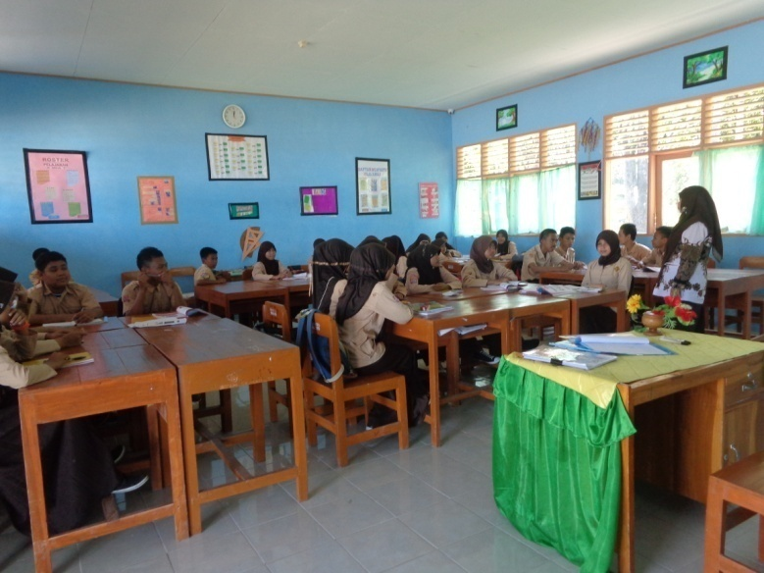
- Preparation

The picture above was taken when the teacher explained what the students needed to do. She told about the project work. It is a new kind of assignment that the students never had before. The assignment was a part of their midterm test. The teacher explained that they would have a week to do their projects, they should work together with their group, and they could decide themselves about their parts in a group. Some students had a questions related to this project but the teacher explained it well so all students could understand it at the end.
After giving the instructions to the students, the teacher grouped them into six groups. The way of grouping was very simple. The teacher asked the students, what kind of grouping they want and the students wanted to make group based on their seats as performed on the picture above. In the regular class, the seat arrangement of this class was always like that. The students sat every day on the same chair with their best friends that they were comfortable with.
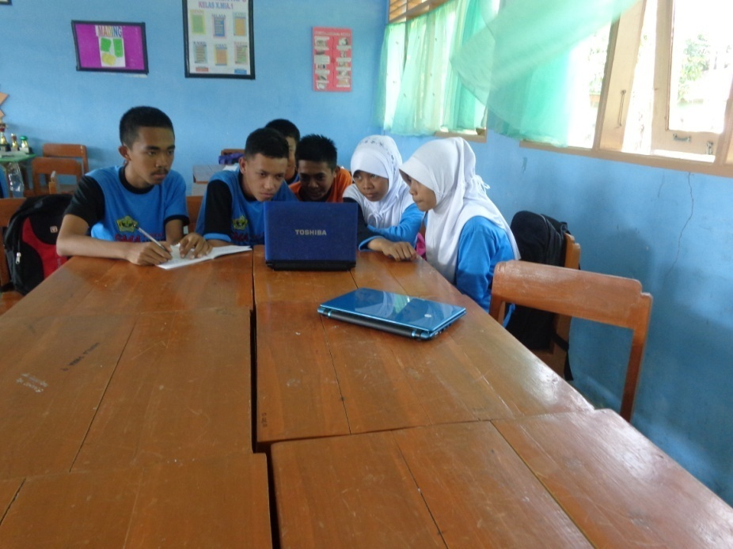
- Process

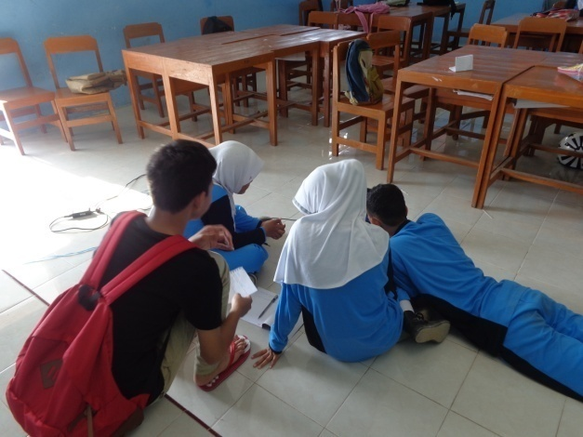
In this picture, the students did the first thing in the project namely watching movie. They watched together and one of them wrote some important information and other ones watched while commenting. Mostly students talked when they were watching. It happened to the following picture.

One of the students in this group on the picture above was analyzing the movie. The one who wore a black shirt was explaining his interpretation. His friends were listening to him without looking at him. They seemed like really relax in watching the movie.
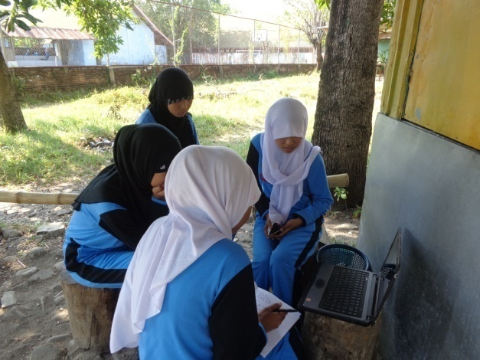

The students on this picture took different place. They chose a place where other students did not really walk around. This place was not a popular place in this part of the school. This group thought that this place helped them to concentrate on their project. It was a quiet place. Mostly, other groups did their project in the classroom but they did it out of classroom. The other activity was like other group, one of the members wrote some important thing in the movie.

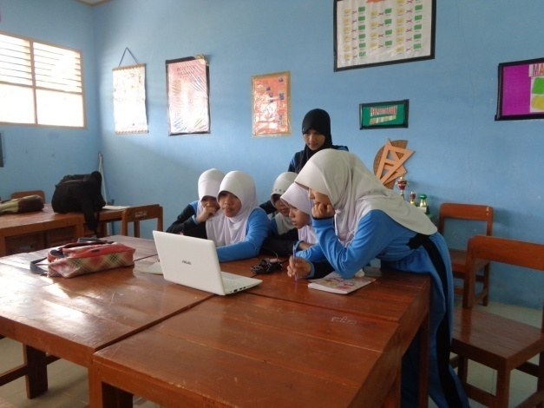

Most of the students discussed their project while watching again the movie. Some of the students watched it one or two times to make sure their matter in the presentation. It can be seen on the picture above. The other picture is about when the students discussed and simulated their presentation.

This picture tells about one of the group simulated their presentation. Some students stood in front of their friends in a same group. The members who sat on the chair commented the presentation and suggested what lacked of. They did it in turn.
- Report of Result
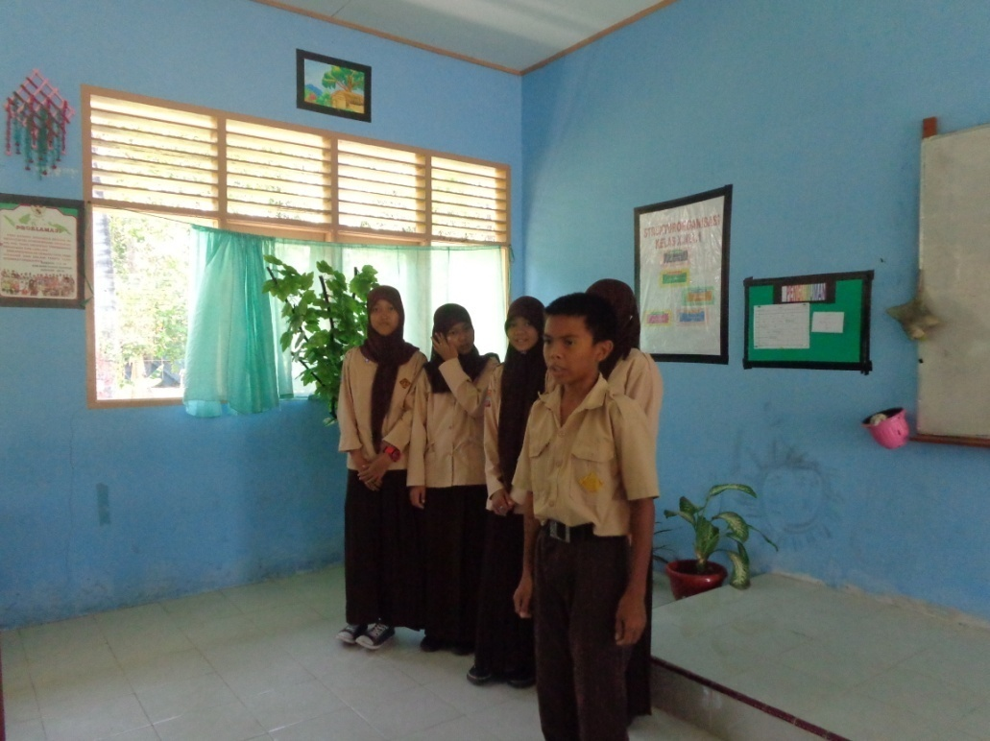

The picture above shows the students’ report of result. All the members of a group had to speak in front of the class. Some students looked very nervous while presenting. They looked reluctant at the first time in presenting but then, they could figure it out. This group looked nervous because they were the first presenter in this class. The group on the picture above seemed like afraid to make a mistake so they looked really serious. The other group was less nervous because they had seen the example. Even they did a mistake, they were ok. The following picture shows it.

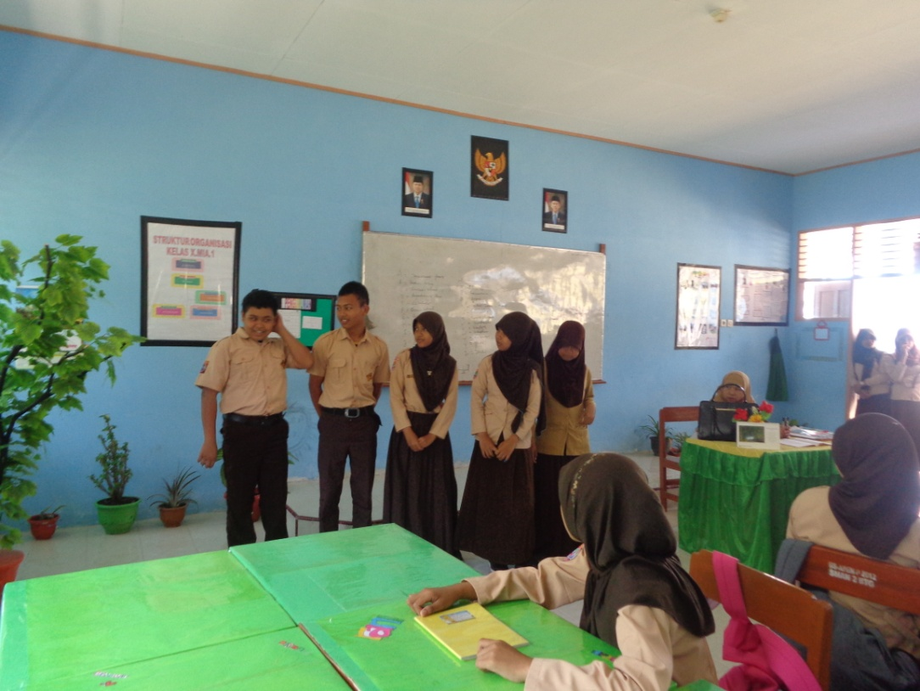

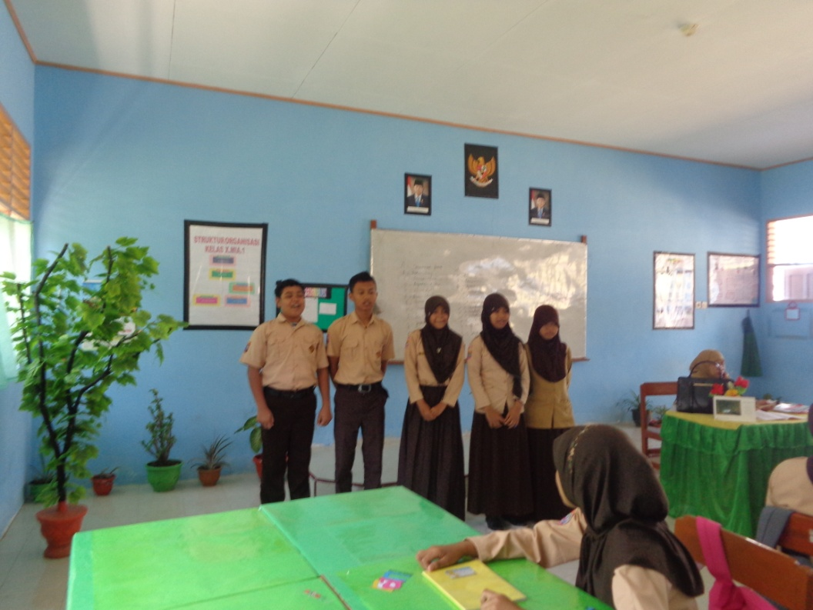
This group more relaxed in presenting their result. One of them looked confused but his friends tried to help him. Then at the end he could present well. It can be seen in the following picture.

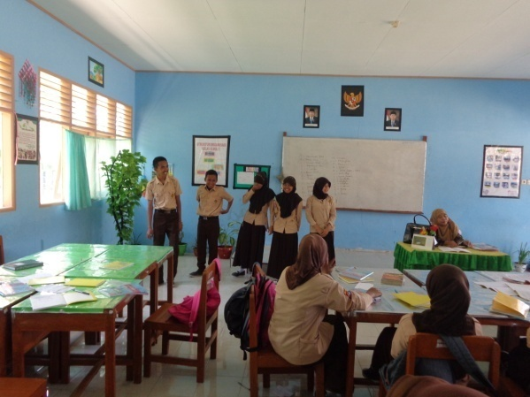

The picture above shows the other group presenting easily. They looked enjoying their presentation. They laughed together. It happened as well to the group below.
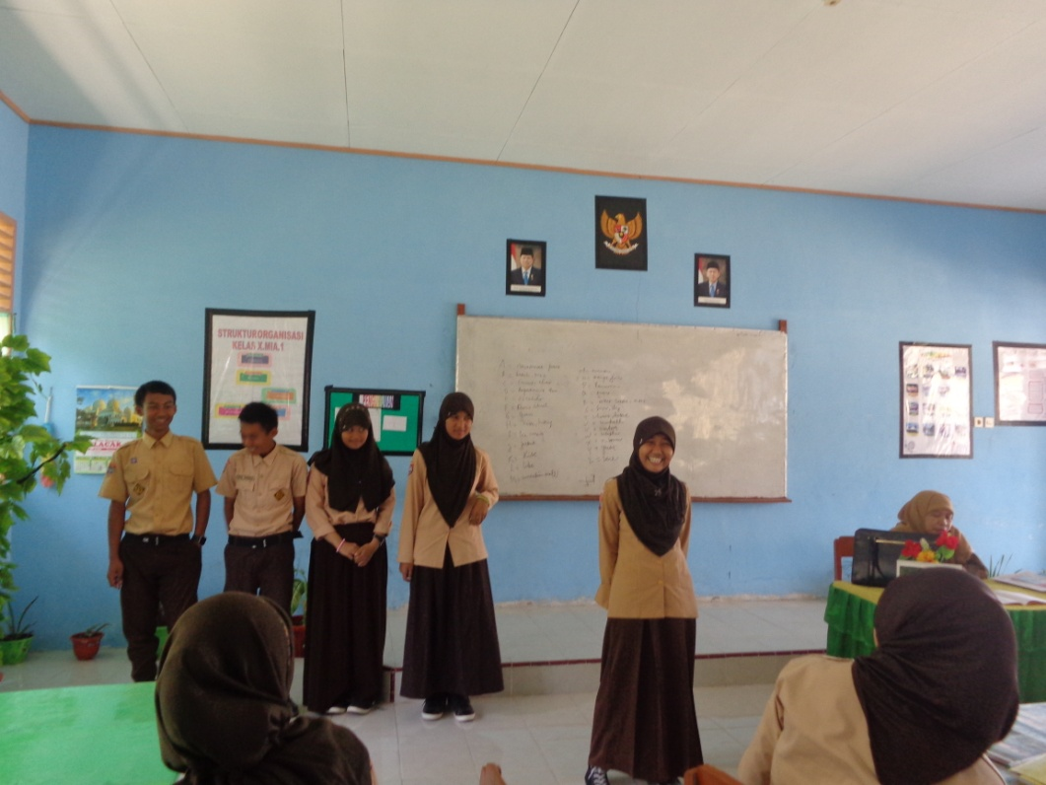

Appendix 4
Synopsis of Exam
Eight candidates for a top job at a mysterious company are gathered in a windowless room with two rows of desks. They have passed previous requirements not mentioned in the film. They each choose a seat and upon each desk is a piece of paper which identifies them as, "Candidate 1", "Candidate 2", etc. The invigilator, (Colin Salmon), arrives and sets forth the rules for the test.
Inside the room there will be no laws other than what the company permits, as such. The candidates cannot try to communicate with the invigilator himself nor the guard. They cannot spoil the paper and they cannot leave the room for any reason. If they break any of the rules, they will be disqualified. The test consists of answering one question. The invigilator asks the candidates whether they have any questions. He sets the clock at 80 minutes and leaves the room.
Once alone, the candidates turn their paper over and find nothing is written on the back. They look at each other in confusion, and the candidate "Oriental" (Gemma Chan) starts writing "I believe I deserve..." The guard (Chris Carey) puts her out because she has written on her paper, spoiling it.
A young white man, (Luke Mably) starts talking, stands up and convinces everyone to work together until they find what the question is. He also gives insulting names to the candidates according to their physical appearance, like Blonde, Deaf, White, Brown, Dark...
At first, they try to read a hidden message in the papers by placing them in front of tubes of ultraviolet lights that horizontally surround the room. They then break the tubes so that the emergency lights come on. When they break the emergency tubes they find infrared light. None of this helps them to see anything on the paper. They further discover that if a candidate spoils another candidate's paper, neither of the two will be disqualified.
They try spilling liquids over the paper. White urinates on his but finds nothing. White takes charge of the group as a de-facto leader. Brunette (Pollyanna McIntosh) discovers they can touch the guard as long as they don't talk to him. She finds a lighter in one of his pockets. She wants to set off the fire alarms because it may produce something other than water which may reveal a photograph that shows the question. She jumps onto a table, but still cannot reach the sprinkler. White offers her a paper and after succeeding she discovers that White gave her her own paper, so she is disqualified.
White picks on Deaf (John Lloyd Fillingham) who speaks only French. Deaf displays symptoms of a mental or nervous disorder. He says in French that they only have to look at the papers while he tries to re-order some small pieces of glass on top of the paper. White bullies him into tearing the paper and eating it. The guard puts Deaf out.
They discover that Brown (Jimi Mistry) is a professional gambler, and he suggests that the board of directors is hidden on the other side of the wall betting on who'll win. Dark (Adar Beck) is a psychoanalyst who seems to be the only one who has some information about the company, the products it sells, its expansion etc., but none of the other candidates were able to find any information in spite of doing some research. They think she's a spy within the company and is actually working for them and they want to get the question out from her with torture. When Brown is going to torture her by cutting her with a piece of paper, they discover that she has self-hurt on one of her thighs before. Brown makes a cut. Blonde offers her a piece of plastic plaster.
White deceived them by saying the group could collaborate until they guessed but after tricking Brunette into being disqualified each one begins to mistrust the others. As the tension builds to greater levels White ends up tied to a chair by Black (Chukwudi Iwuji) and Brown. White starts convulsing and is unable to find his medication, which is required every hour. While everyone else is trying to decide the best way to help, Dark turns toward the blank screen and pleads, and is thereby disqualified. Blonde (Nathalie Cox) discovers that Brown stole White's pill and stuck it under his desk with a piece of chewing-gum. Blonde forces the pill into White's mouth, they free him and he gets well almost immediately.
White believes only one can win. He and Black begin arguing and race to get the guard's gun. White is allegedly shot by Black, but they discover the gun didn't actually fire. White gains possession of it and tries to shoot Black, but once again, the gun doesn't shoot. White figures out that the gun may only be shot by the guard, so he puts the gun into the guard's hand and shoots. White threatens everybody that they must leave or be killed. Brown leaves. Blonde leaves and shouts "lights out" in order to give Black the opportunity to win. In the dark, White kills Black.
White shouts to the other side of the wall that he's won, however, he loses because Deaf has adjusted the clock so that the 80-minute time slot has not yet expired. The glass wall is turned on and White can see the silhouette of the invigilator. He looks at Black on the floor and realizes that it has all been in futility, so he tries to commit suicide. He is unable to because, as recalled, the gun will only work with the guard's fingers. The guard disqualifies him by putting his arm on White's shoulder and leads him out.
Blonde enters the room again and picks up her paper. She fumbles with the pieces of Deaf's broken glasses and reads "Question 1" written on the watermark of the paper in very small print. She offers it to the invigilator and says "no", answering the question put forth "Are there any questions?". She is offered the job. She is explained Deaf is the CEO of the company. He is a troubled but genius scientist who has discovered a pill to heal wounds really fast.

Blonde says that she may not accept the job. When the invigilator points to why she went through all that trouble if she didn't want the position, she points to Black lying on the floor and says that it's unacceptable. The invigilator asks, "Who told you that he's dead?". She approaches Black and sees that the bullet wound is almost healed. The invigilator says that they put the fast-healing pill inside the bullet.
They own the formula for the medicine which also healed White's illness, but it can only be manufactured in very small quantities. The new director needed to have sympathy alongside ambition, intelligence, drive and hard work.
Blonde accepts the job right away.
Summary written by KrystelClaire
http://www.imdb.com/title/tt1258197/synopsis
Appendix 5

Transcript of Interview

