THE ANALYSIS OF POLITENESS STRATEGIES USED BY EFL STUDENTS IN CLASSROOM INTERACTION AT SEMBILAN BELAS NOVEMBER UNIVERSITY OF KOLAKA

Hariadi Syam
Email: adhy_syam88@gmail.com

A.Qashas Rahman
Email: qashas54@gmail.com

Sukardi Weda
Email: sukardi.weda@unm.ac.id

Graduate Program, State University of Makassar (UNM), Indonesia
Program Pasca Sarjana Universitas Negeri Makassar
Jl. Bonto Langkasa, Makassar.

ABSTRACT
The objectives of this research are (1) to explore the types of politeness strategies uttered by the students on their EFL classroom interaction, (2) to explore the functions of politeness strategies uttered by the students on their EFL classroom interaction, and (3) to examine the students’ perceptions toward the use of politeness strategies in EFL classroom interaction.
This research employed descriptive qualitative method. The subjects of this research were the students of English Department at the first and the third semester of SembilanBelas November University of Kolaka which were taken through purposive sampling. The data of this research were collected by employing the recording, transcribing, and internet survey. The gained data was analyzed in three major phases namely data reduction, data display, and draw conclusion.
The results of the research revealed that (1) there were three types of politeness strategies uttered by the students during lecturing process in EFL classroom namely positive politeness, negative politeness, and off record strategy. (2) Each type of the politeness strategies was uttered in different functions. First, positive politeness consisted of four different functions, such as for offering and promising, giving(or asking for) reason and seeking agreement. Second, negative politeness consisted of three functions, namely be pessimistic, question and hedge, and beg forgiveness. Third, off record consisted of three different functions such as for invite conversational implicatur, and displace H. (3). There were eighteen students participated in the internet survey. The survey result revealed that the students supported if politeness strategies were used in EFL classroom and expected to be taught by lecturers during the lecturing process in EFL classroom..

Keywords: Pragmatics, Politeness Strategies, Students Interaction, EFL Classroom

INTRODUCTION
Being polite is complicated matter in any language. It is difficult to be learnt because it involves understanding not only the language but also the social and the cultural values of the community. In case of communication or daily conversation, there are two levels of speech that are normally used, namely, polite speech and familiar speech. Generally speaking, polite is used in social situations such as conversation between acquaintances or strangers Mahmud, (2010:42). Some sociolinguistics have defined politeness. The most important idea of politeness comes from Brown and Levinson, stated that politeness essentially ‘funds fulfilling communicative and face-oriented ends, in a strictly formal system of rational practical reasoning’ Brown and Levinson in Mahmud (2010:43).

Moreover, for several years ago Brown had developed his theory in 1978 to 1987. He stated that politeness strategies are urbanized with the purpose of save the hearer’s “face”. Face refers to the deference that an individual has for him or herself, and the maintaining of “self esteem” in public or in personal situations. In this case, usually the speakers attempt to stay away from embarrassing other person, or making him feels uncomfortable.

This research was intended to answer the following questions: (1) What types of politeness strategies were uttered by EFL students in interaction? (2) What functions of politeness strategies were uttered by EFL students in interaction? (3) What were the students’ perceptions toward the use of politeness strategies in EFL classroom interaction? The result of the research was expected to give the theoretical, methodological, and practical contribution to the teaching English as a foreign language in Indonesian university context.

LITERATURE REVIEW

Pragmatics
Findlay (1998:151) states that pragmatics is a branch of linguistics that dedicated to the study of language use. Pragmatics is different with formal linguistics, which focuses more on language form than on the use. According to Levinson (1987), pragmatics is the study of the relations between language and context that are encoded in the structure of language. Meanwhile, Lakoff in Brasdefer(2008:15) is one of researchers to adopt Grice’s framework to explain a model of politeness from pragmatic perspective. Lakoff in Watts(2003:60) suggests two overarching rules of pragmatics competence, both compose of a set of sub rules, namely 1. Be clear, and 2. Be polite. Rule 1 (be clear) is cooperative principle (CP), which she renames with “the rules of conversation”. Rule 2 (be polite) consists of a subset of three rules, R1: don’t impose; R2: give options; and R3: make an (addressee) feel good – be friendly. Lakoff’s pragmatic competence can be represented schematically in figure 2.1
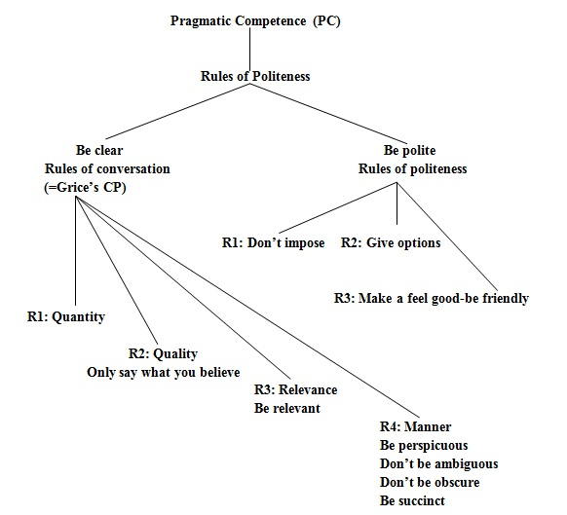

Figure 2.1 Lakoff’s Rules of Pragmatic Competence (1976)
Brown and Levinson's politeness assumption (1987: 69) classifies five strategies: (a) to pursue what it says, bald on record, (b) perform speech acts using positive politeness (refers to the positive face), (c) perform speech acts using negative politeness (refers to the face of a negative), (d) indirect speech act (off the record), and (e) do not do speech act or say anything (do not do the FTA). In connection with this politeness strategy, here are the possible strategies for doing FTAs.
Do FTA
5. Don’t do FTA
On record
4. Off record
1. Without redressive action, baldly
with redressive action
2. Positive politeness
3. Negative politeness
Politeness Strategies

Figure 1. Possible Strategies For Doing FTAs (Brown & Levinson, 1987: 69)
This research functional in qualitative research, the interest in qualitative research has been growing so much in the last few decades. He also added that qualitative research is of specific relevance to the study of social relations, due to the fact of the pluralization of life worlds. Qualitative research can be defined as the collection, analysis, interpretation of comprehensive narrative and visual data in order to obtain the insight into a particular phenomenon of interest. (Flick, 2009),

Participants
This research was conducted at SembilanBelas November University of Kolaka (USN). The research subject was the third semester students of English Education program in academic year 2016. To determine the subject, the researcher applied purposive sampling technique. Third semester students were measured to have more experiences in teaching and learning process in university context, then the researcher was interested to investigate deeply their politeness strategies in EFL classroom interaction. Therefore, the researcher chose one class, namely class A among the two classes. There were 25 students who participated in this research of from A class. It was recommended by the lecturers to be investigated since they considered that their students of this class have English skills better than the other classes.

Data Collection
Observing and recording the use of politeness strategies by the students in the classes. The researcher found the information of the class schedule at first. Then, the observation time was determined. The observation was conducted during the lecturing process. In this case, the researcher observed all the students’ utterances. The researcher will also use the audio or video recorder to support the observation so that the best outcomes were gained optimally. The number of observation meetings was not determined. However, it was situated by the researcher. It means that the observation meetings were ended if the collected data have been saturated.
Transcribing the utterances of the students If data had been recorded using technical media, their transcription is a fundamental stage on the way to their interpretation (Flick: 2009, p.209). Therefore, the data of utterances collected from the observation was transcribed in the form of transcriptions. This stage was conducted to facilitate the researcher to analyze the types and functions of politeness strategy uttered by the students during the lecturing process in EFL classroom.
Conducting an internet survey through facebook accounts. The researcher applied one of internet surveys system namely survey monkey to find out the students’ perceptions on the use of politeness strategies in EFL classroom communication. In this case, the form of the survey was sent to facebook accounts to all respondents. Lazar & Preece (1999) stated that there are three most common reasons for choosing an internet survey over traditional paper-and-pencil approaches are (1) decreased costs, (2) faster response times, and (3) increased response rates. In this case, the researcher will send each interviewee a written interview (interview text) to their email or their facebook accounts. This way was believed by the researcher enables the respondents enjoyed the survey process and received completed surveys in a correspondingly short amount of time.

Note:
S A : Strongly Agreed,
A : Agreed,
Un : Uncertain,
D : Disagreed
S D : Strongly Disagreed
No | Questions/statements | Students perceptions
 |  | S A | A | Un | D | S D
1 | I Think politeness is not important in communication
2 | I am less of vocabulary in order that I feel difficult to use polite word in communication
3 | I don’t use politeness in the classroom because the lecturers never teach about politeness theory.
4 | I don’t know about politeness in English because I never follow an English Course
5 | I don’t use politeness in communication because the lecturers never use it in classroom interaction.
6 | My friends are seldom to use politeness in communication that is why I am not influenced to use the politeness words.
7 | The theory of politeness doesn’t have effect in communication.
8 | The theory of politeness is only make the students are difficult to communicate.
9 | Politeness is not a must in communication
10 | I don’t like to use politeness in communication

RESULTS

The findings discuss the result of the research based on the research questions. The research questions are: First, the types of politeness strategies used by the EFL students. Second, the functions of politeness strategies of EFL students in interactions and third, the students perception in using politeness strategies in interaction.

Types and Function of Politeness Strategies in students’ Interaction

Types | Functions | Excerpts | Utterances
Positive Politeness | Offering and Promise | 1 | I would like to share about unforgettable experience
 | Offering and Promise | 2 | what should I do at the time?
 | Offering and Promise | 3 | May I help you Sir?
 | Give (or ask for) reason | 4 | Can you speak English?
 | Give (or ask for) reason | 5 | Where do you come from?
Off Record | Invite Conversational Implicatur | 6 | Thank you very much for the opportunity that given to me
 | Invite Conversational Implicatur | 7 | the phone don't have voucher and I need recharge the phone
 | Displace H | 8 | so, I text it a delivery to bring as a gallon water, but I just realize that I didn’t any many
Table 4.1. Data Display of excerpt 1, 2 3, 4, 5, 6, 7, and 8 in First Meeting
Types | Functions | Excerpts | Utterances
Negative Politeness | Be Pessimistic | 9 | you can use it for making fire to make smoke, it makes other people know that you are lost and they would give you a help…
 | Be Pessimistic | 10 | I think
 | Question and Hedge | 11 | How could you protect your body..a.a.. how could you protect you self if there is a wild animal?
Table 4.2. Data Display of excerpt 9, 10 and 11 in Second Meeting
Types | Functions | Excerpts | Utterances
Positive Politeness | Give (or ask for) reason | 12 | what do you think about
 |  | 14 | what do you do, if love disappointed you?
 | Seek agreement | 13 | Addition please
 |  | 15 | You know that I will give you example
Negative Politeness | Beg forgiveness | 16 | Sorry
Table 4.2. Data Display of excerpt 11, 12, 13,1 4, 15, and 16
Students’ Perception
In this part the researcher gives several results of the students’ perception on the use of politeness strategies in EFL classroom interaction were obtained from an internet survey conducted by the researcher. The survey consisted of ten different questions which should be answered by 18 respondents.
The first questions explored the students’ perceptions about politeness strategies were not important in interaction. In this question, Most of the respondents strongly disagreed or 44,44% respondents considered that can be concluded that the use of politeness strategies in EFL classroom interaction was very important. The table of the survey can be seen below.

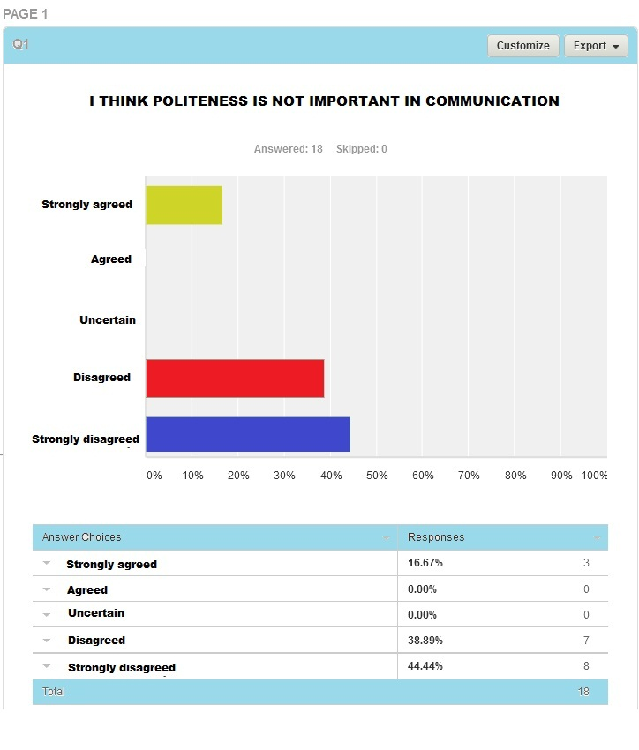

The second question examined the students’ perception about “I am less of vocabularies therefore I was difficult to use the words of politeness strategies in communication”. Most of the respondents or 44,44% answered disagree that the vocabulary mastery had less significant effect toward their interaction way. The table of the survey can be seen below.

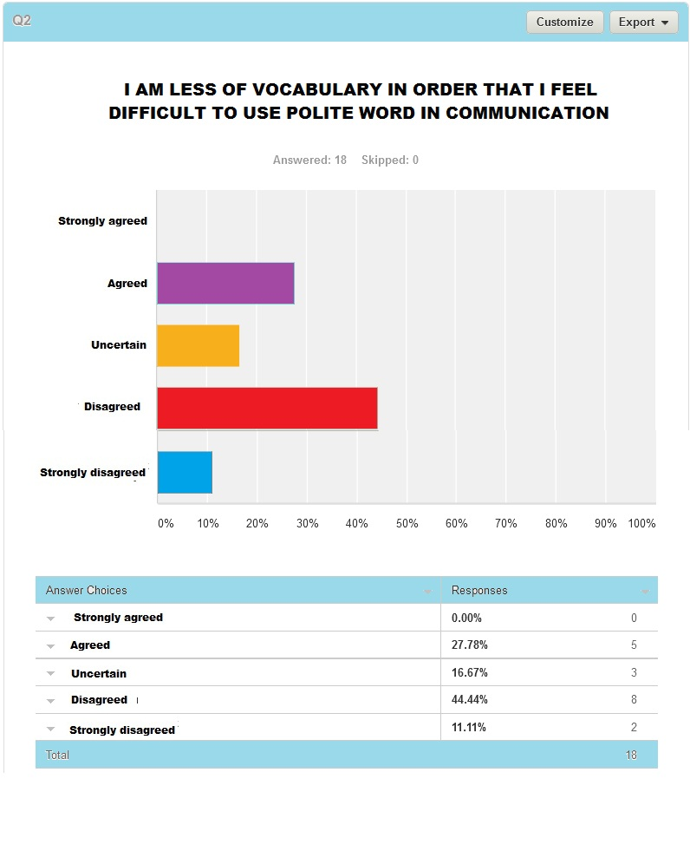

The third question explored the students’ perceptions the students did not use politeness because the lecturer never taught them before.. From this question made two result between the students who choose uncertain 33.33% or 6 respondents and the students who answered disagreed 33,33% or 6 respondents. The table of the survey can be seen below.
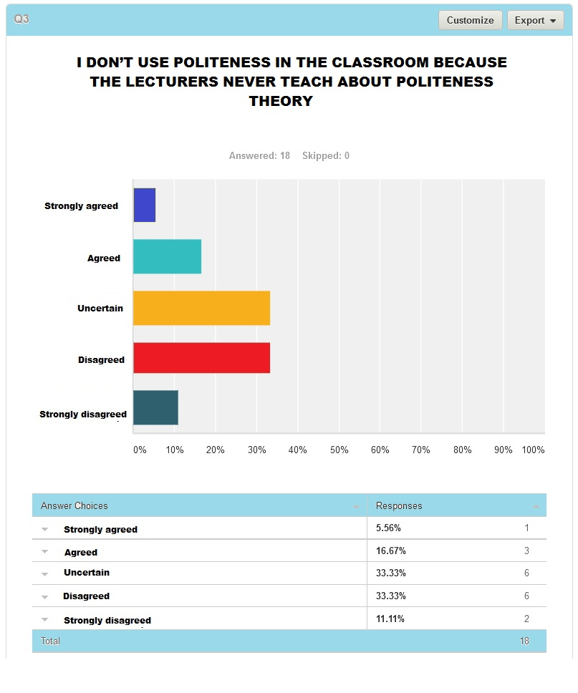

DISCUSSION

- The Types of Politeness Strategies
Based on the previous analysis, the researcher found that there were four types of politeness strategies that were uttered by the students in EFL classroom such as, Bald on record, positive politeness, negative politeness and off record strategies.

        - Posititive Politeness strategy
The first types of politeness strategies identified by the researcher in EFL classroom was positive politeness strategies. Positive politeness strategies were emphasized to get the addressee to do something such as offering and promise, give (or ask for)reason, seek agreement. This type of the positive politeness strategies can be seen in excerpt 1 - 5 and excerpt 12 - 15. It

        - Negative Politeness Strategy
The second type of politeness strategies explored in EFL classroom was negative politeness strategies. It is an act that shows the actual state. The negative politeness can be seen in excerpt 9, 10, 11, and 16. The functions of this politeness strategies were also various such as for be pessimistic, question and hedge, and beg forgiveness. In excerpt 9 and 10 representative negative politenesses were uttered for be pessimistic, while in excerpt 11, the students uttered the negative politeness for question and hedge. Furthermore, in excerpt 16, it functioned for beg forgiveness.

        - Off Record Strategy
The third type of politeness strategies found in EFL classroom by the researcher was off record strategy. Off record strategy can be seen in excerpt 6 to 8. Dealing with the politeness strategies functions, off record strategy were uttered by the students functioned differently. In excerpt 6 and 7, the off record strategy was uttered as invite conversational implicatur . In excerpt 8 the off record strategy as functioned as displace H.

- The Fuction of Politeness Strategies
Based on the previous analysis, the researcher found that there were four types of politeness strategies that were uttered by the students in EFL classroom such as positive politeness, negative politeness and off record strategies. Then each types of the strategies has sub-strategies that can be called as function of politeness strategies such as offering and promising, giving (or ask for) reason, invite conversational implicature, displace hearer, be pessimistic, question and hedge, seek agreement, beg forgiveness.

- The students’ perceptions on the use politeness strategies in EFL classroom interaction
As explained previously that data of the students’ perception on the use of politeness strategies in EFL classroom interaction were obtained from an internet survey conducted by the researcher. The survey consisted of ten different questions which should be answered by 18 respondents.
No | Questions/statements | Students perceptions
 |  | Strongly agreed | agreed | Uncertain | Disagreed | Strongly disagreed
1 | I Think politeness is not important in communication | 16.67 % | 0% | 0% | 38.89% | 44.44%
2 | I am less of vocabulary in order that I feel difficult to use polite word in communication | 0% | 27.78% | 16.67% | 44.44% | 11.11%
3 | I don’t use politeness in the classroom because the lecturers never teach about politeness theory. | 5.56% | 16.67% | 33.33% | 33.33% | 11.11%
4 | I don’t know about politeness in English because I never follow an English Course | 0% | 17.65% | 11.76% | 52.94% | 17.65%
5 | I don’t use politeness in communication because the lecturers never use it in classroom interaction. | 5.58% | 5.58% | 5.58% | 70.59% | 11.76%
6 | My friends are seldom to use politeness in communication that is why I am not influenced to use the politeness words. | 17.65% | 11.76% | 11.76% | 47.06% | 11.76%
7 | The theory of politeness doesn’t have effect in communication. | 5.58% | 5.58% | 11.76% | 47.06% | 29.41%
8 | The theory of politeness is only make the students are difficult to communicate. | 5.58% | 5.58% | 5.58% | 64.71% | 17.65%
9 | Politeness is not a must in communication | 11.11% | 16.67% | 5.56% | 22.22% | 44.44%
10 | I don’t like to use politeness in communication | 5.56% | 5.56% | 5.56% | 44.44% | 38.89%

CONCLUSION

Based on the finding and discussion of this research. This research has three questions. First, there were three types of politeness strategies uttered by the students in EFL classroom communication during the lecturing process such as positive politeness, negative politeness, and off record. Each type of the politeness strategies was uttered by the students in EFL classroom interaction functioned differently. And most of the students used positive politeness in EFL classroom interaction.

REFERENCES

Brown, P. and Levinson, S. C. (1987).Politeness: Some universals in Language Usage. Cambridge: Cambridge University Press.
Flick, U. (2009). An Introduction To Qualitative Fourth Edition . London: SAGE Publications Ltd.
Green. 1994. Conversational Interaction. www.google.com
Lazar, J., and Preece, J. (1999). Designing and implementing Web-based surveys. Journal of Computer Information Systems.
Mahmud, M. (2010).Politeness in Bugis: A Study in Linguistic Anthropology.Vol. 1 and 2.Makassar:Badan Penerbit UNM.
Ogiermann, E. (2009). On Apologizing Negative and Positive Politeness Cultures.Amsterdam: John Benjamins Publishing Company.
Parker, J. (1986).Towards an Anatomy of Impoliteness.Journal of Pragmatics 25(3), 349367.
Senowarsito.(2013). Politeness Strategies in Teacher-Student Interaction.TEFLIN Journal, Vol. 24, no.1, January 2013.

