I. INTRODUCTION

- Background of the Research

In language learning, feedback is very important and it focuses on almost all aspects of language elements and language skills. It can take the forms of verbal, non-verbal feedback expressions, positive feedback, and negative feedback. Moreover, feedback covers both oral and written production. Feedback on written production seems complicated because writing covers more aspects of language performance than other language skills. This argument is supported by Bratcher and Ryan (2004) who said that writing involves a complicated process that a writer needs to master aspects of writing such as context, content, form and language (p.xii), therefore, “the different approaches to evaluating it offer us different bits of information about the process of becoming an articulate writer” (p.140). In addition Clark (2003) compared the complexity of oral and written production that in oral discourse errors tend to be less disturbing for listeners but in written discourse readers have more time to pay attention to form and some of the problems in language usage in student’s written texts are the transfers of informal conventions of speech to the more formal writing conventions (p.332).
Because writing, as a skill comprising some aspects of language experience, requires students to devote their attention to such things as content, styles, organization, vocabulary, mechanics, etc., when a writer writes, he or she is expected to produce correct structure and effective writing paying attention to those aspects of writing. Effective writing enables the readers to grasp the writer’s ideas immediately without having to read it several times (Aridah 2004). In classroom writing, a student is expected to develop skills and abilities in all areas comprising grammar, ideas and other language arts: spelling, handwriting, capitalization, punctuation, and organization. For some reasons, students sometimes find it difficult to incorporate all those areas in their writing. As a result, teachers sometimes complain that the students’ papers are not satisfactory.
To overcome the difficulties faced by learners in relation to writing ability, teachers have made efforts to help learners develop their writing ability. The attempts include not only finding appropriate teaching strategies but also spending time reading students papers and providing necessary feedback, comments and corrections. Providing feedback to learners’ production is considered very important for the teacher on students’ written production. Ferris (1995) stated that feedback helps students improve their grammar and clarify their ideas, as well as prevent them from making any further mistakes so that it improves students writing. She further said that that error correction or feedback on grammatical errors was effective in improving students’ writing.
However, even though teachers have made maximum efforts to improve EFL students’ writing, sometimes teachers still get frustrated when they find their efforts in developing students’ awareness in order to perform better in writing end up with students’ disappointment in reaction to the comments or feedback the students receive on their papers. As a result, students’ papers remain unsatisfactory.
There are two possible reasons that can explain this problem. First, the ways teachers give feedback to the students may not be effective or appropriate to them so that the feedback does not give any positive effect. Kepner (1991) found that teachers’ written feedback which was combined with explicit rule prompts was not effective in improving second language writing ability. Brookhart (2008) suggested that good feedback should include comments or information that can be heard, understood and used by the students for further improvement. Therefore, providing feedback to students without giving them an opportunity to make use of the feedback is not fair to them. Furthermore, effective feedback is one that can help learners improve. Gardner, et.al. (2010) recommended that teacher should give feedback to students in a form that can help them learn and should give them a chance in which students can use feedback for improving their task or to show that they understand or not.
Second, there may be some factors which influence the effectiveness of certain types of feedback in improving writing performance. This performance is the result of learning and students may have different performance due to the factors of individual differences such as gender, age, level of motivation, learning styles, learning strategies, etc. Dornyei (2005) claimed that individual differences such as language aptitude, motivation, or learning styles are not questionable to have important contribution to the success of foreign language learning. Dornyei further more mentioned that other factors that help learners to develop and actively participate in the learning process are language learning strategies; therefore, “language learning strategies were included into the inventory of important learner characteristics” (p.6).
Based on the explanation above, it is assumed that learning strategies students use may contribute to the efficacy of certain types of teacher written feedback in relation to how they revise and correct their errors in writing. Therefore, whether the effectiveness of one particular type of feedback provision is related to the students’ preferred learning strategies will also become the concern of this study, with the assumption that if the types of feedback provided on students’ writing are benefited from the learning strategies they used, they may perform better in their writing.
B. Research Problems
Based on the background of the study, the research questions are formulated as follows:
- Do teacher written feedbacks have significant effects on EFL students’ writing performance? This main research question is broken down into six sub research questions as follows:
  - Which type of teacher written corrective feedback is most effective in improving students’ writing performance?
  - Is there any significant improvement on students’ writing (namely between the first draft and revised/second draft essays) during the writing process stages where a particular type of feedback is provided?
  - Is there any significant improvement on students’ writing (namely between the first essay and each successive essay) during the writing process stages where a particular type of feedback is provided?
  - Which type of teacher written feedback is effective in improving a particular aspect of writing (content, organization, vocabulary, language use and mechanics?
  - What aspect of writing (content, organization, vocabulary, language use, and mechanics) gets most improvement after being provided with a particular teacher written corrective feedback?
  - Is there any significant difference between students’ writing performance during the revision process and students’ independent writing (Delayed Post Test) in each treatment group?
- Do language learning strategies have significant effects on EFL students’ writing performance?
- Is there a significant interaction effect between different types of teacher written feedback and language learning strategies in relation to students writing performance?

C. The Objectives of the Research
Based on the proposed research questions above, this research aims:
- To find out whether written corrective feedbacks have significant effects on EFL students’ writing performance. This objective is broken down into five sub objectives as follows:
  - To find out which type of teacher written feedback is effective in improving students’ writing performance
  - To find out if there is a significant improvement on students’ writing (namely between the first draft and revised/second draft essay) during the writing process stages where a particular type of feedback is provided.
  - To find out if there is any significant improvement on students’ writing (namely between the first essay and each successive essay) during the writing process stages where a particular type of feedback is provided?
  - To find out what aspect of writing (content, organization, vocabulary, language use, and mechanics) gets most improvement after being provided with a particular teacher written corrective feedback
  - To find out what aspect of writing (content, organization, vocabulary, language use, and mechanics) gets most improvement after being provided with a particular teacher written corrective feedback.
  - To find out if there is a significant difference between students’ writing performance during the revision process and students’ independent writing (Delayed Post Test) in each treatment group.
- To identify the students’ learning strategies and whether their writing performance is significantly affected by their learning strategies (Direct Strategy and Indirect Strategy)
- To find out if there is an interaction between different types of corrective feedback and learning strategies in relation to students writing performance?

D. Significances of the Research
This research is expected to give contributions as follows:
- Practically, the findings of this study are expected to be helpful inputs for teachers of English as a foreign language especially those who are teaching composition to develop their teaching performance particularly in providing feedback to students so that they can help students achieve better writing achievement. This study also will help teachers to have better and deeper understanding about how to provide different types of corrective feedback which are relevant with the students’ learning strategies.
- Theoretically, this study will give a contribution to the development of the theories of second language acquisition and foreign language learning that providing corrective feedback will help learners to obtain linguistic input and learn from their own output so that they can enhance their learning.

E. Scope and Limitation of the Study
The scope of this research covered the types of teacher written corrective feedback, EFL Students’ Writing Performance, and Learning Strategies. In terms of teacher corrective feedback, this study was limited to teacher written corrective feedback strategies which covers four types of feedback: direct (explicit) and indirect (implicit) feedback, focused and unfocused feedback, using correction guidelines. EFL Students’ Writing Performance was limited to essay writing which covered five different types of essay development: example essay, comparison and contrast essay, classification essay, process analysis essay, and argumentative essay. All of the essays were given by following process writing approach, giving emphasis on the revising and editing stage. The writing performance was assessed in terms of content, organization, vocabulary, language use and mechanics. Learning Strategies were limited to Language Learning Strategies which were identified using SILL, developed by Oxford (1990) which were classified into two types: Direct Strategies and Indirect Strategies. The study was conducted at the English Department of Mulawarman University, involving the students who were taking Writing III course in the academic year of 2014/2015.

II. REVIEW OF RELATED LITERATURE

- Definitions of Feedback

Generic definition of feedback is conceptualized by Hattie and Timperley (2007) that feedback is “information given by an agent (e.g., teacher, peer, book, parent, self, experience) regarding aspects of one’s performance or understanding” (p.81). Hattie and Timperley (2007:81) furthermore stated that feedback is “a consequence of performance”. More specific definitions of feedback are directed to language teaching and learning. Richards, Platt, and Platt (1992) and Richards and Schmidt (2002) define feedback as comments or information that a learner receives from the teacher or other persons regarding the success of a learning task or a test. This definition is more positive in that it does not address the unsuccessful performance of the students in which the teacher needs to give feedback in the form of correction so that they can achieve success. A most specifically defined feedback can be conceptualized in terms of the language skills it addresses. In writing, feedback is defined as input given by a reader to a writer with the effect of providing information to the writer for revision. It includes “comments, questions, and suggestions that a reader gives to a writer to produce ‘reader-based prose’ (Flower, 1979).

- Types of Corrective Feedback

- Oral and Written Feedback
The first type of contrasted feedback provision in writing discussed in this part is oral vs. written feedback. Teachers may choose to give oral or written feedback. Brookhart (2008) states that the content of oral feedback is just the same as written feedback. The difference lies on the way of delivering the feedback (oral feedback is in the form of speaking not writing). They are also different in terms time (when and where the teacher needs to speak to students in order that they are willing to hear what the teacher says) and in terms of informality level (ranging from the formal and structure such as conference to a more informal such as just whispering a few words when the teacher passes a student’s seat. Furthermore, Brookhart (2008) says that oral feedback is especially good for informal observations of students’ behaviors in the learning and teaching process.

- Direct and Indirect Feedback
Another contrasted type of feedback is Direct and Indirect Feedback. Ellis (2009) created a typology of feedback strategies that consists of five types and two of them are direct feedback and indirect feedback. Direct feedback is the feedback provided by the teacher by showing the correct form of language while indirect feedback is the feedback given by the teacher by indicating the errors students make but not correcting them (Ellis, 2009). Direct feedback according to Ferris (2006: 83) may take the form of crossing out the mistakes and then providing the correct form around the error, while indirect feedback may take the form of “underline, circle, code, or other mark – but does not provide the correct form, leaving the students to solve the problem that has been called to his or her performance”
The issue whether feedback should be given directly or explicitly and indirectly or implicitly has also attracted the attention of researchers in the field. The research findings on the issue of direct and indirect feedback showed that students get benefits from the two types of feedback. Ferris (2006) found that students who were provided with either direct feedback or indirect feedback were successfully revise and correct their mistakes. However, there are also some findings which showed conflicting results. Lalande (1982), for example found that indirect feedback was able to decrease the errors the students made while direct feedback was not (Lalande, 1982). Other findings revealed that direct feedback was the least effective method of feedback provision on students’ writing (Semke, 1984, Robb, Ross, and Shortereed (1986). Those findings were confirmed by a more recent study conducted by Baleghizadeh & Dadashi (2011) who found that indirect feedback provision was more effective than direct feedback provision in improving students’ written work. All of these findings have disapproved the argument given by Ferris and Roberts (2001) and that direct written feedback is probably more effective than indirect feedback. This argument is strengthened by Ferris (2011) who claimed that direct correction of error by the teacher led to more correct revisions (88%) than indirect feedback (77%).

- Focused and Unfocused Feedback
The next contrasted type of feedback is focused and unfocused feedback. This contrasting type of feedback is something to do with whether the teacher comments on all or most of the students’ writing problems or only chooses a certain aspect of writing to be commented on. According to Ellis (2009) in focused feedback provision, the teacher is selective about what specific element(s) of language he or she has to comment on or correct while in unfocused feedback provision, the teacher attempts to comment on all aspects of language performance or correct all of noticed students’ errors. Unfocused feedback is viewed as ‘extensive’ feedback as it deals with multiple errors while focused feedback deals with specific errors to be corrected and ignores other errors (Ellis, Sheen, Murakami, Takashima, 2008).
Ellis et al. (2008) further differentiated between focused and unfocused feedback. They stated that unfocused feedback refers to a normal practice in in teaching writing in which the teacher correct all the errors in students’ paper and it is an extensive correction because it responds to various types of errors rather than one type. On the contrary, focused feedback refers to the selection of certain types of errors and ignores. They also differentiated between highly focused correction and less focused correction, in which the former focuses on only one type of error and the latter focuses on more than one target errors but still restricts on limited number of predetermined types of errors. Van Beuningen (2010:11) defines unfocused corrective feedback as a comprehensive approach of correction which involves correcting all errors in students’ written work without taking a certain category of errors into consideration, whereas focused feedback is defined as a selective approach of correction targeting only a specific type of linguistic aspect such as articles and leaving other errors outside the targeted errors uncorrected.

- Metalinguistic Feedback
The next type of feedback provision is metalinguistic feedback. According to Ellis (2009a:100) Metalinguistic Feedback is a type of feedback provision in which the teacher gives explicit explanation about the nature of erroneous language the students have made but without providing them with correction. Ellis pointed out two different forms of metalinguistic feedback. The first is the use of error codes and he stated that this form is the most commonly used by teachers in providing metalinguistic feedback. The second one is brief grammatical description or explanation about the errors made by the students. In this case the teacher puts numbers nearby the errors or mistakes in the text and then writes a grammatical description which represents each numbered error at the bottom of the paper.

- Reformulation
The last type of teacher written feedback strategy listed in Ellis’ typology is reformulation. This strategy is also proposed by Hyland (2003:13) who stated that responding to students’ writing is important in helping students move through the stages of the writing process and this can be done by giving feedback which includes reformulation. Ellis (2009) describes reformulation as the feedback which includes reworking on the students’ text to make the language sound as native-like as possible but maintaining the content of the original text. Ferris (2011:97) defines reformulation as an elaborate form of direct corrective feedback in which the teacher intentionally rewrites the students’ texts to provide models of correct language for that specific context.
Although this feedback strategy is commonly used by teachers, there are some objections on the use of this type. Ferris (2011) stated that it is worth noting that reformulation technique requires teachers to have confidence with a high degree that they are not misinterpreting the student writer’s intentions. For both practical and philosophical reasons, reformulation seems to be an alternative correction that is unlikely to achieve widespread acceptance. Furthermore, Ferris (2010) questioned about this technique whether it is more effective than other written feedback in promoting acquisition and written accuracy. She argued that:
Because reformulation puts teachers’ words into students’ mouths (or pens or word processors), it is thus adverse to the larger goal of helping students explore their ideas and develop their own voices. In other words, teachers might win the battle (students may use more accurate structures that have been fed to them through expert reformulations of their texts) but lose the war (students’ confidence and motivation to express their ideas through writing may be undermined). (p.190)

Having presented all types of teacher written corrective feedback found in the literature, it is clear that teachers have a lot of choices of how to give feedback to students’ writing. Feedback provisions may depend on what teachers believe as the effective feedback for the students. However, not all of the feedback that the teachers believe as effective feedback may give positive impacts on students writing performance. Some students may be benefitted from a particular type of teacher feedback, some other may not. If the feedback provided by the teacher are not used by the students to revise and correct their writing, it is more likely not able to give positive effects in improving students written texts. Therefore, it is necessary to explore the effect of different types of feedback and to consider the students’ individual differences in order to optimize the efficacy of feedback.

- Peer Feedback

The previous five types of feedback are categorized as teacher feedback. Because this study was an experimental study, using non-teacher feedback as the control group, it is necessary to define the non-teacher feedback used as the control group in this study. It is peer feedback. It is defined as the type of feedback which involves peers to give comments on various elements of the students’ writing draft (Pawlak, 2014 p. 8). Keh (1990) defined peer feedback in different terms such as peer response, peer editing, peer critiquing, and peer evaluation. She divided peer feedback into two categories based on the stages of writing process: peer response which comes to the first draft which focuses on ideas or content and organization and peer editing which comes at the final draft and focuses on grammar, vocabulary, punctuation, etc.

- The Roles of Teacher Written Feedback

The source of feedback that becomes the focus of this study is teacher feedback. It cannot be denied that even though a variety of feedback sources have been identified, teacher feedback is still the most favorable for students (Bitchener and Ferris, 2012, Lee, 2007; Hyland and Hyland, 2006, Ferris, 2003). It is not arguable that teacher feedback has important roles in learning, especially in language learning in which writing is one of the skills that needs to be given a special attention. In relation to written production, a considerable number of studies have been conducted in investigating the roles of teacher feedback in improving students’ compositions. However, some studies reported that feedback given in a specific area of writing does not give any significant effect. Semke (1984) and Robb et al. (1986) found that feedback given on grammar did not have much to do with students’ writing improvement. In addition, Truscott (1996) with his strong opinion stated that error correction is not useful and even harmful and Kepner (1991) concluded that error-correction written feedback type is not helpful for student L2 writer.
In reaction to Truccott (1996), Ferris (2004) responded that Truscott has ignored some research evidence that showed positive effects of corrective feedback. She further showed some research findings which proved that corrective feedback does play roles in improving students’ writing. She found that the students consistently report that they value corrective feedback given by their teachers and find that teacher feedback is very helpful in their learning success (p.55). Moreover, she stated that:
Students are likely to attend to and appreciate feedback on their errors, and this may motivate them both to make corrections and to work harder on improving their writing. The lack of such feedback may lead to anxiety or resentment, which could decrease motivation and lower confidence in their teachers. (p. 56)

Having reviewed the literatures relevant to this study, it is clear that there are a number of feedback types which can be used by teachers to help students improve their writing performance. Some controversial findings on the efficacy of particular types of feedback are still present that make the research findings inconclusive. Research on feedback is still being conducted to reach a consensus about the effectiveness of one particular type of feedback. Again, the same evidence was found that there was no an agreement about what particular type of feedback was effective to improve students’ writing. Therefore it is suspected that there may be factors which contribute the effectiveness of feedback on writing. This is what the previous research failed to consider. The present study then attempted to address this issue by taking individual differences in the form of language learning strategies into account.

- Writing Performance
In instructional setting, performance is defined by Ferris and Hedgcock (2005) as what the learner will be able to do. Assessing writing can be categorized as performance assessment because it requires students to accomplish the tasks assigned to them. Weigle (2009) stated that performance assessments require the students to reflect the actual tasks that are relevant to the knowledge, skill, or ability being measured, and successful and unsuccessful performance are judged by human raters. Ferris and Hedgcock (2005) furthermore stated that when we measure or score student writing performance or proficiency, the outcome must be based on a student-generated text. This text should consist of 100 words or more and be based on a prompt that gives the writer considerable space to generate extended discourse. The writing aspects that may be indirectly related with writing performance include verbal reasoning, error recognition, or grammatical accuracy. Moreover, writing performance is the ability for the writer to perform the skills which are being assessed. Knapp and Watkins (2005) added that the aspects of students’ writing performance include syntax, punctuation and spelling.

- Writing as a Process
Process writing as one of the approaches has drawn more attention of the writing teachers nowadays and it is increasingly used in many writing classrooms. Harmer (2004) states that writing process is the steps a writer follows in order to produce something in its final written form. According to him, the steps of writing include four elements: planning, drafting, editing, and final version. A more elaborated process of writing includes prewriting (brainstorming, outlining, mapping, drafting), revising, editing, and publishing (Panofsky et al. 2005). In relation to feedback provision, Panofsky argues that feedback and its related revision is one of the key aspects of writing process. In addition, Barton (2006) listed the stages of writing process as follows: planning and prewriting, collaborating, researching, drafting, editing, reviewing, revising, and publishing.
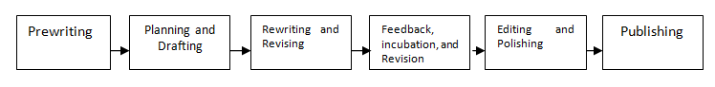
Considering that feedback is a part of the writing process, Ferris and Hedgcock (2005) contended that if the teachers want to achieve effective syllabi, course outlines, and lesson, they need to incorporate “multiple, recursive writing processes by allowing adequate time for reading and exploring genres, composing and revising drafts, giving and using feedback, and exploring new content” (p.106). In relation to this idea, they proposed the process of writing schema as illustrated as follows:
Figure 2.1. Model of Writing Process adapted from Ferris and Hedgcock (2005)
.
This six-step writing process is commonly adopted by writing teachers in a writing classroom. Clark (2003) stated that when students learn to write, the teacher does not merely transfer knowledge into their head, but how the teacher makes them develop an effective writing process in order that they keep learning even though the class has ended (p.2). For the purpose of the experiment in writing instruction, this study also adopted this writing process and it was supported by the experimental design suggested by Ferris (2010).

- Quality of Effective Writing
One of the objectives of providing feedback to students’ writing is to improve its quality. Every writer, including student writer always struggles to achieve an effective writing, making use of the potentials he or she has. The writing teacher also persistently encourages students to produce effective writing. One of the characteristics of effective writing is that it enables the readers to understand the writer’s ides directly without having to read it repeatedly (Aridah, 2004, p.195). Clark (2004) said that in order to produce effective writing, the students must have ideas, that is something that they have to know before they start writing and this idea must be accompanied by grammatical accuracy (p.9
In light with the explanation of effective writing, it is recognized that the quality of effective writing covers both content and linguistic accuracy. Ferris and Hecdgcock (2005) postulated that linguistic accuracy is one of the important aspects of effective writing (p.279). This idea is more specifically supported by Bailey (2006) that effective writing needs accurate use of nouns and adjectives, uses a variety of sentence lengths and aims for economy and precision. Barton (2006) added that in order to write effectively, a writer is required to have an understanding of mechanics of good writing and apply it in writing (p.124). Finally, good writing is characterized by adherence of conventions and correctness, therefore, “good writers are those who can compose quickly on a topic off the tops of their heads, producing relatively clean texts through a single-draft process” (Adler-Kassner and O’Neill, 2010, p. 51).

- Types of Essay Writing
Writing comprises various types depending on the purposes, the methods of development as well as writing tasks. Cory (2005) and Oshima and Hogue (1997) for example divided the types of writing into description, narrative, opinion and action. Smalley and Ruetten (1995) classified essay writing based on the methods of development which include: example essay, comparison and contrast essay, classification essay, process analysis essay, cause and effect analysis essay, and argumentative essay. Using a particular method of development, the types of writing can be examined according to its purpose, for example, an example essay may aims to explain and discuss, so that it is more likely expository. Comparison and contrast essay may give some description, process analysis essay demonstrates a procedure and argumentative essay aims to provide arguments. For the purpose of the experiment in this study, the types of essay writing assigned to the students were essays with different methods of development, namely Example Essay, Comparison and Contrast Essay, Classification Essay, Process Analysis Essay, and Argumentative Essay.
The types of essay based on the methods of development above showed that the students have choices to develop their essay depending on the topics or ideas they have. In relation to writing instruction, the teacher should provide opportunities to students to practice all types of writing development. However, for the purpose of the experiment and for the limited period of time of the cycles of writing process only five types of essay development were practiced by students: examples, comparison and contrast, classification, process, and argumentative essays.

- Assessing Writing Performance

One of the important parts of writing instruction is assessment. Hout (2002: 61)) argued that regardless the purpose of what we read and write, a reasonably continuous assessment needs to follow. He claimed that the ability to assess writing determines the ability to write well. Larsen (cited in Hout, 2002) stated that being unable to identify whether a written text works well or not, one would be unable to make revision or to use the feedback given by others. In assessing students writing, Hout mentioned three important tools which can be used to assess writing, namely holistic, analytic and primary trait. However, he argued that these assessment tools are text-based oriented so he suggested to replace this procedure with “contextually and rhetorically defined testing environment” (p.103), which taking the genre of the text, the discipline in which a text is written and the decision of the assessors make.
In relation to the aspects of writing to be assessed, the experts have different points of view. Ferris (2003) suggested that “teacher should provide feedback on all aspects of student texts, including content, rhetorical structure, grammar and mechanics” (p.123). This view is in line with Jacobs et.al (1981) whose rubric has been used widely, which they call “ESL Composition Profile” which include such aspects of writing as content, organization, vocabulary, language use and mechanics. Overmayer (2009) used 4 aspects of writing to be incorporated in his holistic assessment: content and organization, styles and fluency. Although Overmayer did not mention grammar and mechanics as the major aspects of his holistic assessment, he still takes these two aspects into account in his subsequent elements of his rubric.

- Language Learning Strategies as One Factor of Individual Differences and Mediating Variables for Corrective Feedback

Ferris and Hedgcock (2005:22) asserted that individual differences (IDs) are widely recognized as factors influencing language and academic performances and more specifically influencing students’ writing performance in the writing processes and tasks. Ferris and Hedgcock added that “the factors of individual differences need to be clearly understood which include learners' backgrounds, needs, expectations, styles, and strategies, as well as institutional requirements” (p.106), because these factors are important in formulating the goals of the course and teaching objectives. Students’ writing performance is found to not only be affected by corrective feedback intervention itself but it is also mediated by other factors. The main factor which is hypothesized to be a mediated variable is individual differences.
Individual differences have a strong relationship with feedback. Ferris (2003) suggested that when giving feedback the teacher have to take individual differences into consideration (p.125). In addition, Pawlak (2014: 163) stated that the efficacy of corrective feedback can be related to individual differences between learners, the inherent characteristics of the linguistic features, as well as contextual factors, and these three elements are also inevitably interacting with each other. He further stated that the first element (individual differences) includes individual variation and cognitive element (e.g. age, aptitude, memory, cognitive styles), affective (e.g. anxiety, motivation, personality) and social (e.g. attitudes, beliefs, gender, preferences). These facets could be hypothesized to mediate between the corrective intervention to which students are exposed and the character and degree of their engagement with negative feedback, thereby influencing long-term language development (Pawlak, 2014:164).
Based on the definitions given above, it can be concluded that learning strategies are any actions, mental activities, sets of operations, steps, plans, and routines which are consciously used by learners to make their learning easier, faster, more effective, and more transferrable into new situations. This concluding definition is more likely adapted from Oxford’s (1990) definition. There two main categories and six sub categories of learning strategies as follows:

- Direct Language Learning Strategies
  - Memory Strategies
Memory or memorization strategies refer to “language processing in the working memory such that it can be stored, and later retrieved from the long-term memory” (Macaro, 2001, p.118). Oxford (1990:40) listed 4 sets of memory strategies: Creating Mental Linkages, Applying Image and Sounds, Reviewing Well, and Employing Actions and these strategies will work well if they are used together with metacognitive strategies and affective strategies. In order to maximize the use of memory strategies.

  - Cognitive strategies
Cognitive refers to mental processes used in thinking, remembering, perceiving, recognizing, classifying, etc. Oxford (2008: 52) stated that cognitive strategies are mental processing of the second language learning and creating cognitive schema (frameworks), such as analyzing and synthesizing and these strategies are important for processing language information or integrating it into long-term memory by means of schemata. Oxford (1990) furthermore gives some examples of these strategies which include such activities as associating, classifying, recognizing and using formulas and patterns, reasoning deductively, analyzing, and highlighting.

  - Compensation strategies
Other learning strategies found in Oxford’s Strategy Inventory for Language Learning are compensation strategies. Compensation strategies are steps to compensate for the absence of linguistic knowledge (substitution and reconceptualization strategies). Compensation strategies are related to seeking and using language based on clues in order to guess the meaning of what is heard or read in the target language (Oxford:1990).

- Indirect Language Learning Strategies
- Metacognitive strategies
One type of learning strategies is metacognitive strategies including planning, self-monitoring and self-evaluation. O’Malley and Chamot (1990) stated that advance organizers, directed attention, selective attention, self management, functional planning, self monitoring, delayed production, and self-evaluation are all the major elements of metacognitive strategies. Oxford (1990) also listed all strategies related to metacognitive strategies. Some of the strategies include: setting goals, over viewing and linking, organizing, identifying errors, and self-evaluating. Metacognitive strategies are for guiding the learning process itself, such as planning and evaluating. (Oxford, 2008:52)

- Affective Strategies
Oxford (2008) stated that affective strategies are for managing, preference and emotions, such as developing positive motivation and dealing with negative emotions. Affective strategies help learners to regulate emotions, motivations, and attitudes. Some strategies which reflect these affective strategies are: using a checklist to monitor emotions; pushing one’s to take risks in a language learning situation, writing a language learning diary and making positive talk for self-encouragement (Oxford, 1990: 135).
In O’Malley and Chamot’s (1990) classification, affective and social strategies are combined to produce socio-affective strategies. Socio-affective strategies are more related to social mediating activities where people interact with others. Some examples of these strategies include cooperation and questions for clarification.

- Social Strategies
According to Oxford (1990) social strategies are strategies used by learners in language learning by involving other people. Oxford listed three sets of specific strategies for social strategies which include asking questions, cooperating with others and empathizing with others. O’Malley and Chamot (1990) added one more specific strategy for social strategies which they called self-talk, in which students use “mental redirection of thinking to assure oneself that a learning activity will be successful or to reduce anxiety about a task” (p.46).
The use of these six learning strategies becomes some of the indicators of good language learners. O’Malley and Chamot (1990 :169) argues that good language learners apply a variety of learning strategies in accomplishing tasks. They also stated that the application of many strategies help learners understand and retain information while learners who use fewer learning strategies and rarely use them may be categorized as less effective learners.

- The Models of Conceptual Framework
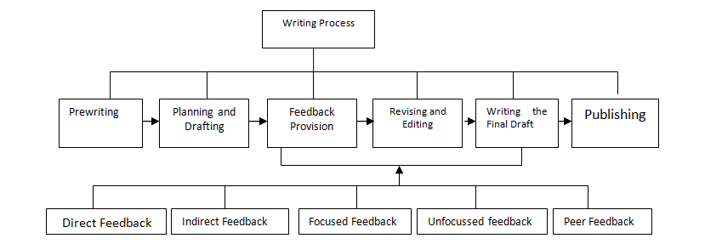
In light of the related literatures which are comprehensively reviewed, there are two models of conceptual framework are obtained. The first one is the writing process in which teacher corrective feedback is incorporated and the second one is the mediating relationship between learning strategies and the effect of corrective feedback provision on the students’ writing performance. The two models of conceptual framework are diagrammed as follows:

Figure 2.1. The framework of writing process incorporated with different types of feedback provision
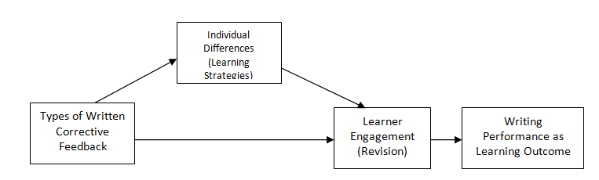

Figure 2.2.The framework of the interaction between the effect of written corrective feedback and learning strategies on writing performance

- Research Hypotheses
In light of the theoretical framework above, the hypotheses of this study are formulated as follows:
  - There is a significant difference of the mean scores among different types of written corrective feedback on students’ writing performance during the writing process and independent writing.
  - There is a significant improvement on students’ writing (namely between the first draft essay and revised/second draft essay) during the writing process stages where a specific types of written feedback is provided.
  - There is a significant improvement on students’ writing (namely between the first essay and each successive essay) during the writing process stages where a specific types of written feedback is provided
  - There is a significant effect of different types of written corrective feedback on of each aspect of students’ essays
  - There is a significant difference of students’ scores in each aspect of writing after being provided with a particular type of written corrective feedback.
  - There is a significant difference between students’ writing performance during the revision process and students’ independent writing (Delayed Post Test) in each treatment group.
  - There is a significant effect of different learning strategies on students’ writing performance both in revision process and independent writing.
  - There is a significant interaction between different types of corrective feedback and learning strategies in relation to students writing performance.

III. RESEARCH METHODOLOGY

- The Type and Design of Research

The type of this research was quantitative in nature which intended to analyze increasing trends, compare groups and relate variables using statistical analysis. It also intended to interpret the results by comparing with the predictions stated in the form of hypotheses in the previous section. The design of this research was true experimental design which consisted of four experimental groups and one control group. Experimental design was selected because it intended to find out the effect of different types of teacher written corrective feedback using randomization to determine the members of the groups.
The procedure of the treatment is explained as follows:
- Students wrote an essay draft on a given topic with one type of essay development.
- Students handed in their drafts and the teacher (researcher) corrected the draft by providing one type of written corrective feedback according to the designated type of feedback in each of the experimental group. The students in the experimental group 1 was provided with direct feedback, experimental group 2 with indirect feedback, experimental group 3 with focused feedback, experimental group 4 with unfocused feedback and the control group with non-teacher feedback (peer feedback).
- The teacher returned the students’ papers with feedback on them for the students to revise and handed in them again to the teacher for grading.
- Students wrote a new essay draft with different topic and different method of development and the teacher gave the same type of feedback in accordance with their group. This process was repeated five times with five different topics of essay until the end of the semester.
- The students were given delayed posttest two weeks after the treatment. In this case the students wrote their essay independently, meaning that they were not provided with any feedback anymore.
- For the purpose of having information about the students’ learning strategies, a questionnaire of SILL was administered to the students right after the experiments were accomplished. The results of the questionnaire were analyzed to determine what types of learning strategy students commonly used: direct strategy or indirect strategy.
Because this study also took learning strategies into account as the control variable which was predicted to affect the engagement of the students in revision process, the factorial design was also used in this study. Gay, Mills and Airasian (2006: 260) stated that factorial design consists of more than one independent variables and at least one variable is controlled by the researcher. This study used a 5 x 2 factorial design.

- The Types and Number of Variables

There were 3 variables of this research: 2 independent variables and one dependent variable. The independent variables include measured variable and control variable. Creswell (2012) stated that measured variable is a “continuous variable that is measured or observed in the study” The first independent variable or measured variable of this research is corrective feedback which consist of 5 categories of variable: four categories in the experimental groups and one category in the controlled group. These 5 categories were: direct feedback, indirect feedback, focused feedback, unfocused feedback for experimental groups and one non-teacher feedback (peer feedback) for controlled group. Each level of variable consisted of two sub levels, namely first draft and second draft respectively.
The second independent variable was the Learning Strategies which function as a control variable. Creswell (2012) stated that control independent variable is a “variable not directly measured but controlled through statistical or research design procedures”. This independent variable consists of two levels or factors: Direct Strategies and Indirect Strategies. This variable was identified by administering a questionnaire to students. The questionnaire was called Strategy Inventory for Language Learning developed by Oxford (1990).
The last variable was the dependent variable which included the students’ writing performance that consisted of students’ performance in the writing tasks during the process of writing and the student’ writing performance in the delayed post test (independent writing). Writing Performance covered 5 different topics and different methods of essay development, namely example, comparison and contrast, classification, process and argumentative. This performance was measured according to the quality of their writing which includes: Content, Organization, Language Use, Vocabulary and Mechanics.

- Operational Definition of Key Terms
The terms used in this research are operationally defined as follows:
    - Teacher Written Corrective Feedback is any written information, comments, marks and symbols, explanations, correction given by the teachers on the students’ compositions as indications of unsuccessful performance in writing. In this study, it covers four types which are operationally defined as follows:
  - Direct Feedback is the feedback provided by the teacher on students’ writing by supplying the correct form of language and other aspects of writing.
  - Indirect Feedback is the feedback given by the teacher by indicating the errors students make and the problems students encounter without providing any correction and explanation, but leaving the students to correct the errors by themselves and fix the problem that has been called to his or her performance.
  - Focused Feedback is the feedback provision in which the teacher is selective about what specific element(s) of language he or she has to comment on or to correct and ignores other errors or problems. It can be direct or indirect or both.
  - Unfocused Feedback is the feedback provision in which the teacher attempts to give comments on all aspects of language performance or to correct all of noticed errors and problems on the students’ writing.
    - Peer Feedback is the feedback provided by the students on their peer’ writing and it can take the forms of direct or indirect, focused or unfocused feedback with the guidelines from the teacher
    - Writing Performance is the quality of the students’ writing after they receive feedback from the teacher during and after the writing instruction and measured by grades according to the quality of content, organization, vocabulary, language use and mechanics.
    - Language Learning Strategies refer to the actions, steps, thoughts, techniques used by students to make their learning easier, faster, and more effective and these learning strategies are measured by using Strategies Inventory of Language Learning (SILL) developed by Oxford (1990).

- Population and Sample
The population of this study was the third semester students of the English Department, Mulawarman University in academic year of 2014/2015. There were 104 students which were distributed into 3 classes. These students were selected as the population because they were considered to have some abilities in writing as they have taken Writing I and Writing II as their prerequisite course to take Writing III and they have presumably got sufficient exposure to writing instruction and feedback from their teachers.
The study employed probability sampling strategy applying total sampling method which means that all of the population was included in the experiments. Therefore, from the total of 104 students in the population, they were randomly assigned to participate in 5 different groups of treatment by using systematic random sampling technique. In order to meet the ethical requirements of the study, the students were asked for their agreement to participate in the experiment. All of them gave their consents to be included in the experiment for one semester. The data of the students were also kept confidential that the data would not be shared with other students or people outside this research.
Another requirement that must be met in an experiment is avoiding the John Hendry Effect, which may affect the internal validity of the research. In order to avoid the John Hendry effect, the students in this experiment were not told that they belong to experimental groups or control group. The communication between the students in the control group and those in the experimental groups were also controlled so although they knew that they were the participants of the research, they did not know in which group the belonged to. Therefore, the threat to the internal validity could be avoided.

- Data Collection Techniques
To collect the data, there were two main instruments used: essay writing assignments and writing test, and a questionnaire.
    - Essay Writing Assignments and Essay Writing Test
- Writing Assignments
There were 5 writing assignments in the form of take-home writing. Each writing assignment was given after the students received an explanation about how to write a particular type of essay based on the method of development.
- Writing Test
The second part of the instrument of writing performance was a writing test. This writing test functioned as a posttest which was used to reflect the true performance of the students in writing for a long-term performance. It was also be used to compare the performance of the students during the revision time in the experiment and the independent writing.
    - Questionnaire
A questionnaire was used to identify the students’ language learning strategies. The questionnaire was called Strategy Inventory for Language Learning which was developed by Oxford (1990). SILL is a structured questionnaire used to assess what specific learning strategies the learners frequently use.

- Instruments of the Research, Validity and Reliability
As it is stated in the previous section, this study used two techniques of collecting data: writing assignment and test and a questionnaire. Therefore, the instruments used in this study included essay writing assignments and test and a questionnaire on language learning strategies called SILL. The validity and reliability of the two instruments are explained in the following section.

1. The Validity of and Reliability of Writing Assignments and Test
The instruments (writing assignments and writing test) in this study were validated by using content validity in the form of expert judgment. Gay, Mills and Airasian (2006) stated that content validity can be assessed by expert judgment technique in which the experts are asked to assess the instrument whether it represents the content which is supposed to measure (p.135). One of the techniques used to measure the content validity of instrument by using expert judgment is Aiken’s V Index. Azwar (2015) says that Aiken’s V index is the one of the common accepted quantitative index used to calculate the content validity. The result of expert judgment for each test item was between 0.75 to 1.
In term of reliability of the students’ essays, inter-rater reliability was used. Three raters were employed to rate the students’ essays. Rater 1 was the researcher herself and the two other raters were the lecturers of English Department who were considered qualified in rating essays. They were independent raters who had experiences in teaching and scoring writing. The result of inter-rater reliability was K = 0.549,(at 95%), p < 0.005) which was moderate agreement according to Cohen’s Kappa statistics .

- The Validity and Reliability of the Questionnaire (SILL)
The questionnaire used to identify the students’ language learning strategies was SILL (Strategy Inventory for Language Learning developed by Oxford (1990). This instrument has been widely used and positively reviewed, both in the ESL and EFL contexts. Therefore, it does not need to be tried out for its validity and reliability. Creswell (2012:169) said that the instrument that has been widely used and reviewed would be a good instrument to survey students. The process of using such instrument is better than developing numerous versions of instrument in which its validity and reliability are questionable. This is also specifically supported by Green and Oxford (1995) who reported that the reliability of SILL for EFL students ranges from 0.86 to 0.91 when the instrument was given in English as the students’ second language and its reliability increases when the instrument was given in their first language, namely between 0.91 to 0.99.

G. Data Analysis Technique
There were some different methods of analysis conducted in this research, depending on the answer of a particular research question and hypothesis. As mentioned in the previous sections, there were 3 main research questions and 6 sub research questions which were attempted to answer. There were five essays that each student produced during the writing process and one essay in the delay post test. Therefore, each student produced 6 essays during the semester. The first draft and the second/revised draft of essay were scored using analytic scoring then analyzed to answer the relevant research questions and hypotheses. There were 520 essay drafts and 520 essay revisions as well as 104 independent writing (post test) were corrected and analyzed. To help in the calculation, the application of SPSS version 21 (Statistical Package for Social Science) was used which were applied in all data analysis.
To answer the main research questions and subsequent questions, the data were analyzed by using one-way ANOVA, the paired-sample t-test for non independent group, one-way ANOVA repeated measure, one way MANOVA, and two-way ANOVA

IV. RESEARCH FINDINGS, DISCUSSIONS AND IMPLICATIONS

This chapter covers three parts of presentation. The first part presents the research findings which are the answers of the research questions. It contains the findings from experiments of four different types of feedback, findings from the questionnaire of learning strategies and findings from the interaction between types of feedback and students’ learning strategies. The second part presents the discussion of the findings, including some theories, other research findings and interpretation which support the findings of this research. The last part presents the implication of the research findings for writing instruction.

A. Research Findings

- The Effects of Teacher Written Feedbacks on EFL University Students’ Writing Performance
In order to be able to answer this main research question, all of its sub research questions should be first answered. There were six questions under this main research questions. The following are the results of data analysis which were used to answer each of the sub questions.
- The Type of Teacher Written Corrective Feedback Which Was Most Effective in Improving Students’ Writing Performance

To answer the sub research question (a), the data were analyzed by using one way ANOVA. The explanation about the findings of these two measurements is presented one by one in the following section.
    - Revision Process
The result of descriptive statistical analysis is presented in the in the following table:

Table 4.1.
The Average Scores of Students in Each Experimental Group and Control Group
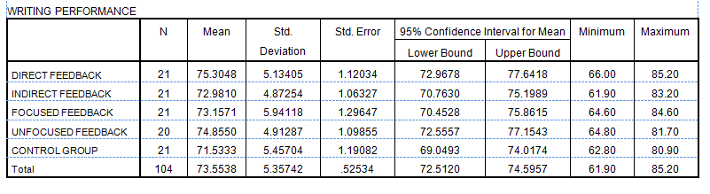

It can be seen on table 4.1 that the highest score of writing performance was found in the Direct Feedback group and the lowest score was found in the control group where peer feedback was given to students. However, whether the mean scores were significantly different, the data were then analyzed by using one way ANOVA. The result of ANOVA can be seen on Table 4.2. The result of ANOVA showed that simultaneously there was no any significant difference of mean scores among the four groups of experiment and the control group with F (4, 99) = 1.740, p = 0.147.

Table 4.2.
The Result of the One-way ANOVA Using SPSS Version 21
ANOVA
WRITING PERFORMANCE
 | Sum of Squares | Df | Mean Square | F | Sig.
Between Groups | 194.169 | 4 | 48.542 | 1.740 | .147
Within Groups | 2762.129 | 99 | 27.900
Total | 2956.298 | 103

    - Independent Writing (Delayed Post Test)
In addition to the investigation of the effect of different types of feedback on students’ writing performance in the writing process which incorporated revision, this study also intended to identify whether the four types of feedback also gave a relatively long time effect on students’ writing performance. Therefore, a delayed post test of independent writing was also measured. The delayed post test was given at the time of final examination of the students, two weeks after the last (the fifth essay). In this delayed post test, the students’ essays were no longer provided with any types of feedback.
Different from the result of writing performance in the writing process, where direct feedback scored the highest, the result of writing performance in the independent writing showed that focused feedback scored the highest. To find out whether the difference in mean score was significant, one-way ANOVA was performed again. The result of one-way ANOVA revealed that there was no any statistically significant difference of mean scores of the students among different types of feedback in the experimental groups and control group with F(4, 99) = 0.714, p = 0.584).

Table 4.3
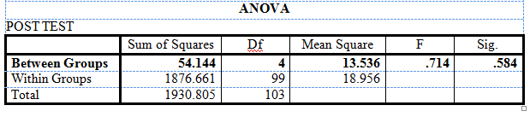
The Result of One-way ANOVA for Post Test

The result of ANOVA showed that the research hypothesis number 1 which stated that there was a significant difference of the mean scores among different types of written corrective feedback on students’ writing performance during the writing process and independent writing was rejected. This means that all types of feedback had the same effect, no single type of feedback is more effective than the others.

- Significant Improvement on Students’ Writing Between the First Draft and Revised/Second Draft Essay
Sub research question (b) intended to know whether there was a significant difference between the mean score of the first draft and the mean score of the revised or second draft of the students’ essay after a particular type feedback was given. The data were analyzed by using paired sample t-test for non-independent sample. The result of the analysis using SPSS version 21 is presented as follows:

Table 4.4
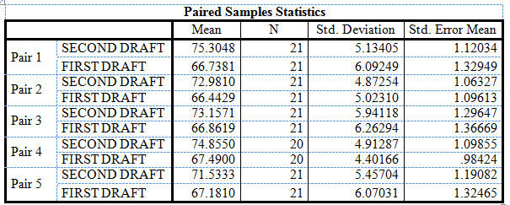
The Mean Score of the First Draft and Second/revised Draft of the Students’ essays

Notes: Pair 1 = Direct Feedback; Pair 2 = Indirect Feedback; Pair 3 = Focused Feedback; Pair 4 = Unfocused Feedback; Pair 5 = Peer Feedback

Table 4.4 showed that the highest mean score of the first draft was found in the unfocused feedback group and the highest mean score of the second draft was found in the indirect feedback group. Whether the mean score differences were significant can be seen in the following table:

Table 4.5.
The Result of Paired Sample T-Test
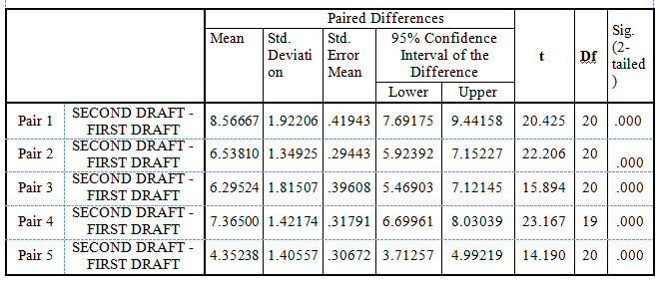

Table 4.5 showed that all of the groups made significant improvement from the first draft to the second/revised draft at the significance level of 0.000. This also indicated that the hypothesis which stated that there was a significant improvement of the students’ writing namely between the first draft and the second/revised draft was accepted. This means that all of the types of feedback including peer feedback were able to improve the students’ writing performance significantly.

- Significant Improvement on Students’ Writing between the First Essay and Each Successive Essay
Next, to answer the sub research question (c), the data were analyzed by using One Way ANOVA with repeated measures or within subject ANOVA. The improvement gained from each experimental group and the control group is explained as follows:

- Direct Feedback
After analyzing the data using one-way ANOVA with repeated measures related to the writing performance of the students in the Direct Feedback (DF) group, it was found that there was a significant improvement of students’ essay from the first essay to each subsequent or new essay. The improvement can be seen from the mean scores of the students’ essay which showed an increasing trend from one essay to each subsequent essay. The gain achieved by the students in this group calculated from the first essay to the last essay was 78.0476 – 72.0952 = 5.9524. To know whether the gain was statistically significant, one way ANOVA with repeated measures was run. Using Wilks' Lambda test, the result of ANOVA revealed that for Direct Feedback group there was a significant difference of mean scores of the students in the five types of essay which were assigned in different times, F(4,80) = 17.532, p = 0.000 < α = 0.05 and main effect of 0.467. By this value, the research hypothesis was accepted. This means that Direct Feedback was effective in improving students writing performance from time to time. It showed that the differences among the five types of essay were significant. This means that there was a significant improvement of the students’ writing performance provided with direct feedback.

- Indirect Feedback
In terms of indirect feedback, the same analysis was run to find out if there is a significant improvement among the five types essay which were provided with indirect feedback. The result of the descriptive statistical analysis showed that the students gained 5.8095 points from the first essay to the fifth essay, slightly lower than the gain in the direct feedback group. Whether the changes were significant was proved by statistical analysis using a one way ANOVA with repeated measures with the help of SPSS version 21.The result of the analysis revealed that there was a significant difference among the types of essay, F(4, 80) = 9.494, p value = 0.000 < α = 0.05, with the main effect η² = 0.322. Thus, the research hypothesis which states: “There is a significant improvement on students’ writing (namely between the first essay and the new essay) during the writing process stages where a specific types of written feedback is provided”, was accepted.

Table 4.6
The Result of ANOVA Repeated Measures for the Essays in Indirect Feedback Group
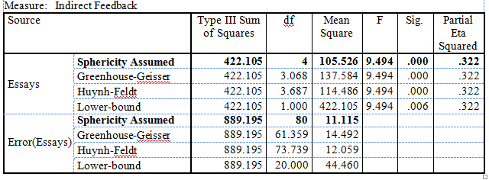

- Focused Feedback
The third type of feedback investigated in this study was focused feedback. The result of statistical analysis showed the mean scores of the students’ essays in the Focused Feedback group in which the argumentative essay had the highest score, just like what was found in the previous two groups. However, to determine whether the mean score differences were significant, a statistical analysis using One Way ANOVA with repeated measures was performed and the result can be found in Table 4.7
Table 4.7
The Result of ANOVA Repeated Measures for the Essays in
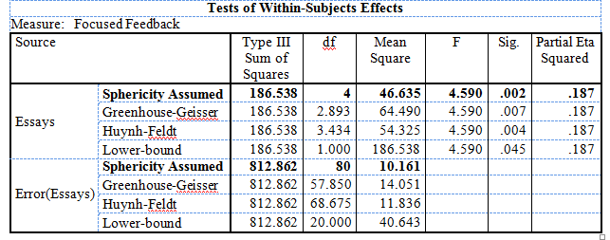

Similar to the previous two types of feedback which showed significant difference among the 5 types of essay, the result of analysis using one way ANOVA with repeated measures for the essays in the focused feedback group also revealed that there was a significant difference of means score of students’ essays from the first essay to each consecutive essay with F (4, 80) = 4.590, p value = 0.002 < α = 0.05, with the main effect η² = 0.187. Therefore, the research hypothesis which stated that there was a significant improvement on students’ writing (namely between the first essay and each successive essay) during the writing process stages where a specific types of written feedback was provided, was accepted.

- Unfocused Feedback
In terms of unfocused feedback, the same ANOVA repeated measures analysis was performed to find out if there was a significant improvement among the five types essay which were provided with unfocused feedback. The result of the descriptive statistical analysis showed that the students gained 5.1 points from the first essay to the fifth essay. This gain was lower than the gain obtained in the direct and indirect feedback groups, but much higher than the gain obtained in the focused feedback group.
Whether the differences in mean scores of the students’ essays were significant, the analysis using a one way ANOVA with repeated measures with the help of SPSS version 21 was run again. The result of one way ANOVA with repeated measures showed that there was a significant difference between the mean score of the first essay and that of each successive essay with F (4, 76) = 9.812, p value = 0.000 < α = 0.05, and with the main effect η² = 0.341. Thus, the research hypothesis which states: There is a significant improvement on students’ writing (namely between the first essay and the new essay) during the writing process stages where a specific types of written feedback is provided, was accepted.

Table 4.8
The result of ANOVA Repeated Measures for Essays in Unfocused Feedback Group
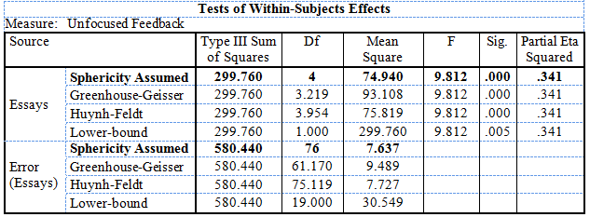

.

- Peer Feedback (Control Group)
The last group investigated in this study was the control group in which a non-teacher written feedback (peer feedback) was used in correcting students’ essays. The result of descriptive statistical analysis showed that the last essay still got the highest score among other essays. The gain obtained from the first essay to the last essay was 4.3357 points. This gain was lower than the gain obtained in the direct and indirect feedback groups, but higher than that in the focused feedback. It is interesting to note that in this group there was a decrease in mean score, which was found from essay 2 to essay 3. This phenomenon was not found in the four experimental groups.

Table 4.9
The Mean Scores of Students’ Essays in Control Group
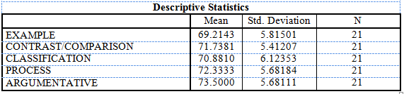

Table 4.9 showed that the mean scores of each essay were different. To know whether the differences were statistically significant, the data then were analyzed by using a one way ANOVA with repeated measures. The result of the analysis showed that there was a significant difference among the types of essay with F (4, 80) = 13.368, p value = 0.000 < α = 0.05 (Table 4.12). It is concluded that the research hypothesis which states: “There is a significant improvement on students’ writing (namely between the first essay and the new essay) during the writing process stages where a specific types of written feedback is provided”, was accepted.

Table 4. 10
The Result of One Way ANOVA Repeated Measures for Essays in the Control Group
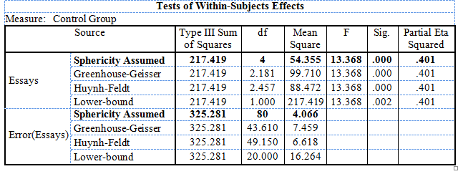

After examining the result of ANOVA repeated measures for all types of feedback, and after observing the gains obtained by each treatment group, it is concluded that the research hypothesis which stated that there is a significant improvement on students’ writing (namely between the first essay and each successive essay) during the writing process stages where a specific types of written feedback is provided, was accepted. This implies that all of the types of feedback were able to improve the students’ writing performance from the first essay to the each successive essay, in which direct feedback obtained the highest gains among other types of feedback, followed by indirect feedback, unfocused feedback and focused feedback. It is interesting to note that peer feedback outperformed one of the teacher feedback types, namely focused feedback. In this case the gain obtained from peer feedback was higher than the gain obtained from focused feedback group.

- The Type of Teacher Written Feedback which was Effective in Improving the Aspects of Writing
This section presents the findings related to the aspects of writing. The sub research question (d) related to the findings from the experiment states: “Which type of teacher corrective feedback is effective in improving a particular aspect of writing (content, organization, vocabulary, language use and mechanics)?” To answer this question another one way ANOVA was performed. In order to know which type of feedback provision was more effective in improving one particular aspect of writing, it is a good idea to compare the mean score of each group in relation to the relevant aspect of writing. There were five aspects of writing investigated in this study, so the one-way ANOVA were also performed separately for every aspect of writing. The result of analysis using one way ANOVA is presented as follows.
- Content
Content was the first aspect of writing which was investigated in this study. It refers to how well the students understood the topic assigned to them and how well they developed the topic into adequate and relevant details. The result of descriptive statistical analysis showed that the average scores of the students’ writing in relation to content in all experimental groups and control group were not far different ranging from 22.49 (control group) to 24.07 (unfocused group). The highest mean score of content was reached by the students in the unfocused feedback group and the lowest mean score was found in the control group. To find out whether the mean scores of content were significantly different among the groups of experiment and control group, a one way ANOVA was run and it was found that there was a significant difference in mean scores of the content aspect of writing among the groups with F (4, 99) = 2.600, (p value = 0.041 < α = 0.05). Therefore, the research hypothesis which stated that “there is a significant effect of different types of written corrective feedback on of each aspect of students’ essays (in this case aspect of content)” was accepted. This finding indicated that unfocused feedback was more effective in improving the content of the essay compared with other types of feedback.

- Organization
The second aspect of writing investigated in this study was the organization of the essay. Organization refers to how the students arranged their ideas in such a way so that the essay is coherent and the ideas flowed smoothly from one to another. Good organization in an essay has fluent expression and the ideas are clearly stated and supported and it also has logical sequencing coherence (Jacob, at.al., 1981). The descriptive statistical analysis shows that the highest mean score of organization was reached by the students in the Direct Feedback group, followed by unfocused feedback, indirect feedback and focused feedback and the lowest mean score was found in the control group (peer feedback).
To know whether the differences found in the aspect of organization for all experimental groups and control group were significant, the data were analyzed by using one way ANOVA. The result of the analysis showed that there was no significant difference in organization scores among the five groups of treatment, F (4, 99) = 1.951, p = 0.108 > α 0.05. This value shows that the research hypothesis which stated that “there is a significant effect of different types of written corrective feedback on of each aspect of students’ essays (in this case aspect of organization)” was rejected. This implies that whatever the types of feedback was used in commenting the aspect of organization, it would produce relatively the same outcome.

- Vocabulary
The third aspect of writing observed in this study was vocabulary. It refers to the ability of students in using sophisticated range and effective word and idiom choice and usage; mastering word form and using appropriate registers (Jacob, et.al., 1981). The score range of vocabulary was from 7 to 20. After the data were analyzed descriptively, it was found that Direct Feedback reached the highest mean score (15.8476) and peer feedback had the lowest mean score (15.0714). To know whether the difference in mean score was significant, it needed to be statistically analyzed using one-way ANOVA.
Similar to the aspect of organization, the result of analysis using one-way ANOVA showed that the aspect of vocabulary showed insignificant difference of mean scores among the five types of teacher written feedback, F(4,99) = 1.609, p = 0.178 > α = 0.05. Therefore, the research hypothesis for vocabulary was rejected.

- Language Use
The fourth aspect of writing investigated in this study was language use. It refers to the ability of students in constructing effective sentences in which there were no or only few errors in agreement, tense, plurality, word order, articles, pronouns and preposition . The result of descriptive statistical analysis shows that the highest mean score was found in Direct Feedback group (15.3190) and the lowest score was found in the control group (14.6333). The differences among the types of teacher written feedback resulted from the descriptive analysis above were then tested for their significance. This is to determine whether the difference in mean score of each group was significant or not. For this purpose, one way ANOVA was performed to find the significant difference of mean scores among the four types of teacher written feedback in experimental groups and the feedback used in the control group in term of language use.
The result of ANOVA showed that there was no any significant difference of mean scores of the students from one group to another group in term of language use, F(4,99) =0.951, p = 0.438 > α = 0.05. This means that there is no any single feedback which was more effective than any other one. They had equal efficacy in improving the students’ writing performance. After trying to perform a post hoc test, it was found that there was no any single type of feedback which showed a significant difference. Therefore, the research hypothesis for language use was rejected.

- Mechanics
The last aspect of writing investigated in this study was mechanics. It refers the ability of students to demonstrate mastery of writing technical convention such as capitalization, spelling, punctuation, paragraphing and handwriting. The descriptive statistical analysis revealed that the highest mean score was achieved by the students who were given unfocused feedback (4.1850) and the lowest means score was found in the focused feedback group (4.0048). To find out whether the differences were significant, one-way ANOVA was performed once more. The result of ANOVA showed that there was no any significant difference among five groups related to the aspect of mechanics with F (4, 99) = 1.304, p = 0.274 > α = 0.05. Therefore, the research hypothesis for mechanics was also rejected. This finding suggested that there was no any single type of feedback provision which was more effective than the others. It also implies that all types of feedback had the same effect on mechanical aspect of writing.
From a number of analyses done to find out which type of feedback was more effective in improving a particular aspect of writing, it was found that Direct Feedback and Unfocused Feedback were more effective than Peer Feedback in improving Content and Organization of the essay, and only Direct Feedback is more effective than Peer Feedback in improving Vocabulary. However, there has been no empirical evidence yet, which showed that one particular teacher corrective feedback was more effective than other types of teacher corrective feedback. Generally, all types of the teacher written feedback were equally effective in improving students’ writing performance.

- The Most Improved Aspect of Writing
The sub research question (e) says “What aspect of writing (content, organization, vocabulary, language use, and mechanics) gets most improvement after being provided with a particular teacher written corrective feedback. To identify which aspect of writing got most improvement after one particular feedback was given, a within-subject ANOVA with repeated measures was performed. After analyzing the data descriptively, the results showed that the students in all feedback groups got the highest mean score in the aspect of organization but the mean scores in other types of feedback were fluctuating..

Table 4.11
The Average Score of Each Aspect of Writing for Experimental and Control Group
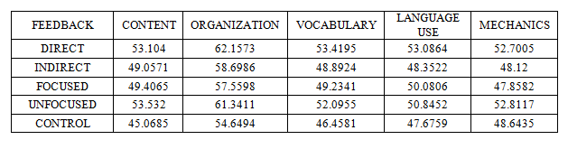

Table 4.11 clearly indicates that the aspect of organization got the highest score in each type of feedback, while the mean scores of other aspects of writing (content, vocabulary, language use and mechanics) were much lower than the mean score of the organization. The differences of mean scores of each aspect of writing in each type of written feedback are illustrated in Figure 4.1.

Figure 4.1. Graph of the average score of all aspects of writing in each group

- The Difference between Students’ Writing Performance During the Revision Process and Students’ Independent Writing
The sub research question (f) was also related to the results of the experiment stating: “Is there any significant difference between students’ writing performance during the revision process and students’ independent writing (Delayed Post Test) in each treatment group?” To answer this research question the data were analyzed by using a Paired-Sample T-test. The paired-samples t-test was used to determine whether there was a statistically significant mean difference between the independent delayed post test and the writing performance during the revision process.
The result of descriptive statistical analysis showed that the mean scores of the students’ essays in the independent writing for all paired samples were higher than those in the writing performance of revision process, in which the highest score of independent writing was found in the focused feedback group with the mean score of 78.1429. In order to know whether these differences were significant, the analysis was continued by using paired sample t-test. The result of the paired sample t-test is presented in Table 4.12.

Table 4.12
The Result of Paired Sample t-test for All Groups
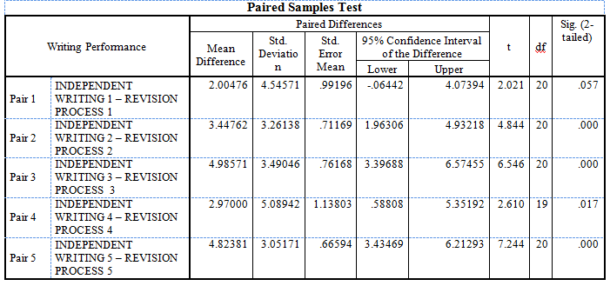

The table of paired sample t-test (Table 4.12) shows that there was a significant difference of writing performance between independent writing and revision process in each pair, except pair 1, in which direct feedback was given. The other four types of teacher written feedback (indirect feedback, focused feedback, unfocused feedback and even peer feedback) were able to give long effect of retention on students’ writing performance. Although the score of independent writing was higher than the score of revision time in the direct feedback group, it was not different significantly with t = 2.021 (p=0.057). This implies that direct feedback did not give a significant long retention effect on students’ essays. Therefore, the hypothesis which stated: there is a significant difference between students’ writing performance during the revision process and students’ independent writing (Delayed Post Test) in each treatment group was accepted.

- The Effects of Learning Strategies on Students’ Writing Performance
Another variable which is hypothesized to have an effect on students’ writing performance in relation to feedback provision is Learning Strategies. The strategies used by the students in learning and in accommodating feedback given by the teacher may affect their writing performance. Therefore, this study also intended to investigate whether the students’ writing performance (both in the revision process and independent writing or delayed post test) was significantly affected by their different learning strategies (Direct Strategy and Indirect Strategy).
The result of descriptive statistical analysis showed that students with direct and indirect strategies have higher scores in their independent writing (M=76.7653 and M=77.5660, respectively) than that in their revision writing (M=73.4755 and M=73.4745, respectively). The result also showed that the mean score of students with direct strategies and indirect strategies were almost the same in the revision process. The mean difference was only 0.0019, which was believed insignificant. For independent writing, the mean score of the students with different learning strategies was also slightly different, in which the students with indirect strategies had higher score than those with direct strategies; the mean difference was only 0.8. The illustration of how these two types learning strategies differed in two different conditions: Revision Process and Independent Writing can be seen in Figure 4.2.

Figure 4.2. Mean Score of the Students with Different Learning Strategies

Even though it is clear that the students with different learning strategies have almost the same mean score where the mean difference was below 1, it is still necessary to test these differences using statistical analysis, In this case, one way MANOVA was applied. The result of one way MANOVA shows that using Wilks’ Lambda test there was no significant difference between learning strategies on the combined dependent variables: revision and independent writing, F(2, 99) = 0.795, p = 0.455 > α = 0.05; Wilks' Λ = .984; partial η² = 0.016. This result can be found in Table 4.16.

Table 4.13
The Result of One Way MANOVA for Learning Strategies

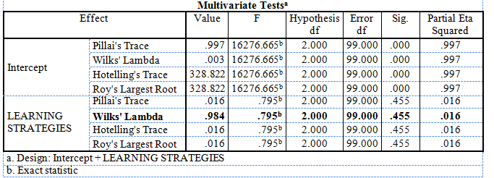

To identify which dependent variable (revision or independent writing) contributed to the statistically significant MANOVA, the result of the one-way ANOVA for every dependent variable can be inspected. Therefore, in this case, the first effect that was investigated was the effect of learning strategies on students’ writing performance in revision process and the second one was the effect of learning strategies on students’ writing performance in independent writing. The results of this analysis can be found in the Tests of Between-Subjects Effects table, as shown in Table 4.14. The result showed that there was no any statistically significant difference in revision process between students with different learning strategies, F (1,100) = 0.000, p = 0.999 > 0.05; partial η² = 0.000 and there was no any significant difference in independent writing between students with different learning strategies, F (1,100) = 0.873, p=0.532 > 0.05; partial η² = 0.009. This implies that learning strategies did not have a statistically significant effect on both revision process and independent writing where no feedback was provided. These results confirmed that the research hypothesis which stated “there is a significant effect of different language learning strategies on students’ writing performance both in revision process and independent writing” was rejected.

Table 4.14
The Result of Test between Subject Effects of Learning Strategies on Writing Performances
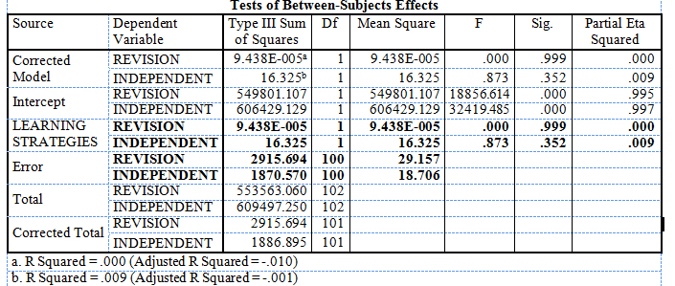

This means that students’ language learning strategies did not have any effect on students’ writing performance. This also indicated that whatever the strategies the students used, it did not make any difference in their performance.

- Interaction between Corrective Feedback and Learning Strategies on Writing Performance
The last issue which was investigated in this study was the interaction between Corrective Feedback and Learning Strategies on Writing Performance. This issue refers to whether one particular type of feedback works well on a certain language learning strategy but not on another language learning strategy. In other words, whether there is an interaction between different types of corrective feedback and different learning strategies in relation to students’ writing performance. In order to find out if there is a significant interaction effect between teacher written feedback and language learning strategies on the overall performance of the students, a 5 x 2 factorial design was applied. The result of factorial analysis using two-way ANOVA can be seen on Table 4.15.

Table 4.15
The Average Scores of Students in Different Types of Feedback and Learning Strategies

Leaning Strategies | Direct Feedback |  |  | Indirect Feedback |  | Focused Feedback |  | Unfocused Feedback |  | Peer Feedback |  | Total
 | M |  | SD | M | SD | M | SD | M | SD | M | ST | M
DIRECT | 74.2 | 5.9 |  | 73.1 | 6.14 | 75.6 | 4.7 | 73.3 | 3.97 | 70.4 | 5.83 | 73.3
INDIRECT | 76.4 | 3.95 |  | 72.9 | 3.65 | 70 | 5.68 | 76.1 | 5.03 | 71.7 | 4.67 | 73.4

he result of two-way ANOVA revealed that simultaneously, there was no any statistically significant interaction between language learning strategies and teacher written feedbacks on students’ writing performance score, F(4,92) = 2.159, p = 0.080, partial η² = 0.086. This indicated that the effect of feedback variable was the same for each level of language learning strategy variable. This means that the main effects of feedbacks and learning strategies on writing performance were equal. In other words, this would mean that the effect of different teacher written feedbacks on writing performance was the same for the students who used direct strategies and the students who used indirect strategies. The interaction of the two independent variables on writing performance can be clearly observed in Figure 4.3.
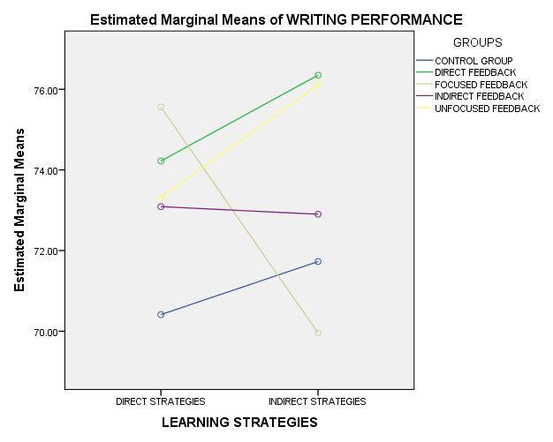

Figure 4.3. The interaction between teacher written feedbacks and language learning strategies on students’ writing performance

As found in the result of two-way ANOVA analysis, simultaneously there was no any significant interaction effect of feedback variable on learning strategy variable. However, when the graph of interaction in Figure 4.4 was examined, it was shown that at least one type of feedback had an interaction effect with at least one type of learning strategies. It was suspected that focused feedback and unfocused feedback interacted with learning strategies, because the students who used direct language learning strategies scored higher than those who used indirect language learning strategies in the focused group. On the contrary the students who used indirect language learning strategies scored higher than those who used direct strategies in the unfocused group.
To prove whether focused and unfocused feedback and language learning strategies had a significant interaction effect on students’ writing performance, partial analysis using two-way ANOVA was performed again. The result was not surprising; even it was in line with what was expected that there was a significant interaction between types of feedback and language learning strategies in relation to students’ writing achievement.
Based on the result of partial analysis of two-way ANOVA for focused, unfocused and peer feedback, it was found that there was a significant interaction effect of feedback and language learning strategies on students’ writing performance, F(2, 55) = 3.771, p = 0.026, partial η² = 0.12. This revealed that focused feedback worked significantly well for the students who used direct strategies while unfocused feedback significantly worked well for the students who used indirect strategies. The interaction can be seen in Figure 4.4.
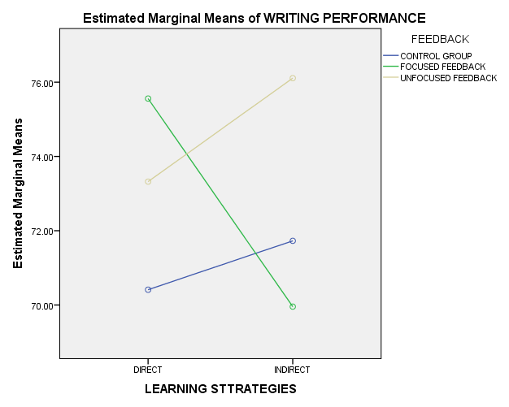

Figure 4.4. The interaction between three different types of feedback and learning strategies for students’ writing performance

- DISCUSSIONS
Having analyzed the data and answered the main and sub research questions, it is necessary to discuss the results for further interpretation. This discussion will be divided into two sections. The first section refers to the results of experiment in which the first independent variable together with its all factors and aspects will be discussed. The second section refers to the variable of learning strategies and the interaction effect of the two independent variables: teacher written feedbacks and language learning strategies on the dependent variable (students’ writing performance).

- The Results of Experiments
- Written Corrective Feedback and Writing Performance
The result of statistical analysis showed that among the four types of feedback under this study, direct feedback scored higher than other types of feedback in the revision process, but not in the independent writing. Focused feedback was found to have higher score than any other types of feedback in the independent writing. However, the result of analysis using one-way ANOVA showed that the mean scores of the students in the four types of feedback were not significantly different, both in the revision process and in the independent writing. This means that there was no single type of feedback which was significantly superior to other types of feedback given in the experimental groups both in the revision process and independent writing.
Because all types of feedback were found to be able to increase the students writing performance, as what was found in the answer of sub research question number (b), it can be said that all of the four types of feedback had the same effect in improving the students’ writing performance. It also indicated that all of the four types of feedback can be used interchangeably, dynamically to improve the students’ writing performance. This finding supports other studies where their findings were inconclusive, meaning that there was no any exact conclusion of which particular feedback was most effective to be used to promote writing performance. Some research findings showed that direct feedback was more effective than other types of feedback and some others found that there was no significant difference between contrasting types of feedback. For example Ferris and Roberts (2001), investigated the efficacy of explicit and implicit feedback and they found that both groups in their experiment significantly outperformed the control group but the two type of feedback which they labeled the ‘codes’ and the ‘no codes’ showed insignificant difference, a finding that was line with the finding of this study.
The fact that there was no a common conclusion that could be used to decide which specific type of feedback should be given to students to promote their writing performance was supported by other conflicting research findings. Some findings revealed that direct feedback was more effective while other findings revealed that indirect feedback was more effective. The examples of study which favored direct feedback are those of Ferris (2006), Ferris (2011) and Ferris and Roberts (2001). They all revealed that direct feedback was more effective than indirect feedback. Even, Ferris (2001, 2006, 2011) consistently claimed that direct feedback would result in positive effects than indirect feedback. In addition, Gue´nette and Lyster (2013) claimed that in Quebec pre-service ESL teachers were mostly dependent on direct feedback when they gave corrections on writing to L2 learners.
In short, if asked which type of teacher written corrective feedback was effective in improving students’ writing performance, the answer is all of the types of teacher feedback were equally effective; no single type of feedback was significantly more superior than the others. However, if compared with peer feedback, two types of teacher feedback (direct feedback and unfocused feedback) were more effective than peer feedback in the revision process but not in the independent writing. Therefore, in providing feedback to students’ writing the teacher may use any type of feedback, either a single type or a combined type of feedback, or an interchangeable type of feedback, all would work the same, rather than not giving feedback at all.

b. Improvements of Students’ Writing Performance During the Writing Process
The sub research question (b) wanted to know if there was a significant improvement from the first draft to the second draft. The finding sowed that all of the five types of feedback, including the peer feedback, were able to improve the students’ writing performance from the first drafts to the second drafts of the students’ essays. It was found that the second drafts of the students’ essay were far much improved. This was because the students used and incorporated the feedback given to them in their revisions. Some students found difficulties in understanding some of the feedback given by the teacher. To overcome those difficulties, they met the teacher and asked for clarification. This may also become a contribution to the improvement of their revision.
The sub research question (c) asked whether the students’ writing performance improved from the first essay to each successive essay during the writing process after a particular type of feedback was provided. The results of analysis show that only the focused feedback group did not show any significant improvement (p=0.067). All other types of feedback, including the peer feedback showed significant improvement with the p value < 0.005. However, in the focused feedback, when essay one was compared to essay 4 and 5, they showed significant improvement with p = 0.007 for essay one to essay 4; p = 0.012 for essay 1 to essay 5; and p = 0.027 for essay 2 to essay 5. And when essay 3 was compared to essay 4, it also showed significant improvement with p = 0.026.
There were a plenty of studies which investigated the efficacy of focused feedback in improving linguistic accuracy in writing. Some examples of such studies were conducted by Ellis, et al., (2008), Sheen (2007), Sheen, Wright, & Moldawa (2009), Bichener and Knoch (2009), and Bichener and Ferris (2012). Ellis, et al., (2008) found that the unfocused feedback was found to work better than focused feedback at the initial stage, but later when focused feedback continued to improve students’ writing, the unfocused feedback did not. In addition, Sheen (2007) discovered that written corrective feedback which focused on a targeted single linguistic feature was able to improve students’ writing accuracy and her finding suggested that focused feedback was more effective if it was accompanied by the correct form and metalinguitic explanation.
While the present study found that focused feedback was less effective than other types of feedback, the earlier studies indeed showed its effectiveness. However, Ferris, (2011) tried to encourage the use of unfocused feedback by stating that focused feedback was superior to unfocused feedback but there might be a specific occasion where unfocused, comprehensive feedback may be valuable to students. There were some arguments why this finding was different from the previous studies. First, in the present study, focused feedback addressed a more general aspect of writing such content, organization, vocabulary, grammar and mechanics, whereas the previous study addressed an extremely specific linguistic feature such as articles only, tenses, or preposition. Second, the present study provided feedback only once for one aspect of writing, while the previous studies provided continuous and repeated feedback on the same linguistic aspect during the course of the experiment. Third, because the targeted aspect of writing was too general and comprehensive, as well as very limited time, the students might find it difficult to accommodate all of the correction for them to make uptakes. Fourth, peer feedback used in the control group played significant roles in improving students’ writing. Bitchener and Ferris (2012) stated that in the peer feedback provision, learners can get experiences in finding the location of the errors and they may read their own papers carefully and correct the errors by themselves before they are corrected by their teacher or their peer.

c. Improvement of the Aspects of Writing
Sub research question (c) of this study asked which type of teacher corrective feedback was effective in improving a particular aspect of writing (content, organization, vocabulary, language use and mechanics). The results of analysis showed that for the aspect of content, unfocused feedback and direct feedback was found to be more effective in improving the aspect of content. This finding was consistent with the previous finding of this research, where direct feedback and unfocused feedback were also found to be more effective in promoting students’ overall writing performance.
Again, the empirical evidence showed that although focused feedback gave special emphasis on content, it did not outperform the direct and unfocused feedback, This was caused by the fact that in direct and unfocused feedback, the students got feedback on content every time they write, while in the focused feedback group, the students received feedback on content only once during the course of the experiment.
In term of organization, it was found that simultaneously, there was no significant difference among the five types of feedback, (4, 99) = 1.951, (p = 0.108). This indicates that all of the five types of written feedback worked well in improving the organization of students’ essays. Some studies previously conducted showed that the aspect of organization indeed got improved whatever the type of feedback provided. Chapman (2006) investigated the role of explicit instruction and found that it was able to improve the organization and the quality of narrative writing of the children. Ferris (2012) also agreed that different types of teacher feedback were valued by students in terms of ideas and organization (p.46). .
The next aspect of writing was vocabulary. Like in the other aspects of writing discussed previously, direct and unfocused feedback also got the highest mean score in the aspect of vocabulary. This was in line with the previous finding of the study that direct feedback and unfocused feedback worked well to improve students’ writing performance. So, it is also consistent with the finding for the aspect of writing, especially for vocabulary. However, this finding was not in line with the previous research findings in which focused feedback was found to be more effective than unfocused feedback. Ferris (2011) stated that recently many researchers agreed that focused feedback was better than unfocused feedback, but there might be certain conditions in which unfocused, comprehensive feedback on students’ writing could be valuable.
Language use was the next aspect of writing performance observed in this study. The result of ANOVA shows that there was no any significant difference of mean scores of the students from one group to another group in term of language use. This means all types of teacher written feedback were equally effective in improving the grammatical errors made by the students. This finding also proved that the claim made by Truscott (1996) about the uselessness and the danger of error correction on grammar was refused. However, it is worth to note that among the five aspects of writing performance, the aspect of language use got relatively low score, even though the difference might not be significant.
The last aspect was mechanics. The result of data analysis gain showed that there was no any significant difference among the types of written feedback. It means that all types of teacher written feedback were equally effective in improving the mechanical aspect of students’ writing. This also implies that the teacher may use any type of feedback to improve mechanics. If we look at the comparison of the mean score of the students, it was actually found that direct feedback and unfocused feedback got the highest score in mechanics, similar to the evidence found in other aspects of writing where direct and unfocused feedback also obtained the highest scores, even though they were not significant.
Having found that the four types of feedback investigated in this study were equally effective in improving writing performance in general and all aspects of writing in particular, it can be confidently stated that all of the types of feedback can be used by the teacher either interchangeably, simultaneously, or dynamically in treating, responding to, or correcting students’ written work. The most important thing to note is that teacher written corrective feedback, either direct or indirect, either focused or unfocused, is able to foster EFL students’ writing performance in all aspects.

d. The Comparison between Revision Process and Independent Writing
Most of the issues discussed in the previous sections refer to result of treatment in the revision process. In order to know that teacher written feedbacks really contributed to the improvement of writing performance, the mean score of students’ essay in the revision process and in the independent writing were compared. This will give information about whether the teacher written feedbacks were able to contribute to the long-term retention and which type of teacher written feedback gave maximum retention. The answer of those inquiries was manifested in the answer of the sub research question (f) which asked: “Is there any significant difference between students’ writing performance during the revision process and students’ independent writing (Delayed Post Test) in each treatment group? The result indicated that all types of feedback, except the direct feedback were able to give long effect on students’ writing performance. What happened to the direct feedback group that it was not able to contribute to the long-term performance?
There were some supporters of direct feedback such as Bitchener and Knoch (2008). However, in the long run or for long term-retention which was measured in the independent writing where students did not receive any more corrections from the teacher, direct feedback was found to be significantly less effective. This finding supported those who favor the indirect feedback provision (Lalande, 1982, Hyland and Hyland 2006) who argued that indirect feedback provision enabled students to get benefit from guided and learning and problem solving, thus leading to more successful self-corrections and long-term acquisition of the target forms. The distinction of the two types of feedback in relation to theories of language acquisition may become the underlying reason why indirect feedback turned out to be effective in the independent writing. The fact that the students wrote a type of essay that had been studied and had been practiced in the writing process might lead them to obtain significant better writing performance, while in the revision process, all of the types of essay were new for them.

- The Interaction Effect of Different Types of Corrective Feedback and Learning Strategies on Students’ Writing Performance
The finding of this study on the effect of learning strategies on the success of different types of feedback in improving students’ writing performance implies that whatever the learning strategies used by the students, it would not influence their performance after they were provided with particular feedback. This finding was different from other factors of individual differences which were examined by Sheen (2007) who found that students who have high level of language analytic ability benefitted more from corrective feedback compared to those with low level of analytic ability. In addition, Sheen (2011) investigated three different factors of individual differences and found that language aptitude and learner attitudes had a mediating effect on the success of written corrective feedback, while language anxiety did not. This finding proved that not all of the factors in the individual differences mediated the effect of written feedback on writing. This may be true to the finding of this study that the factor of learning strategy did not affect the students’ writing performance after they were provided with different types of feedback.
The finding also showed language learning strategies as one factor of individual differences did not really affect learning outcome of the students as what Dornyei (2005) have claimed that individual differences such as language aptitude, motivation, or learning styles are not questionable to have important contribution to the success of foreign language learning and language learning strategies were included into the inventory of important learner variables. This may be true for other aspects of language but for writing performance, language learning strategies do not seem to have important contribution especially in writing in English as a foreign language. It was also found that learning strategies did not significantly mediate the effect of the four different types of teacher written feedback. This means that all of the students regardless what types of learning strategies they used (either direct or indirect strategies) were benefitted from all types of feedback.

- IMPLICATIONS FOR WRITING INSTRUCTION
In light with the findings and discussions presented previously, some implications of the findings for writing instruction need to be taken into consideration.
First, having identified the effects of teacher written feedbacks and language learning strategies on students’ writing performance, there is a need to incorporate feedbacks in writing instruction because the empirical evidence showed that feedbacks still play important roles in enhancing students’ learning behaviors, especially in improving students’ writing performance. The teacher should not let the students’ paper without giving any feedback.
Second, the findings of this study also give an implication that in responding to students’ writing, teachers may use a combination of different types of feedback (teacher and non-teacher written feedback) because it was proven that both teacher and peer feedback was able to improve EFL students’ writing performance. Having found that the four types of feedback investigated in this study were equally effective in improving writing performance in general and all aspects of writing in particular, it can be confidently stated that all of the types of feedback can be used by the teachers either integratedly, interchangeably, simultaneously, or dynamically in treating, responding to, or correcting students’ written work.
Third, this finding gives an implication to writing instruction that whatever the language learning strategies used by the students; their performance would not be affected after they were provided with particular feedback. Therefore, in teaching writing, especially in responding and commenting on students’ essays, the factors of language learning strategies may not be a big issue for the teachers. They should take other factors of individual differences into consideration when they respond and give feedbacks to students’ writing.
V. CONCLUSIONS, SUGGESTIONS AND RECOMMENDATIONS

- CONCLUSIONS
After analyzing the data and discussing the results of data analysis, some conclusions are drawn based on the answers of the research questions.
- Teacher written feedbacks had significant effects on students’ writing performance. The details of the effects are summarized as follows;
  - There was no significant difference of the students’ mean score of writing performance among the four types of feedback investigated in this study. This indicated that these two types of teacher written feedback were more effective than the non-teacher written feedback in the revision process, but all types of feedback were equally effective in the independent writing.
  - There was a significant improvement of the students’ writing from the first draft to the second/revised draft. All of the types of feedback, including the peer feedback were able to improve the students’ essay in the revised version.
  - There was a significant improvement of students’ writing performance provided with different types of feedback during the writing process. All types of the teacher feedback were able to significantly improve the students’ writing performance from the first essay to each of four successive essays.
  - There was no significant difference of the students’ mean scores in these three aspects across the five types of teacher written feedback. In terms of content and vocabulary, direct feedback and unfocused feedback were significantly more effective than peer feedback, but equally effective with the other two types of teacher feedback.. All of them have the same effect in improving the aspects of writing.
  - The aspect of writing performance which got most improvement was the aspect of organization. The other aspect improved relatively the same rate. All of the types of feedback obtained the highest score in the organization.
  - All types of feedback, except the direct feedback were effective in giving long term effect on the students’ writing performance.
- Language learning strategies did not have an effect on the improvement of the students’ writing performance after being provided with different feedback. The result of statistical analysis confirmed that neither direct language learning strategies nor indirect language learning strategies showed any effect on students’ writing performance. Whatever the language learning strategies the students used, it gave the same result.
- Simultaneously, there was no significant interaction effect of learning strategies on the success of the four different teacher’s written feedback in improving students’ writing performance. This means that learning strategies did not significantly mediate the effect of the four different types of teacher written feedback. This also means that all of the students regardless what types of learning strategies they used (either direct or indirect strategies) were benefitted from all types of feedback in improving their writing.

- SUGGESTIONS FOR WRITING TEACHERS
Based on the research findings, some suggestions are provided as follows:
- Feedback provisions on students’ writing should not be abandoned because they provide a great impact on students’ writing improvement.
- Teachers should not use one particular type of feedback only persistently but rather use more than one integratedly or interchangeably, dynamically or even simultaneously.
- Teachers should consider using these two different types of feedback when correcting and commenting on the aspects of writing separately.
- Teachers should give emphasis on the other aspects of writing, especially mechanics and language use which still got lower mean score than other aspects.
- Learning strategies were found not to affect the students’ writing performance; therefore, teachers should consider other aspects of individual differences such as learning styles, personality and preferences in teaching writing.
- Teachers should give more focused feedback to students with direct learning strategies and provide more unfocused feedback to students with indirect learning strategies.
- RECOMMENDATIONS FOR FUTURE RESEARCHERS
- This study was purely quantitative which employed an experiment design. Therefore, it had insufficient qualitative supporting data about why a particular aspect of writing got more improvement than others. Therefore, it is recommended that future researchers collect qualitative data to supplement the quantitative data.
- This study incorporated two types of essay writing, namely expository and argumentative essay. Future researchers may elaborate the types of essay such as narrative, and descriptive essay.
- This study was limited to language learning strategies as one factor to be considered in identifying the efficacy of teacher written feedbacks. Future researchers are recommended to take other factors of individual differences such as learning styles, feedback preferences and personality, etc.
- The essays were written and revised by the students at home that open the possibility for the students to work together and ask for help from others. Therefore, it is recommended that they essays be written and revised in the classroom to avoid this possibility.
- Future researchers may conduct an experiment to see the effects of teacher written feedbacks if they are used simultaneously in responding to students’ writing compared if only one particular type of feedback is used.

REFERENCES

Adler-Kassner, L., & O’Neill, P. (2010). Reframing writing assessment to improve teaching and learning. Utah: Utah University Press.
Aridah.(2004). Students' preferences and reactions to teacher feedback. In B. Y. Cahyono & U. Widiati (Eds.), The tapestry of English language teaching and learning in Indonesia (pp 195-103). Malang: State University of Malang Press.
Azwar, S. (2015). Reliabilitas dan validitas (Edisi 4). Yogyakarta: Pustaka Pelajar.
Bailey, S. (2006). Academic writing: A handbook for international students (Second Edition). London: Routledge.
Baleghizadeh, S., & Dadashi, M. (2012). The effect of direct and indirect corrective feedback on students’ spelling errors. Profile Vol. 13, No. 1, pp.129-137.
Barton, M. D. (2006). Rhetoric and composition: A guide for the college writer. USA:, Wikimedia Foundation.
Bitchener, J. & Knoch, U. (2008). The value of written corrective feedback for migrant and international students. Language Teaching Research Vol. 12(3). pp. 409– 431.
Bitchener, J., & Ferris, D. (2012). Written corrective feedback in second language acquisition and writing. New York: Routledge.
Bratcher, S., & Ryan, L. (2004). Evaluating children’s writing : A Handbook of Grading Choices for Classroom Teachers (Second Edition) London: Lawrence Erlbaum Associates.
Brookhart, S.M. (2008). How to give effective feedback to students. Virginia: Association for Supervision and Curriculum Development.
Chapman, M. (2006). Preschool through elementary writing. In P. Smagorinsky (Ed.). Research on composition: Multiple perceptive in two decade of change. New York: Teachers College Press.
Clark, I. L. (2003). Concepts in composition: Theory and practice in the teaching of writing. London: Lawrence Erlbaum Associates.
Cory, H. (2005). Advanced writing with English in use. Oxford: Oxford University Press.
Creswell, J.W. (2012). Educational research: Planning, conducting and evaluating quantitative and qualitative research (Fourth Edition). Boston: Pearson.
Dornyei, Z. (2005). The psychology of the language learners: Individual differences. New Jersey: Lawrence Erlbaum Associates.
Ellis, R. (2009). Typology of written corrective feedback types. ELT Journal Volume 63(2), pp. 97-107.
Ellis, R., Sheen, Y., Murakami,M., & Takashima, H. (2008). The effects of focused and unfocused written corrective feedback in an English as a foreign language context. System, 36 pp. 353–371.
Ferris, D., & Roberts, B. (2001). Error feedback in L2 writing classes: how explicit does it need to be? Journal of Second Language Writing,10, pp.161-184.
Ferris, D. (2003). Responding to writing. In B. Kroll (Ed.). Exploring the dynamic of Second Language Writing (pp 119-140). Cambridge: Cambridge University Press.
Ferris, D. (2009). Response to student writing. New Jersey: Routledge.
Ferris, D. (2010). Second language writing research and written corrective feedback in SLA: Intersections and practical applications. Studies in Second Language Acquisition, 32, pp 181-2001.
Ferris, D. (2011). Treatment of error in second language student writing (2nd Ed,). Ann Arbor: University of Michigan Press.
Ferris, D.( 2006). Does error feedback help student writers?: New evidence on short- and long-term effects of written error correction’ in K. Hyland and F. Hyland (eds.). Feedback in Second Language Writing: Contexts and Issues. Cambridge: Cambridge: University Press.
Ferris, D., & Hedgcock, J. (2005). Teaching ESL composition. London: Lawrence Erlbaum Associates, Publishers
Ferris, D.R. (2004). The ‘‘Grammar Correction’’ Debate in L2 Writing: Where are we, and where do we go from here? (and what do we do in the meantime . . .?). Journal of Second Language Writing, Vol. 13, pp. 49–62.
Flower, L. (1979). Writer-Based Prose: A Cognitive Basis for Problems in Writing. College English, vol .41 (1), pp.19-37. Available at: http://www.jstor.org/stable/376357 (accessed 19/07/2013)
Gardner, J., Harlen, W., Hayward, L., Stobart, G., & Montgomery, M. (2010). Developing teacher assessment. New York: McGraw Hill.
Gay, L.R., Mills, G. E., & Airasian, P. (2006) Educational research: Competencies for analysis and applications (Fourth Edition).Ohio: Pearson.
Gue´nette , D., & Lyster, R. (2013). Written corrective feedback and its challenges for pre-Service ESL Teachers. Canadian Modern Language Review, Vol. 69 (2) pp. 129-153.
Hattie, J., & Timperley, H. (2007). The power of feedback. Review of Educational Research, 77, pp.81-112.
Huot, B. (2002). (Re)articulating writing assessment for teaching and learning. Utah: Utah State University Press,
Hyland, F. (2003). Focusing on form: Student engagement with teacher feedback. System, Vol. 31. pp. 217–230.
Hyland, K., & Hyland, F (2006) Interpersonal aspects of response: Constructing and interpreting teacher written feedback in Ken Hyland &Fiona Hyland (eds.) Feedback in Second Language Writing. Cambridge: CUP.
Hyland, K. (2009). Teaching and researching writing. England: Pearson Education.
Hyland, K. (2003). Second Language Writing. Cambridge: Cambridge University Press.
Hyland, K., & Hyland, F. (2006). Feedback on second language students’ writing. Language Teaching, Vol. 39, pp. 83–101.
Jacobs, H. L., Zingraf, S. A., Wormuth, D. R., Hartfield, V. F., and Hughey, J. B. (1981). Testing ESL compositions: a practical approach. Rowley, Mass: Newbury House.
Keh, C.L. (1990). Feedback in the writing process: a model and methods for implementation. ELT Journal, Vol. 44 (4), pp. 294-304.
Kepner, C. (1991). An experiment in the relationship of types of written feedback to the development of second-language writing skills. Modern Language Journal, 75, pp.305-313.
Knapp, P., & Watkins, M. (2005). Genre, text, grammar: Technologies for teaching and assessing writing. Sidney: University of New South Wales Press.
Lalande , J. F. , II . ( 1982 ). Reducing composition errors: An experiment . Modern Language Journal , 66 , 140 – 149.
Macaro, E. (2001). Learning strategies in foreign and second language classrooms. London : Continuum.
O’Malley, J.M., & Chamot, A.U. (1990). Learning strategies in second language acquisition. Cambridge: Cambridge University Press.
Oshima, A,. & Hogue, A. (1999). Writing Academic English. New York: Addison Wesley Longman.
Oxford, R. L. (1990). Language learning strategies: What every teacher should know. New York: Newbury House.
Oxford, R. L. (2008). Hero with a thousand faces: Learner autonomy, learning strategies and learning tactics in independent language learning. In S. Hurd and T. Lewis (Eds.). Language learning strategies in independent settings (pp 41-63). Bristol: Multilingual Matters.
Panofsky, C. Pacheco, M., Smith, S, Santos, J., Fogelman, C., & Harrington, M. (2005). Approaches to writing instruction for adolescent English language learners. USA: The Education Alliance at Brown University.
Pawlak, M. (2014). Error correction in the foreign language classroom: Reconsidering the issues. Heidelberg: Springer.
Richards, J.C., & Schmidt, R. (2002). Longman dictionary of language teaching and applied linguistics (3rd Edition). London: Pearson Education.
Richards, S (2000). The student, the test and the classroom context: A case study of teacher response. Assessing Writing,7, pp. 23–56.
Robb, T., Ross, S., & Shortreed, I. (1986). Salience of feedback on error and its effect on EFL writing quality. TESOL Quarterly , 20, pp. 83-93.
Semke, H.D. (1984). Effects of the red pen. Foreign Language Annals, 17, pp.195-202.
Sheen, Y. (2007). The effect of focused written corrective feedback and language aptitude on ESL learners’ acquisition of articles. TESOL Quarterly, Vol. 41 (2), pp.255-283.
Sheen, Y. (2011) Corrective feedback, individual differences and second language learning. New York: Springer.
Sheen, Y., Wright, D., & Moldawa, A. (2009). Differential effects of focused and unfocused written correction on the accurate use of grammatical forms by adult ESL learners. System, 37, pp. 556-569.
Smalley, R.L., & Ruetten, M.K. (1995). Refining composition skills: Rhetoric and grammar (4th Ed.). USA: Heinle ELT.
Truscott, J. (1996). Review article: The case against grammar correction in L2 writing classes. Language Learning, 46,2, pp. 327-369.
Van Beuningen, C. (2010). Corrective feedback in L2 writing: Theoretical perspectives, empirical insights, and future directions. International Journal of English Studies, Vol. 10 (2), pp. 1-27.
Weigle, S.C. (2009). Assessing writing. Cambridge: Cambridge University Press

