Effect Self Concept and Attitudes to Behavior of Farmer in Sustainable Land Management

Muh. Djafar Aidid, Mulyadi, Bahkrani Rauf, and Nurlita Pertiwi

Universitas Negeri Makassar
Email: aididdjafar61@yahoo.com

Abstract
This research aimed to analyze the dominant variables that influence the behavior of farmers in sustainable land management. Sampling procedures individuals were randomized to receive 200 respondents with proportional stratified random sampling technique. Based on the type and data analysis, categorized in quantitative research. Data were analyzed using multiple linear regression to determine the effect of one variable to another variable. Variables in this research is the variable self-concept (X1), the attitude of the community (X2) and behavior (Y). The results of analysis that there is a very strong relationship between the attitudes of farmers and self-concept of the behavior of rice farmers in sustainable land management. Furthermore based on multiple regression analysis showed that rice farmers attitude positive effect on the behavior of farmers, as well as a positive self-concept influential on the behavior of the farmer.

Keywords: Self-Concept, Attitudes, and Farmers Behavior.

Introduction

Natural resources are all the riches of the earth, both biotic and abiotic can be utilized to meet the needs and welfare of human beings, like plants, animals, air, water, farmland, minerals, wind, light and microbes (microorganisms). The living environment is interact for humans, as well as dealing with fellow human beings and other creatures. Thus the man is obliged to create awareness, aware of the bad consequences, foster the spirit of love of the environment, realizing the friendly attitude towards the environment, do actualization and further embed environmental wisdom in the soul principle - the principle of personality environment. The concept of self-identity through childbirth attitude in utilizing, maintaining and controlling for environmental sustainability for the benefit and generation.
Every human activities related to economic dimension to support the development of infrastructure, including agricultural infrastructure, for and by minimizing the level of poverty. While the dimensions of the environment can be seen from the importance of managing and processing of natural resources for sustainable development. Then on the social dimension of education and health are very important to have knowledge as a key factor in the implementation of energy development. To show that the construction carried out according to the needs the community, therefore all the people can have the empowerment to participate to the planned development goals in a sustainable manner.
Dirawan and Pertiwi (2010), explains that the concept of sustainable development, connects the three pillars in the process of sustainable development, namely, economic, environmental and social. Implementation of sustainable developmet improve of high economic growth, due to the high economic growth, the variety of life needs can be met adequately.
Importance of the environment as essential needs of living beings, but because for the sake of high economic growth sometimes sacrificing environmental impact. Therefore, it is necessary to balance economic development and environmental sustainability. While social development is directed to the substance that builds human with the target shape and has a concept to their environment. And further create balance and harmony of life together, both with between humans and humans with his environment and in order to realize sustainable social development.
Hasim (2009), describes that the implementation of the three sectors of the construction described in the facts have not been targeted and overlapping even cause social problems are prolonged. Among a lot going on neighborhood development and growth of settlements or urban development, for example in the agricultural sector, which generally degrades the environment and will then extinction, because the capacity of its resources continue to decrease in support. Problems various environmental damage caused by the negative impact of industrial growth resulted in pollution, excessive use of agricultural land and land control is less balanced and ultimately decreasing agricultural products, agricultural land conversion to settlements or the expansion needs of the area and the provision of infrastructure. Various information and the fact that in Indonesia, this time every one hour of farmers will lose fifty hectares of land due to land conversion and extinction.
According to Salim (1993), a good living environment is an environment that can preserve its function is to maintain the carrying capacity and the capacity to biotic factors and abiotiknya. Environment that is well managed will provide lasting benefits to mankind. Such circumstances require coaching and development environment that is based on the state of the carrying capacity and environmental carrying capacity will increase harmony, harmony, and balance subsystems, which will mean increasing the resilience of the subsystem itself. Coaching and development of subsystems which one will affect the other subsystems, which in turn will increase the knowledge about the environment, obedience and utilize environmental awareness on the need to live with reflections behave preserving the environment and implemented fully.
From some facts and indications show that the conditions of environmental management in Indonesia has many problems, such as science and environmental awareness is still considered low, environmental policy in the form of symbolic, and therefore the population of population increase. Further and end all of the problems affecting the onset of urbanization to the urban areas, which in turn raises new environmental problems at the destination. Environmental damage (or factors that have the potential to damage the environment) did not decrease even tends to increase. This is seen in some strategic sectors in the development of Indonesia such as forestry, agriculture and fisheries, and mining. This is as a result of natural resource management and environmental management scheme is likely to lead the short-term oriented. Natural resources and environment serve as the foundation for economic growth, thereby limiting no longer care about conservation principles. Even if there are policies and regulations governing the necessity to control and preserve the environment functions.
One of the goals of awareness for sustainable development is how the efforts to improve the lives of people so that poverty (food availability) could be reduced in such a way. Therefore, poverty is one of the main problems faced by the community. Poverty will not only reduce people's access to sources of livelihood, despite indications that poverty will also increase the likelihood of a healthy life and realized in a different context, with such an attitude of poverty will be reduced. Then the emergence of social unrest because of ignorance about the environmental benefits, this will always bring a sense of dissatisfaction, jealousy and suspicion that would result in other impacts.

Research Methods
This research was conducted in August-September 2016, with the population are the community who work as farmers in Takalar with a sample size of 200 respondents. The samples were done using stratified proportional random sampling. This research classified as research surveys and ex post facto. Mantra (2000), the expression of that type of survey research is so large its use, as the unit of analysis is individual and done in a planned and systematic, with each other to be mutually supportive. Survey research as research that takes a sample of the population and the questionnaire as a data collection tool staple (Singarimbun, 2006). In addition Babbie (in Creswell, 2010) survey research purposes to generalize a population of some samples that can be made conclusions/allegations while on the characteristics, behaviors, or attitudes of the population. If the terms of the kind of research is classified according to the purpose of applied research, the research aimed to obtain information that can be used to solve problems of practical life (Suriasumantri, 2011). While the types and categorized data analysis in quantitative research (Sugiyono, 2012).
This research aims to find the dominant variables that influence the behavior of farmers in a sustainable manner in Takalar. Based on the data, information and facts obtained, then the data were analyzed using multiple linear regression analysis to determine the condition of each of the variables studied, which is expected to note the effect of one variable to another variable. The variables in this study consisted of the independent variable is the variable self-concept (X1), farmers attitude variables (X2) and the dependent variable is the behavior of the farmer (Y).

Research Results

Descriptive analysis
To describe the general conditions based on the data and information obtained in accordance with pre-defined categories of variable attitude, self-concept and behavior of farmers.
Table 1. Distribution of respondents by attitude variables
 | Frequency | Percent
Very low | 18.00 | 9.00
Low | 42.00 | 21.00
Moderate | 71.00 | 35.50
High | 48.00 | 24.00
Very High | 21.00 | 10.50
 | 200.00 | 100.00

Table 1 above shows the distribution of research data by farmers attitude variables are divided into five levels categories in describing the condition of community. Categories of respondents with an attitude very low obtained for 9.00% or 18 people, the attitude of the respondents with low categories of 21.00% or 42 people, respondents with moderate category at 35.50% or 71 people, respondents being higher by 24.00% or 48 people and respondents being very high by 10.50 or 21% of the 200 total respondents. From these results it can be concluded that most of the farmers behave with category towards sustainable agriculture.
The description of the self concept of rice farmers are also divided into five categories, which can be seen in Table 2.
Table 2. Distribution of respondents by self concept variable
 | Frequency | Percent
Very low | 15.00 | 7.50
Low | 39.00 | 19.50
Moderate | 50.00 | 25.00
High | 65.00 | 32.50
Very High | 31.00 | 15.50
 | 200.00 | 100.00

Table 2 shows that the distribution of respondents on the concept of self farmers with high category by 65 respondents or 32.50%, while respondents with very high category as many as 31 people or 15.50%. However, there are 50 people (25%) who have moderate self-concept, and farmers with low self-concept as many as 39 people or 19.50%. Based on these descriptions, it can generally be stated that rice farmers have a good self-concept toward sustainable agriculture. Description of the behavior of farmers in sustainable agriculture described in the table 3 bellow.

Table 3. Distribution of respondents by Behavior Variable
 | Frequency | Percent
Very low | 19.00 | 9.50
Low | 46.00 | 23.00
Moderate | 85.00 | 42.50
High | 35.00 | 17.50
Very high | 15.00 | 7.50
 | 200.00 | 100.00

Table 3 shows that the behavior of farmers is divided into five categories and the general behavior of farmers in moderate category (85 or 23%). Respondents who exhibit behaviors of sustainable land management with high category as many as 35 people (17.50%) and very high category as many as 15 people (7.5%). In addition, there are also a number of 46 people (23%) are behaving low and 19 people (9.5%) with very low behavior.
Classic assumption test
This test is a test analysis assuming a classic symptom of irregularities which must be met to get a good model is normality, non multikolinieritas, non heteroscedastisity.
Normality
One of the easiest seeing residuals normality is to look at the histogram graph that compares the observation data is approximately normally distributed. If the data is spread around the diagonal line and follow the direction of the diagonal, then the model meet the assumption of normality. If the data are spread far from the diagonal line, the model did not meet the assumptions of normality (Santoso, 2014).

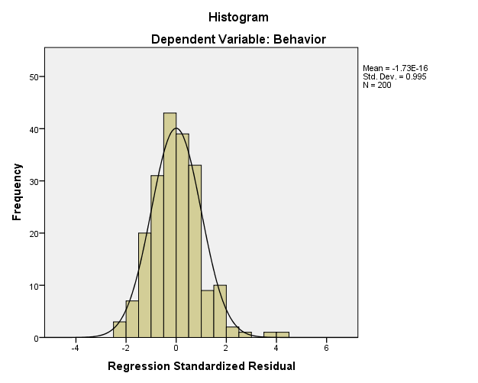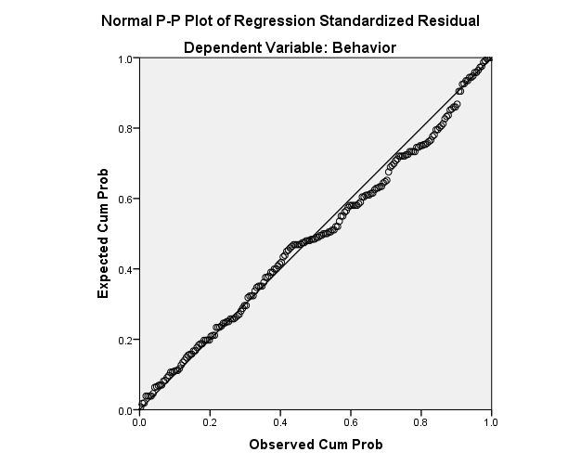
(a) (b)
Figure 1. a) Histogram Chart normality; b) Normal P-P Graph Plot

By looking at a histogram graph display can be concluded that the distribution of the data or the residual value shows a normal distribution (bell form). While in the normal graph plots the data visible (in the form of dot) spread around the diagonal line and follow the direction of the diagonal, then the model meet the assumption of normality. Both graphs show that the regression model to meet the assumptions of normality or residue of the model can be considered normal distribution.

Heteroscedastisity
Heteroscedastisity test aimed at testing whether the variance of the model occurred inequality residual one observation to another observation. If the variance of the residuals of the observations to other observations that remain, it is called homoscedasticity and if different called heteroscedasticity. A good model is the homoscedasticity. If there is a specific pattern, such as dots that no particular form regular patterns (wavy, widened and then narrowed), then the indicate has occurred Heteroscedasticity. If there is no clear pattern, as well as the points spread above and below the number 0 on the Y axis, then it does not happen heteroscedasticity.
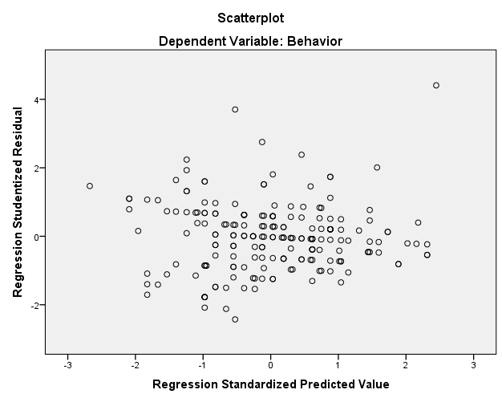

Figure 2. Scatter Plot of heteroscedasticity

Based on the results of the scatter plot seems that the plot formed spreads do not have a specific pattern or spread above and below zero on the Y axis as well as on the right and left on the X axis. This indicates that the model is not happening with the relationship between the independent variables residual value. Thus the assumption of non heteroscedastisity models is fulfilled.

Multicolinearity
Multicolinearity shows the relationship between the independent variables in the model. Fit models do not show any symptoms of multicollinearity. Detecting the presence or absence of multicollinearity done by looking at the value of VIF and Tolerance. If the value of VIF <10 and the value of Tolerance> 0.10 then the model is free from multicollinearity (Santoso, 2014). Here is the value of VIF and Tolerance generated:

Table 4. Collinearity Statistics
Model | Tolerance | VIF
Self concept | .902 | 1.009
Attitude | .902 | 1.009

From the table above shows that VIF of all independent variables in the model above is smaller than 10 and Tolerance value greater than 0.10. So it can be said to be a model free from multicollinearity. Thus non multicolinearity on the model assumptions are fulfilled.
Multiple Linear Regression
The correlation coefficient (R) and coefficient of determination (R-Square)
The correlation coefficient (R) indicates how much the linear relationship and the direction of the relationship between the independent variables (X1,X2, ...... Xn) simultaneously to the dependent variable (Y). The correlation coefficient (R) ranges from 0 to 1, the value closer to 1 means that the relationship is getting stronger, otherwise the value closer to 0 then the relationship is getting weaker. The coefficient of determination (R-Square) shows how much influence the independent variables are able to explain the change in the dependent variable in a study. This value can be seen in table 5 below.
Table 5. Model Summary Dependent Variable
Model | R | R Square | Adjusted R Square | Std. Error of the Estimate
1 | .976 | .952 | .944 | 9.757

Table 2 above shows the correlation coefficient (R) and the coefficient of determination (R-Square) obtained from analysis using SPSS program. The correlation coefficient (R) which is obtained for 0.976. Attitudes and self-concept shows a very strong connection to the behavior of farmers in sustainable land management. The coefficient of determination (R-Square) obtained for 0.952 or 95.20% indicates that the independent variable is the attitude and the concept of self to the dependent variable, namely farmers behavior have the effect of 95.20% while the rest of 4.80% was influenced by variables or other factors beyond the research.
Furthermore, to examine whether all the independent variables jointly affect the dependent variable tested simultaneously. Simultaneous testing based on the value of Sig. provided that if the Sig. <0.05 means independent variables jointly affect the dependent variable and vice versa. Simultaneous testing results can be seen in Table 6 below.

Table 6. ANOVA Dependent Variable
Model |  | Sum of Squares | df | Mean Square | F | Sig.
1 | Regression | 17.368 | 2 | 8.684 | 4.807 | .008
 | Residual | 2120.507 | 197 | 10.764
 | Total | 2137.875 | 199
Table 6 shows that the value of sig 0.008 <0.05 or variable attitudes and self-concept simultaneously influence the behavior of rice farmers in land management. The results were partially or regression coefficient test that aims to determine which variables are significant or not used to the regression model obtained, this partial test can be done by looking at the value of Sig. (P-value) provided that if the Sig. <0.05 means that the variable of the model used significantly and vice versa, the value can be seen in Table 7 below.
Table 7. Coefficients Dependent Variable
Model |  | Unstandardized Coefficients |  | Standardized Coefficients | t | Sig.
 |  | B | Std. Error | Beta
1 | (Constant) | 9.286 | 3.758 |  | 5.132 | .000
 | Self concept (X₂) | .125 | .107 | .583 | 3.169 | .004
 | Attitude (X₁) | .186 | .156 | .739 | 4.552 | .001

Table 7 above shows of the analysis of the independent variables on the dependent variable in this study was obtained with a coefficient equation model constants and coefficients of the variables in the column unstandardized Coefficients B produces the following equation:

Y = 9.286 + 0.125 X₁ + 0.186 X₂
Specification:
Y = Behavior
X₁ = Attitude
X₂ = Self concept

Then, as shown in Figure 3 in the form of a research model by using multiple linear regression analysis between independent variables and their influence the attitude and the concept of self to the dependent variable is the farmer behavior variable.
Behavior
Self Concept
Attitude
0.583
0.739

Figure 3. Multiple Linear Regression Model Research

From Figure 3 shows that the obtained effect of 0.583 between the variable self-concept of the behavior of farmers and later obtained an impact for 0.739 among farmers attitude variables to variable farmer behavior.

Research Hypothesis Testing
Influence attitudes toward farmers behavior
Hypothesis:
H₀: Attitudes do not effect on Behavior
H₁: Attitudes effect on Behavior
Base Decision:
H₀ is rejected if the value of Sig. < 0.05
H₀ is accepted if the value of Sig Sig. > 0.05

From the analysis values obtained Standardized Beta Coefficients of variable attitude towards positive behavioral variables for 0.739 and the Sig. obtained for 0.001 <0.05 then H₀ is rejected.
Based on these results, which means farmers attitude positive and significant effect on the behavior of farmers that can be interpreted that if the attitude of the farmer the higher the higher the smallholder attitudes or vice versa.

Influence self concept towards farmers behavior
Hypothesis:
H₀ : self concept effect on behavior
H₁ : self concept do not effect on behavior

Base Decision:
H₀ is rejected if the value. < 0.05
H₀ is rejected if the value. > 0.05
From the analysis values obtained Standardized Beta Coefficients of variable attitude towards positive behavioral variables for 0.583 and the Sig of 0001 <0.05. This means that H₀ is rejected or the self concept significantly influence to the behavior of farmers that can be interpreted that if the attitude is higher, the higher the farmer behavior or vice versa.

Discussion
Influence attitudes toward farmers behavior
Influence attitudes toward the behavior of farmers obtained in this research for 0739. Thus the effect of attitudes tend to be strong / high in transforming smallholder attitudes. The attitude is a constellation of cognitive components (related to mind), affective (associated with feelings), and conative (related to the tendency to act) that integrate with each other to understand, feel, and behave towards something.
Results were related to the theory of Reasoned Action (Ajzen, 2005) that attitudes influence behavior through a decision making process that is thorough and reasoned, and the impact is limited to just three things: (1) the behavior is largely determined by the attitude of the public, but by specific attitude towards something; (2) behavior is influenced not only by the attitude, but also by subjective norms, namely beliefs about what others want us to behave; and (3) attitudes toward a behavior shared norms of subjective form an intention or the intention to behave in certain ways.
Furthermore, there are four typologies according to the characteristic attitude (Krech, 1962): (1) affective association, is the attitude that has the content of cognition and trends of minimal action. The response of this attitude is based on the low emotions generated by the stimulus object. This type can not predict a person's behavior; (2) intellectualized attitude, the attitude of this character have a high component of cognition, but less action-oriented as well as the type of affective association is also inaccurate in predicting attitudes; (3) action oriented attitudes, characters, action-oriented attitude can represent the tendency of the action, but with a minimum content of cognition; (4) balance Attitudes, character type of attitude is very action-oriented and component-rich feeling. This type tends to have close links with other systems in the constellation of attitudes that a person's attitude. Therefore, this type can predict the tendency of one's actions.
Influence self concept towards farmers behavior
Influence attitudes towards smallholder attitudes obtained in this research for 0583. Thus the effect of attitudes tend to be moderate in Farmer Behavior change especially in the implementation of rural infrastructure development program. The attitude in this case is an impulse from within and from outside that directs individuals to act in accordance with the interests to be achieved.
With a positive self concept, a person will be optimistic, confidence new things, acts of success and failure of control, confidence, enthusiasm, feeling of self-worth, a concentration set life goals, as well as act and think positively. Conversely, the more negative self-concept, it will be increasingly difficult for someone to succeed. Because, with a negative self concept resulted in growing insecurity, think of failure and resigned to the challenge. If the negative beliefs and attitudes will reflect negative views of herself. Negative views of themselves cause behavior people expect success to be achieved only at a low level. The low benchmark cause the individual concerned does not have an attitude to achieve glorious achievement.
From the research (Yumi et al, 2011) revealed that the characteristic aspects of farmers, particularly the aspect of self-concept, extrinsic and intrinsic attitude influence the behavior of farmers in managing community forests. Positive self-concept generates good conduct in the management of Sustainable Community Forest, and vice versa negative self concept produces unfavorable behavior in the management of Sustainable Community Forest.
Based on the description of the results of the research, the development of sustainable agriculture supported by rice farmers can be done by taking into account the attitude and self-concept of farmers. The attitude is the result of the development of cognition can be achieved through education and socialization actions sustainable farming practices. The development of self-concept rice farmers can be achieved through the provision of motivation of farmers by the government continuously.

Conclusion
There is a relationship between the attitudes of farmers and self-concept of the behavior of rice farmers in sustainable land management. The coefficient of determination (R-Square) obtained for 0.952 or 95.20% or farmers' attitudes and self concept relates very strongly to his behavior.
Regresi multiple analysis results indicate vatiabel coefficient 0.739 to 0.583 in the variable behavior and self-concept. This shows the attitude of rice farmers, positive effect on the behavior of farmers, as well as a positive self-concept influential on the behavior of farmers. Behavioral variables influence attitudes towards larger than the influences of self-concept

References
Ajzen, I. 2005. Attitudes, Personality and Behavior, (2nd edition), Berkshire, UK: Open University Press-McGraw Hill Education
Creswell, J. W. 2010. Reseach Design. Sage Publication: Thousand Oaks California.
Dirawan, Gufran dan Pertiwi,. 2010. Sustainable Development dalam Pengelolaan Daerah aliran sungai. Universitas Negeri Makassar.
Hull’s D., & Sounders, Jr., J.C., 1996. The Coming Challenge: Are Community Colleges Ready for The New Wave of Contextual Learners, Community College Journal, 67: 15-17.
Krech, David. 1962. Crutchfield, dan Ballachey L. Egerton. Individual in Society. Tokyo: Mc Graw Hill Kogakusha Ltd
Mantra, Ida Bagoes, 2000. Demografi Umum. Yogyakarta : Putaka Pelajar.
Santoso, Singgih. 2014. SPSS 22 from Essential to Expert Skills. Jakarta: PT. Elex Media Komputindo
Salim, E,. (1993). Analisis Kebijakan Ekonomi yang Berkelanjutan. Jurnal Ekonomi Lingkungan. Edisi Keempat. Jakarta: EMDI project.
Suriasumantri, Jujun S. 2011. Filsafat Ilmu Sebuah Pengantar Populer. Jakarta: Pustaka Sinar Harapan.
Sugiyono. 2012. Statistika untuk Penelitian. Bandung: Alfabeta Bandung
Singarimbun M, Effendi S. 2006. Metode Penelitian Survai. Jakarta: LP3ES Indonesia.
Yumi, Sumardjo, Darwis S Gani, and Basita Ginting Sugihen. 2011. “Model Pengembangan Pembelajaran Petani Dalam Pengelolaan Hutan Rakyat Lestari: Kasus Di Kabupaten Gunung Kidul, Provinsi Daerah Istimewa Yogyakarta Dan Kabupaten Wonogiri, Provinsi Jawa Tengah.” Jurnal Penelitian Sosial dan Ekonomi Kehutanan 8(3): 196–210. http://www.forda-mof.org/index.php/content/jurnal.

