Systemic Approach and Reading Comprehension

SULKIFLI, MANSUR AKIL, AND SUKARDI WEDA

Universitas Negeri Makassar
teater_talas@yahoo.com

ABSTRACT
This study aimed to find out whether or not the systemic approach improved the first year students’ reading comprehension at Makassar Muhamadiyah University. The study employed experimental design with pre test-post test control groups design. The sample consisted of 35students at Makassar Muhammadiyah University. The research instrument was used to collect the data in the study, namely reading comprehension test. The data were analyzed by using descriptive and inferential statistics on SPSS for windows 20 program. The finding showed that there is significant difference of the students’ reading comprehension achievement between the students who were taught by using systemic approach and those who were taught by using lecturing method of the first semester at Makassar Muhammadiyah University especially literal comprehension. Moreover, the three components of reading comprehension are merely same in view of significant value, however, there is improvement of mean score in extrapolative comprehension by using systemic approach.

Keywords: systemic approach, level of comprehension, and narrative text

INTRODUCTION
As a process for getting the message conveyed the writer on the medium of writing text, reading comprehension skill obtains further academic learning success. To get further knowledge, college students are required to have critical and analytical competence in comprehending academic texts, in searching more academic information through various types of reading materials such as textbooks, journals, reports, or electronic messages; however, not all students are good at comprehending the text being read. Most of them understand the informational of the text; in other words, they are good in decoding the text but struggling to comprehend what the underlying meaning and purpose beyond the text are. In this condition, the reason why some students struggle is due to the lack of reading comprehension strategies used as parts of background knowledge.
Moreover, the ability to read the text, process and understand its meaning, reading comprehension is not necessarily simple to teach. Learn on practice since the secondary student even college student are still filed to pass the reading. Various method or approach was introduced to solve the ultimate problem; however, they only solve one part or more not whole part of reading comprehension. In thus, to teach reading comprehension, teacher and lecturer needs to be selective in applying the method or approach based on what students’ weaknesses.
The method as an alternative solution to suspend the students’ difficulties in reading comprehension is systemic approach. Akil (2015:4-5) stated that systemic approach is an approach which consider all elements of the system intersecting, interrelating, and interacting one another, if any element miss any of these systemic features, the element should be excluded from the system, otherwise, it will jeopardize the system. The absence, any of these five absolute features will ruin the system. Thus, considering the various difficulties possessed by each student, systematic approach is novel to be researched to solve the difficulties derived from comprehension components since this approach is still not conducted yet by another researcher in reading skill area.
This case also happens at Makassar Muhamadiyah University which it is obtain through preliminary observation. The data revealed that students are not able to comprehend messages of authors. It is proved by their scores during reading activity in classroom. Besides, the English teachers in this school explained that they taught reading comprehension by using conventional way (Three-Phases Technique) without recognizing the all aspects of reading like aspect, level, factor, and text genre in reading comprehension as provided by systemic approach.
Referring to explanations above, the researcher intends to conduct a research with the tittle “Systemic Approach to Improve Students’ Reading Comprehension”.
Staring to the problem, the researcher attempted to conduct systematic approach to solve the students’ problem in reading by formulating two research questions as follows:
- Does the use of systemic approach improve students’ reading comprehension?
These minor questions are pinpointed to the mayor question, as follows:
  - Does the application of systemic approach improve the students’ reading comprehension in term of literal comprehension?
  - Does the application of systemic approach improve the students’ reading comprehension in term of interpretative comprehension?
  - Does the application of systemic approach improve the students’ reading comprehension in term of extrapolative comprehension?
- Which of the three components of reading comprehension is the most significantly improved by using systemic approach?

LITERATURE REVIEW

Definitions of Reading

Definitions of reading appear in various perspectives. According to Tarigan (1990:7) reading is as a process that is done by the readers to be used for getting the message conveyed the writer on the medium of writing text. Based on Harmes (2007:99) reading is useful for language acquisition. Heilman (1981:4) states reading is an active and ongoing process that is affected directly by an individual’s interaction with his environment. Reading is a process of understanding written language. Since reading is a process, it stars from viewing the linguistic surface representation and ends with the certain ideas or meaning about the messages intended by the writer. Thus reading is the combination of perceptual process and cognitive process.

Definition of systemic approach

Systemic approach is inspired by the concept of systems thinking. So, to understand what systemic approach is, we, first of all, must understand the concept of systems thinking. Then, what is systems thinking? “systems thinking is a holistic approach to analysis that focus on the way that a systems constituent parts intersect, interrelate, interact and how systems work overtime within the context of larger systems (Akil:2013:3).

METHOD

Design and Samples

The research designs quasi-experimental design with the non-equivalent control group. It consists of an experimental class and control class. The experimental and the control group weregiven pre-test, treatment, and post-test. The comparison between pre-test and post-test scores depend on the success of the treatment that investigate the use of systemic approach influence the students’ reading comprehension related to the level of the comprehension for the first semester students at Muhammadiyah University.
The researcher took two classes from teen classes in first semester as the research subjects; they were experimental and control class. Sample was selected by using cluster random sampling technique. The researcher covered70 students as the sample of the research with 35 students as experimental class and 35 students class in as control class.
Instruments and Procedures
In this research, the researcher use reading test. The test was applied in two sections which those were conducted before giving treatment (pre-test) and after giving treatment (post-test). The pre-test was conducted to obtain data related to students’ prior knowledge in reading comprehension, while post-test was conducted to measure the students’ ability in reading comprehension after receiving treatment. The achievement test consists of pretest and posttest on readingcomprehension in the form of multiple choices. The test consists of identifyingthe main idea of the text, meaning of words, and communicative purpose of the text, text organization, and language features of narrative texts. The students had to find the answers based on the texts. This test aimed to know how much the students know about the content of the text. The test comprisedthree levels of comprehension, namely:
- Literal questions : 10 items, (number 2,5,6,7,9,10,12,13,15, 16)
- Interpretative questions : 10 items, (number1,4,11,17,19,20,21,23,25,27)
- Extrapolative questions :10 items, (number 3,8,14,18,22,24,26,28,29,30)
Before the present researcher used the test as an instrument in this research, she did the activity as follows:
- The researcher analyzed the formulation of questions and the alternative of answers.
- The researcher tried out the test before the test was used. This test was tried out to target of population, but it was not include as sample. The researcher analyzed validity and reliability of the test. The result of tried out of the test indicated that 25 items were valid and 5 items were invalid, namely number 9, 10, 13, 18 and 30 while the reliability of the test was 0.79.
- The researcher revised the invalid test before used them in the research. She used the tests after they had a good validity and reliability to measure the students’ reading comprehension.
To collect the data, the researcher used some procedures as follows:
To collect the data, the researcher used some procedures as follows:
- Pre-test
Before treatment, the researcher gavethe pre-test to the students in control and experimental group using reading test in the first meeting which it is consecutively presented into steps below:
- The researcher gave a worksheet that comprises some topics to each student
- The researcher instructed the students answer the question related to the text. They were given 60 minutes to finish the test.
- Treatment
After giving the pre-test, the students undergo the 6 sections in 90 minutes per sections for each group.
- Experimental Group
The procedure of giving treatment by using systemic approach is applied as follows:
- Introducing the material
- Asking the students about the material found out the prior knowledge.
- Have you ever learnt about narrative text?
- The researcher explains to the students the aim of systemic approach in reading the text.
- The researcher provides one example for the students to see as an example of systemic approach.
- The researcher instructs the students to read the narrative text silently (see appendix b).
Meeting 1
- After reading, the students write the important points in the orientation of the narrative text.
- The researcher invites the students to formulate some questions to question about main idea, characters in the story, stated facts, and the sequences of event by using what, who, where, and when.
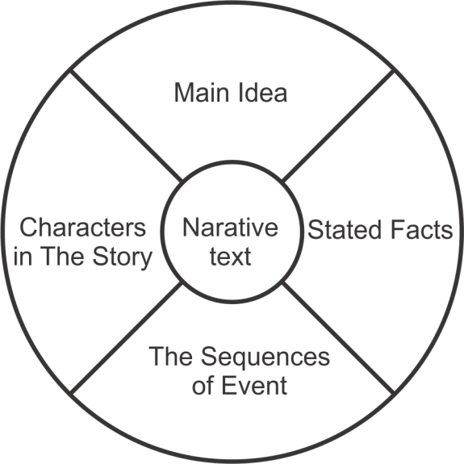
Meeting 2
- After reading, the students write the complication (problem[s] in the text) of the narrative text.
- The students freely express their opinions about the difficulty and the ease related to the problem in the text.
- The researcher triggers the students to give the solution the problem in the text
- The other students are free to interpret, add, critic, suggest or comment the one student’s solution

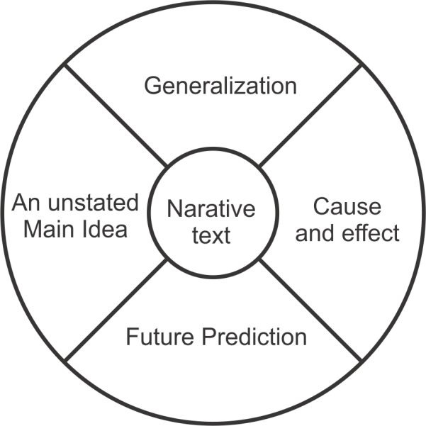
Meeting 3
- The researcher divides the students into group.
- After reading, the students connect the problem of the narrative text with their real life.
- The students in groups discuss their experience related to the problem of the text.
- The researcher invites the students to present the result of the group that had discussing and draw the conclusion.
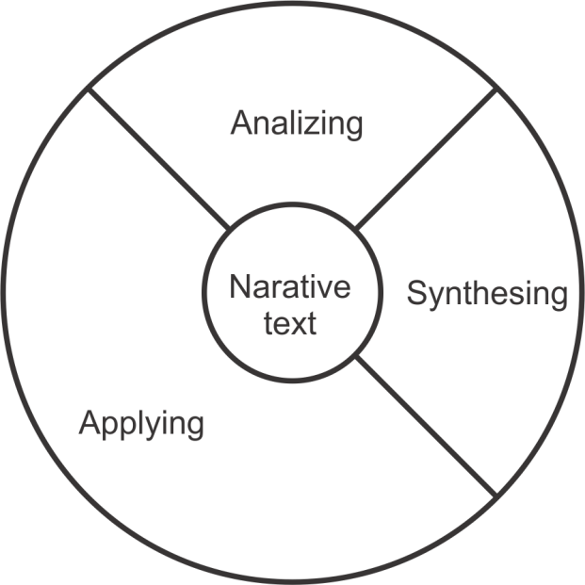
- Then, the researcher instructs the students to do the task related to the narrative text.
- The researcher gives feedback to the students’ work
- Control Group
Different with experimental group, the procedures of giving treatment by using conventional way generally is applied as follows:
Pre activity (+20 minutes)
- Introducing the material.
- Asking the students about the material found out the prior knowledge.
- Have you ever learnt about reading comprehension?
Whilst activities (+50 minutes)
- The researcher explains about narrative text further to the students and also the components
- The researcher asks the students to read narrative text.
- The researcher observes the students’ reading comprehension activity in the class.
- The researcher gives the chance for students to ask unclear explanation.
Post activities (+20 minutes)
- The researcher gives chance for the students to give comment or question about unclear explanation.
- The researcher informs to the students what they have done.
- Post-test
The procedures given in the post test was same with the pre-test for experimental and control group.

Data Analysis

- The data collected from each variable was analyzed by using the Statistical Package for Social and Science (SPSS) version 20.0 for windows. Procedure that taken for Reading Comprehension Achievement Test in analyzing the test are:
- Analyzing the raw data of pretest and posttest. Each of students’ correct answer got 1 and the wrong answer got 0.
- Calculating the students’ score
- Tabulating the score of the students’ test result
- Classifying the students’ score.

RESULT AND DISCUSSIONS

To collect data, the researcher used pretest and posttest. The experimental and control group were given pretest before treatment to know the students’ reading comprehension. The purpose of the test was to find out the prior knowledge of experimental and control group before treatment. After giving treatment, the same test was given to both experimental and control group to measure whether or not applying systemic approach can improve the students’ reading comprehension. To analyze the data, the researcher applied the independent t-test and ANOVA analysis.
Table 4.7 The t-test of the students’ reading comprehension
Variables | Probablity Value | Alpha | Remarks
Pretest of experimental and control group | .299 | 0.050 | not significantly different
Posttest of experimental and control group | .001 | 0.050 | Significantly different

By table 4.7 there was no a significant difference between experimental group and control group in pretest because the significant value (2-tailed) was 0.299, it was higher than α = 0.050. Nevertheless, the significant value (2-tailed) in posttest was 0.001, it was smaller than α = 0.050. It indicates that the alternative hypothesis (H₁) was significantly approved. It means that the use of systemic approach is improve the students’ ability in reading comprehension descriptive text in terms of literal, interpretative, and extrapolative of the first year students at Muhammadiyah University.
Although, overall score was significant difference in posttest but there was not a significant difference between experimental group and control group in terms of reading comprehension components. The data obtained in both group were different result in term of significant of the three components. The significant value of the literal was 0.043, the interpretative was 0.463, the extrapolative was 1.000. Those significant values of the reading comprehension components clearly illustrate that only literal comprehension was smaller than α (0.050). In other words, the literal comprehension was highly improved by application of systemic approach. Which the significant value (2-tailed) was given in the following table:

Table 4.8 The t-test of the students’ reading comprehension in three components reading comprehension
Variables | Component | Probablity Value | Alpha | Remarks
Pretest of experimental and control group | - literal  - interpretative  - extrapolative | 0.00  0.528  0.120 | 0.050 | Significant  Not significant  Not Significant
Posttest of experimental and control group | - literal  -interpretative  - extrapolative | 0.043  0.463  1.000 | 0.050 | Significant  Not Significant  Not significant

4. Test of Analysis of Variance (ANOVA)

Table 4.9 Test of analysis of variance
ANOVA
Score
 | Sum of Squares | Df | Mean Square | F | Sig.
Between Groups | 196.190 | 2 | 98.095 | .407 | .666
Within Groups | 24560.000 | 102 | 240.784
Total | 24756.190 | 104

By table 4.9 the score of F-obs 0.407 was smaller than F-table 0.407 <2.43. Thus, H1 was rejected and H0 was accepted. So, the three components (literal, interpretative, and extrapolative,) have same average score and the data also showed that the statistics test p = 0.666 > α (0.05) it showed that there was no a significant difference score among the three components of students’ reading comprehension in experimental group.
Table 4.10Descriptive of Reading comprehension Component
Descriptive Statistics
 | N | Minimum | Maximum | Mean | Std. Deviation
Extrapolative | 35 | 30.00 | 90.00 | 69.42 | 14.93
Interpretative | 35 | 40.00 | 90.00 | 66.85 | 14.90
literal | 35 | 30.00 | 100.00 | 66.28 | 16.64
Valid N (listwise) | 35
By table 4.10 the component in reading comprehension dominantly improvedwas Extrapolative. It is proven the mean score of the extrapolative was69.42 and it was higher than the other components can analytically the sequence of the story in narrative text. Then, component that has higher score after extrapolativewasinterpretative (66.85) because students can interpret the text. The lowest score among the other components was literal (66.28).
To know the different variant of the three components, table 4.11 shows the distribution among the aspects. The different variant can be seen by analyzing the point marks in each aspect. It was proved from the multiple comparisons table by which the three aspects namely literal, interpretative,and extrapolativehave varied mean difference as follows:

Table 4.11 multiple comparisons (dependent variable: posttest of experimental)
Multiple Comparisons
Dependent Variable: Score
LSD
(I) LevelsofComprehension | (J) LevelsofComprehension | Mean Difference  (I-J) | Std. Error | Sig. | 95% Confidence Interval
 |  |  |  |  | Lower Bound | Upper Bound
Literal Comprehension | Interpretative Comprehension | -.57143 | 3.70933 | .878 | -7.9289 | 6.7860
 | Extrapolative Comprehension | -3.14286 | 3.70933 | .399 | -10.5003 | 4.2146
Interpretative Comprehension | Literal Comprehension | .57143 | 3.70933 | .878 | -6.7860 | 7.9289
 | Extrapolative Comprehension | -2.57143 | 3.70933 | .490 | -9.9289 | 4.7860
Extrapolative Comprehension | Literal Comprehension | 3.14286 | 3.70933 | .399 | -4.2146 | 10.5003
 | Interpretative Comprehension | 2.57143 | 3.70933 | .490 | -4.7860 | 9.9289

By table 4.11 the researcher gives description on the comparison that the result score of the component 1 till component 3 was not different related to the significant value in the table above. Here are the descriptions all scores as follows:
- Between literal and interpretative has no mean different -0.571 with P value 0.87>0.05. it means that H₀ is accepted. So, between literal and interpretative comprehension are not different.
- Between literal and extrapolative has no mean different -3.14 with P value 0.39>0.05. it means that H₀ is accepted. So, between literal and extrapolative comprehension are not different.
- Between interpretative and literal has no mean different -0.57 with P value 0.87>0.05. it means that H₀ is accepted. So, between interpretative and literal comprehension are not different.
- Between interpretative and extrapolative has no mean different -2.57 with P value 0.49>0.05. it means that H₀ is accepted. So, between interpretative and extrapolative comprehension are not different.
- Between extrapolative and literal has no mean different 3.14 with P value 0.39>0.05. it means that H₀ is accepted. So, between extrapolative and literal comprehension are not different.
- Between extrapolative and interpretative has no mean different 2.57 with P value 0.49>0.05. it means that H₀ is accepted. So, between extrapolative and interpretative comprehension are not different.

CONCLUSION

Based on the findings and discussion in the previous chapter, the researcher concluded that the using systemic approach affected the students’ literal comprehension at Makassar Muhammadiyah University. Moreover, the three components of reading comprehension are merely same in view of significant value. However, there is significant difference of the students’ reading comprehension achievement between the students who were taught by using systemic approach and those who were taught by using lecturing method of the first semester at Makassar Muhammadiyah University.

REFERENCES

Akil, Mansur 2013, Aplikasi dan Implikasi Berfikir Systemik dalam Kehidupan, Pidato Ilmiah Dalam Rangkaian Upacara Wisuda Sarjana XXV STKIP Muhammadiyah Sidrap, 22 Oktober 2013

Akil, Mansur 2015 Systemic Approach (SA) To Curriculum Development ICOLE Conference 4th 2015

Alderson, J. Charles. (2000). Assessing Reading. Cambridge: Cambridge University Press.

Brady, F.neil. 1999. Systemic Approach to teach Ethic in Business. Journal of business ethics: Apr 1999; 19, 3; Arts & Humanities Full Text pg. 309. Retrieve on September 24, 2016 from http://link.springer.com/article/10.1023/A:1005904915906

Brown, Douglas H. 2001. Teaching by Principles: and interactive approach to language pedagogy. New York: Pearson Education.

Depdiknas. 2006. Kurikulum Tingkat Satuan Pendidikan 2006. Jakarta: Badan Standar Nasional Pendidikan.

Depdiknas. 2006. Petunjuk Teknis Pengembangan Silabus dan Contoh Model Silabus SMA/MA. Jakarta: Badan Standar Nasional Pendidikan.

Depdiknas. 2006. Standar Nasional Pendidikan. Jakarta: Badan Standar Nasional Pendidikan.

Gay, L.R., Mills,G.E., and Airasian, P. 2006. Educational Research: competencies for analysis and application. Colombia, Ohio: Upper Saddle River, New Jersey.

Grellet, Francoise. 1998. Developing reading skill. Cambridge: Cambridge University Press.

Hamid, Abdul. 2014. The Effectiveness of Collaborative Strategic Reading (CSR) in Improving Reading Comprehension of The First Year Students at SMA Pondok Pesantren Modern Al-Ikhlash Lampokko Campalagian Polewali Mandar. Unpublished Thesis. Makassar: Graduate Program of UNM.

Harmer, Jeremy. 2007. How to teach English. England: Pearson Longman.

Nadirah. 2012. Using PQ4r Technique to Improve Reading Comprehension of the Sixth Semester Students of English Department of Muhammadiyah University of Makassar. Unpublished Thesis. Makassar: Graduate Program of UNM

Nur Hasanah.2013. Improving Students’ Motivation in Reading Comprehension by Using Multiple Intelligences Strategies. Published Thesis. Semarang: State University of Makassar

Swain, Merrill. Problem in output and the cognition process they generate: A step towards second language learning. Applied linguistic journal. 16(2), 371

