Lampiran 3

Nilai Kompetensi Pedagogik Guru Tersertifikasi di Sekolah Dasar se-wilayah Tamamaung Kecamatan Panakukkang Kota Makassar Tahun 2015
Descriptive Statistics
 | N | Minimum | Maximum | Sum | Mean | Std. Deviation
YN | 10 | .00 | 60.00 | 459.80 | 45.9800 | 20.61298
NR | 10 | .00 | 66.70 | 467.90 | 46.7900 | 21.42208
MS | 10 | .00 | 100.00 | 436.70 | 43.6700 | 31.31950
KS | 10 | .00 | 60.00 | 361.50 | 36.1500 | 26.36097
BS | 10 | .00 | 66.70 | 428.20 | 42.8200 | 24.57572
SN | 10 | .00 | 100.00 | 720.00 | 72.0000 | 31.81544
TR | 10 | .00 | 60.00 | 406.30 | 40.6300 | 24.47275
RI | 10 | .00 | 66.70 | 456.80 | 45.6800 | 22.46112
EL | 10 | .00 | 66.70 | 489.70 | 48.9700 | 20.43309
PT | 10 | 25.00 | 100.00 | 612.30 | 61.2300 | 23.44175
RN | 10 | .00 | 100.00 | 483.70 | 48.3700 | 28.68271
Valid N (listwise) | 10

Lampiran 4.
Tabel 4.3. Hasil analisis angket formative class evaluation (FCE)

RESPONDEN EL1
 |  | Frequency | Percent | Valid Percent | Cumulative Percent
Valid | .00 | 16 | 30.2 | 30.2 | 30.2
 | 1.00 | 37 | 69.8 | 69.8 | 100.0
 | Total | 53 | 100.0 | 100.0

RESPONDEN EL2
 |  | Frequency | Percent | Valid Percent | Cumulative Percent
Valid | .00 | 14 | 26.4 | 26.4 | 26.4
 | 1.00 | 39 | 73.6 | 73.6 | 100.0
 | Total | 53 | 100.0 | 100.0

RESPONDEN EL3
 |  | Frequency | Percent | Valid Percent | Cumulative Percent
Valid | .00 | 21 | 39.6 | 39.6 | 39.6
 | 1.00 | 32 | 60.4 | 60.4 | 100.0
 | Total | 53 | 100.0 | 100.0

RESPONDEN EL4
 |  | Frequency | Percent | Valid Percent | Cumulative Percent
Valid | .00 | 7 | 13.2 | 13.2 | 13.2
 | 1.00 | 46 | 86.8 | 86.8 | 100.0
 | Total | 53 | 100.0 | 100.0

RESPONDEN EL5
 |  | Frequency | Percent | Valid Percent | Cumulative Percent
Valid | .00 | 6 | 11.3 | 11.3 | 11.3
 | 1.00 | 47 | 88.7 | 88.7 | 100.0
 | Total | 53 | 100.0 | 100.0

RESPONDEN EL6
 |  | Frequency | Percent | Valid Percent | Cumulative Percent
Valid | .00 | 17 | 32.1 | 32.1 | 32.1
 | 1.00 | 36 | 67.9 | 67.9 | 100.0
 | Total | 53 | 100.0 | 100.0

RESPONDEN EL7
 |  | Frequency | Percent | Valid Percent | Cumulative Percent
Valid | .00 | 6 | 11.3 | 11.3 | 11.3
 | 1.00 | 47 | 88.7 | 88.7 | 100.0
 | Total | 53 | 100.0 | 100.0

RESPONDEN EL8
 |  | Frequency | Percent | Valid Percent | Cumulative Percent
Valid | .00 | 11 | 20.8 | 20.8 | 20.8
 | 1.00 | 42 | 79.2 | 79.2 | 100.0
 | Total | 53 | 100.0 | 100.0

RESPONDEN EL9
 |  | Frequency | Percent | Valid Percent | Cumulative Percent
Valid | .00 | 19 | 35.8 | 35.8 | 35.8
 | 1.00 | 34 | 64.2 | 64.2 | 100.0
 | Total | 53 | 100.0 | 100.0

RESPONDEN EL10
 |  | Frequency | Percent | Valid Percent | Cumulative Percent
Valid | .00 | 24 | 45.3 | 45.3 | 45.3
 | 1.00 | 29 | 54.7 | 54.7 | 100.0
 | Total | 53 | 100.0 | 100.0

RESPONDEN PT1
 |  | Frequency | Percent | Valid Percent | Cumulative Percent
Valid | .00 | 9 | 17.0 | 17.0 | 17.0
 | 1.00 | 44 | 83.0 | 83.0 | 100.0
 | Total | 53 | 100.0 | 100.0

RESPONDEN PT2
 |  | Frequency | Percent | Valid Percent | Cumulative Percent
Valid | .00 | 5 | 9.4 | 9.4 | 9.4
 | 1.00 | 48 | 90.6 | 90.6 | 100.0
 | Total | 53 | 100.0 | 100.0

RESPONDEN PT3
 |  | Frequency | Percent | Valid Percent | Cumulative Percent
Valid | .00 | 26 | 49.1 | 49.1 | 49.1
 | 1.00 | 27 | 50.9 | 50.9 | 100.0
 | Total | 53 | 100.0 | 100.0

RESPONDEN PT4
 |  | Frequency | Percent | Valid Percent | Cumulative Percent
Valid | .00 | 8 | 15.1 | 15.1 | 15.1
 | 1.00 | 45 | 84.9 | 84.9 | 100.0
 | Total | 53 | 100.0 | 100.0

RESPONDEN PT5
 |  | Frequency | Percent | Valid Percent | Cumulative Percent
Valid | .00 | 8 | 15.1 | 15.1 | 15.1
 | 1.00 | 45 | 84.9 | 84.9 | 100.0
 | Total | 53 | 100.0 | 100.0

RESPONDEN PT6
 |  | Frequency | Percent | Valid Percent | Cumulative Percent
Valid | .00 | 13 | 24.5 | 24.5 | 24.5
 | 1.00 | 40 | 75.5 | 75.5 | 100.0
 | Total | 53 | 100.0 | 100.0

RESPONDEN PT7
 |  | Frequency | Percent | Valid Percent | Cumulative Percent
Valid | .00 | 7 | 13.2 | 13.2 | 13.2
 | 1.00 | 46 | 86.8 | 86.8 | 100.0
 | Total | 53 | 100.0 | 100.0

RESPONDEN PT8
 |  | Frequency | Percent | Valid Percent | Cumulative Percent
Valid | .00 | 7 | 13.2 | 13.2 | 13.2
 | 1.00 | 46 | 86.8 | 86.8 | 100.0
 | Total | 53 | 100.0 | 100.0

RESPONDEN PT9
 |  | Frequency | Percent | Valid Percent | Cumulative Percent
Valid | .00 | 8 | 15.1 | 15.1 | 15.1
 | 1.00 | 45 | 84.9 | 84.9 | 100.0
 | Total | 53 | 100.0 | 100.0

RESPONDEN PT10
 |  | Frequency | Percent | Valid Percent | Cumulative Percent
Valid | .00 | 18 | 34.0 | 34.0 | 34.0
 | 1.00 | 35 | 66.0 | 66.0 | 100.0
 | Total | 53 | 100.0 | 100.0

RESPONDEN MS1
 |  | Frequency | Percent | Valid Percent | Cumulative Percent
Valid | .00 | 16 | 30.2 | 30.2 | 30.2
 | 1.00 | 37 | 69.8 | 69.8 | 100.0
 | Total | 53 | 100.0 | 100.0

RESPONDEN MS2
 |  | Frequency | Percent | Valid Percent | Cumulative Percent
Valid | .00 | 14 | 26.4 | 26.4 | 26.4
 | 1.00 | 39 | 73.6 | 73.6 | 100.0
 | Total | 53 | 100.0 | 100.0

RESPONDEN MS3
 |  | Frequency | Percent | Valid Percent | Cumulative Percent
Valid | .00 | 8 | 15.1 | 15.1 | 15.1
 | 1.00 | 45 | 84.9 | 84.9 | 100.0
 | Total | 53 | 100.0 | 100.0

RESPONDEN MS4
 |  | Frequency | Percent | Valid Percent | Cumulative Percent
Valid | .00 | 7 | 13.2 | 13.2 | 13.2
 | 1.00 | 46 | 86.8 | 86.8 | 100.0
 | Total | 53 | 100.0 | 100.0

RESPONDEN MS5
 |  | Frequency | Percent | Valid Percent | Cumulative Percent
Valid | .00 | 15 | 28.3 | 28.3 | 28.3
 | 1.00 | 38 | 71.7 | 71.7 | 100.0
 | Total | 53 | 100.0 | 100.0

RESPONDEN MS6
 |  | Frequency | Percent | Valid Percent | Cumulative Percent
Valid | .00 | 15 | 28.3 | 28.3 | 28.3
 | 1.00 | 38 | 71.7 | 71.7 | 100.0
 | Total | 53 | 100.0 | 100.0

RESPONDEN MS7
 |  | Frequency | Percent | Valid Percent | Cumulative Percent
Valid | .00 | 14 | 26.4 | 26.4 | 26.4
 | 1.00 | 39 | 73.6 | 73.6 | 100.0
 | Total | 53 | 100.0 | 100.0

RESPONDEN MS8
 |  | Frequency | Percent | Valid Percent | Cumulative Percent
Valid | .00 | 12 | 22.6 | 22.6 | 22.6
 | 1.00 | 41 | 77.4 | 77.4 | 100.0
 | Total | 53 | 100.0 | 100.0

RESPONDEN MS9
 |  | Frequency | Percent | Valid Percent | Cumulative Percent
Valid | .00 | 10 | 18.9 | 18.9 | 18.9
 | 1.00 | 43 | 81.1 | 81.1 | 100.0
 | Total | 53 | 100.0 | 100.0

RESPONDEN MS10
 |  | Frequency | Percent | Valid Percent | Cumulative Percent
Valid | .00 | 15 | 28.3 | 28.3 | 28.3
 | 1.00 | 38 | 71.7 | 71.7 | 100.0
 | Total | 53 | 100.0 | 100.0

RESPONDEN YN1
 |  | Frequency | Percent | Valid Percent | Cumulative Percent
Valid | .00 | 8 | 15.1 | 15.1 | 15.1
 | 1.00 | 45 | 84.9 | 84.9 | 100.0
 | Total | 53 | 100.0 | 100.0

RESPONDEN YN02
 |  | Frequency | Percent | Valid Percent | Cumulative Percent
Valid | .00 | 3 | 5.7 | 5.7 | 5.7
 | 1.00 | 50 | 94.3 | 94.3 | 100.0
 | Total | 53 | 100.0 | 100.0

RESPONDEN YN03
 |  | Frequency | Percent | Valid Percent | Cumulative Percent
Valid | .00 | 4 | 7.5 | 7.5 | 7.5
 | 1.00 | 49 | 92.5 | 92.5 | 100.0
 | Total | 53 | 100.0 | 100.0

RESPONDEN YN04
 |  | Frequency | Percent | Valid Percent | Cumulative Percent
Valid | .00 | 8 | 15.1 | 15.1 | 15.1
 | 1.00 | 45 | 84.9 | 84.9 | 100.0
 | Total | 53 | 100.0 | 100.0

RESPONDEN YN05
 |  | Frequency | Percent | Valid Percent | Cumulative Percent
Valid | .00 | 4 | 7.5 | 7.5 | 7.5
 | 1.00 | 49 | 92.5 | 92.5 | 100.0
 | Total | 53 | 100.0 | 100.0

RESPONDEN YN06
 |  | Frequency | Percent | Valid Percent | Cumulative Percent
Valid | .00 | 12 | 22.6 | 22.6 | 22.6
 | 1.00 | 41 | 77.4 | 77.4 | 100.0
 | Total | 53 | 100.0 | 100.0

RESPONDEN YN07
 |  | Frequency | Percent | Valid Percent | Cumulative Percent
Valid | .00 | 4 | 7.5 | 7.5 | 7.5
 | 1.00 | 49 | 92.5 | 92.5 | 100.0
 | Total | 53 | 100.0 | 100.0

RESPONDEN YN08
 |  | Frequency | Percent | Valid Percent | Cumulative Percent
Valid | .00 | 3 | 5.7 | 5.7 | 5.7
 | 1.00 | 50 | 94.3 | 94.3 | 100.0
 | Total | 53 | 100.0 | 100.0

RESPONDEN YN09
 |  | Frequency | Percent | Valid Percent | Cumulative Percent
Valid | .00 | 1 | 1.9 | 1.9 | 1.9
 | 1.00 | 52 | 98.1 | 98.1 | 100.0
 | Total | 53 | 100.0 | 100.0

RESPONDEN YN10
 |  | Frequency | Percent | Valid Percent | Cumulative Percent
Valid | .00 | 1 | 1.9 | 1.9 | 1.9
 | 1.00 | 52 | 98.1 | 98.1 | 100.0
 | Total | 53 | 100.0 | 100.0

RESPONDEN RI01
 |  | Frequency | Percent | Valid Percent | Cumulative Percent
Valid | .00 | 27 | 50.9 | 50.9 | 50.9
 | 1.00 | 26 | 49.1 | 49.1 | 100.0
 | Total | 53 | 100.0 | 100.0

RESPONDEN RI02
 |  | Frequency | Percent | Valid Percent | Cumulative Percent
Valid | .00 | 18 | 34.0 | 34.0 | 34.0
 | 1.00 | 35 | 66.0 | 66.0 | 100.0
 | Total | 53 | 100.0 | 100.0

RESPONDEN RI03
 |  | Frequency | Percent | Valid Percent | Cumulative Percent
Valid | .00 | 14 | 26.4 | 26.4 | 26.4
 | 1.00 | 39 | 73.6 | 73.6 | 100.0
 | Total | 53 | 100.0 | 100.0

RESPONDEN RI04
 |  | Frequency | Percent | Valid Percent | Cumulative Percent
Valid | .00 | 21 | 39.6 | 39.6 | 39.6
 | 1.00 | 32 | 60.4 | 60.4 | 100.0
 | Total | 53 | 100.0 | 100.0

RESPONDEN RI05
 |  | Frequency | Percent | Valid Percent | Cumulative Percent
Valid | .00 | 26 | 49.1 | 49.1 | 49.1
 | 1.00 | 27 | 50.9 | 50.9 | 100.0
 | Total | 53 | 100.0 | 100.0

RESPONDEN RI06
 |  | Frequency | Percent | Valid Percent | Cumulative Percent
Valid | .00 | 15 | 28.3 | 28.3 | 28.3
 | 1.00 | 38 | 71.7 | 71.7 | 100.0
 | Total | 53 | 100.0 | 100.0

RESPONDEN RI07
 |  | Frequency | Percent | Valid Percent | Cumulative Percent
Valid | .00 | 13 | 24.5 | 24.5 | 24.5
 | 1.00 | 40 | 75.5 | 75.5 | 100.0
 | Total | 53 | 100.0 | 100.0

RESPONDEN RI08
 |  | Frequency | Percent | Valid Percent | Cumulative Percent
Valid | .00 | 16 | 30.2 | 30.2 | 30.2
 | 1.00 | 37 | 69.8 | 69.8 | 100.0
 | Total | 53 | 100.0 | 100.0

RESPONDEN RI09
 |  | Frequency | Percent | Valid Percent | Cumulative Percent
Valid | .00 | 18 | 34.0 | 34.0 | 34.0
 | 1.00 | 35 | 66.0 | 66.0 | 100.0
 | Total | 53 | 100.0 | 100.0

RESPONDEN RI10
 |  | Frequency | Percent | Valid Percent | Cumulative Percent
Valid | .00 | 11 | 20.8 | 20.8 | 20.8
 | 1.00 | 42 | 79.2 | 79.2 | 100.0
 | Total | 53 | 100.0 | 100.0

RESPONDEN NM01
 |  | Frequency | Percent | Valid Percent | Cumulative Percent
Valid | .00 | 8 | 15.1 | 15.1 | 15.1
 | 1.00 | 45 | 84.9 | 84.9 | 100.0
 | Total | 53 | 100.0 | 100.0

RESPONDEN NM02
 |  | Frequency | Percent | Valid Percent | Cumulative Percent
Valid | .00 | 8 | 15.1 | 15.1 | 15.1
 | 1.00 | 45 | 84.9 | 84.9 | 100.0
 | Total | 53 | 100.0 | 100.0

RESPONDEN NM03
 |  | Frequency | Percent | Valid Percent | Cumulative Percent
Valid | .00 | 8 | 15.1 | 15.1 | 15.1
 | 1.00 | 45 | 84.9 | 84.9 | 100.0
 | Total | 53 | 100.0 | 100.0

RESPONDEN NM04
 |  | Frequency | Percent | Valid Percent | Cumulative Percent
Valid | .00 | 9 | 17.0 | 17.0 | 17.0
 | 1.00 | 44 | 83.0 | 83.0 | 100.0
 | Total | 53 | 100.0 | 100.0

RESPONDEN NM05
 |  | Frequency | Percent | Valid Percent | Cumulative Percent
Valid | .00 | 12 | 22.6 | 22.6 | 22.6
 | 1.00 | 41 | 77.4 | 77.4 | 100.0
 | Total | 53 | 100.0 | 100.0

RESPONDEN NM06
 |  | Frequency | Percent | Valid Percent | Cumulative Percent
Valid | .00 | 8 | 15.1 | 15.1 | 15.1
 | 1.00 | 45 | 84.9 | 84.9 | 100.0
 | Total | 53 | 100.0 | 100.0

RESPONDEN NM07
 |  | Frequency | Percent | Valid Percent | Cumulative Percent
Valid | .00 | 8 | 15.1 | 15.1 | 15.1
 | 1.00 | 45 | 84.9 | 84.9 | 100.0
 | Total | 53 | 100.0 | 100.0

RESPONDEN NM08
 |  | Frequency | Percent | Valid Percent | Cumulative Percent
Valid | .00 | 7 | 13.2 | 13.2 | 13.2
 | 1.00 | 46 | 86.8 | 86.8 | 100.0
 | Total | 53 | 100.0 | 100.0

RESPONDEN NM09
 |  | Frequency | Percent | Valid Percent | Cumulative Percent
Valid | .00 | 12 | 22.6 | 22.6 | 22.6
 | 1.00 | 41 | 77.4 | 77.4 | 100.0
 | Total | 53 | 100.0 | 100.0

RESPONDEN NM10
 |  | Frequency | Percent | Valid Percent | Cumulative Percent
Valid | 1.00 | 53 | 100.0 | 100.0 | 100.0

RESPONDEN SN01
 |  | Frequency | Percent | Valid Percent | Cumulative Percent
Valid | .00 | 17 | 32.1 | 32.1 | 32.1
 | 1.00 | 36 | 67.9 | 67.9 | 100.0
 | Total | 53 | 100.0 | 100.0

RESPONDEN SN02
 |  | Frequency | Percent | Valid Percent | Cumulative Percent
Valid | .00 | 12 | 22.6 | 22.6 | 22.6
 | 1.00 | 41 | 77.4 | 77.4 | 100.0
 | Total | 53 | 100.0 | 100.0

RESPONDEN SN03
 |  | Frequency | Percent | Valid Percent | Cumulative Percent
Valid | .00 | 5 | 9.4 | 9.4 | 9.4
 | 1.00 | 48 | 90.6 | 90.6 | 100.0
 | Total | 53 | 100.0 | 100.0

RESPONDEN SN04
 |  | Frequency | Percent | Valid Percent | Cumulative Percent
Valid | .00 | 6 | 11.3 | 11.3 | 11.3
 | 1.00 | 47 | 88.7 | 88.7 | 100.0
 | Total | 53 | 100.0 | 100.0

RESPONDEN SN05
 |  | Frequency | Percent | Valid Percent | Cumulative Percent
Valid | .00 | 14 | 26.4 | 26.4 | 26.4
 | 1.00 | 39 | 73.6 | 73.6 | 100.0
 | Total | 53 | 100.0 | 100.0

RESPONDEN SN06
 |  | Frequency | Percent | Valid Percent | Cumulative Percent
Valid | .00 | 9 | 17.0 | 17.0 | 17.0
 | 1.00 | 44 | 83.0 | 83.0 | 100.0
 | Total | 53 | 100.0 | 100.0

RESPONDEN SN07
 |  | Frequency | Percent | Valid Percent | Cumulative Percent
Valid | .00 | 20 | 37.7 | 37.7 | 37.7
 | 1.00 | 33 | 62.3 | 62.3 | 100.0
 | Total | 53 | 100.0 | 100.0

RESPONDEN SN08
 |  | Frequency | Percent | Valid Percent | Cumulative Percent
Valid | .00 | 7 | 13.2 | 13.2 | 13.2
 | 1.00 | 46 | 86.8 | 86.8 | 100.0
 | Total | 53 | 100.0 | 100.0

RESPONDEN SN09
 |  | Frequency | Percent | Valid Percent | Cumulative Percent
Valid | .00 | 9 | 17.0 | 17.0 | 17.0
 | 1.00 | 44 | 83.0 | 83.0 | 100.0
 | Total | 53 | 100.0 | 100.0

RESPONDEN SN10
 |  | Frequency | Percent | Valid Percent | Cumulative Percent
Valid | .00 | 14 | 26.4 | 26.4 | 26.4
 | 1.00 | 39 | 73.6 | 73.6 | 100.0
 | Total | 53 | 100.0 | 100.0

RESPONDEN KS01
 |  | Frequency | Percent | Valid Percent | Cumulative Percent
Valid | .00 | 2 | 3.8 | 3.8 | 3.8
 | 1.00 | 51 | 96.2 | 96.2 | 100.0
 | Total | 53 | 100.0 | 100.0

RESPONDEN KS02
 |  | Frequency | Percent | Valid Percent | Cumulative Percent
Valid | .00 | 5 | 9.4 | 9.4 | 9.4
 | 1.00 | 48 | 90.6 | 90.6 | 100.0
 | Total | 53 | 100.0 | 100.0

RESPONDEN KS03
 |  | Frequency | Percent | Valid Percent | Cumulative Percent
Valid | .00 | 3 | 5.7 | 5.7 | 5.7
 | 1.00 | 50 | 94.3 | 94.3 | 100.0
 | Total | 53 | 100.0 | 100.0

RESPONDEN KS04
 |  | Frequency | Percent | Valid Percent | Cumulative Percent
Valid | .00 | 9 | 17.0 | 17.0 | 17.0
 | 1.00 | 44 | 83.0 | 83.0 | 100.0
 | Total | 53 | 100.0 | 100.0

RESPONDEN KS05
 |  | Frequency | Percent | Valid Percent | Cumulative Percent
Valid | .00 | 6 | 11.3 | 11.3 | 11.3
 | 1.00 | 47 | 88.7 | 88.7 | 100.0
 | Total | 53 | 100.0 | 100.0

RESPONDEN KS06
 |  | Frequency | Percent | Valid Percent | Cumulative Percent
Valid | .00 | 14 | 26.4 | 26.4 | 26.4
 | 1.00 | 39 | 73.6 | 73.6 | 100.0
 | Total | 53 | 100.0 | 100.0

RESPONDEN KS07
 |  | Frequency | Percent | Valid Percent | Cumulative Percent
Valid | .00 | 15 | 28.3 | 28.3 | 28.3
 | 1.00 | 38 | 71.7 | 71.7 | 100.0
 | Total | 53 | 100.0 | 100.0

RESPONDEN KS08
 |  | Frequency | Percent | Valid Percent | Cumulative Percent
Valid | .00 | 6 | 11.3 | 11.3 | 11.3
 | 1.00 | 47 | 88.7 | 88.7 | 100.0
 | Total | 53 | 100.0 | 100.0

RESPONDEN KS09
 |  | Frequency | Percent | Valid Percent | Cumulative Percent
Valid | .00 | 10 | 18.9 | 18.9 | 18.9
 | 1.00 | 43 | 81.1 | 81.1 | 100.0
 | Total | 53 | 100.0 | 100.0

RESPONDEN KS10
 |  | Frequency | Percent | Valid Percent | Cumulative Percent
Valid | .00 | 5 | 9.4 | 9.4 | 9.4
 | 1.00 | 48 | 90.6 | 90.6 | 100.0
 | Total | 53 | 100.0 | 100.0

RESPONDEN BS01
 |  | Frequency | Percent | Valid Percent | Cumulative Percent
Valid | .00 | 12 | 22.6 | 22.6 | 22.6
 | 1.00 | 41 | 77.4 | 77.4 | 100.0
 | Total | 53 | 100.0 | 100.0

RESPONDEN BS02
 |  | Frequency | Percent | Valid Percent | Cumulative Percent
Valid | .00 | 8 | 15.1 | 15.1 | 15.1
 | 1.00 | 45 | 84.9 | 84.9 | 100.0
 | Total | 53 | 100.0 | 100.0

RESPONDEN BS03
 |  | Frequency | Percent | Valid Percent | Cumulative Percent
Valid | .00 | 9 | 17.0 | 17.0 | 17.0
 | 1.00 | 44 | 83.0 | 83.0 | 100.0
 | Total | 53 | 100.0 | 100.0

RESPONDEN BS04
 |  | Frequency | Percent | Valid Percent | Cumulative Percent
Valid | .00 | 12 | 22.6 | 22.6 | 22.6
 | 1.00 | 41 | 77.4 | 77.4 | 100.0
 | Total | 53 | 100.0 | 100.0

RESPONDEN BS05
 |  | Frequency | Percent | Valid Percent | Cumulative Percent
Valid | .00 | 13 | 24.5 | 24.5 | 24.5
 | 1.00 | 40 | 75.5 | 75.5 | 100.0
 | Total | 53 | 100.0 | 100.0

RESPONDEN BS06
 |  | Frequency | Percent | Valid Percent | Cumulative Percent
Valid | .00 | 9 | 17.0 | 17.0 | 17.0
 | 1.00 | 44 | 83.0 | 83.0 | 100.0
 | Total | 53 | 100.0 | 100.0

RESPONDEN BS07
 |  | Frequency | Percent | Valid Percent | Cumulative Percent
Valid | .00 | 12 | 22.6 | 22.6 | 22.6
 | 1.00 | 41 | 77.4 | 77.4 | 100.0
 | Total | 53 | 100.0 | 100.0

RESPONDEN BS08
 |  | Frequency | Percent | Valid Percent | Cumulative Percent
Valid | .00 | 19 | 35.8 | 35.8 | 35.8
 | 1.00 | 34 | 64.2 | 64.2 | 100.0
 | Total | 53 | 100.0 | 100.0

RESPONDEN BS09
 |  | Frequency | Percent | Valid Percent | Cumulative Percent
Valid | .00 | 5 | 9.4 | 9.4 | 9.4
 | 1.00 | 48 | 90.6 | 90.6 | 100.0
 | Total | 53 | 100.0 | 100.0

RESPONDEN BS10
 |  | Frequency | Percent | Valid Percent | Cumulative Percent
Valid | .00 | 8 | 15.1 | 15.1 | 15.1
 | 1.00 | 45 | 84.9 | 84.9 | 100.0
 | Total | 53 | 100.0 | 100.0

RESPONDEN TR01
 |  | Frequency | Percent | Valid Percent | Cumulative Percent
Valid | .00 | 7 | 13.2 | 13.2 | 13.2
 | 1.00 | 46 | 86.8 | 86.8 | 100.0
 | Total | 53 | 100.0 | 100.0

RESPONDEN TR02
 |  | Frequency | Percent | Valid Percent | Cumulative Percent
Valid | .00 | 3 | 5.7 | 5.7 | 5.7
 | 1.00 | 50 | 94.3 | 94.3 | 100.0
 | Total | 53 | 100.0 | 100.0

RESPONDEN TR03
 |  | Frequency | Percent | Valid Percent | Cumulative Percent
Valid | .00 | 13 | 24.5 | 24.5 | 24.5
 | 1.00 | 40 | 75.5 | 75.5 | 100.0
 | Total | 53 | 100.0 | 100.0

RESPONDEN TR04
 |  | Frequency | Percent | Valid Percent | Cumulative Percent
Valid | .00 | 16 | 30.2 | 30.2 | 30.2
 | 1.00 | 37 | 69.8 | 69.8 | 100.0
 | Total | 53 | 100.0 | 100.0

RESPONDEN TR05
 |  | Frequency | Percent | Valid Percent | Cumulative Percent
Valid | .00 | 9 | 17.0 | 17.0 | 17.0
 | 1.00 | 44 | 83.0 | 83.0 | 100.0
 | Total | 53 | 100.0 | 100.0

RESPONDEN TR06
 |  | Frequency | Percent | Valid Percent | Cumulative Percent
Valid | .00 | 8 | 15.1 | 15.1 | 15.1
 | 1.00 | 45 | 84.9 | 84.9 | 100.0
 | Total | 53 | 100.0 | 100.0

RESPONDEN TR07
 |  | Frequency | Percent | Valid Percent | Cumulative Percent
Valid | .00 | 12 | 22.6 | 22.6 | 22.6
 | 1.00 | 41 | 77.4 | 77.4 | 100.0
 | Total | 53 | 100.0 | 100.0

RESPONDEN TR08
 |  | Frequency | Percent | Valid Percent | Cumulative Percent
Valid | .00 | 12 | 22.6 | 22.6 | 22.6
 | 1.00 | 41 | 77.4 | 77.4 | 100.0
 | Total | 53 | 100.0 | 100.0

RESPONDEN TR09
 |  | Frequency | Percent | Valid Percent | Cumulative Percent
Valid | .00 | 11 | 20.8 | 20.8 | 20.8
 | 1.00 | 42 | 79.2 | 79.2 | 100.0
 | Total | 53 | 100.0 | 100.0

RESPONDEN TR10
 |  | Frequency | Percent | Valid Percent | Cumulative Percent
Valid | .00 | 8 | 15.1 | 15.1 | 15.1
 | 1.00 | 45 | 84.9 | 84.9 | 100.0
 | Total | 53 | 100.0 | 100.0

RESPONDEN RN01
 |  | Frequency | Percent | Valid Percent | Cumulative Percent
Valid | 1.00 | 53 | 100.0 | 100.0 | 100.0

RESPONDEN RN02
 |  | Frequency | Percent | Valid Percent | Cumulative Percent
Valid | .00 | 6 | 11.3 | 11.3 | 11.3
 | 1.00 | 47 | 88.7 | 88.7 | 100.0
 | Total | 53 | 100.0 | 100.0

RESPONDEN03
 |  | Frequency | Percent | Valid Percent | Cumulative Percent
Valid | .00 | 3 | 5.7 | 5.7 | 5.7
 | 1.00 | 50 | 94.3 | 94.3 | 100.0
 | Total | 53 | 100.0 | 100.0

RESPONDEN RN04
 |  | Frequency | Percent | Valid Percent | Cumulative Percent
Valid | .00 | 3 | 5.7 | 5.7 | 5.7
 | 1.00 | 50 | 94.3 | 94.3 | 100.0
 | Total | 53 | 100.0 | 100.0

RESPONDEN RN05
 |  | Frequency | Percent | Valid Percent | Cumulative Percent
Valid | .00 | 1 | 1.9 | 1.9 | 1.9
 | 1.00 | 52 | 98.1 | 98.1 | 100.0
 | Total | 53 | 100.0 | 100.0

RESPONDEN RN06
 |  | Frequency | Percent | Valid Percent | Cumulative Percent
Valid | .00 | 4 | 7.5 | 7.5 | 7.5
 | 1.00 | 49 | 92.5 | 92.5 | 100.0
 | Total | 53 | 100.0 | 100.0

RESPONDEN RN07
 |  | Frequency | Percent | Valid Percent | Cumulative Percent
Valid | .00 | 3 | 5.7 | 5.7 | 5.7
 | 1.00 | 50 | 94.3 | 94.3 | 100.0
 | Total | 53 | 100.0 | 100.0

RESPONDEN RN08
 |  | Frequency | Percent | Valid Percent | Cumulative Percent
Valid | .00 | 8 | 15.1 | 15.1 | 15.1
 | 1.00 | 45 | 84.9 | 84.9 | 100.0
 | Total | 53 | 100.0 | 100.0

RESPONDEN RN09
 |  | Frequency | Percent | Valid Percent | Cumulative Percent
Valid | .00 | 5 | 9.4 | 9.4 | 9.4
 | 1.00 | 48 | 90.6 | 90.6 | 100.0
 | Total | 53 | 100.0 | 100.0

RESPONDEN RN10
 |  | Frequency | Percent | Valid Percent | Cumulative Percent
Valid | .00 | 13 | 24.5 | 24.5 | 24.5
 | 1.00 | 40 | 75.5 | 75.5 | 100.0
 | Total | 53 | 100.0 | 100.0

Descriptive Statistic
 | N | Range | Maximum | Sum | Mean
 | Statistic | Statistic | Statistic | Statistic | Statistic
VAR00001 | 110 | 24.00 | 51.00 | 4124.00 | 37.4909
Valid N (listwise) | 110

Lampiran 5. Uji asumsi

Case Processing Summary
 | Cases
 | Valid |  | Missing |  | Total
 | N | Percent | N | Percent | N | Percent
Unstandardized Residual | 11 | 100.0% | 0 | 0.0% | 11 | 100.0%

Descriptives
 |  |  | Statistic | Std. Error
Unstandardized Residual | Mean |  | 0E-7 | 8.47470086
 | 95% Confidence Interval for Mean | Lower Bound | -18.8828102
 |  | Upper Bound | 18.8828102
 | 5% Trimmed Mean |  | -.9733824
 | Median |  | -2.5417775
 | Variance |  | 790.026
 | Std. Deviation |  | 28.10740295
 | Minimum |  | -43.20601
 | Maximum |  | 60.72689
 | Range |  | 103.93290
 | Interquartile Range |  | 23.81723
 | Skewness |  | .645 | .661
 | Kurtosis |  | 1.409 | 1.279

Tests of Normality
 | Kolmogorov-Smirnovª |  |  | Shapiro-Wilk
 | Statistic | df | Sig. | Statistic | df | Sig.
Unstandardized Residual | .172 | 11 | .200* | .951 | 11 | .663
*. This is a lower bound of the true significance.
a. Lilliefors Significance Correction

Unstandardized Residual

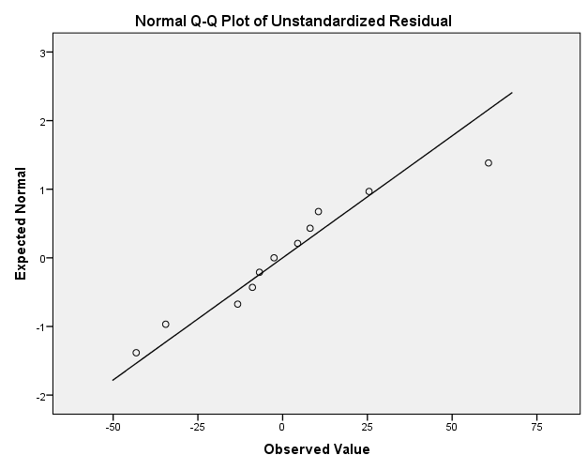
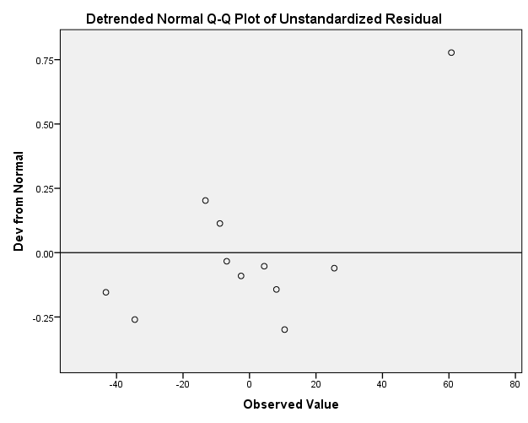

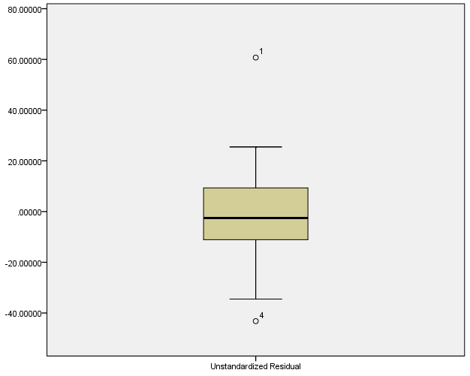

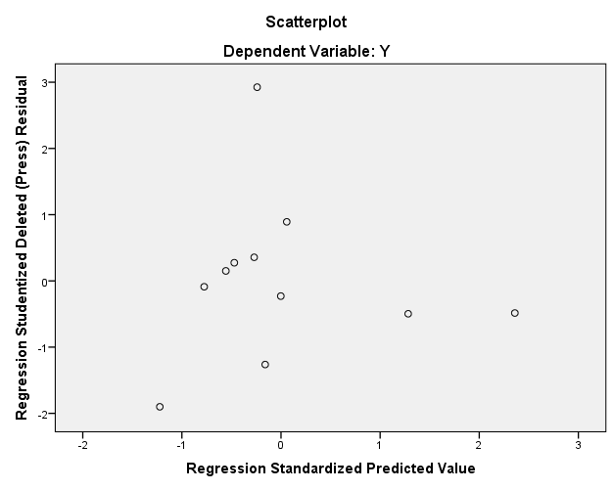

Lampiran 6. Model regresi

Variables Entered/Removedª
Model | Variables Entered | Variables Removed | Method
1 | X^{b} | . | Enter
a. Dependent Variable: Y
b. All requested variables entered.

Model Summary^{b}
Model | R | R Square | Adjusted R Square | Std. Error of the Estimate | Durbin-Watson
1 | .700ª | .490 | .433 | 29.62780 | 2.271
a. Predictors: (Constant), X
b. Dependent Variable: Y

ANOVAª
Model |  | Sum of Squares | df | Mean Square | F | Sig.
1 | Regression | 7594.648 | 1 | 7594.648 | 8.652 | .016^{b}
 | Residual | 7900.261 | 9 | 877.807
 | Total | 15494.909 | 10
a. Dependent Variable: Y
b. Predictors: (Constant), X

Coefficientsª
Model |  | Unstandardized Coefficients |  | Standardized Coefficients | t | Sig. | 95.0% Confidence Interval for B
 |  | B | Std. Error | Beta |  |  | Lower Bound | Upper Bound
1 | (Constant) | 294.666 | 46.172 |  | 6.382 | .000 | 190.219 | 399.113
 | X | .275 | .094 | .700 | 2.941 | .016 | .064 | .487
a. Dependent Variable: Y

Charts

