Lampiran 7. Hasil Analisi Statistik Deskriptif
- Deskripsi Data Pre Test Kelas Eksperimen
Statistics
PreTestEksperimen
N | Valid | 17
 | Missing | 0
Mean |  | 65.5882
Median |  | 75.0000
Mode |  | 75.00ª
Std. Deviation |  | 22.56119
Variance |  | 509.007
Range |  | 65.00
Minimum |  | 25.00
Maximum |  | 90.00
Sum |  | 1115.00

PreTestEksperimen
 |  | Frequency | Percent | Valid Percent | Cumulative Percent
Valid | 25.00 | 2 | 11.8 | 11.8 | 11.8
 | 30.00 | 1 | 5.9 | 5.9 | 17.6
 | 40.00 | 1 | 5.9 | 5.9 | 23.5
 | 55.00 | 1 | 5.9 | 5.9 | 29.4
 | 65.00 | 2 | 11.8 | 11.8 | 41.2
 | 70.00 | 1 | 5.9 | 5.9 | 47.1
 | 75.00 | 3 | 17.6 | 17.6 | 64.7
 | 80.00 | 1 | 5.9 | 5.9 | 70.6
 | 85.00 | 3 | 17.6 | 17.6 | 88.2
 | 90.00 | 2 | 11.8 | 11.8 | 100.0
 | Total | 17 | 100.0 | 100.0

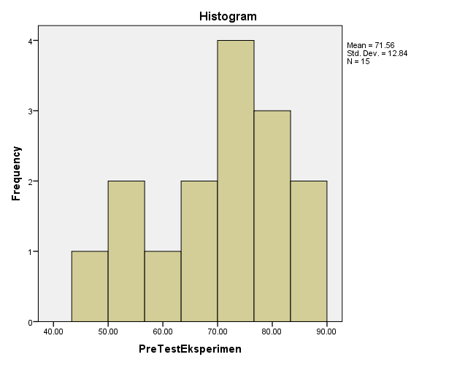

- Deskripsi Data Pre Test Kelas Kontrol

Statistics
PreTestKontrol
N | Valid | 17
 | Missing | 0
Mean |  | 64.7059
Median |  | 70.0000
Mode |  | 75.00
Std. Deviation |  | 18.41115
Variance |  | 338.971
Range |  | 60.00
Minimum |  | 25.00
Maximum |  | 85.00
Sum |  | 1100.00

PreTestKontrol
 |  | Frequency | Percent | Valid Percent | Cumulative Percent
Valid | 25.00 | 1 | 5.9 | 5.9 | 5.9
 | 30.00 | 1 | 5.9 | 5.9 | 11.8
 | 45.00 | 2 | 11.8 | 11.8 | 23.5
 | 55.00 | 1 | 5.9 | 5.9 | 29.4
 | 65.00 | 2 | 11.8 | 11.8 | 41.2
 | 70.00 | 2 | 11.8 | 11.8 | 52.9
 | 75.00 | 4 | 23.5 | 23.5 | 76.5
 | 80.00 | 2 | 11.8 | 11.8 | 88.2
 | 85.00 | 2 | 11.8 | 11.8 | 100.0
 | Total | 17 | 100.0 | 100.0

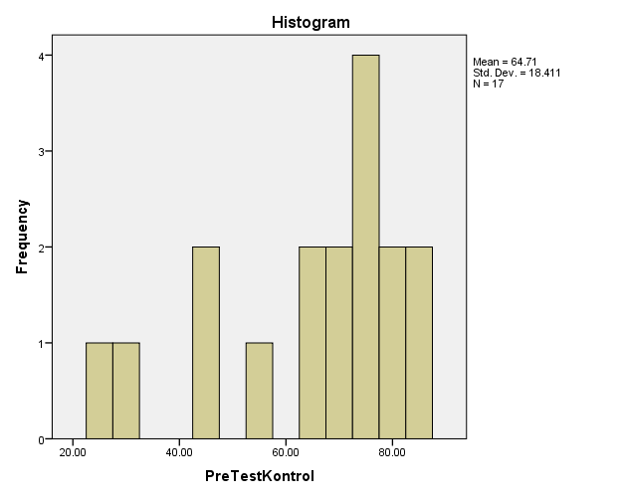

- Deskripsi Data Post Test Kelas Eksperimen

Statistics
PostTestEksperimen
N | Valid | 17
 | Missing | 0
Mean |  | 82.3529
Median |  | 85.0000
Mode |  | 85.00
Std. Deviation |  | 10.32558
Variance |  | 106.618
Range |  | 35.00
Minimum |  | 60.00
Maximum |  | 95.00
Sum |  | 1400.00

PostTestEksperimen
 |  | Frequency | Percent | Valid Percent | Cumulative Percent
Valid | 60.00 | 1 | 5.9 | 5.9 | 5.9
 | 70.00 | 4 | 23.5 | 23.5 | 29.4
 | 85.00 | 6 | 35.3 | 35.3 | 64.7
 | 90.00 | 4 | 23.5 | 23.5 | 88.2
 | 95.00 | 2 | 11.8 | 11.8 | 100.0
 | Total | 17 | 100.0 | 100.0

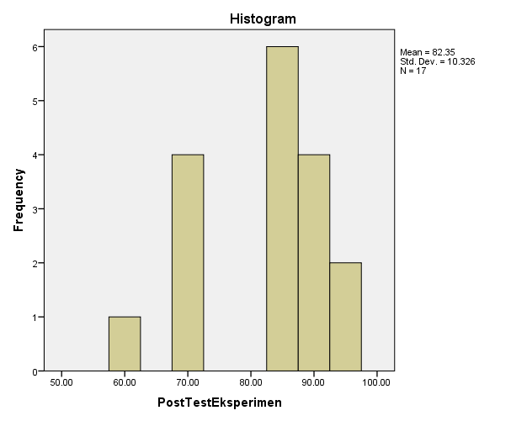

- Deskripsi Data Post Test Kelas Kontrol

Statistics
PostTestKontrol
N | Valid | 17
 | Missing | 0
Mean |  | 74.4118
Median |  | 80.0000
Mode |  | 80.00ª
Std. Deviation |  | 12.23243
Variance |  | 149.632
Range |  | 45.00
Minimum |  | 50.00
Maximum |  | 95.00
Sum |  | 1265.00

PostTestKontrol
 |  | Frequency | Percent | Valid Percent | Cumulative Percent
Valid | 50.00 | 1 | 5.9 | 5.9 | 5.9
 | 55.00 | 1 | 5.9 | 5.9 | 11.8
 | 60.00 | 1 | 5.9 | 5.9 | 17.6
 | 65.00 | 2 | 11.8 | 11.8 | 29.4
 | 70.00 | 2 | 11.8 | 11.8 | 41.2
 | 75.00 | 1 | 5.9 | 5.9 | 47.1
 | 80.00 | 4 | 23.5 | 23.5 | 70.6
 | 85.00 | 4 | 23.5 | 23.5 | 94.1
 | 95.00 | 1 | 5.9 | 5.9 | 100.0
 | Total | 17 | 100.0 | 100.0

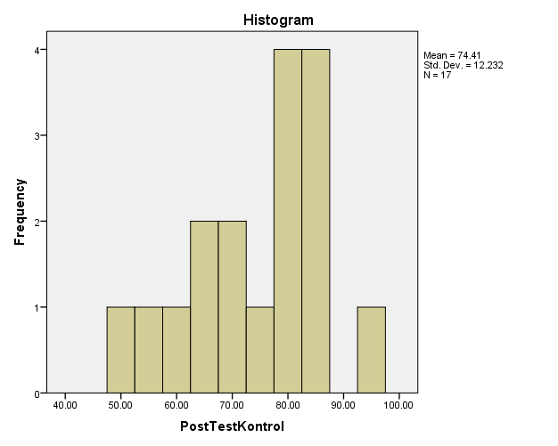

Hasil Uji Asumsi Analisis Data
- Uji Normalitas

One-Sample Kolmogorov-Smirnov Test
 |  | PreTestEksperimen | PreTestKontrol | PostTestEksperimen | PostTestKontrol
N |  | 17 | 17 | 17 | 17
Normal Parameters^{a,b} | Mean | 65.5882 | 64.7059 | 82.3529 | 74.4118
 | Std. Deviation | 22.56119 | 18.41115 | 10.32558 | 12.23243
Most Extreme Differences | Absolute | .195 | .212 | .307 | .206
 | Positive | .140 | .135 | .178 | .135
 | Negative | -.195 | -.212 | -.307 | -.206
Kolmogorov-Smirnov Z |  | .806 | .875 | 1.266 | .847
Asymp. Sig. (2-tailed) |  | .534 | .428 | .081 | .469
a. Test distribution is Normal.
b. Calculated from data.

- Uji Homogenitas
- Pre Test Kelas Eksperimen dan Kontrol
Test of Homogeneity of Variances
KeterampilanMembaca
Levene Statistic | df1 | df2 | Sig.
.803 | 1 | 32 | .377

ANOVA
KeterampilanMembaca
 | Sum of Squares | df | Mean Square | F | Sig.
Between Groups | 6.618 | 1 | 6.618 | .016 | .901
Within Groups | 13567.647 | 32 | 423.989
Total | 13574.265 | 33

- Post Test Kelas Eksperimen dan Kontrol

Test of Homogeneity of Variances
KeterampilanMembaca
Levene Statistic | df1 | df2 | Sig.
.651 | 1 | 32 | .426

ANOVA
KeterampilanMembaca
 | Sum of Squares | df | Mean Square | F | Sig.
Between Groups | 536.029 | 1 | 536.029 | 4.184 | .049
Within Groups | 4100.000 | 32 | 128.125
Total | 4636.029 | 33

Hasil Uji Hipotesis
- Paired Sample t-Test
- Pre Test dan Post Test Kelas Eksperimen
Paired Samples Statistics
 |  | Mean | N | Std. Deviation | Std. Error Mean
Pair 1 | PostTestEksperimen | 82.3529 | 17 | 10.32558 | 2.50432
 | PreTestEksperimen | 65.5882 | 17 | 22.56119 | 5.47189

Paired Samples Correlations
 |  | N | Correlation | Sig.
Pair 1 | PostTestEksperimen & PreTestEksperimen | 17 | .939 | .000

Paired Samples Test
 |  | Paired Differences |  |  |  |  | T | df | Sig. (2-tailed)
 |  | Mean | Std. Deviation | Std. Error Mean | 95% Confidence Interval of the Difference
 |  |  |  |  | Lower | Upper
Pair 1 | PostTes Eksperimen – PreTes Eksperimen | 16.76471 | 13.33946 | 3.23529 | 9.90619 | 23.62322 | 5.182 | 16 | .000

- Pre Test dan Post Test Kelas Kontrol
Paired Samples Statistics
 |  | Mean | N | Std. Deviation | Std. Error Mean
Pair 1 | PostTestKontrol | 74.4118 | 17 | 12.23243 | 2.96680
 | PreTestKontrol | 64.7059 | 17 | 18.41115 | 4.46536

Paired Samples Correlations
 |  | N | Correlation | Sig.
Pair 1 | PostTestKontrol &  PreTestKontrol | 17 | .769 | .000

Paired Samples Test
 |  | Paired Differences |  |  |  |  | T | df | Sig. (2-tailed)
 |  | Mean | Std. Deviation | Std. Error Mean | 95% Confidence Interval of the Difference
 |  |  |  |  | Lower | Upper
Pair 1 | PostTestKontrol - PreTestKontrol | 9.70588 | 11.92039 | 2.89112 | 3.57699 | 15.83478 | 3.357 | 16 | .004

- Independent Sample T-Test
- Pre Test Kelas Eksperimen dan Kontrol
Group Statistics
 | Kelas | N | Mean | Std. Deviation | Std. Error Mean
KeterampilanMembaca | Eksperimen | 17 | 65.5882 | 22.56119 | 5.47189
 | Kontrol | 17 | 64.7059 | 18.41115 | 4.46536

Independent Samples Test
 |  | Levene's Test for Equality of Variances |  | t-test for Equality of Means
 |  | F | Sig. | t | Df | Sig. (2-tailed) | Mean Difference | Std. Error Difference | 95% Confidence Interval of the Difference
 |  |  |  |  |  |  |  |  | Lower | Upper
Keterampilan  Membaca | Equal variances assumed | .803 | .377 | .125 | 32 | .901 | .88235 | 7.06265 | -13.50380 | 15.26850
 | Equal variances not assumed |  |  | .125 | 30.763 | .901 | .88235 | 7.06265 | -13.52652 | 15.29122

- Post Test Kelas Eksperimen dan Kontrol

Group Statistics
 | Kelas | N | Mean | Std. Deviation | Std. Error Mean
KeterampilanMembaca | Eksperimen | 17 | 82.3529 | 10.32558 | 2.50432
 | Kontrol | 17 | 74.4118 | 12.23243 | 2.96680

 |  | Levene's Test for Equality of Variances |  | t-test for Equality of Means
 |  | F | Sig. | t | df | Sig. (2-tailed) | Mean Difference | Std. Error Difference | 95% Confidence Interval of the Difference
 |  |  |  |  |  |  |  |  | Lower | Upper
Keterampilan  Membaca | Equal variances assumed | .651 | .426 | 2.045 | 32 | .049 | 7.94118 | 3.88246 | .03286 | 15.84950
 | Equal variances not assumed |  |  | 2.045 | 31.123 | .049 | 7.94118 | 3.88246 | .02411 | 15.85825

