Lampiran 8.2: ANALISIS INVERENSIAL
Pengujian Normalitas Data
Tests of Normality
 | Kolmogorov-Smirnovª |  |  | Shapiro-Wilk
 | Statistic | df | Sig. | Statistic | Df | Sig.
Preetest | ,226 | 24 | ,003 | ,889 | 24 | ,013
a. Lilliefors Significance Correction
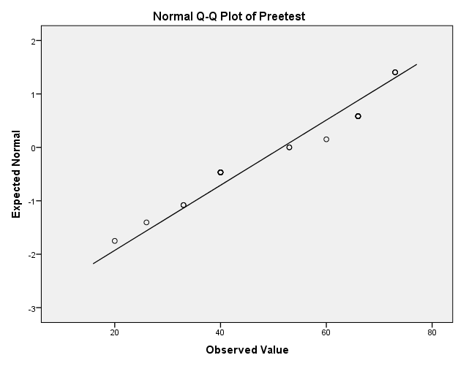

Tests of Normality
 | Kolmogorov-Smirnovª |  |  | Shapiro-Wilk
 | Statistic | df | Sig. | Statistic | Df | Sig.
Posttest | ,196 | 24 | ,018 | ,892 | 24 | ,015
a. Lilliefors Significance Correction
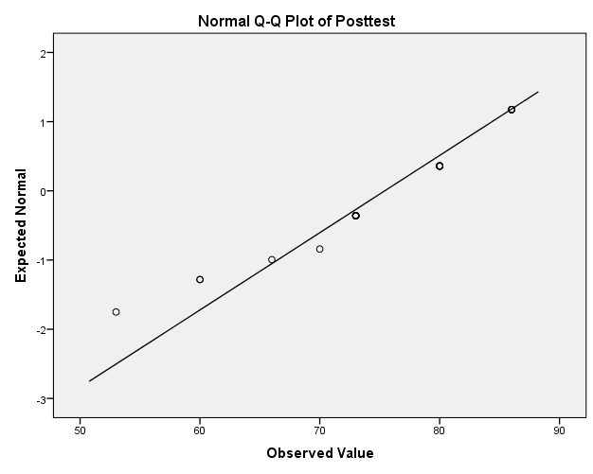

Uji Inverensial data sebelum setelah diterapkan Pembelajaran kooperatip Tipe Two Stay Two Stray dalam Pembelajaran IPA Pada Siswa Kelas IV SD Negeri 85 Laba.
Paired Samples Test
 |  | Paired Differences |  |  |  |  | t | df | Sig. (2-tailed)
 |  | Mean | Std. Deviation | Std. Error Mean | 95% Confidence Interval of the Difference
 |  |  |  |  | Lower | Upper
Pair 1 | Posttest – Preetest | 23,8 | 16,32 | 3,331 | 16,901 | 30,682 | 7,114 | 23 | ,000

