Lampiran 9
ANALISIS DEKSRPTIF
A. Analisis Deskriptif Pre-test Kelompok Eksperimen

Statistics
Hasil PreTest K5B
N | Valid | 26
 | Missing | 0
Mean |  | 48,27
Median |  | 52,50
Mode |  | 35
Std. Deviation |  | 19,542
Range |  | 75
Minimum |  | 15
Maximum |  | 90
Sum |  | 1255
Sumber : IBM SPSS version 20.0

Hasil PreTest K5B
 |  | Frequency | Percent | Valid Percent | Cumulative Percent
Valid | 15 | 1 | 3,8 | 3,8 | 3,8
 | 20 | 3 | 11,5 | 11,5 | 15,4
 | 30 | 1 | 3,8 | 3,8 | 19,2
 | 35 | 5 | 19,2 | 19,2 | 38,5
 | 40 | 1 | 3,8 | 3,8 | 42,3
 | 45 | 1 | 3,8 | 3,8 | 46,2
 | 50 | 1 | 3,8 | 3,8 | 50,0
 | 55 | 4 | 15,4 | 15,4 | 65,4
 | 60 | 2 | 7,7 | 7,7 | 73,1
 | 65 | 4 | 15,4 | 15,4 | 88,5
 | 75 | 2 | 7,7 | 7,7 | 96,2
 | 90 | 1 | 3,8 | 3,8 | 100,0
 | Total | 26 | 100,0 | 100,0
Sumber : IBM SPSS version 20.0

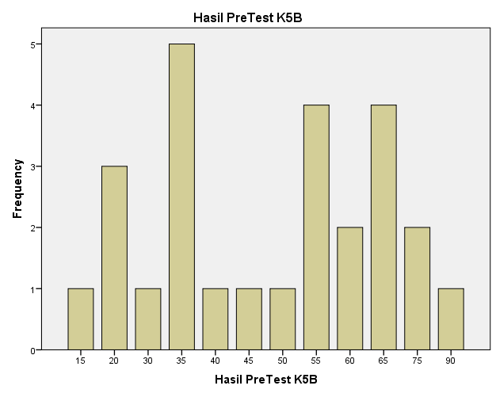
Sumber : IBM SPSS version 20.0

B. Analisis Deskriptif Pre-test Kelompok Kontrol
PreTest 5A
N | Valid | 21
 | Missing | 0
Mean |  | 55,71
Median |  | 60,00
Mode |  | 65
Std. Deviation |  | 14,856
Range |  | 60
Minimum |  | 15
Maximum |  | 75
Sum |  | 1170

Sumber : IBM SPSS version 20.0
PreTest 5A
 |  | Frequency | Percent | Valid Percent | Cumulative Percent
Valid | 15 | 1 | 4,8 | 4,8 | 4,8
 | 25 | 1 | 4,8 | 4,8 | 9,5
 | 45 | 2 | 9,5 | 9,5 | 19,0
 | 50 | 4 | 19,0 | 19,0 | 38,1
 | 55 | 2 | 9,5 | 9,5 | 47,6
 | 60 | 2 | 9,5 | 9,5 | 57,1
 | 65 | 5 | 23,8 | 23,8 | 81,0
 | 70 | 3 | 14,3 | 14,3 | 95,2
 | 75 | 1 | 4,8 | 4,8 | 100,0
 | Total | 21 | 100,0 | 100,0
Sumber : IBM SPSS version 20.0

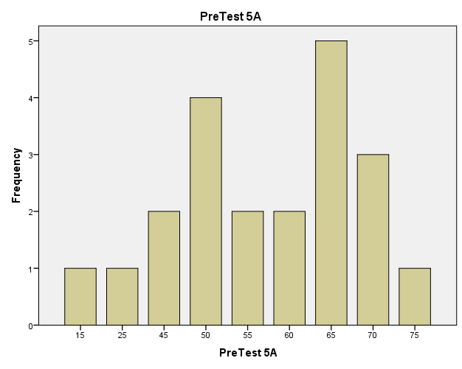
Sumber : IBM SPSS version 20.0

C. Analisis Deskriptif Post-Test Kelompok Ekspeimen

Statistics
PostTest k5b
N | Valid | 26
 | Missing | 0
Mean |  | 76,35
Median |  | 80,00
Mode |  | 80
Std. Deviation |  | 18,142
Range |  | 70
Minimum |  | 25
Maximum |  | 95
Sum |  | 1985
Sumber : IBM SPSS version 20.0

PostTest k5b
 |  | Frequency | Percent | Valid Percent | Cumulative Percent
Valid | 25 | 1 | 3,8 | 3,8 | 3,8
 | 30 | 1 | 3,8 | 3,8 | 7,7
 | 55 | 2 | 7,7 | 7,7 | 15,4
 | 70 | 4 | 15,4 | 15,4 | 30,8
 | 75 | 2 | 7,7 | 7,7 | 38,5
 | 80 | 6 | 23,1 | 23,1 | 61,5
 | 85 | 2 | 7,7 | 7,7 | 69,2
 | 90 | 4 | 15,4 | 15,4 | 84,6
 | 95 | 4 | 15,4 | 15,4 | 100,0
 | Total | 26 | 100,0 | 100,0

Sumber : IBM SPSS version 20.0

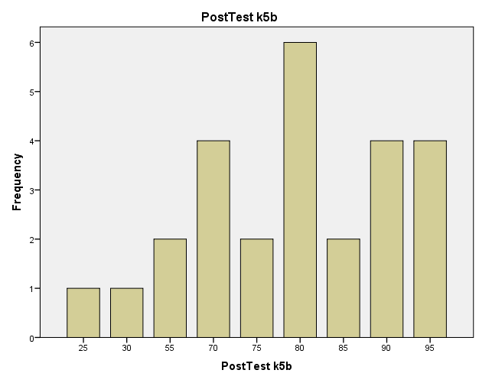
Sumber : IBM SPSS version 20.0

D. Analisis Deskriptif Post-Test Kelompok Kontrol
Statistics
Hasil PostTest 5A
N | Valid | 21
 | Missing | 0
Mean |  | 45,00
Median |  | 45,00
Mode |  | 45
Std. Deviation |  | 8,660
Range |  | 35
Minimum |  | 20
Maximum |  | 55
Sum |  | 945

Sumber : IBM SPSS version 20.0
Hasil PostTest 5A
 |  | Frequency | Percent | Valid Percent | Cumulative Percent
Valid | 20 | 1 | 4,8 | 4,8 | 4,8
 | 35 | 2 | 9,5 | 9,5 | 14,3
 | 40 | 4 | 19,0 | 19,0 | 33,3
 | 45 | 6 | 28,6 | 28,6 | 61,9
 | 50 | 3 | 14,3 | 14,3 | 76,2
 | 55 | 5 | 23,8 | 23,8 | 100,0
 | Total | 21 | 100,0 | 100,0
Sumber : IBM SPSS version 20.0

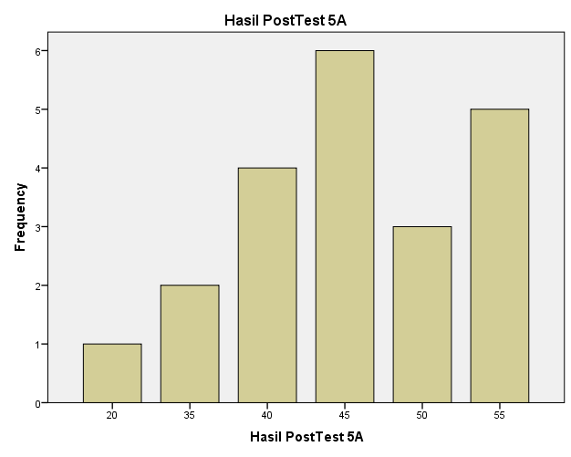
Sumber : IBM SPSS version 20.0

