LAMPIRAN

LAMPIRAN I
RENCANA PELAKSANAAN PEMBELAJARAN (RPP)
Nama Sekolah : SD Negeri 20 Totakka
Standar Kompetensi : Memahami teks pendek dengan membaca nyaring
Kompetensi Dasar : 3.2 Membaca nyaring suku kata, kata, kalimat sederhana dengan
lafal dan intonasi yang tepat
Indikator : Dapat membaca nyaring kata dan kalimat dengan lafal dan
intonasi yang tepat
Alokasi Waktu : 2 x 35 menit
- Tujuan Pembelajaran:
      - Siswa dapat membaca dengan lafal dan intonasi yang tepat sesuai isi/maksud kalimat
- Materi Pembelajaran:
Suku kata; kata; kalimat; gambar
- Metode Pembelajaran:
Ceramah; Suku Kata; tanya jawab; penugasan

- Langkah-langkah Kegiatan Pembelajaran:
Waktu Kegiatan | Jenis kegiatan | Alokasi Waktu
Kegiatan Awal | - Apresepsi  - Memeriksa kehadiran | 15 menit
Kegiatan inti | - Guru menjelaskan cara membaca dengan metode suku kata.  - Siswa menyusun kartu suku kata menjadi sebuah kalimat.  - Siswa mengerjakan LKS berdasarkan instruksi guru  - Siswa bergantian di tes lisan oleh guru | 50 menit
Kegiatan akhir | - Salah satu siswa menyimpulkan isi cerita  - Guru memberikan pesan moral | 5 menit

- Sumber Pembelajaran:
- Buku ”Bina Bahasa Indonesia 1”, Erlangga
- Sumber lain yang relevan
- Penilaian:
- Tes membaca saat pembelajaran selesai.

LEMBAR KERJA SISWA
Kerjakan berdasarkan petunjuk guru. ( Soal akan di bacakan oleh guru )
Nama Siswa :
1. AMBIL
AM - .......
A - ..... – B - .... - ...... - L

2. POTONG
PO - ..... – NG
P – O - .... - .... - ..... - G

3. LAMA
LA - .....
L – A - .... - ....

4. JALAN
..... – LAN
..... - ..... - L – A - .....

5. TIDUR
..... - ......
.... - ..... - ..... - ...... - ......

LAMPIRAN II
KISI-KISI INSTRUMEN ASESMEN MEMBACA PERMULAAN
KOMPONEN | RUANG LINGKUP | BUTIR SOAL | Kreteria | Skor
A. Membaca Permulaan | 1. Membaca huruf | 1.Suarakan huruf Berikut.  Q w e r t y u I o p a s d f g h j k l z x c v b n m | Baik  Jika semua terjawab dengan lancar | Nilai maksimal  26  +  1 (jika lancer)
Cukup
Jika terjawab stengah atau lebih
Kurang
Jika hanya mampu menjawab kurang dari stengah
 | 2. Membaca suku kata berpola. “KV” (konsonan-vokal), “VK” (-konsonan), “KVK” (konsonan-vokal-konsonan), ”KV-KV” (konsonan-vokal – konsonan-vokal), “KV – KVK” (konsonan-vokal – konsonan-vokal-konsonan), “KVK – KVK” (konsonan-vokal-konsonan – konsonan-vokal-konsonan), “KV– KV – KV” (konsonan-vokal – konsonan-vokal – konsonan-vokal), “KVK – KV” (konsonan-vokal-konsonan – konsonan-vokal), “KV – KVKK” (konsonan-vokal – konsonan-vokal-konsonan- konsonan) | 1.Bacalah kata berikut  - Ba  - Om  - Yuk  - Baca  - Becak  - Kulkas  - Kecapi  - Kursi  - Piring  - Kaleng  - Jerawat | Baik  Jika semua terjawab dengan lancar | Nilai Maksimal  11  +  1 (Jika Lancar)
Cukup
Jika terjawab stengah atau lebih
Kurang
Jika hanya mampu menjawab kurang dari stengah
 | 3.Membaca kata.  - Kata benda  - Kata sifat  - Kata kerja  - Kata berimbuhan | - .Paku Payung  - Berani  - Main  - Mengajar  - Belajar  - Diajarkan | Baik Jika  Semua  Terjawab dengan lancar | Nilai Maksimal  7  +  1 (Jika Lancar)
Cukup
jika terjawab stengah atau lebih
Kurang
jika hanya mampu menjawab kurang dari stengah
 | 4. Membaca kalimat.  - Kalimat Perintah  - Kalimat Tanya | - Jangan nakal waktu pelajaran di mulai  - Siapa yang mau pintar | Baik Jika  Semua  Terjawab dengan lancar | Nilai Maksimal  10  +  1 (Jika Lancar)
Cukup
jika terjawab stengah atau lebih
Kurang
jika hanya mampu menjawab kurang dari stengah

*Keterangan : - Jumlah Skor 58
- Setiap kata bernilai 1 point
- Dan setiap 1 item soal yang benar dan dijawab lancar
Diberi tambahan point 1

LAMPIRAN III
Tabel Penskoran Preetest
No | Nama siswa | Aspek yang dinilai |  |  |  | Jumlah  Nilai
 |  | Pemahaman bahasa (huruf).dan konsonan | Membaca suku kata berpola | Membaca Kata | Membaca Kalimat

Soppeng, Januari 2017
Mengetahui:
Wali Kelas 1, Peneliti,

________________ Muhammad.Akbar.A
Nip: 1247041027

LAMPIRAN IV
Tabel Penskoran Preetest Kontrol
No | Nama siswa | Aspek yang dinilai |  |  |  | Jumlah  Nilai
 |  | Pemahaman bahasa (huruf).dan konsonan | Membaca suku kata berpola | Membaca Kata | Membaca Kalimat
 | Muh Akmal | 27 | 12 | 8 | 11 | 58
 | Syahmi Fahra | 27 | 12 | 8 | 11 | 58
 | Ahmad Faizi A | 27 | 12 | 8 | 11 | 58
 | Miftahul Ulum | 24 | 9 | 7 | 10 | 50
 | Aditya Fosan | 27 | 10 | 5 | 7 | 49
 | Rahma | 27 | 10 | 6 | 10 | 53
 | Muh Sabri | 24 | 9 | 6 | 8 | 47
 | Novita A | 27 | 9 | 6 | 9 | 48
 | Nurul Rahma | 24 | 12 | 8 | 11 | 55
 | Muh Agil | 27 | 12 | 8 | 11 | 58
 | Zaldi | 27 | 6 | 3 | 4 | 40
 | Andini | 27 | 10 | 5 | 10 | 53
 | Wahyu Trirosad | 27 | 12 | 8 | 11 | 58
 | Muh Al Fatir | 27 | 12 | 8 | 11 | 58
Soppeng, Januari 2017
Mengetahui:
Wali Kelas 1, Peneliti,

________________ Muhammad.Akbar.A
Nip: 1247041027

Tabel Penskoran Preetest Eksperimen
No | Nama siswa | Aspek yang dinilai |  |  |  | Jumlah  Nilai
 |  | Pemahaman bahasa (huruf) dan konsonan | Membaca suku kata berpola | Membaca Kata | Membaca Kalimat
 | Muh Adiaksa | 27 | 9 | 6 | 10 | 52
 | Dahyar S | 27 | 12 | 8 | 11 | 58
 | Ferry A | 27 | 5 | 4 | 5 | 41
 | Annisah | 27 | 12 | 8 | 11 | 58
 | Ahmad Aiko | 22 | 3 | 3 | 5 | 34
 | Muh Haidir | 24 | 9 | 6 | 9 | 48
 | Faiz | 24 | 6 | 2 | 4 | 36
 | Ahmad Fahri | 27 | 10 | 6 | 9 | 52
 | Zaenab | 27 | 12 | 8 | 11 | 58
 | Muh Fausan | 27 | 12 | 8 | 11 | 58
 | Herul Aswar | 27 | 12 | 8 | 11 | 58
 | Muh Zaki | 27 | 12 | 8 | 11 | 58
 | Ayu | 23 | 5 | 3 | 3 | 34
 | Rapiqul | 20 | 3 | 3 | 5 | 31

Soppeng, Januari 2017
Mengetahui:
Wali Kelas 1, Peneliti,

________________ Muhammad.Akbar.A
Nip: 1247041027

Tabel Penskoran Post test Kontrol
No | Nama siswa | Aspek yang dinilai |  |  |  | Jumlah  Nilai
 |  | Pemahaman bahasa (huruf) dan konsonan | Membaca suku kata berpola | Membaca Kata | Membaca Kalimat
 | Muh Akmal | 27 | 12 | 8 | 11 | 58
 | Syahmi Fahra | 27 | 12 | 8 | 11 | 58
 | Ahmad Faizi A | 27 | 12 | 8 | 11 | 58
 | Miftahul Ulum | 24 | 11 | 7 | 11 | 53
 | Aditya Fosan | 27 | 11 | 5 | 7 | 50
 | Rahma | 27 | 12 | 5 | 11 | 55
 | Muh Sabri | 24 | 9 | 6 | 8 | 47
 | Novita A | 27 | 9 | 7 | 10 | 50
 | Nurul Rahma | 24 | 12 | 8 | 11 | 55
 | Muh Agil | 27 | 12 | 8 | 11 | 58
 | Zaldi | 27 | 6 | 3 | 4 | 40
 | Andini | 27 | 11 | 5 | 9 | 52
 | Wahyu Trirosad | 27 | 12 | 8 | 11 | 58
 | Muh Al Fatir | 27 | 12 | 8 | 11 | 58

Soppeng, Januari 2017
Mengetahui:
Wali Kelas 1, Peneliti,

________________ Muhammad.Akbar.A
Nip: 1247041027

Tabel Penskoran Post test Eksperiment
No | Nama siswa | Aspek yang dinilai |  |  |  | Jumlah  Nilai
 |  | Pemahaman bahasa (huruf) dan konsonan | Membaca suku kata berpola | Membaca Kata | Membaca Kalimat
 | Muh Adiaksa | 27 | 9 | 7 | 10 | 53
 | Dahyar S | 27 | 12 | 8 | 11 | 58
 | Ferry A | 26 | 9 | 5 | 8 | 48
 | Annisah | 27 | 12 | 8 | 11 | 58
 | Ahmad Aiko | 22 | 3 | 3 | 5 | 34
 | Muh Haidir | 24 | 10 | 6 | 8 | 48
 | Faiz | 27 | 8 | 5 | 4 | 44
 | Ahmad Fahri | 27 | 11 | 6 | 10 | 54
 | Zaenab | 27 | 12 | 8 | 11 | 58
 | Muh Fausan | 27 | 12 | 8 | 11 | 58
 | Herul Aswar | 27 | 12 | 8 | 11 | 58
 | Muh Zaki | 27 | 12 | 8 | 11 | 58
 | Ayu | 24 | 9 | 4 | 4 | 41
 | Rapiqul | 21 | 3 | 3 | 5 | 32

Soppeng, Januari 2017
Mengetahui:
Wali Kelas 1, Peneliti,

________________ Muhammad.Akbar.A
Nip: 1247041027 LAMPIRAN IV

Tabel Penskoran Preetest
No | Nama siswa | Aspek yang dinilai |  |  |  | Jumlah  Nilai
 |  | Pemahaman bahasa (huruf).dan konsonan | Membaca suku kata berpola | Membaca Kata | Membaca Kalimat
 | Muh Akmal | 27 | 12 | 8 | 11 | 58
 | Syahmi Fahra | 27 | 12 | 8 | 11 | 58
 | Ahmad Faizi A | 27 | 12 | 8 | 11 | 58
 | Miftahul Ulum | 24 | 9 | 7 | 10 | 50
 | Aditya Fosan | 27 | 10 | 5 | 7 | 49
 | Rahma | 27 | 10 | 6 | 10 | 53
 | Muh Sabri | 24 | 9 | 6 | 8 | 47
 | Novita A | 27 | 9 | 6 | 9 | 48
 | Nurul Rahma | 24 | 12 | 8 | 11 | 55
 | Muh Agil | 27 | 12 | 8 | 11 | 58
 | Zaldi | 27 | 6 | 3 | 4 | 40
 | Andini | 27 | 10 | 5 | 10 | 53
 | Wahyu Trirosad | 27 | 12 | 8 | 11 | 58
 | Muh Al Fatir | 27 | 12 | 8 | 11 | 58
Soppeng, Januari 2017
Mengetahui:
Wali Kelas 1, Peneliti,

________________ Muhammad.Akbar.A
Nip: 1247041027

Tabel Penskoran Preetest Eksperiment
No | Nama siswa | Aspek yang dinilai |  |  |  | Jumlah  Nilai
 |  | Pemahaman bahasa (huruf) dan konsonan | Membaca suku kata berpola | Membaca Kata | Membaca Kalimat
 | Muh Adiaksa | 27 | 9 | 6 | 10 | 52
 | Dahyar S | 27 | 12 | 8 | 11 | 58
 | Ferry A | 27 | 5 | 4 | 5 | 41
 | Annisah | 27 | 12 | 8 | 11 | 58
 | Ahmad Aiko | 22 | 3 | 3 | 5 | 34
 | Muh Haidir | 24 | 9 | 6 | 9 | 48
 | Faiz | 24 | 6 | 2 | 4 | 36
 | Ahmad Fahri | 27 | 10 | 6 | 9 | 52
 | Zaenab | 27 | 12 | 8 | 11 | 58
 | Muh Fausan | 27 | 12 | 8 | 11 | 58
 | Herul Aswar | 27 | 12 | 8 | 11 | 58
 | Muh Zaki | 27 | 12 | 8 | 11 | 58
 | Ayu | 23 | 5 | 3 | 3 | 34
 | Rapiqul | 20 | 3 | 3 | 5 | 31

Soppeng, Januari 2017
Mengetahui:
Wali Kelas 1, Peneliti,

________________ Muhammad.Akbar.A
Nip: 1247041027

Tabel Penskoran Post test Kontrol
No | Nama siswa | Aspek yang dinilai |  |  |  | Jumlah  Nilai
 |  | Pemahaman bahasa (huruf) dan konsonan | Membaca suku kata berpola | Membaca Kata | Membaca Kalimat
 | Muh Akmal | 27 | 12 | 8 | 11 | 58
 | Syahmi Fahra | 27 | 12 | 8 | 11 | 58
 | Ahmad Faizi A | 27 | 12 | 8 | 11 | 58
 | Miftahul Ulum | 24 | 11 | 7 | 11 | 53
 | Aditya Fosan | 27 | 11 | 5 | 7 | 50
 | Rahma | 27 | 12 | 5 | 11 | 55
 | Muh Sabri | 24 | 9 | 6 | 8 | 47
 | Novita A | 27 | 9 | 7 | 10 | 50
 | Nurul Rahma | 24 | 12 | 8 | 11 | 55
 | Muh Agil | 27 | 12 | 8 | 11 | 58
 | Zaldi | 27 | 6 | 3 | 4 | 40
 | Andini | 27 | 11 | 5 | 9 | 52
 | Wahyu Trirosad | 27 | 12 | 8 | 11 | 58
 | Muh Al Fatir | 27 | 12 | 8 | 11 | 58
Soppeng, Januari 2017
Mengetahui:
Wali Kelas 1, Peneliti,

________________ Muhammad.Akbar.A
Nip: 1247041027
Tabel Penskoran Post test Eksperiment
No | Nama siswa | Aspek yang dinilai |  |  |  | Jumlah  Nilai
 |  | Pemahaman bahasa (huruf) dan konsonan | Membaca suku kata berpola | Membaca Kata | Membaca Kalimat
 | Muh Adiaksa | 27 | 9 | 7 | 10 | 53
 | Dahyar S | 27 | 12 | 8 | 11 | 58
 | Ferry A | 26 | 9 | 5 | 8 | 48
 | Annisah | 27 | 12 | 8 | 11 | 58
 | Ahmad Aiko | 22 | 3 | 3 | 5 | 34
 | Muh Haidir | 24 | 10 | 6 | 8 | 48
 | Faiz | 27 | 8 | 5 | 4 | 44
 | Ahmad Fahri | 27 | 11 | 6 | 10 | 54
 | Zaenab | 27 | 12 | 8 | 11 | 58
 | Muh Fausan | 27 | 12 | 8 | 11 | 58
 | Herul Aswar | 27 | 12 | 8 | 11 | 58
 | Muh Zaki | 27 | 12 | 8 | 11 | 58
 | Ayu | 24 | 9 | 4 | 4 | 41
 | Rapiqul | 21 | 3 | 3 | 5 | 32

Soppeng, Januari 2017
Mengetahui:
Wali Kelas 1, Peneliti,

________________ Muhammad.Akbar.A
Nip: 1247041027
LAMPIRAN V
PRETEST KELOMPOK EKSPERIMENT
Descriptive Statistics
 | N | Minimum | Maximum | Sum | Mean | Std. Deviation
Pre_Eksperiment | 14 | 31.00 | 58.00 | 676.00 | 48.2857 | 10.75910
Valid N (listwise) | 14

Descriptive Statistics
 | Variance
Pre_Eksperiment | 115.758
Valid N (listwise)

PRETEST KELOMPOK KONTROL
N | Valid | 14
 | Missing | 0
Mean |  | 53.0714
Median |  | 54.0000
Mode |  | 58.00
Std. Deviation |  | 5.60857
Variance |  | 31.456
Range |  | 18.00
Minimum |  | 40.00
Maximum |  | 58.00
Sum |  | 743.00
 |  | Frequency | Percent | Valid Percent | Cumulative Percent
Valid | 40.00 | 1 | 7.1 | 7.1 | 7.1
 | 47.00 | 1 | 7.1 | 7.1 | 14.3
 | 48.00 | 1 | 7.1 | 7.1 | 21.4
 | 49.00 | 1 | 7.1 | 7.1 | 28.6
 | 50.00 | 1 | 7.1 | 7.1 | 35.7
 | 53.00 | 2 | 14.3 | 14.3 | 50.0
 | 55.00 | 1 | 7.1 | 7.1 | 57.1
 | 58.00 | 6 | 42.9 | 42.9 | 100.0
 | Total | 14 | 100.0 | 100.0

POSTES KELOMPOK EKSPERIMEN
 |  | Frequency | Percent | Valid Percent | Cumulative Percent
Valid | 40.00 | 1 | 7.1 | 7.1 | 7.1
 | 47.00 | 1 | 7.1 | 7.1 | 14.3
 | 50.00 | 2 | 14.3 | 14.3 | 28.6
 | 52.00 | 1 | 7.1 | 7.1 | 35.7
 | 53.00 | 1 | 7.1 | 7.1 | 42.9
 | 55.00 | 2 | 14.3 | 14.3 | 57.1
 | 58.00 | 6 | 42.9 | 42.9 | 100.0
 | Total | 14 | 100.0 | 100.0
N | Valid | 14
 | Missing | 0
Mean |  | 50.1429
Median |  | 53.5000
Mode |  | 58.00
Std. Deviation |  | 9.25583
Variance |  | 85.670
Range |  | 26.00
Minimum |  | 32.00
Maximum |  | 58.00
Sum |  | 702.00

POSTES KELOMPOK KONTROL
N | Valid | 14
 | Missing | 0
Mean |  | 53.5714
Median |  | 55.0000
Mode |  | 58.00
Std. Deviation |  | 5.38822
Variance |  | 29.033
Range |  | 18.00
Minimum |  | 40.00
Maximum |  | 58.00
 |  | Frequency | Percent | Valid Percent | Cumulative Percent
Valid | 40.00 | 1 | 7.1 | 7.1 | 7.1
 | 47.00 | 1 | 7.1 | 7.1 | 14.3
 | 50.00 | 2 | 14.3 | 14.3 | 28.6
 | 52.00 | 1 | 7.1 | 7.1 | 35.7
 | 53.00 | 1 | 7.1 | 7.1 | 42.9
 | 55.00 | 2 | 14.3 | 14.3 | 57.1
 | 58.00 | 6 | 42.9 | 42.9 | 100.0
 | Total | 14 | 100.0 | 100.0

UJI NORMALITAS
One-Sample Kolmogorov-Smirnov Test
 |  | Pretest_Eksperimen | Pretest_Kontrol | Postest_Eksperiment
N |  | 14 | 14 | 14
Normal Parameters^{a,b} | Mean | 48.2857 | 53.0714 | 50.1429
 | Std. Deviation | 10.75910 | 5.60857 | 9.25583
Most Extreme Differences | Absolute | .245 | .239 | .231
 | Positive | .183 | .190 | .198
 | Negative | -.245 | -.239 | -.231
Kolmogorov-Smirnov Z |  | .918 | .894 | .863
Asymp. Sig. (2-tailed) |  | .369 | .402 | .446

One-Sample Kolmogorov-Smirnov Test
 |  | Postest_Kontrol
N |  | 14
Normal Parameters^{a,b} | Mean | 53.5714
 | Std. Deviation | 5.38822
Most Extreme Differences | Absolute | .223
 | Positive | .206
 | Negative | -.223
Kolmogorov-Smirnov Z |  | .834
Asymp. Sig. (2-tailed) |  | .489

a. Test distribution is Normal.
b. Calculated from data.

UJI HOMOGENITAS PRETES EKSPERIMEN DAN KONTROL
Test of Homogeneity of Variances
Pretest_Kontrol
Levene Statistic | df1 |  | df2 |  | Sig.
.012 | 2 |  | 7 |  | .988
ANOVA
Pretest_Kontrol
 |  | Sum of Squares |  | Df |  | Mean Square |  | F | Sig.
Between Groups |  | 89.095 |  | 6 |  | 14.849 |  | .325 | .904
Within Groups |  | 319.833 |  | 7 |  | 45.690
Total |  | 408.929 |  | 13

UJI HOMOGENITAS PRETES EKSPERIMEN DAN KONTROL
Test of Homogeneity of Variances
Postes_Eksperiment
Levene Statistic | df1 |  | df2 |  | Sig.
.617 | 2 |  | 7 |  | .567
ANOVA
Postes_Eksperiment
 |  | Sum of Squares |  | Df |  | Mean Square |  | F | Sig.
Between Groups |  | 334.381 |  | 6 |  | 55.730 |  | .501 | .791
Within Groups |  | 779.333 |  | 7 |  | 111.333
Total |  | 1113.714 |  | 13
INDEPENDENT SAMPEL T TES PREE TEST
Group Statistics
 | Kelompok_Kelas |  |  | N |  | Mean |  |  | Std. Deviation |  |  | Std. Error Mean
Skor_Prestasi | Eksperimen |  |  | 14 |  | 48.2857 |  |  | 10.75910 |  |  | 2.87549
 | Kontrol |  |  | 14 |  | 50.1429 |  |  | 9.25583 |  |  | 2.47372
Independent Samples Test
 |  |  |  |  | Levene’s Test for Equality of Variances |  |  |  |  |  |  |  | t-test for Equality of Means
 |  |  |  |  | F |  |  |  |  | Sig. |  |  | T |  |  | Df
Skor_membaca | Equal variances assumed |  |  |  | .939 |  |  |  |  | .341 |  |  | -.490 |  |  | 26
 | Equal variances not assumed |  |  |  |  |  |  |  |  |  |  |  | -.490 |  |  | 25.433
Independent Samples Test
 |  |  |  |  |  |  | t-test for Equality of Means
 |  |  |  |  |  |  | Sig. (2-tailed) |  |  |  | Mean Difference |  |  |  | Std. Error Difference
Skor_membaca |  | Equal variances assumed |  |  |  |  | .629 |  |  |  | -1.85714 |  |  |  | 3.79312
 |  | Equal variances not assumed |  |  |  |  | .629 |  |  |  | -1.85714 |  |  |  | 3.79312
Independent Samples Test
 |  |  |  |  |  |  |  | t-test for Equality of Means
 |  |  |  |  |  |  |  | 95% Confidence Interval of the Difference
 |  |  |  |  |  |  |  | Lower |  |  |  |  |  | Upper
Skor_membaca |  |  | Equal variances assumed |  |  |  |  | -9.65401 |  |  |  |  |  | 5.93973
 |  |  | Equal variances not assumed |  |  |  |  | -9.66249 |  |  |  |  |  | 5.94820

INDEPENDENT SAMPLE T TES POST TES
Group Statistics
 | Kelompok_Kelas |  |  | N |  | Mean |  |  | Std. Deviation |  |  | Std. Error Mean
Skor_Prestasi | Eksperimen |  |  | 14 |  | 53.0714 |  |  | 5.60857 |  |  | 1.49895
 | Kontrol |  |  | 14 |  | 53.5714 |  |  | 5.38822 |  |  | 1.44006
Independent Samples Test
 |  |  |  |  | Levene’s Test for Equality of Variances |  |  |  |  |  |  |  | t-test for Equality of Means
 |  |  |  |  | F |  |  |  |  | Sig. |  |  | t |  |  | Df
Skor_Prestasi | Equal variances assumed |  |  |  | .062 |  |  |  |  | .805 |  |  | -.241 |  |  | 26
 | Equal variances not assumed |  |  |  |  |  |  |  |  |  |  |  | -.241 |  |  | 25.958
Independent Samples Test
 |  |  |  |  |  |  | t-test for Equality of Means
 |  |  |  |  |  |  | Sig. (2-tailed) |  |  |  | Mean Difference |  |  |  | Std. Error Difference
Skor_Prestasi |  | Equal variances assumed |  |  |  |  | .812 |  |  |  | -.50000 |  |  |  | 2.07862
 |  | Equal variances not assumed |  |  |  |  | .812 |  |  |  | -.50000 |  |  |  | 2.07862
Independent Samples Test
 |  |  |  |  |  |  |  | t-test for Equality of Means
 |  |  |  |  |  |  |  | 95% Confidence Interval of the Difference
 |  |  |  |  |  |  |  | Lower |  |  |  |  |  | Upper
Skor_Prestasi |  |  | Equal variances assumed |  |  |  |  | -4.77266 |  |  |  |  |  | 3.77266
 |  |  | Equal variances not assumed |  |  |  |  | -4.77299 |  |  |  |  |  | 3.77299

LAMPIRAN VI
Foto-foto dokumentasi
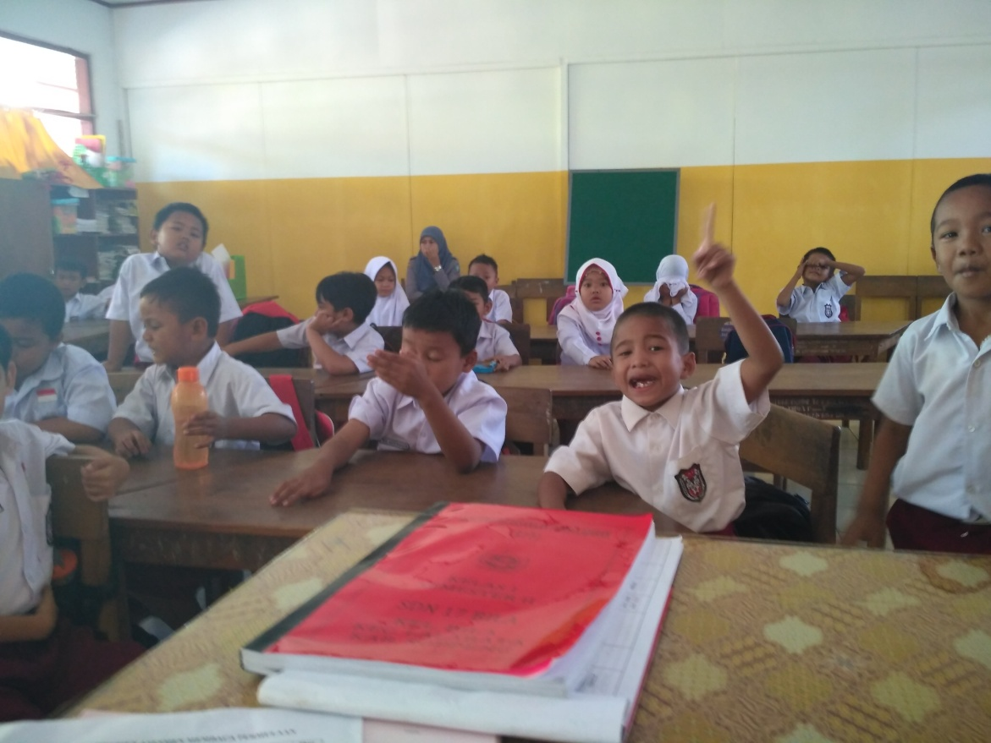
Suasana pengambilan Pree-tes Kelas Eksperimen (Hari 1)
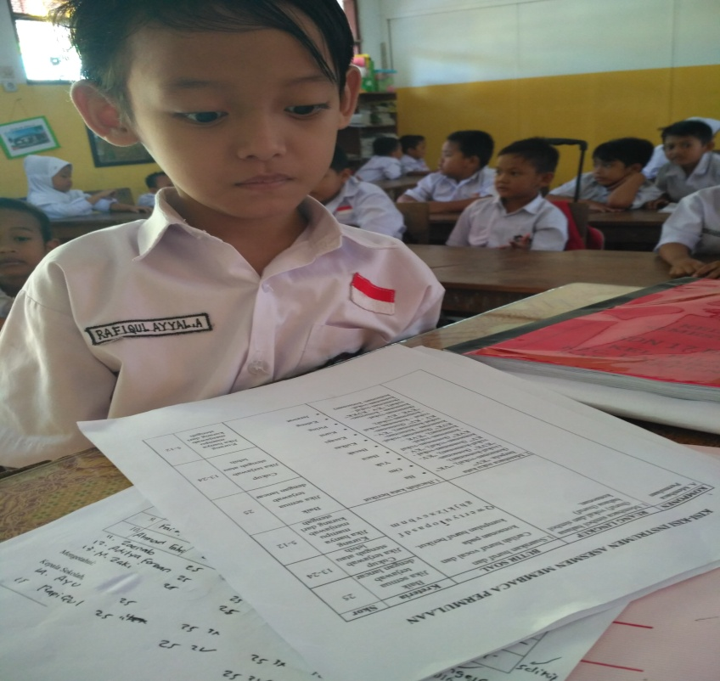
Proses pengambilan nilai pre tes (hari 1)

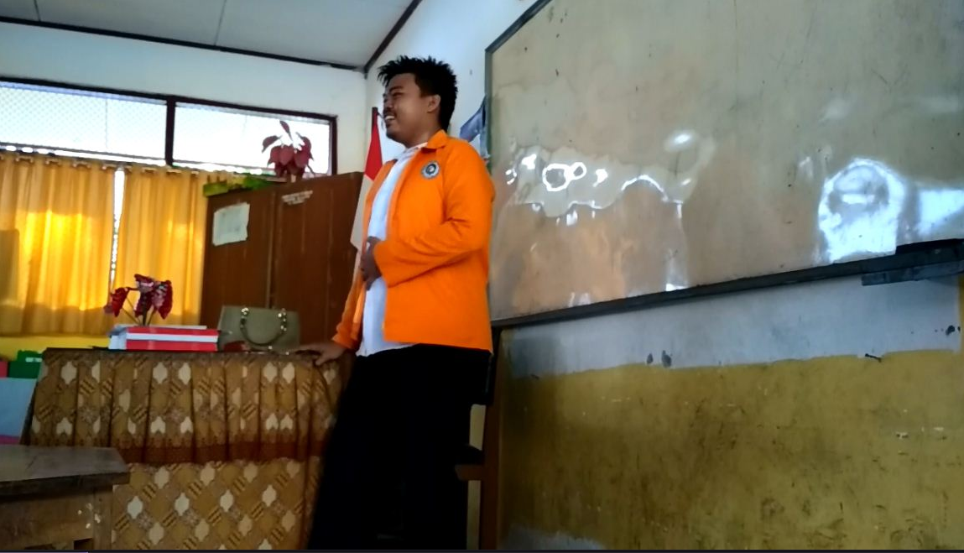
Proses awal perlakuan untuk kelas eksperimen menggunakan metode suku kata
(Perkenalan) (hari 2)
Dengan bantuan salah satu siswa, semua siswa kelas eksperimen di ajak menyanyikan
Lagu alphabet (Apresepsi) (hari 2)

Menyanyikan lasgu alphabet namun dengan cara dan tempo berbeda (hari 2)
Guru menjelaskan pembelajaran membaca dengan menggunakan metode suku kata (hari 2)
Guru menjelaskan pembelajaran membaca dengan menggunakan metode suku kata (hari 2)
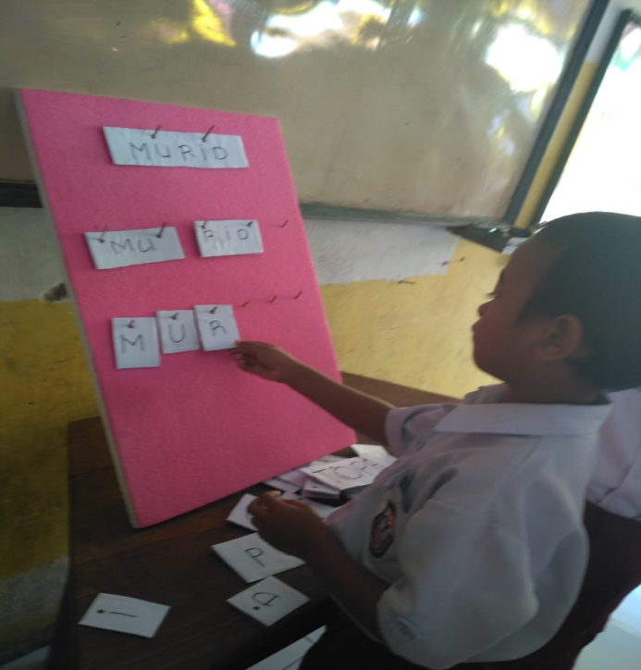
Pembelajaran membaca permulaan dengan metode suku kata
menggunakan media kartu kata (hari 2)

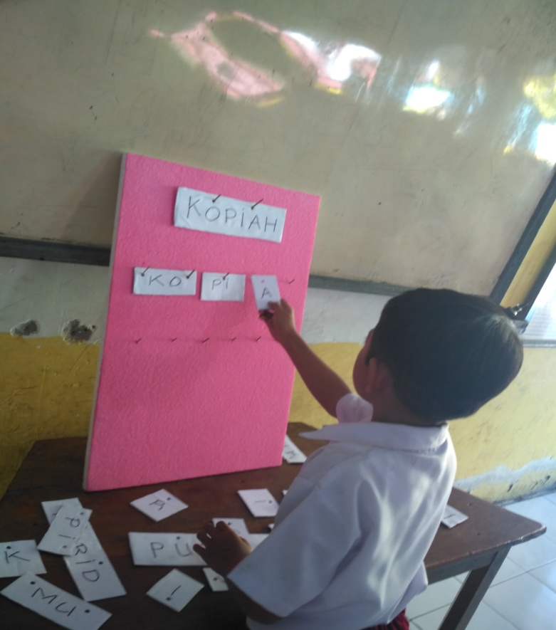
Pembelajaran membaca permulaan dengan metode suku kata
menggunakan media kartu kata (hari 2)
Proses penjelasan dan pengerjaan LKS (hari 2)

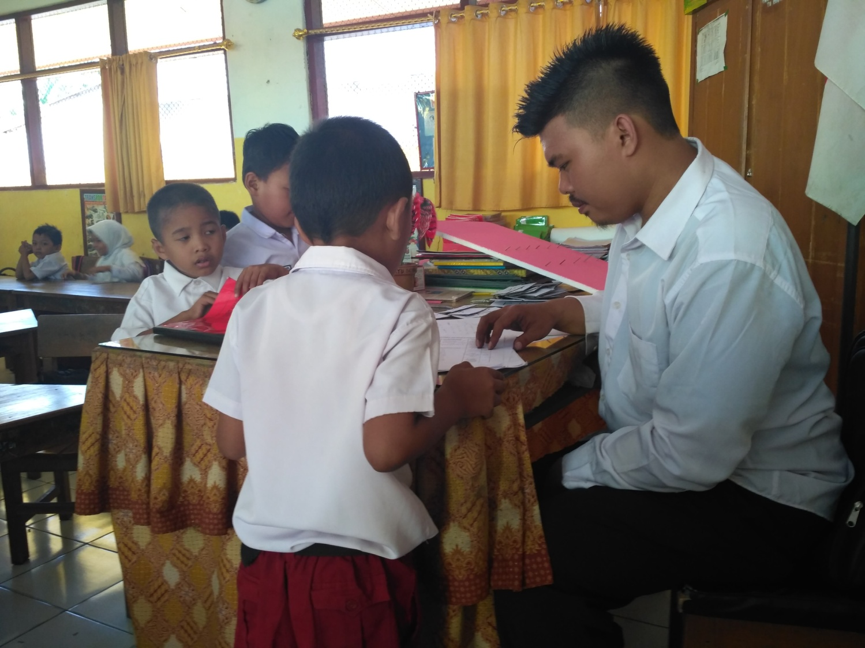
Proses Pengambilan nilai Pos tes (hsri 2)

