Lampiran 16: Uji Deskriptif dan Normalitas Pretest Kelas Eksperimen
Uji Deskriptif Pretest Kelas Eksperimen
Statistics
PKN
N | Valid | 28
 | Missing | 0
Mean |  | 60.7143
Median |  | 60.0000
Mode |  | 60.00
Std. Deviation |  | 15.12628
Variance |  | 228.804
Range |  | 60.00
Minimum |  | 24.00
Maximum |  | 84.00
Sum |  | 1700.00

PKN
 |  | Frequency | Percent | Valid Percent | Cumulative Percent
Valid | 24.00 | 2 | 7.1 | 7.1 | 7.1
 | 44.00 | 1 | 3.6 | 3.6 | 10.7
 | 48.00 | 4 | 14.3 | 14.3 | 25.0
 | 56.00 | 3 | 10.7 | 10.7 | 35.7
 | 60.00 | 6 | 21.4 | 21.4 | 57.1
 | 64.00 | 1 | 3.6 | 3.6 | 60.7
 | 68.00 | 2 | 7.1 | 7.1 | 67.9
 | 72.00 | 3 | 10.7 | 10.7 | 78.6
 | 76.00 | 3 | 10.7 | 10.7 | 89.3
 | 80.00 | 2 | 7.1 | 7.1 | 96.4
 | 84.00 | 1 | 3.6 | 3.6 | 100.0
 | Total | 28 | 100.0 | 100.0

Uji Normalitas Pretest Kelas Eksperimen
Tests of Normality
 | Kolmogorov-Smirnovª |  |  | Shapiro-Wilk
 | Statistic | df | Sig. | Statistic | df | Sig.
PKN | .128 | 28 | .200* | .931 | 28 | .064

Lampiran 17: Uji Deskriptif dan Normalitas Posttest Kelas Eksperimen
Uji Deskriptif Posttest Kelas Eksperimen
Statistics
PKN
N | Valid | 28
 | Missing | 0
Mean |  | 82.1429
Median |  | 82.0000
Mode |  | 72.00ª
Std. Deviation |  | 11.89994
Variance |  | 141.608
Range |  | 36.00
Minimum |  | 64.00
Maximum |  | 100.00
Sum |  | 2300.00

PKN
 |  | Frequency | Percent | Valid Percent | Cumulative Percent
Valid | 64.00 | 2 | 7.1 | 7.1 | 7.1
 | 68.00 | 3 | 10.7 | 10.7 | 17.9
 | 72.00 | 4 | 14.3 | 14.3 | 32.1
 | 76.00 | 4 | 14.3 | 14.3 | 46.4
 | 80.00 | 1 | 3.6 | 3.6 | 50.0
 | 84.00 | 3 | 10.7 | 10.7 | 60.7
 | 88.00 | 2 | 7.1 | 7.1 | 67.9
 | 92.00 | 2 | 7.1 | 7.1 | 75.0
 | 96.00 | 4 | 14.3 | 14.3 | 89.3
 | 100.00 | 3 | 10.7 | 10.7 | 100.0
 | Total | 28 | 100.0 | 100.0

Uji Normalitas Posttest Kelas Eksperimen
Tests of Normality
 | Kolmogorov-Smirnovª |  |  | Shapiro-Wilk
 | Statistic | df | Sig. | Statistic | df | Sig.
PKN | .161 | 28 | .060 | .922 | 28 | .038

Lampiran 18: Uji Deskriptif dan Normalitas Pretest Kelas Kontrol
Uji Deskriptif Pretest Kelas Kontrol
Statistics
PKN
N | Valid | 27
 | Missing | 0
Mean |  | 60.7407
Median |  | 60.0000
Mode |  | 56.00ª
Std. Deviation |  | 14.96815
Variance |  | 224.046
Range |  | 56.00
Minimum |  | 28.00
Maximum |  | 84.00

PKN
 |  | Frequency | Percent | Valid Percent | Cumulative Percent
Valid | 28.00 | 1 | 3.7 | 3.7 | 3.7
 | 32.00 | 1 | 3.7 | 3.7 | 7.4
 | 40.00 | 1 | 3.7 | 3.7 | 11.1
 | 44.00 | 1 | 3.7 | 3.7 | 14.8
 | 48.00 | 2 | 7.4 | 7.4 | 22.2
 | 52.00 | 2 | 7.4 | 7.4 | 29.6
 | 56.00 | 3 | 11.1 | 11.1 | 40.7
 | 60.00 | 3 | 11.1 | 11.1 | 51.9
 | 64.00 | 3 | 11.1 | 11.1 | 63.0
 | 68.00 | 3 | 11.1 | 11.1 | 74.1
 | 72.00 | 2 | 7.4 | 7.4 | 81.5
 | 76.00 | 1 | 3.7 | 3.7 | 85.2
 | 80.00 | 1 | 3.7 | 3.7 | 88.9
 | 84.00 | 3 | 11.1 | 11.1 | 100.0
 | Total | 27 | 100.0 | 100.0
Uji Normalitas Pretest Kelas Kontrol
Tests of Normality
 | Kolmogorov-Smirnovª |  |  | Shapiro-Wilk
 | Statistic | df | Sig. | Statistic | df | Sig.
PKN | .079 | 27 | .200* | .970 | 27 | .604
Lampiran 19: Uji Deskriptif dan Normalitas Posttest Kelas Kontrol
Uji Deskriptif Posttest Kelas Kontrol

Statistics
PKN
N | Valid | 27
 | Missing | 0
Mean |  | 71.1111
Median |  | 76.0000
Mode |  | 96.00
Std. Deviation |  | 20.25479
Variance |  | 410.256
Range |  | 68.00
Minimum |  | 28.00
Maximum |  | 96.00
Sum |  | 1920.00

PKN
 |  | Frequency | Percent | Valid Percent | Cumulative Percent
Valid | 28.00 | 1 | 3.7 | 3.7 | 3.7
 | 32.00 | 1 | 3.7 | 3.7 | 7.4
 | 44.00 | 1 | 3.7 | 3.7 | 11.1
 | 48.00 | 3 | 11.1 | 11.1 | 22.2
 | 52.00 | 1 | 3.7 | 3.7 | 25.9
 | 60.00 | 1 | 3.7 | 3.7 | 29.6
 | 64.00 | 1 | 3.7 | 3.7 | 33.3
 | 68.00 | 2 | 7.4 | 7.4 | 40.7
 | 72.00 | 1 | 3.7 | 3.7 | 44.4
 | 76.00 | 4 | 14.8 | 14.8 | 59.3
 | 80.00 | 4 | 14.8 | 14.8 | 74.1
 | 92.00 | 2 | 7.4 | 7.4 | 81.5
 | 96.00 | 5 | 18.5 | 18.5 | 100.0
 | Total | 27 | 100.0 | 100.0
Uji Normalitas Posttest Kelas Kontrol
Tests of Normality
 | Kolmogorov-Smirnovª |  |  | Shapiro-Wilk
 | Statistic | df | Sig. | Statistic | df | Sig.
PKN | .151 | 27 | .117 | .923 | 27 | .046
Lampiran 20: Uji Homogenitas
Uji Homogenitas Pretest Kelas Eksperimen dan Kelas Kontrol

Test of Homogeneity of Variances
PRE TEST EKSPERIMEN
Levene Statistic | df1 | df2 | Sig.
1.498 | 7 | 13 | .251

Uji Homogenitas Posttest Kelas Eksperimen dan Kelas Kontrol
Test of Homogeneity of Variances
POST TEST KELAS EKSPERIMEN
Levene Statistic | df1 | df2 | Sig.
2.366 | 5 | 14 | .094

Lampiran 21: Uji Hipotesis
Independent Sample T-Test Pretest Kelas Eksperimen dan PreTest Kelas Kontrol
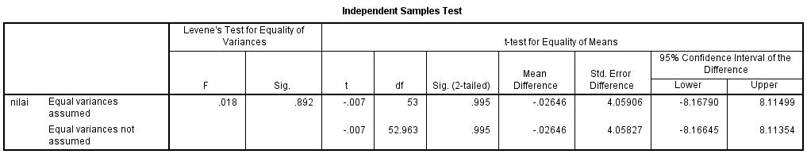

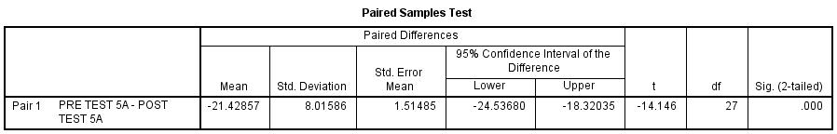
Paired Sample T Test Pretest Kelas Eksperimen dan Posttest Kelas Eksperimen

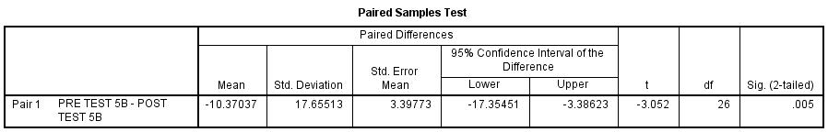
Paired Sample T-Test Pretest Kelas Kontrol dan Posttest Kelas Kontrol

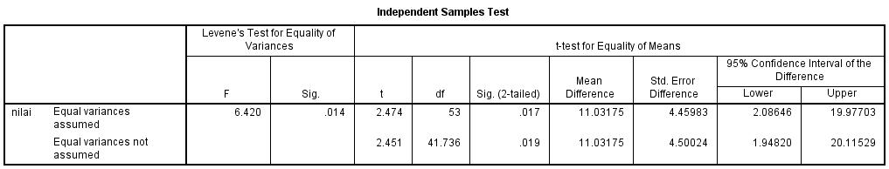
Independent Sample T Test Posttest Kelas Eksperimen dan Posttest Kelas Kontrol

