ANALISIS DESKRIPTIF DAN INFERENSIAL SPSS
Lampiran 9

- ANALISIS DESKRIPTIF
Descriptive Statistics

 | N | Minimum | Maximum | Mean | Std. Deviation
PRETEST | 31 | 25 | 75 | 50,00 | 13,478
POSTTEST | 31 | 60 | 100 | 84,19 | 10,809
Valid N (listwise) | 31

PRETEST

 |  | Frequency | Percent | Valid Percent | Cumulative Percent
Valid | 25 | 2 | 6,5 | 6,5 | 6,5
 | 30 | 3 | 9,7 | 9,7 | 16,1
 | 35 | 1 | 3,2 | 3,2 | 19,4
 | 40 | 1 | 3,2 | 3,2 | 22,6
 | 45 | 6 | 19,4 | 19,4 | 41,9
 | 50 | 4 | 12,9 | 12,9 | 54,8
 | 55 | 5 | 16,1 | 16,1 | 71,0
 | 60 | 3 | 9,7 | 9,7 | 80,6
 | 65 | 3 | 9,7 | 9,7 | 90,3
 | 70 | 2 | 6,5 | 6,5 | 96,8
 | 75 | 1 | 3,2 | 3,2 | 100,0
 | Total | 31 | 100,0 | 100,0

POSTTEST

 |  | Frequency | Percent | Valid Percent | Cumulative Percent
Valid | 60 | 1 | 3,2 | 3,2 | 3,2
 | 65 | 1 | 3,2 | 3,2 | 6,5
 | 70 | 2 | 6,5 | 6,5 | 12,9
 | 75 | 4 | 12,9 | 12,9 | 25,8
 | 80 | 7 | 22,6 | 22,6 | 48,4
 | 85 | 3 | 9,7 | 9,7 | 58,1
 | 90 | 6 | 19,4 | 19,4 | 77,4
 | 95 | 2 | 6,5 | 6,5 | 83,9
 | 100 | 5 | 16,1 | 16,1 | 100,0
 | Total | 31 | 100,0 | 100,0

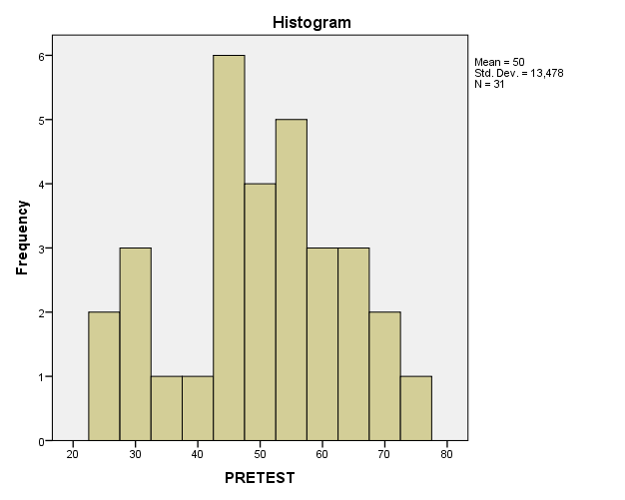
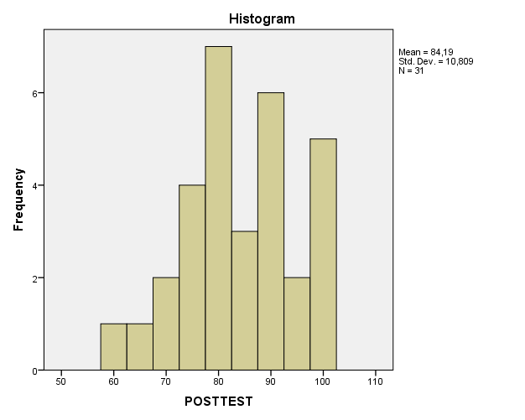

- ANALISIS INFERENSIAL
Tests of Normality
 | Kolmogorov-Smirnovª |  |  | Shapiro-Wilk
 | Statistic | Df | Sig. | Statistic | df | Sig.
PRETEST | ,130 | 31 | ,199 | ,962 | 31 | ,334
POSTTEST | ,135 | 31 | ,160 | ,951 | 31 | ,161
*. This is a lower bound of the true significance.
a. Lilliefors Significance Correction

One-Sample Test
 | Test Value = 0
 | t | df | Sig. (2-tailed) | Mean Difference | 95% Confidence Interval of the Difference
 |  |  |  |  | Lower | Upper
PRETEST | 20,654 | 31 | ,000 | 50,000 | 45,06 | 54,94
POSTTEST | 43,370 | 30 | ,000 | 84,194 | 80,23 | 88,16

