Lampiran 6: Hasil Belajar Siswa Kelas V Pada Mata Pelajaran IPA
HASIL BELAJAR SISWA KELAS V SD KOMPLEKS LARIANGBANGI KECAMATAN MAKASSAR KOTA MAKASSAR

No. | Inisial Responden | Mata Pelajaran IPA
1 | MFA | 69
2 | SAS | 76
3 | FD | 80
4 | ERP | 74
5 | H | 75
6 | K | 74
7 | RR | 75
8 | ZAM | 78
9 | M | 76
10 | NN | 75
11 | MR | 75
12 | F | 72
13 | MD | 69
14 | D | 78
15 | IS | 69
16 | B | 75
17 | A | 72
18 | AP | 70
19 | MR | 72
20 | A | 68
21 | C | 69
22 | MF | 72
23 | A | 69
24 | RA | 74
25 | N | 76
26 | RA | 72
27 | MAP | 80
28 | APPW | 76
29 | RCF | 75
30 | SA | 72
31 | AF | 75
32 | MIRR | 72
33 | AI | 74
34 | R | 73
35 | MN | 68
36 | D | 68
37 | S | 74
38 | ANKJ | 76
39 | A | 75
40 | H | 75
41 | NN | 75
42 | RIN | 72
43 | MI | 75
44 | MA | 69
45 | AMMA | 74
46 | T | 76
47 | L | 75
48 | KPAF | 75
49 | LR | 72
50 | NP | 76
51 | SN | 69
52 | DZS | 70
53 | M | 68
54 | D | 68
55 | AG | 78
56 | M | 75
57 | NA | 74
58 | SAZ | 72
59 | PRS | 78
60 | BCA | 75
61 | MRA | 74
62 | FZ | 68
63 | RSR | 72
64 | Y | 73
65 | AAA | 75
66 | WD | 69
67 | SF | 75
68 | NA | 74
69 | I | 75
70 | IM | 78
71 | I | 80

Lampiran 7: Output Uji Reabilitas

Reliability Statistics
Cronbach's Alpha | N of Items
.829 | 50

Lampiran 8: Output Uji Normalitas
One-Sample Kolmogorov-Smirnov Test
 |  | motivasi_belajar | hasil_belajar
N |  | 71 | 71
Normal Parameters^{a,b} | Mean | 23.5915 | 73.4648
 | Std. Deviation | 4.16646 | 3.17954
Most Extreme Differences | Absolute | .139 | .158
 | Positive | .062 | .117
 | Negative | -.139 | -.158
Kolmogorov-Smirnov Z |  | 1.174 | 1.335
Asymp. Sig. (2-tailed) |  | .127 | .057
a. Test distribution is Normal.
b. Calculated from data.

Lampiran 9: Output Uji Linearitas

Case Processing Summary
 | Cases
 | Included |  | Excluded |  | Total
 | N | Percent | N | Percent | N | Percent
hasil_belajar * motivasi_belajar | 71 | 100.0% | 0 | 0.0% | 71 | 100.0%

ANOVA Table
 |  |  | Sum of Squares | df | Mean Square | F | Sig.
hasil_belajar * motivasi_belajar | Between Groups | (Combined) | 434.470 | 17 | 25.557 | 4.958 | .000
 |  | Linearity | 350.349 | 1 | 350.349 | 67.969 | .000
 |  | Deviation from Linearity | 84.120 | 16 | 5.258 | 1.020 | .452
 | Within Groups |  | 273.192 | 53 | 5.155
 | Total |  | 707.662 | 70

Measures of Association
 | R | R Squared | Eta | Eta Squared
hasil_belajar * motivasi_belajar | .704 | .495 | .784 | .614

Lampiran 10: Output Analisis Deskripsi Motivasi Belajar
Statistics
motivasi_belajar
N | Valid | 71
 | Missing | 0
Mean |  | 23.59
Median |  | 25
Mode |  | 25
Std. Deviation |  | 4.16
Minimum |  | 11
Maximum |  | 30
Sum |  | 1675

Lampiran 11: Output Analisis Deskripsi Hasil Belajar

Statistics
hasil_belajar
N | Valid | 71
 | Missing | 0
Mean |  | 73.46
Median |  | 74
Mode |  | 75
Std. Deviation |  | 3.17
Minimum |  | 68
Maximum |  | 80
Sum |  | 5216

Lampiran 12: Tabel Frekuensi Motivasi Belajar
motivasi_belajar
 |  | Frequency | Percent | Valid Percent | Cumulative Percent
Valid | 11.00 | 1 | 1.4 | 1.4 | 1.4
 | 14.00 | 1 | 1.4 | 1.4 | 2.8
 | 15.00 | 2 | 2.8 | 2.8 | 5.6
 | 16.00 | 1 | 1.4 | 1.4 | 7.0
 | 17.00 | 2 | 2.8 | 2.8 | 9.9
 | 18.00 | 3 | 4.2 | 4.2 | 14.1
 | 19.00 | 2 | 2.8 | 2.8 | 16.9
 | 20.00 | 3 | 4.2 | 4.2 | 21.1
 | 21.00 | 4 | 5.6 | 5.6 | 26.8
 | 22.00 | 4 | 5.6 | 5.6 | 32.4
 | 23.00 | 6 | 8.5 | 8.5 | 40.8
 | 24.00 | 6 | 8.5 | 8.5 | 49.3
 | 25.00 | 11 | 15.5 | 15.5 | 64.8
 | 26.00 | 6 | 8.5 | 8.5 | 73.2
 | 27.00 | 8 | 11.3 | 11.3 | 84.5
 | 28.00 | 5 | 7.0 | 7.0 | 91.5
 | 29.00 | 3 | 4.2 | 4.2 | 95.8
 | 30.00 | 3 | 4.2 | 4.2 | 100.0
 | Total | 71 | 100.0 | 100.0

Lampiran 13: Tabel Frekuensi Hasil Belajar
hasil_belajar
 |  | Frequency | Percent | Valid Percent | Cumulative Percent
Valid | 68.00 | 6 | 8.5 | 8.5 | 8.5
 | 69.00 | 8 | 11.3 | 11.3 | 19.7
 | 70.00 | 2 | 2.8 | 2.8 | 22.5
 | 72.00 | 11 | 15.5 | 15.5 | 38.0
 | 73.00 | 2 | 2.8 | 2.8 | 40.8
 | 74.00 | 9 | 12.7 | 12.7 | 53.5
 | 75.00 | 18 | 25.4 | 25.4 | 78.9
 | 76.00 | 7 | 9.9 | 9.9 | 88.7
 | 78.00 | 5 | 7.0 | 7.0 | 95.8
 | 80.00 | 3 | 4.2 | 4.2 | 100.0
 | Total | 71 | 100.0 | 100.0

Lampiran 14: Output Uji Produc Moment
Correlations
 |  | motivasi_belajar | hasil_belajar
motivasi_belajar | Pearson Correlation | 1 | .704**
 | Sig. (2-tailed) |  | .000
 | N | 71 | 71
hasil_belajar | Pearson Correlation | .704** | 1
 | Sig. (2-tailed) | .000
 | N | 71 | 71
**. Correlation is significant at the 0.01 level (2-tailed).

Lampiran 15: Lembar Validasi Angket Motivasi Belajar
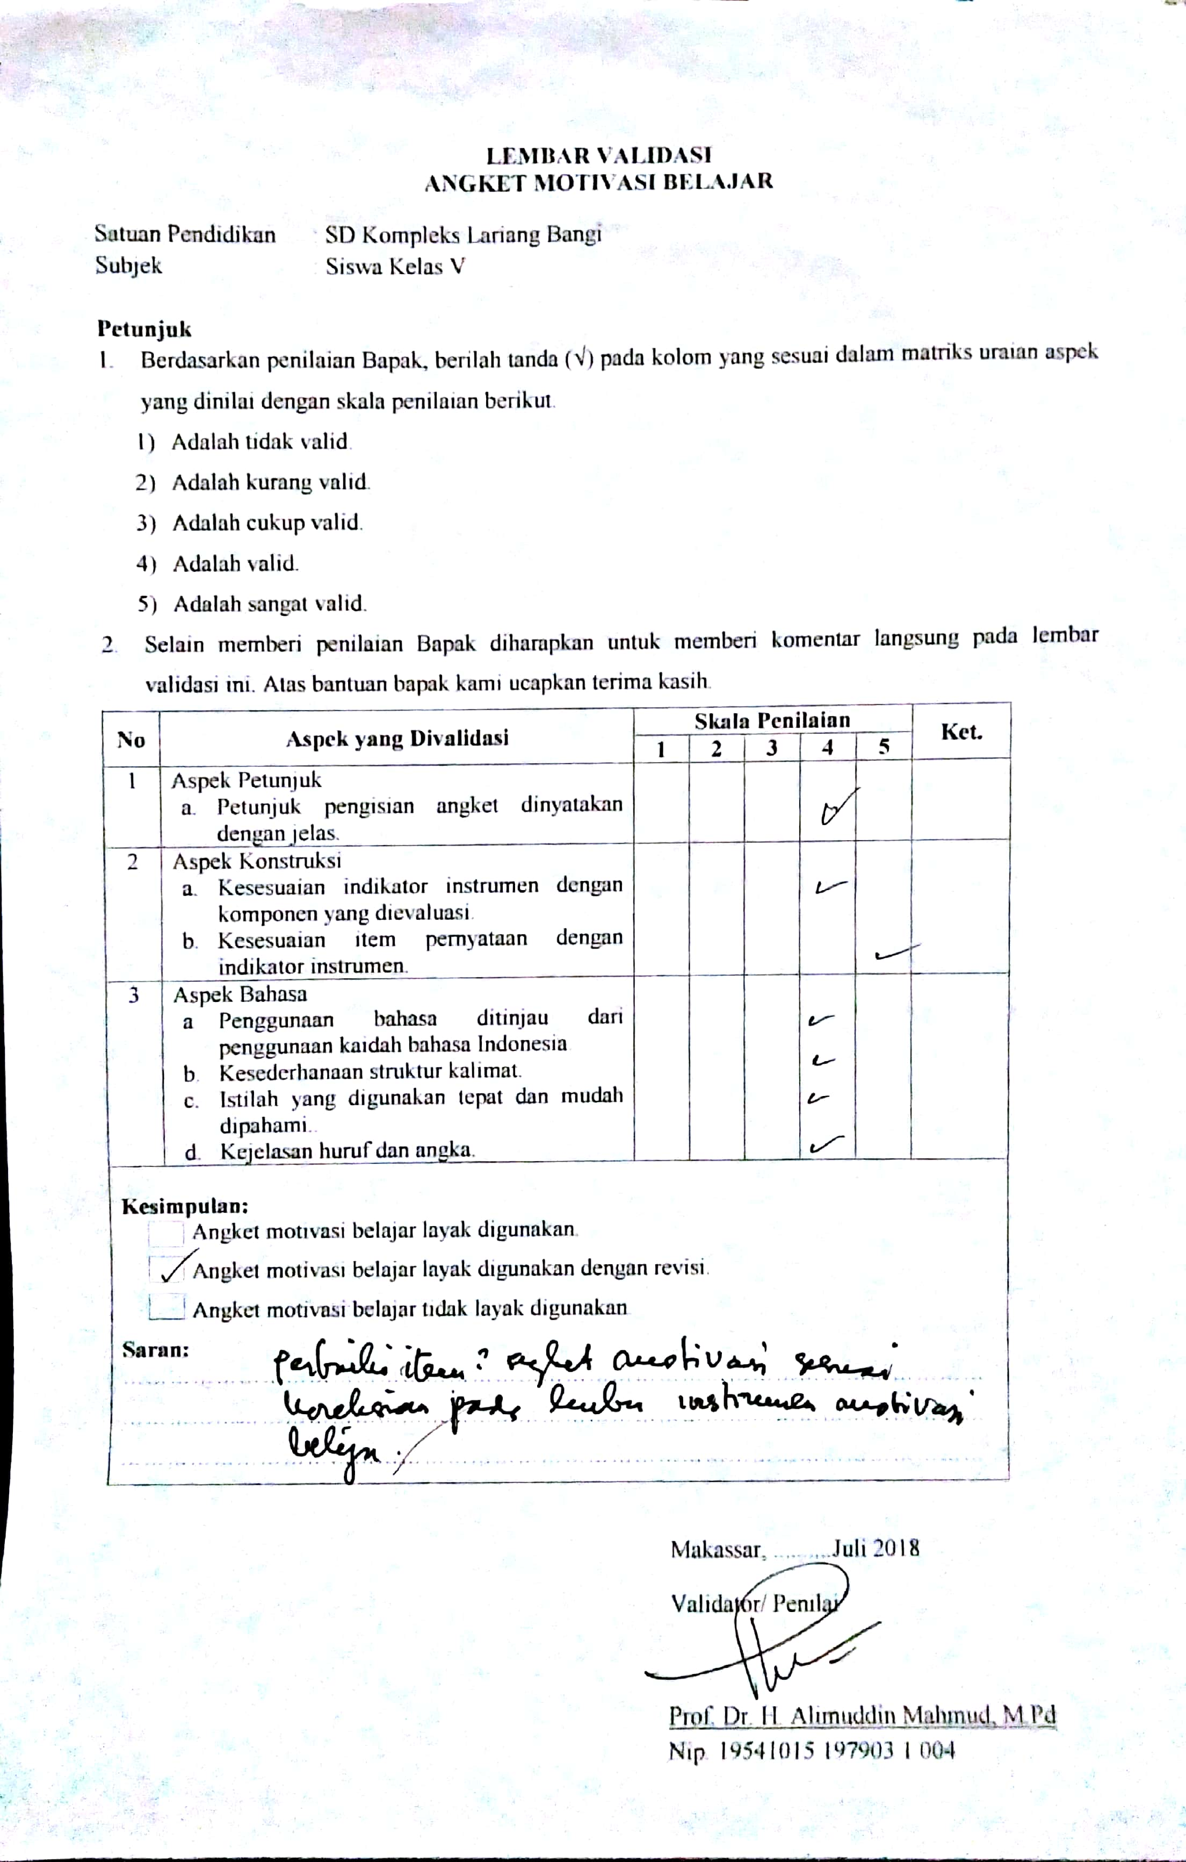

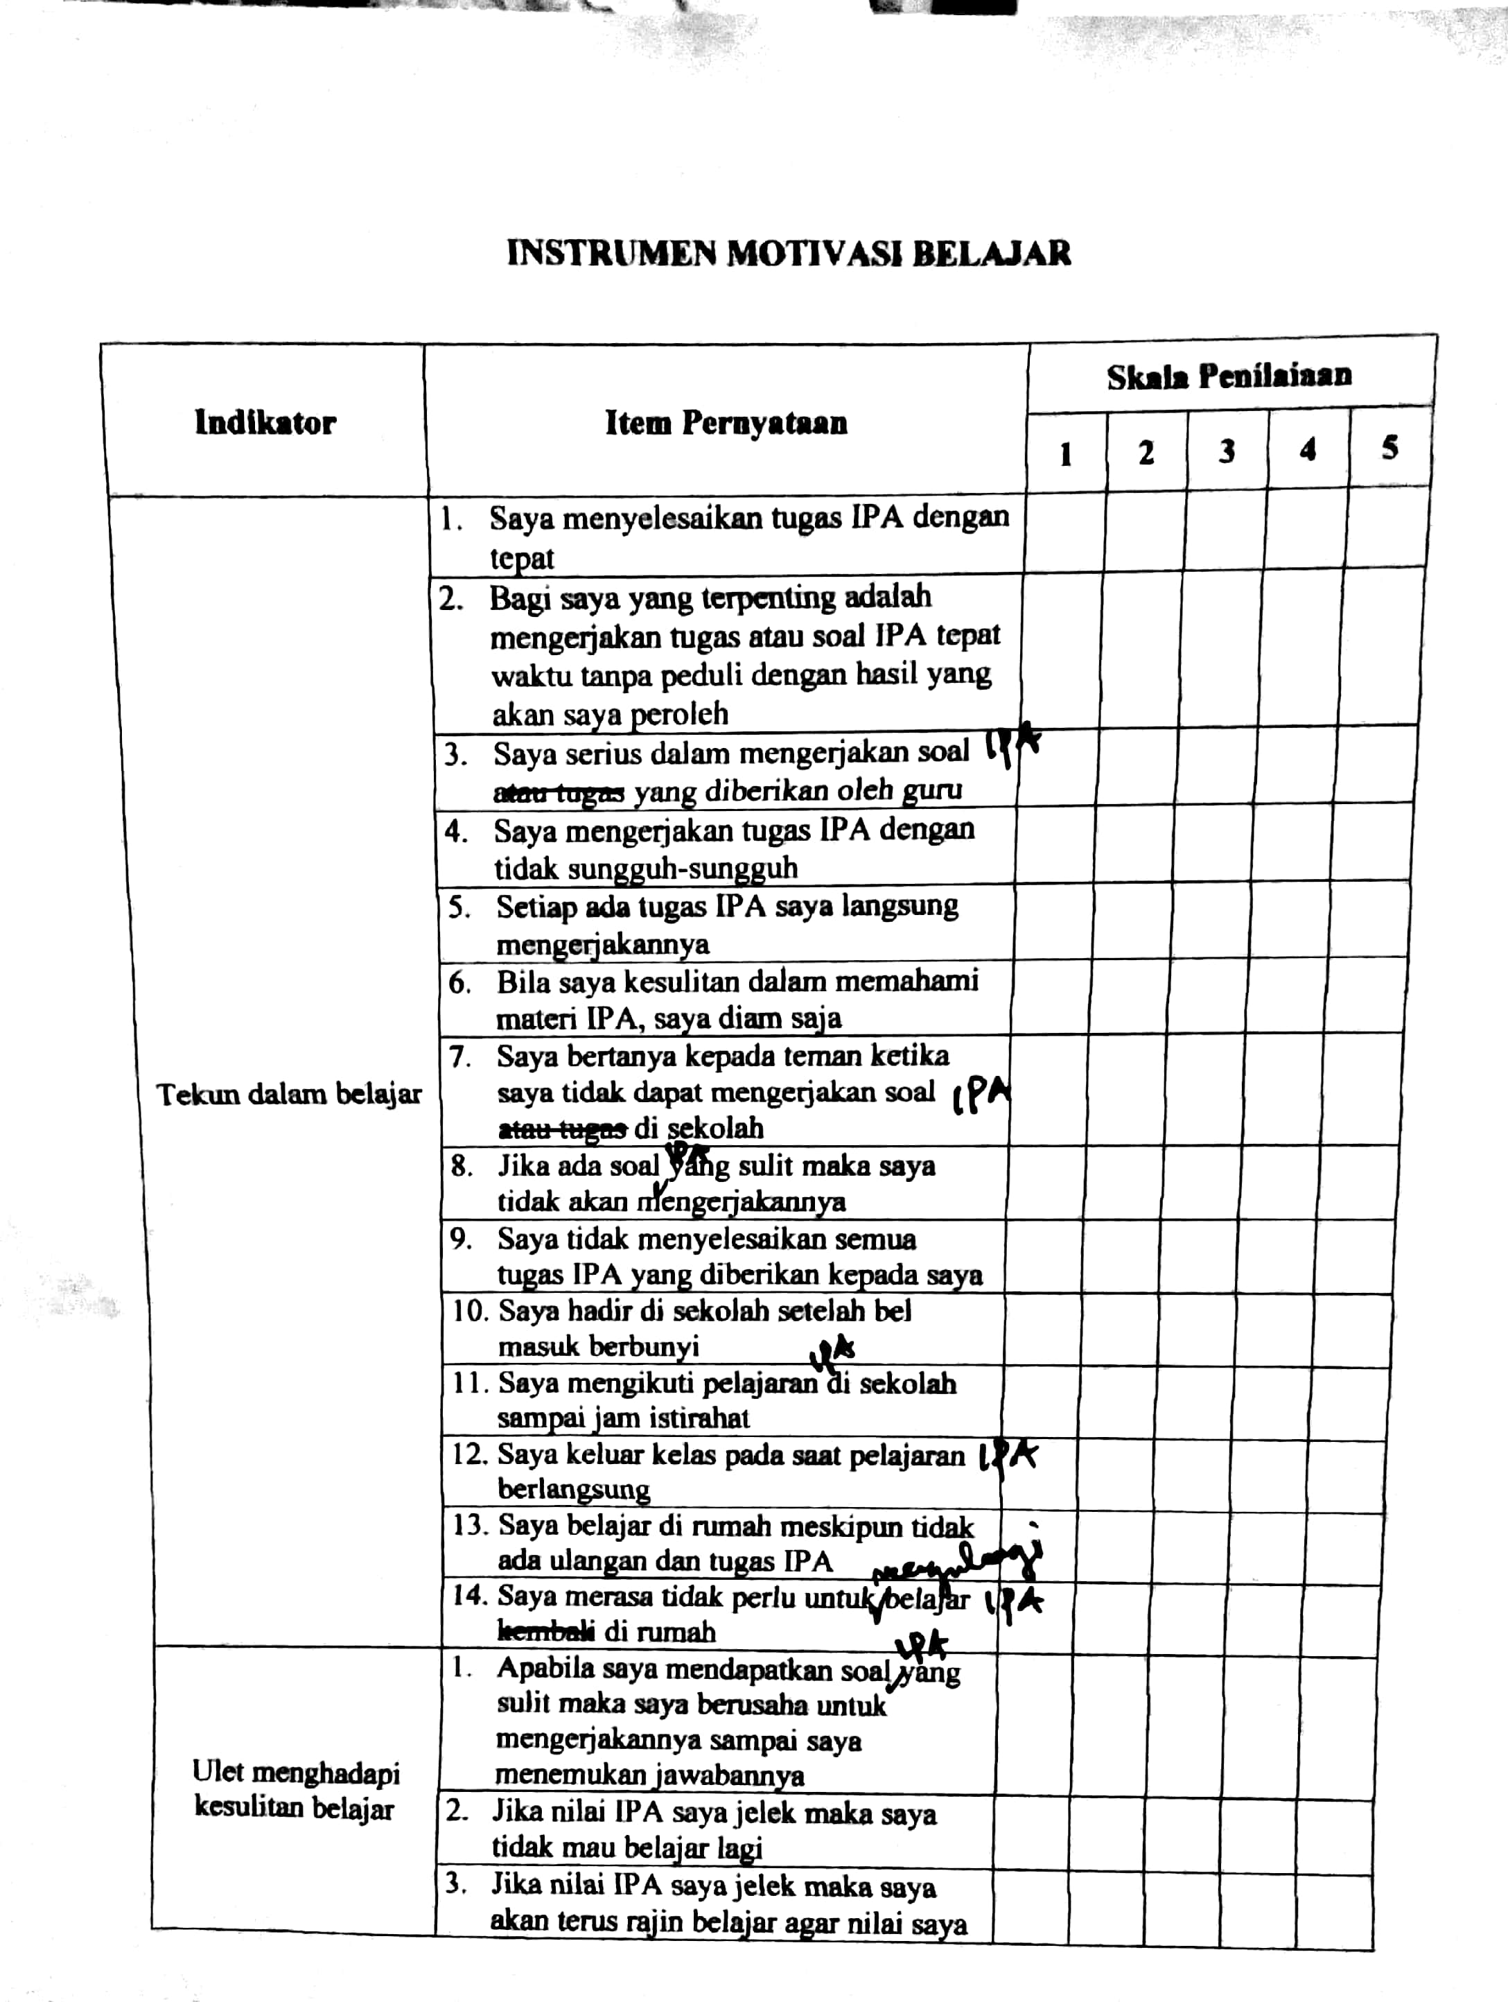

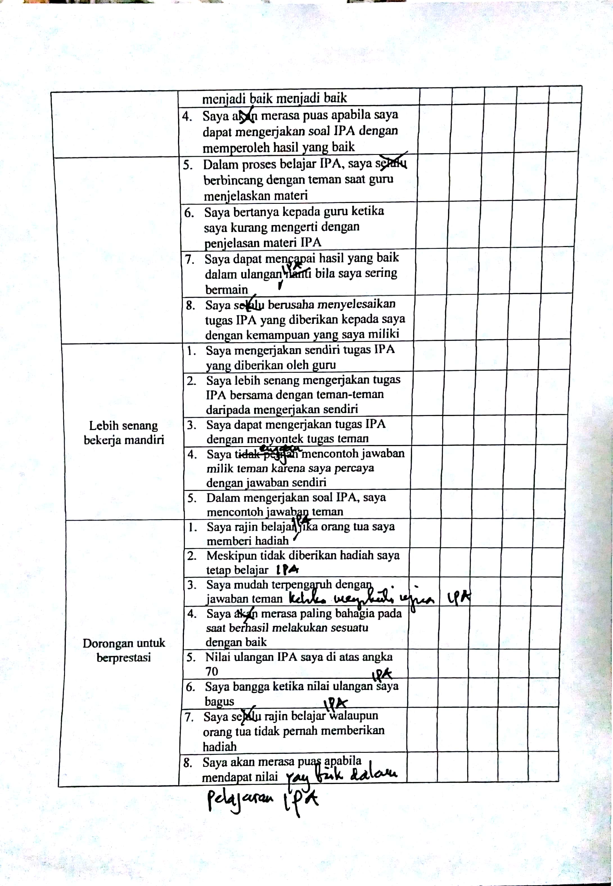

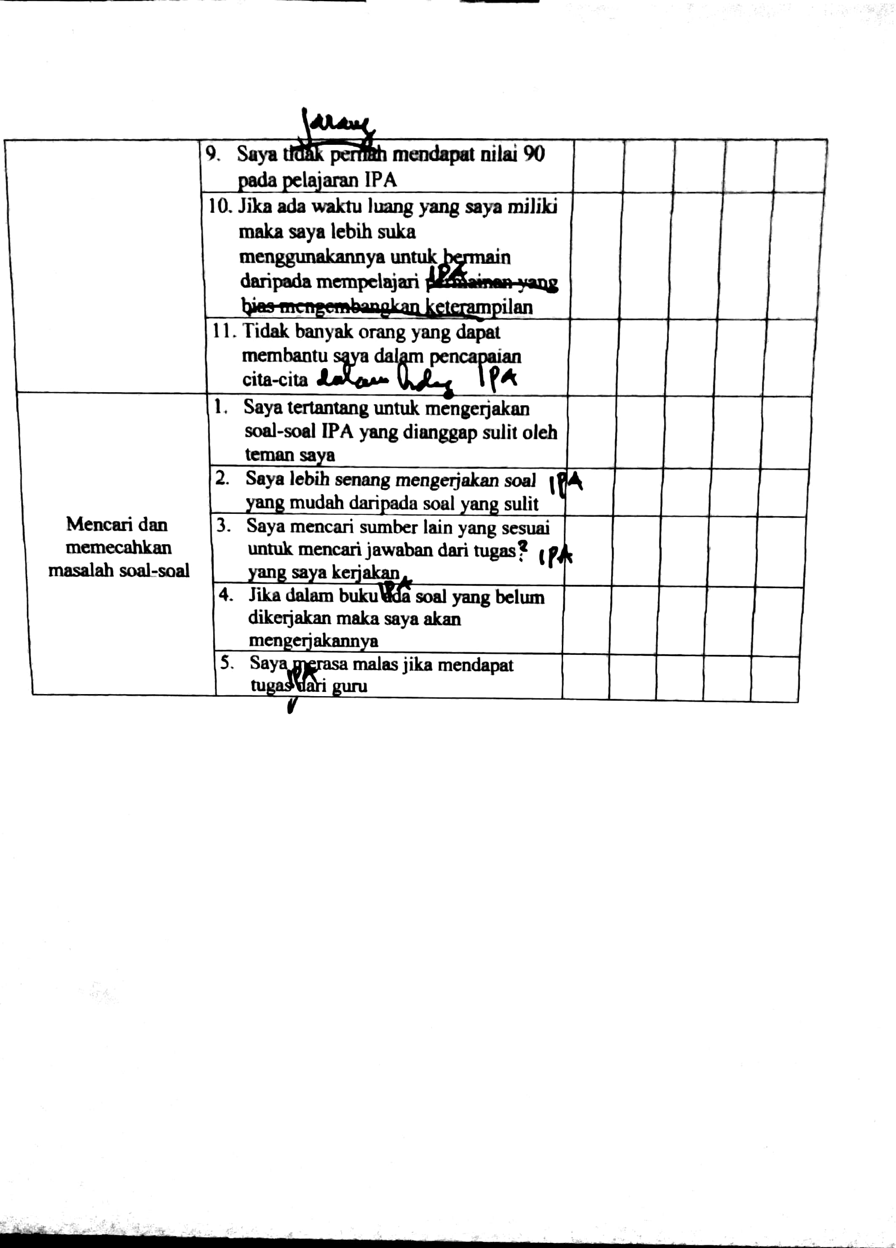

Lampiran 16: Surat Keterangan Validator Instrument
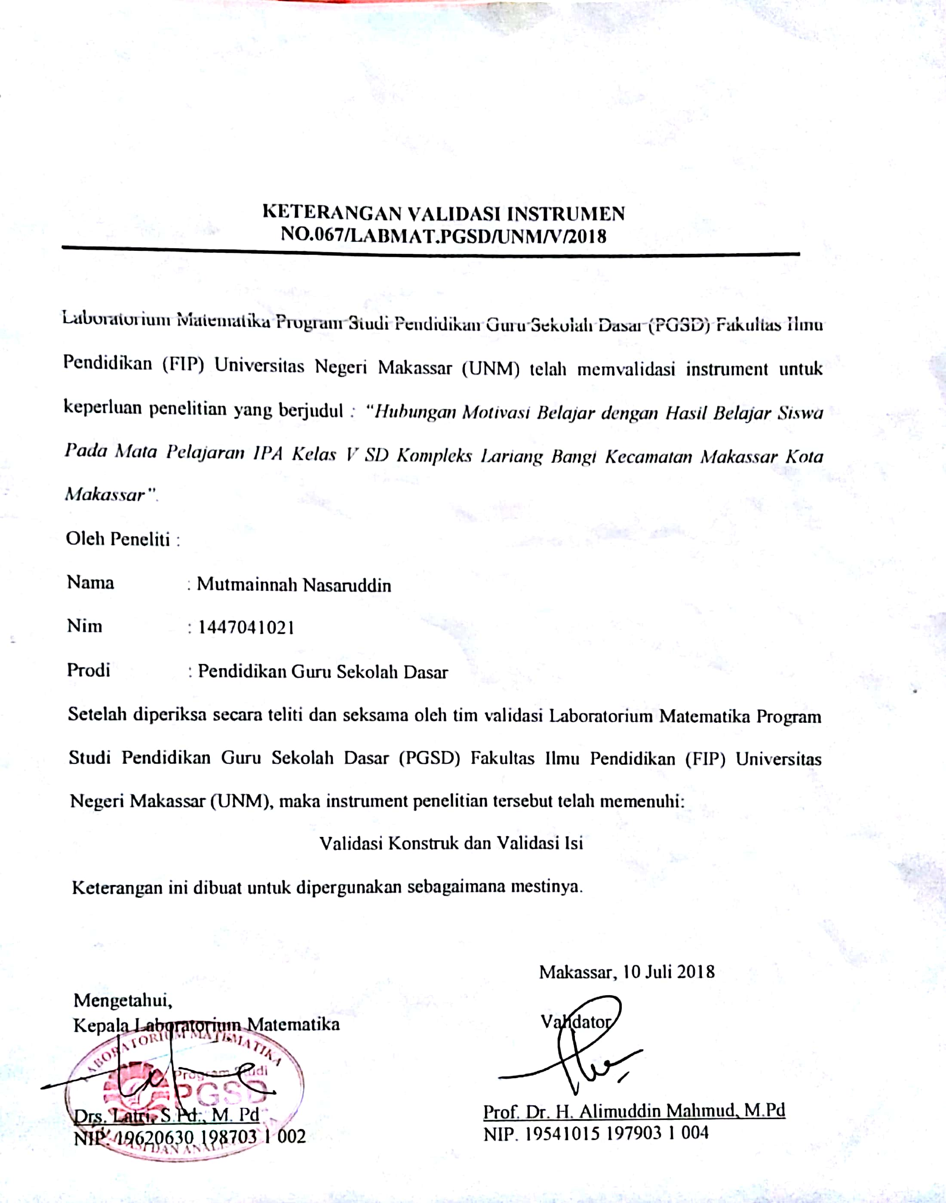

Lampiran 17: Surat Permohonan Izin Meneliti
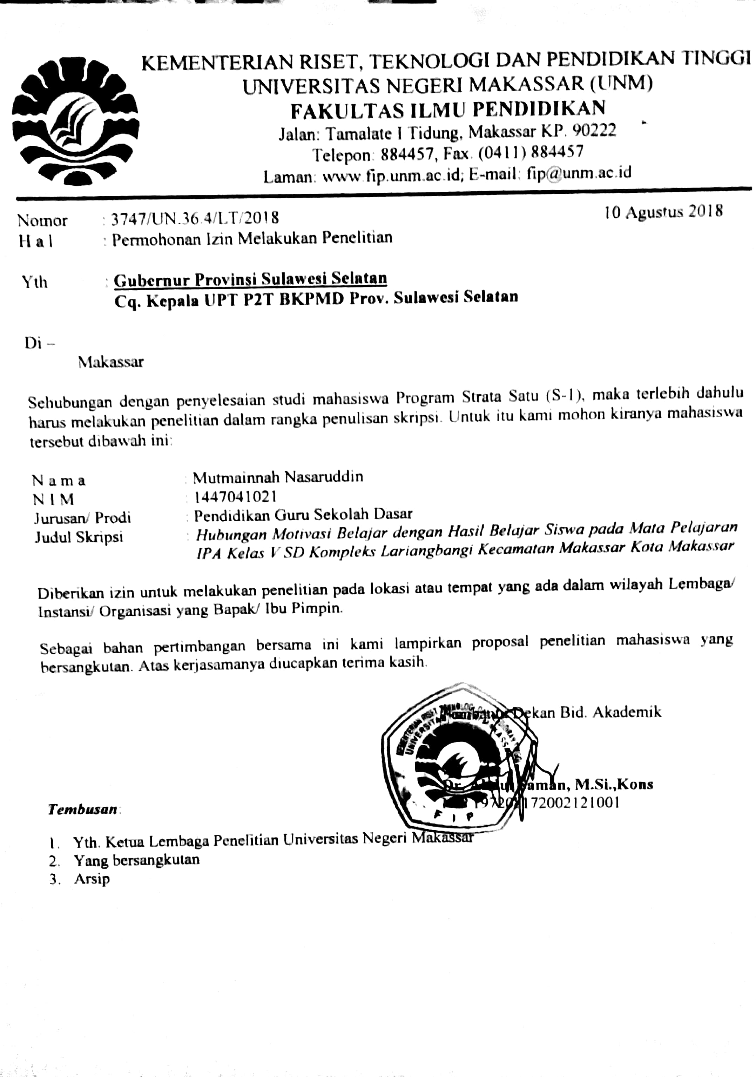
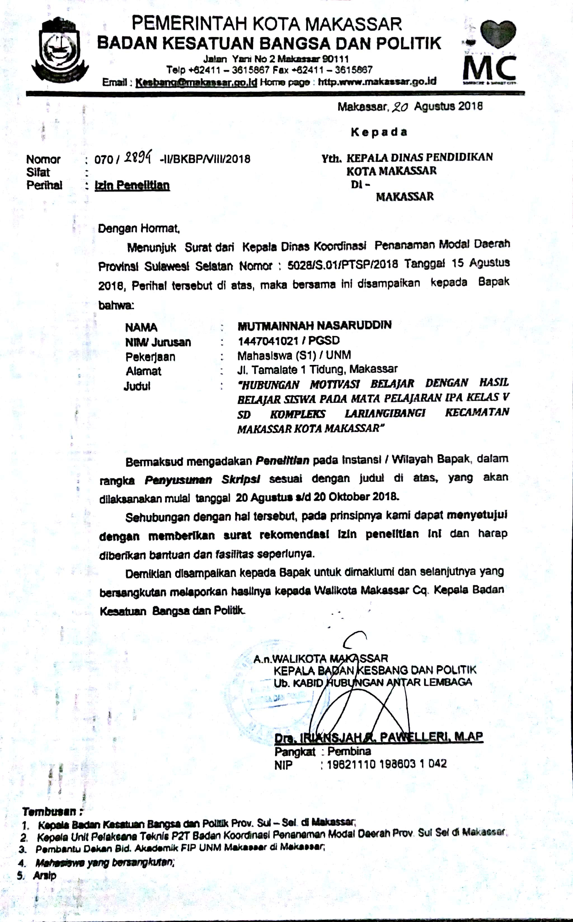
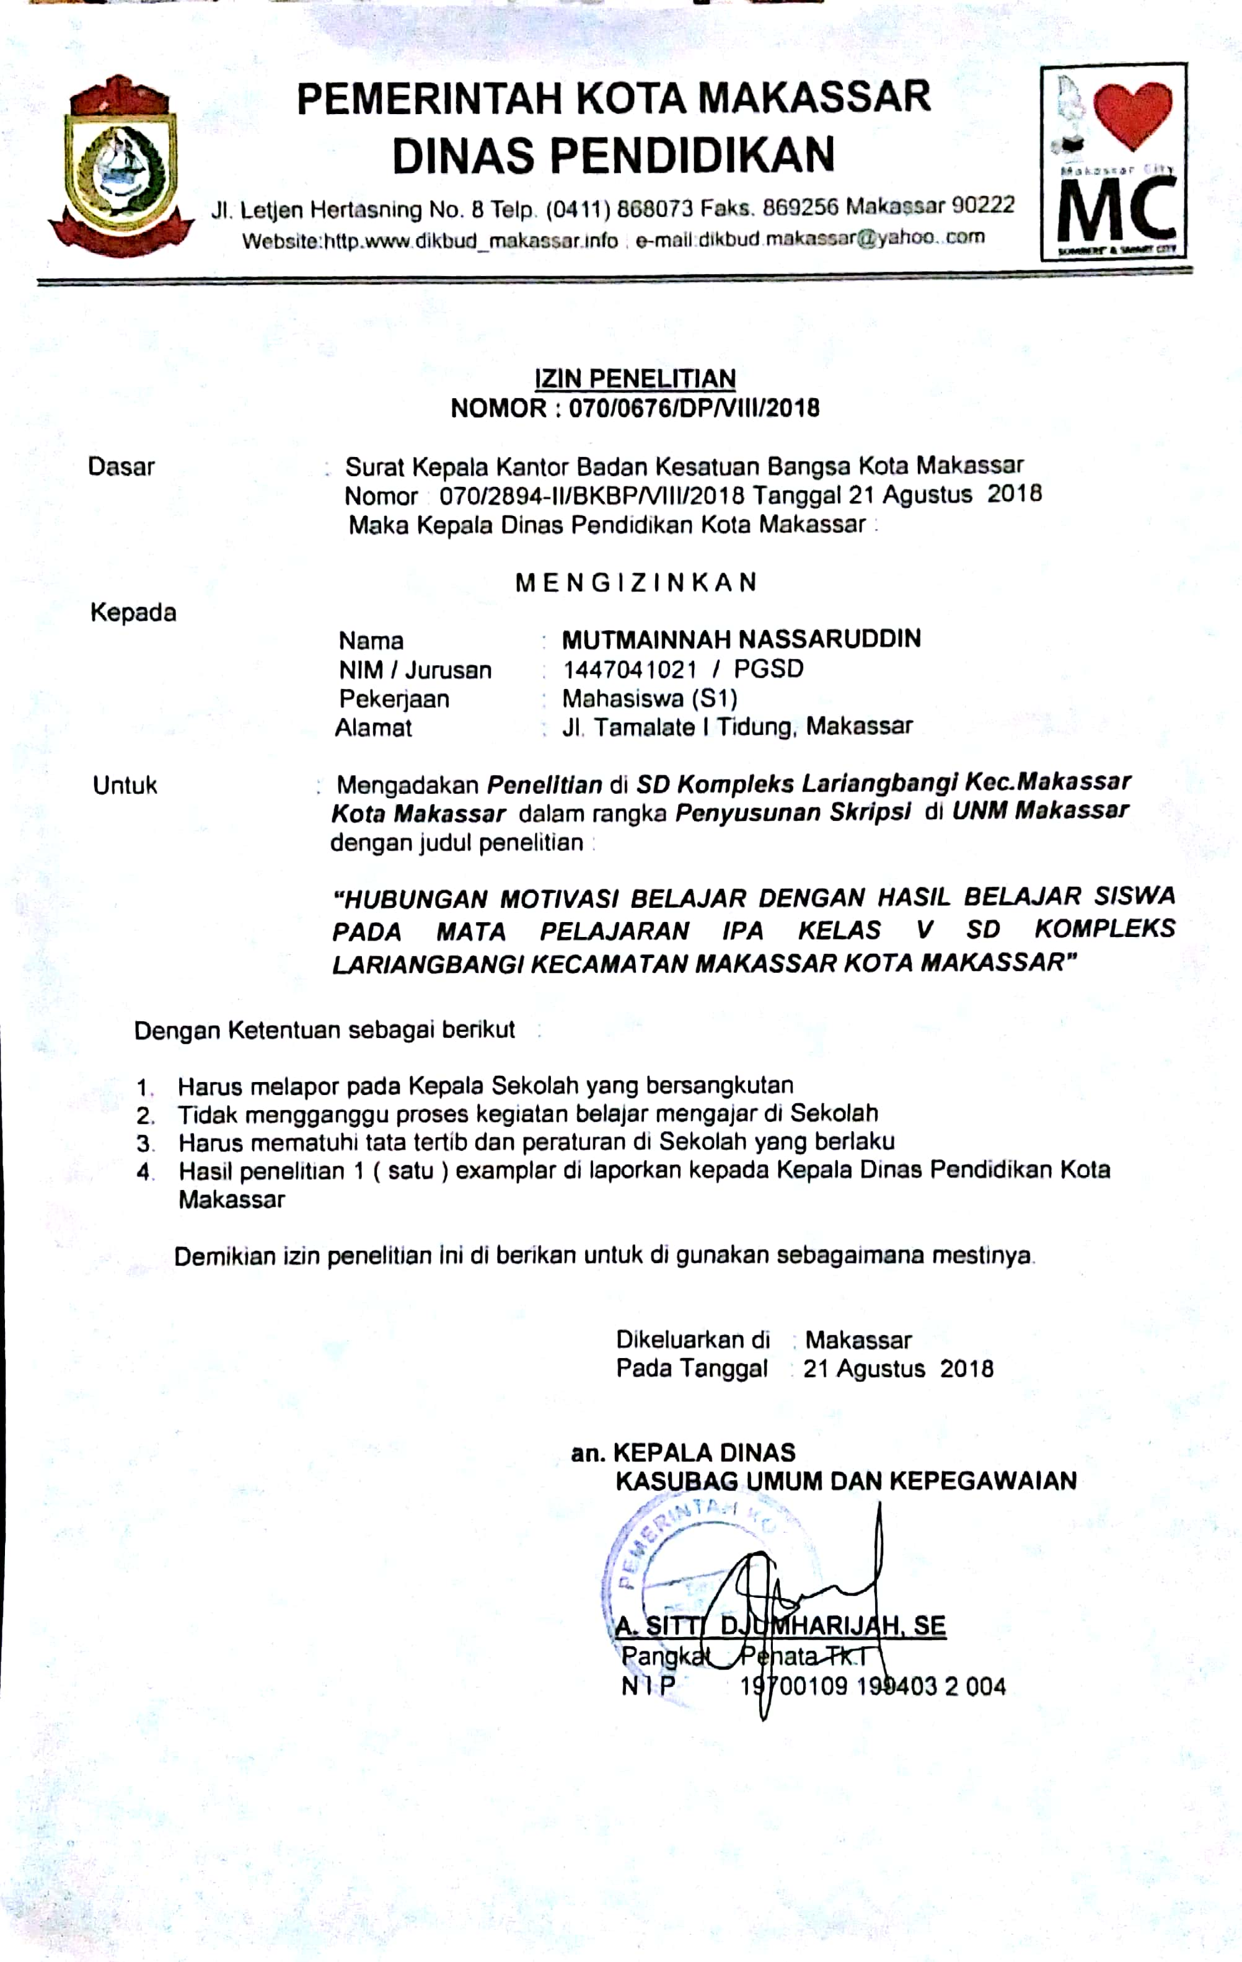
Lampiran 18: Surat Keterangan Telah Melaksanakan Penelitian
