Lampiran 33
Tabel Distribusi t
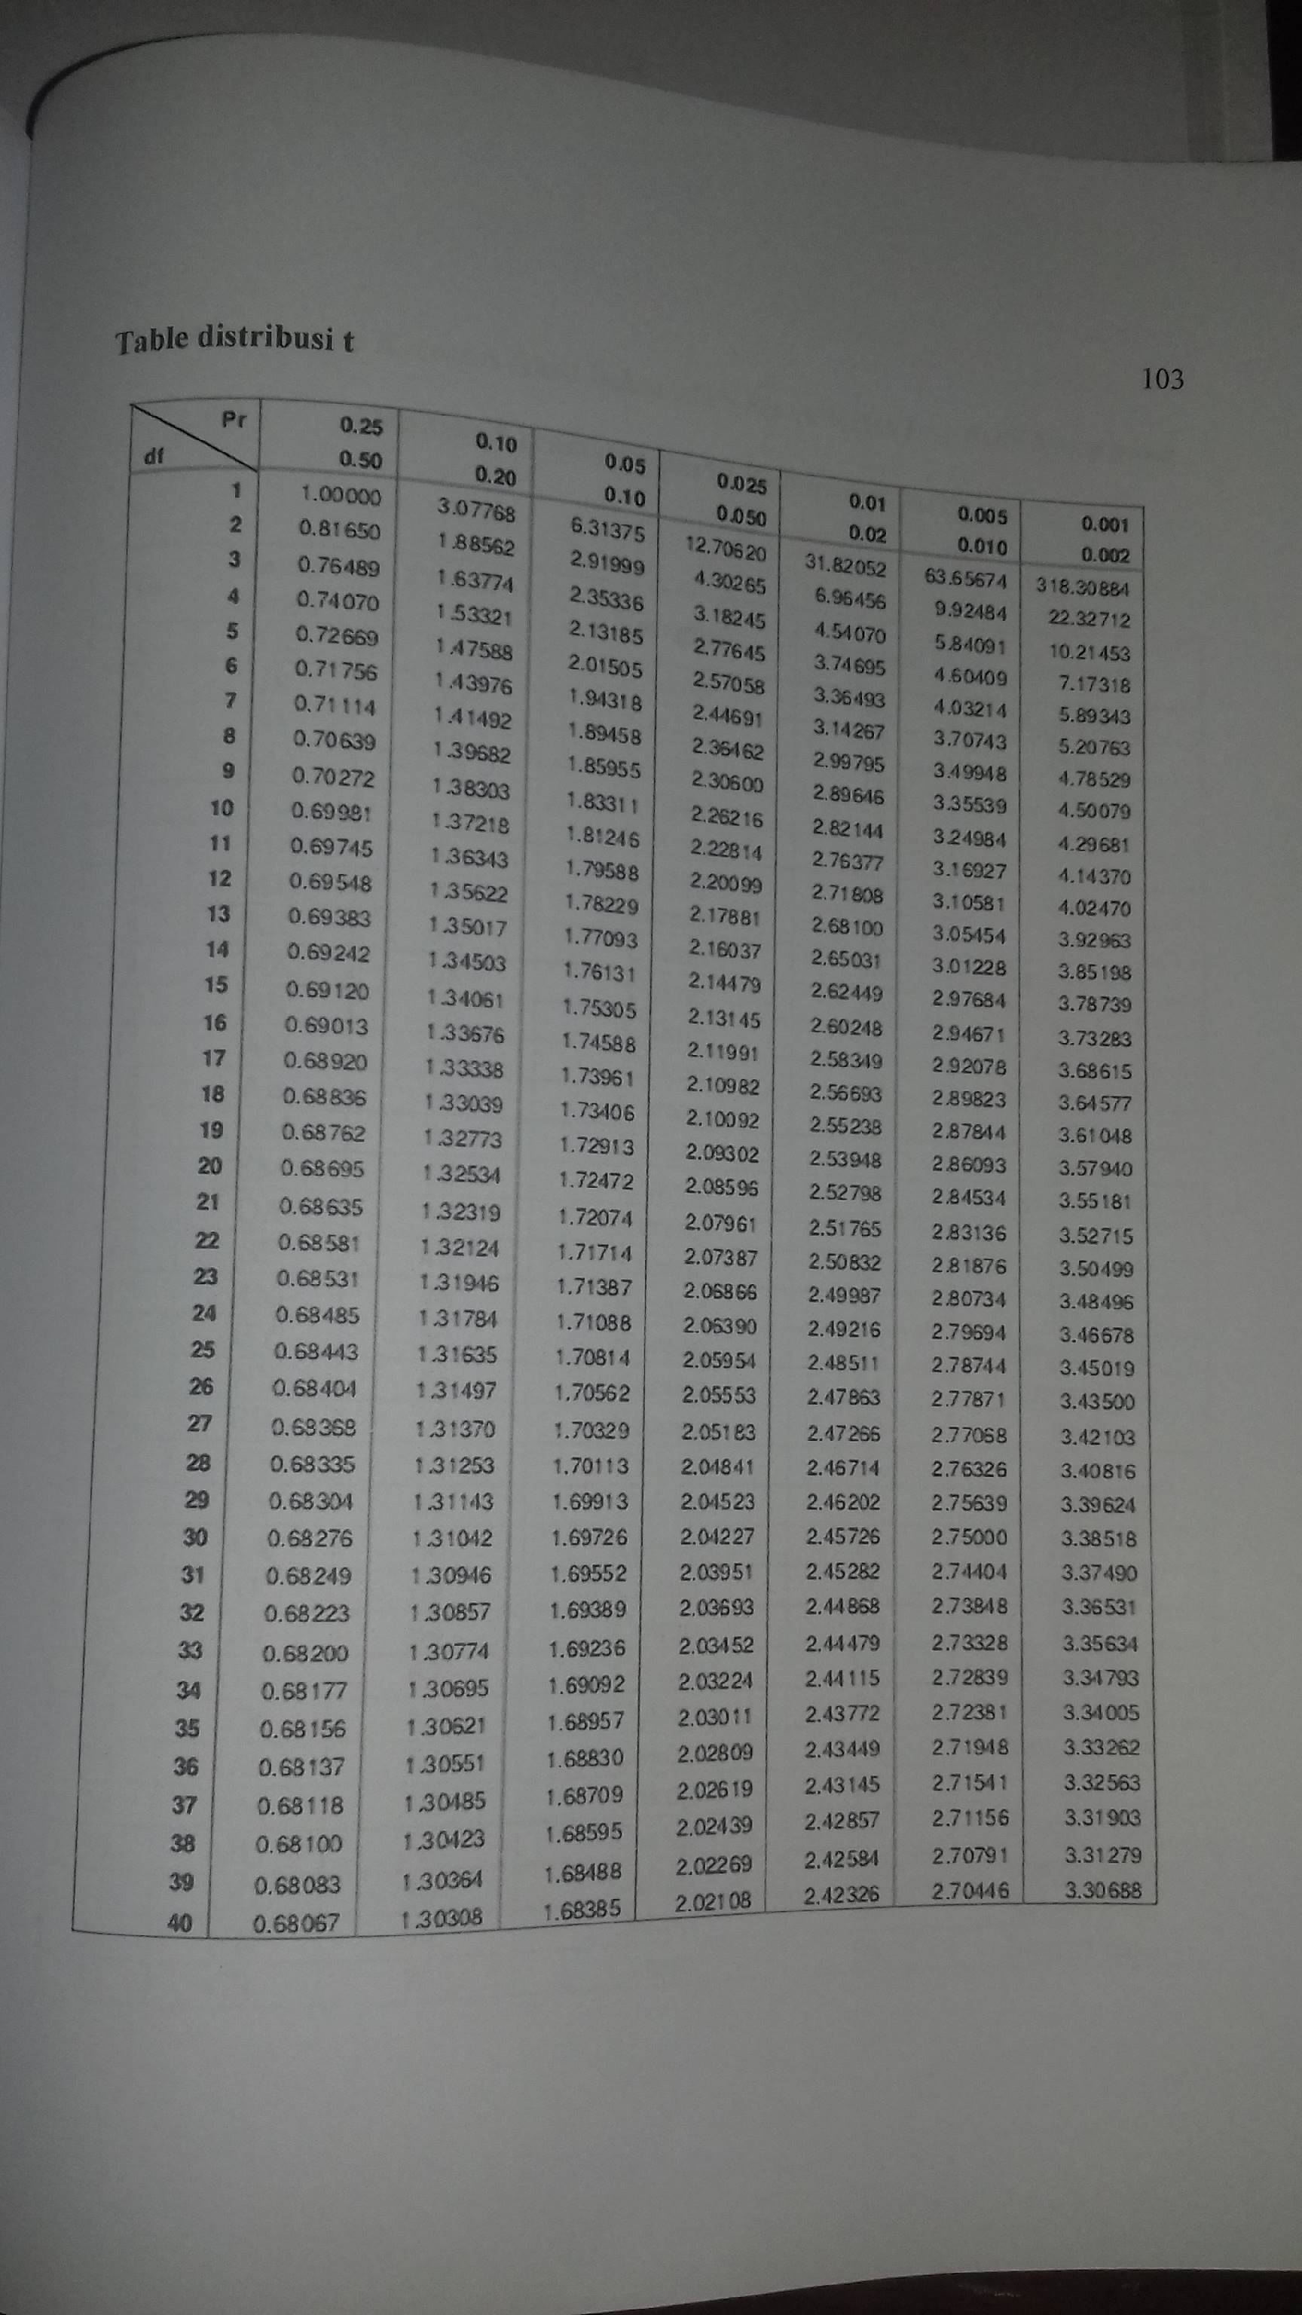s

