LAMPIRAN 6
NAMA SISWA KELAS VB SD NEGERI AROEPPALA KECAMATAN RAPPOCINI KOTA MAKASSAR

No | Nama Siswa | L/P
1 | Agus Salim | L
2 | Andi Rayhan Octa R | L
3 | Astika | P
4 | Ayu Wulandari | P
5 | Fitrah Nizam | L
6 | Herlim Erlangga M | L
7 | Indri Mulia Sari | P
8 | Muh Ariya | L
9 | Muh Farhan Asri | L
10 | Muhammad Husein MZ | L
11 | Mutmainnah | P
12 | Nabila Pratiwi | P
13 | Nabila Putri Amanda | P
14 | Nadia Ayumi | P
15 | Nadila Zaskia Sahirud | P
16 | Nailah Nathania H | P
17 | Najwa Arini Diaul HH | P
18 | Nurhidayat | L
19 | Nur Nirmala Dewi Putri | P
20 | Nur Aina Rusman | P
21 | Nurhaliza Nitswat | P
22 | Nur Azhimi Z | P
23 | Putri Aprilia | P
24 | Riki Adrian | L
25 | Siti Nur Avira | P
26 | Sri Ramadani S | P
27 | Vidia Aulia R | P
28 | Yudistira Ageng Tirta | L

LAMPIRAN 7
NILAI SISWA
No | Nama Siswa | Jenis Kelamin | Gaya Belajar | Hasil Belajar
1 | AS | L | 70 | 75
2 | ARO | L | 72 | 75
3 | A | P | 70 | 75
4 | AW | P | 75 | 85
5 | FN | L | 75 | 80
6 | HE | L | 80 | 85
7 | IMS | P | 75 | 75
8 | MA | L | 65 | 70
9 | MFA | L | 65 | 70
10 | MH | L | 80 | 90
11 | M | P | 70 | 75
12 | NP | P | 75 | 75
13 | NPA | P | 75 | 90
14 | NA | P | 65 | 70
15 | NZS | P | 65 | 70
16 | NNH | P | 75 | 80
17 | NAD | P | 75 | 80
18 | N | L | 70 | 70
19 | NNDP | P | 70 | 70
20 | NAR | P | 70 | 70
21 | NN | P | 75 | 80
22 | NAZ | P | 70 | 70
23 | PA | P | 70 | 75
24 | RA | L | 75 | 75
25 | SNA | P | 85 | 90
26 | SRS | P | 75 | 75
27 | VAR | P | 80 | 85
28 | YAT | L | 70 | 70

LAMPIRAN 8
LEMBAR HASIL ANGKET GAYA BELAJAR
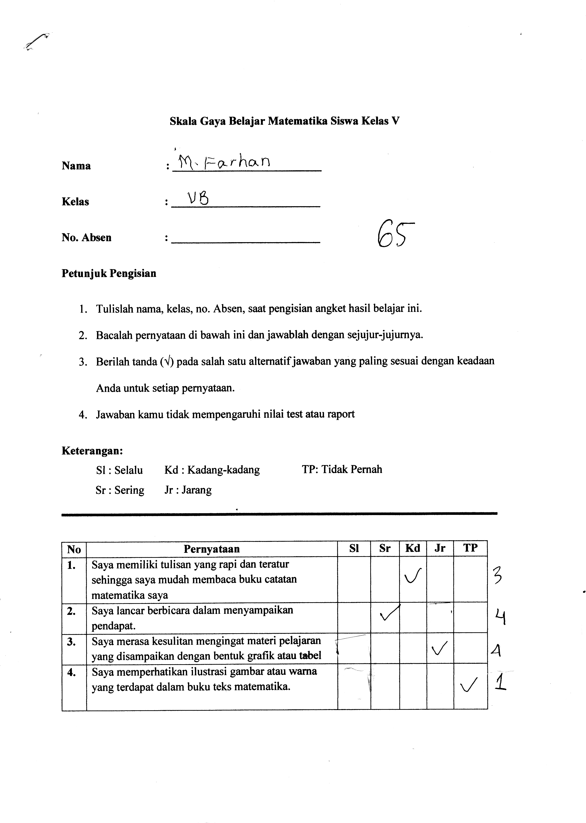

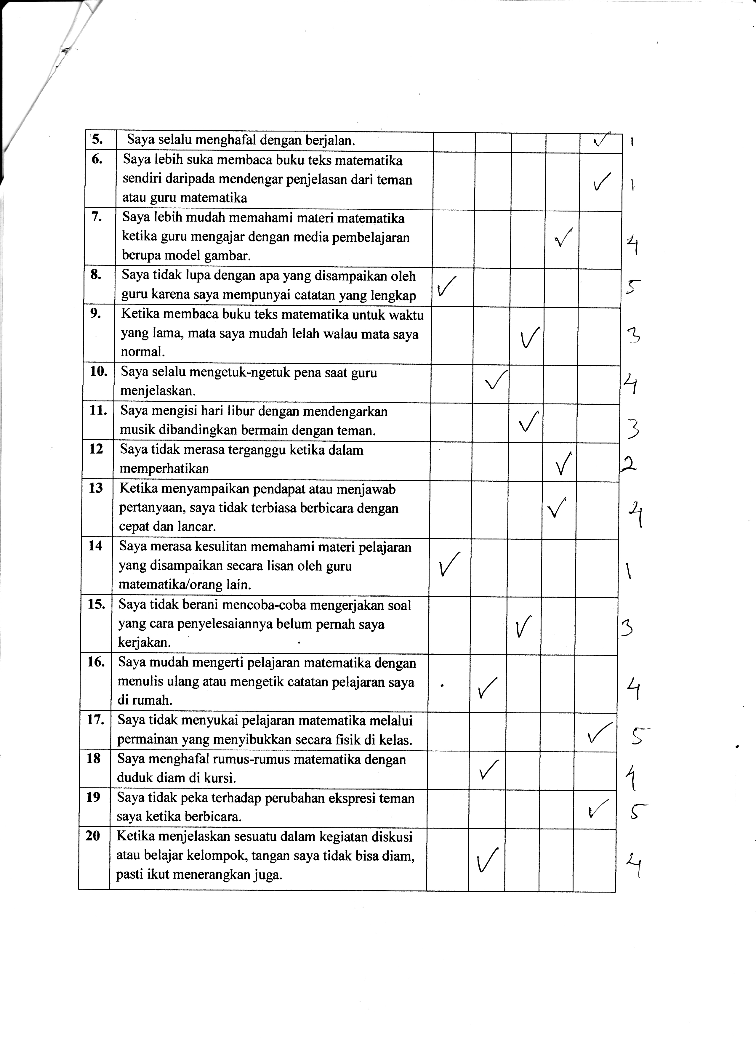

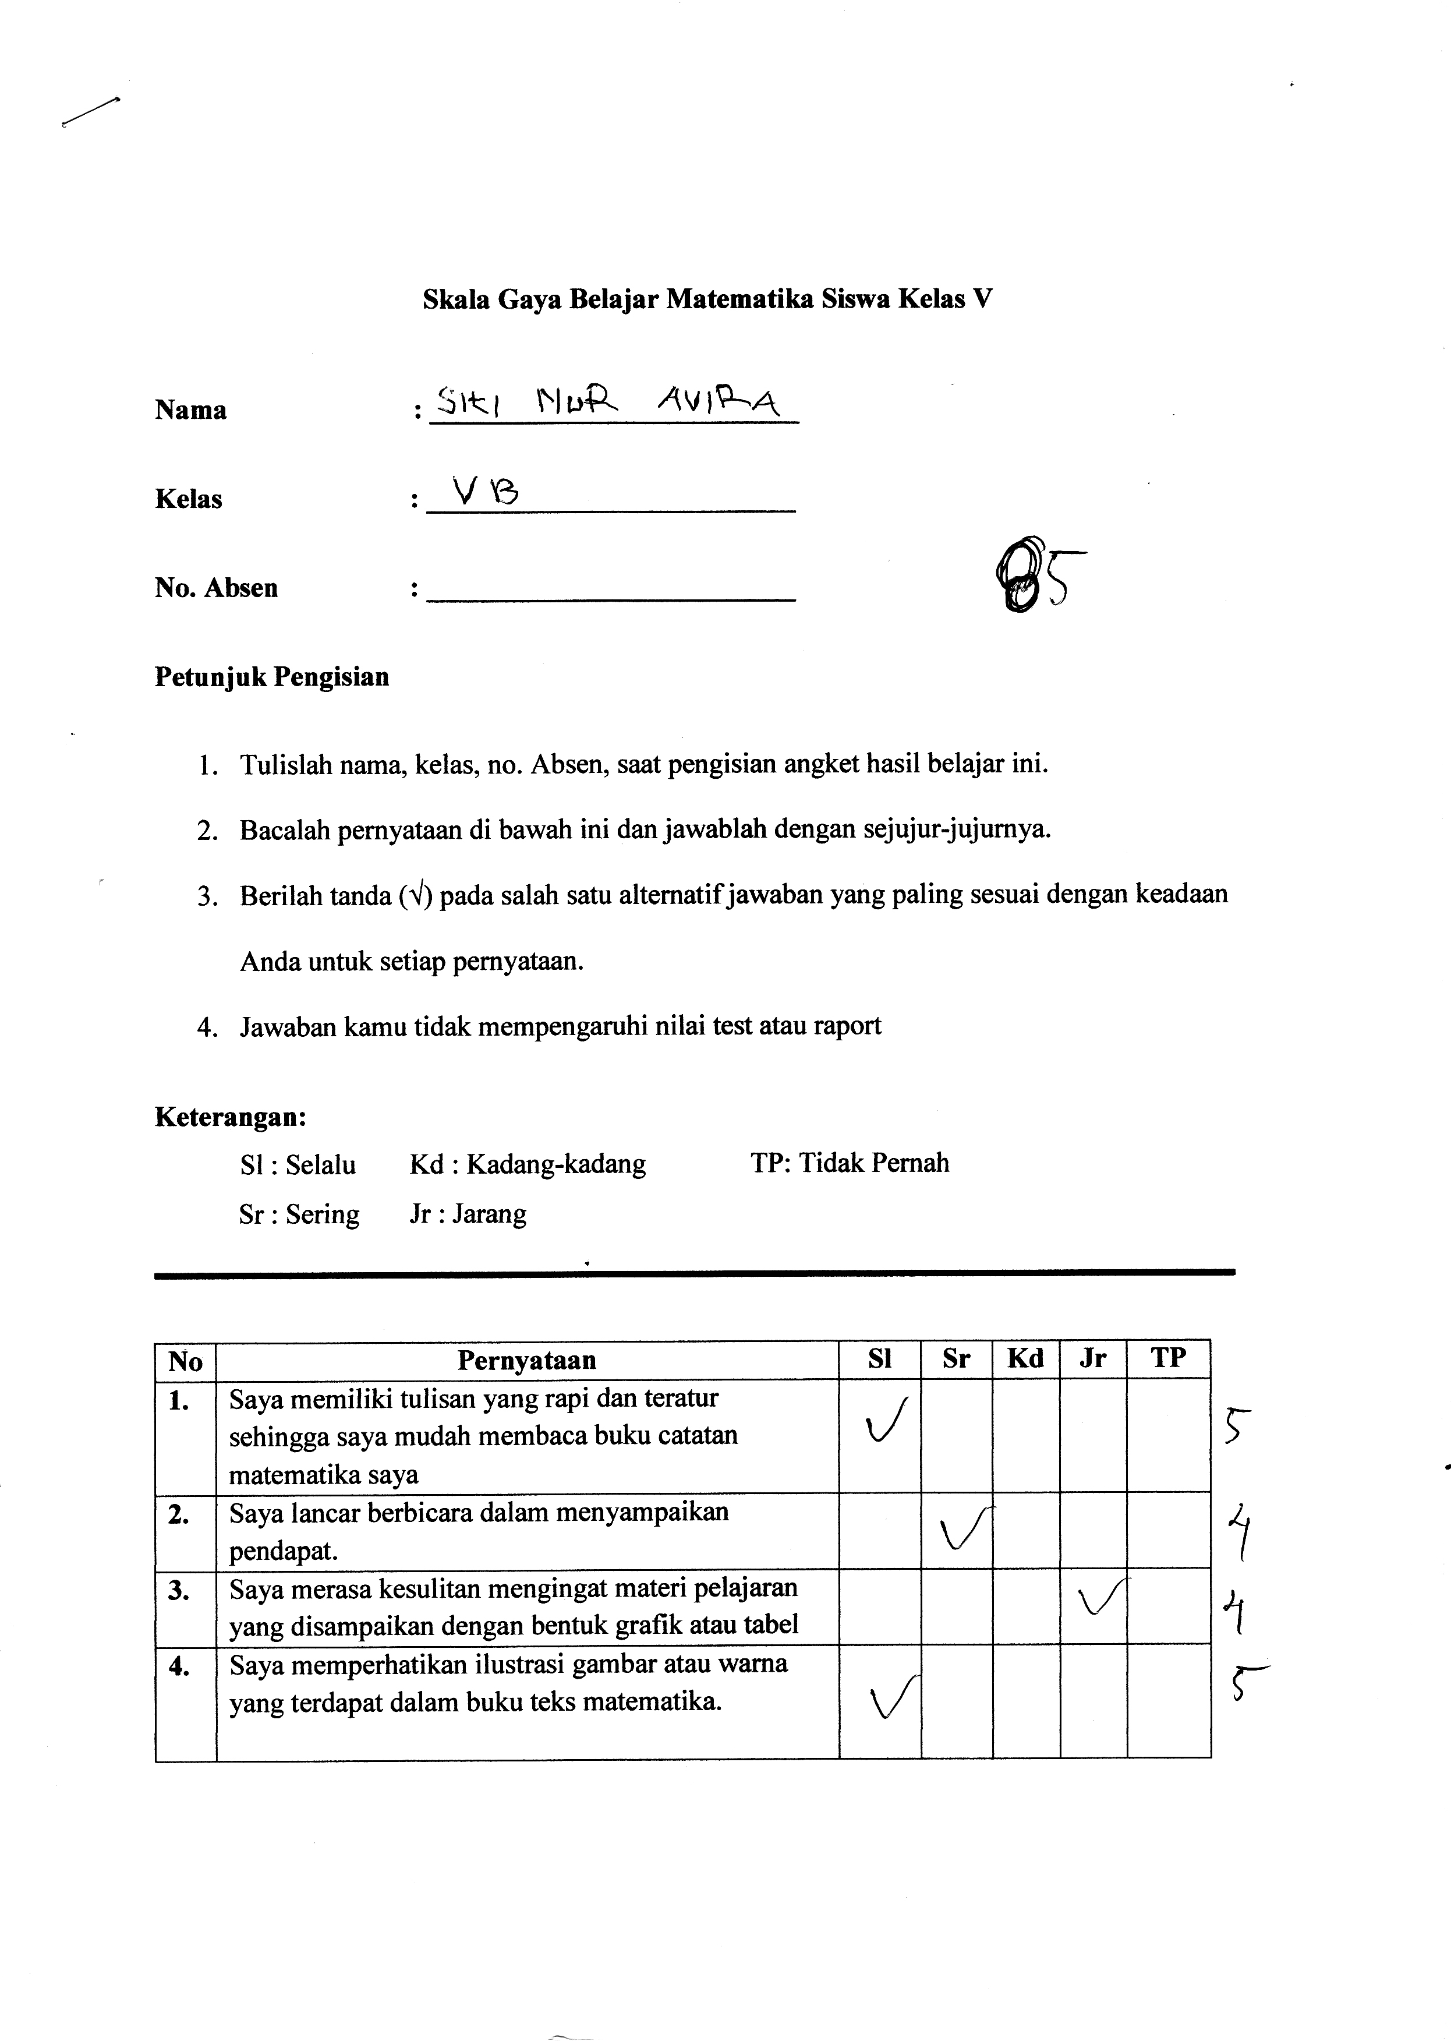

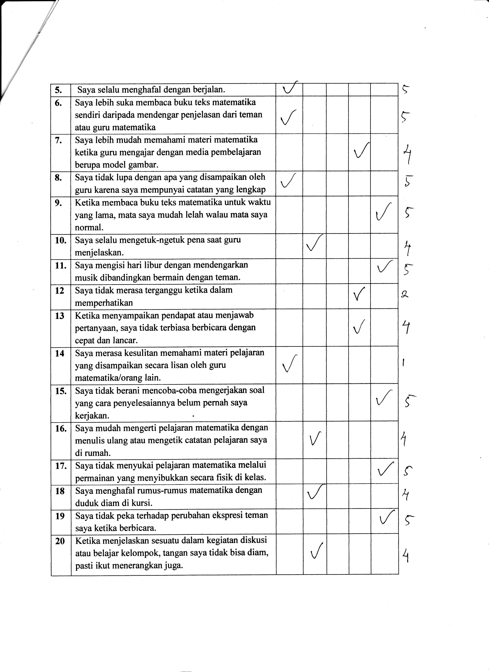

LAMPIRAN 9
LEMBAR HASIL BELAJAR
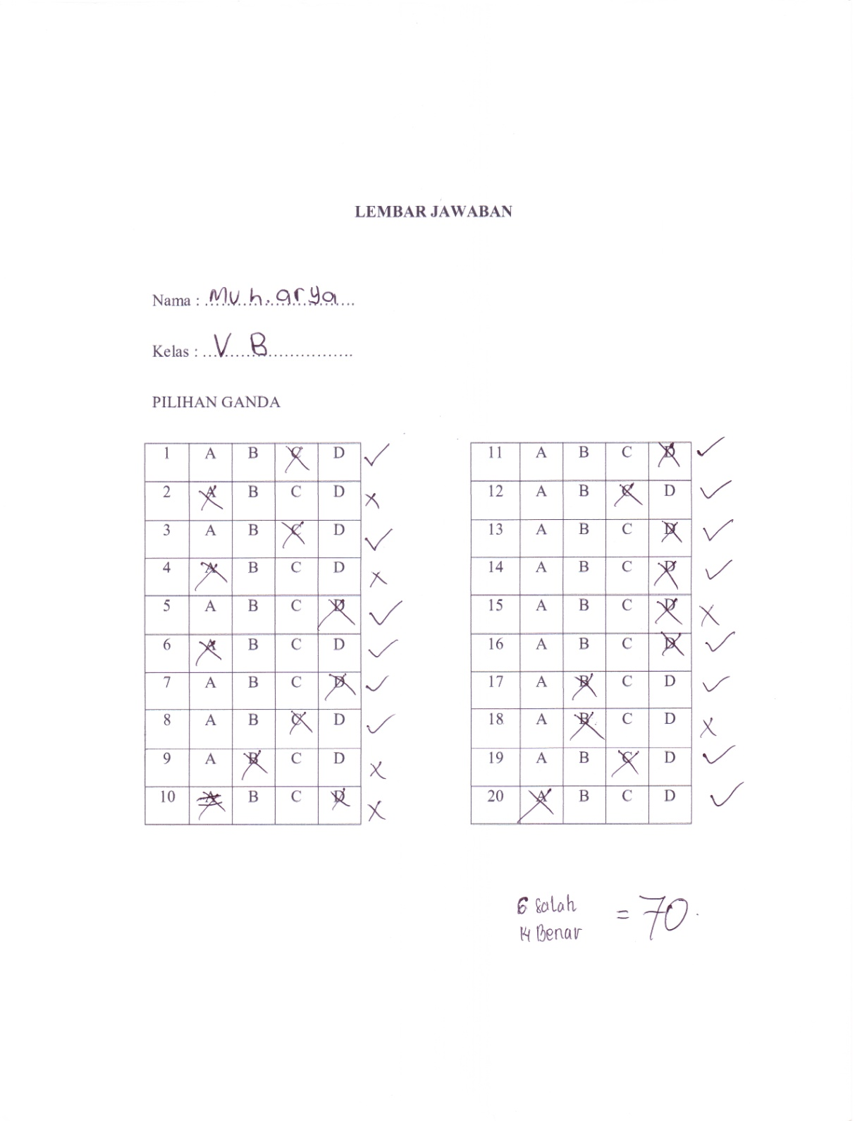

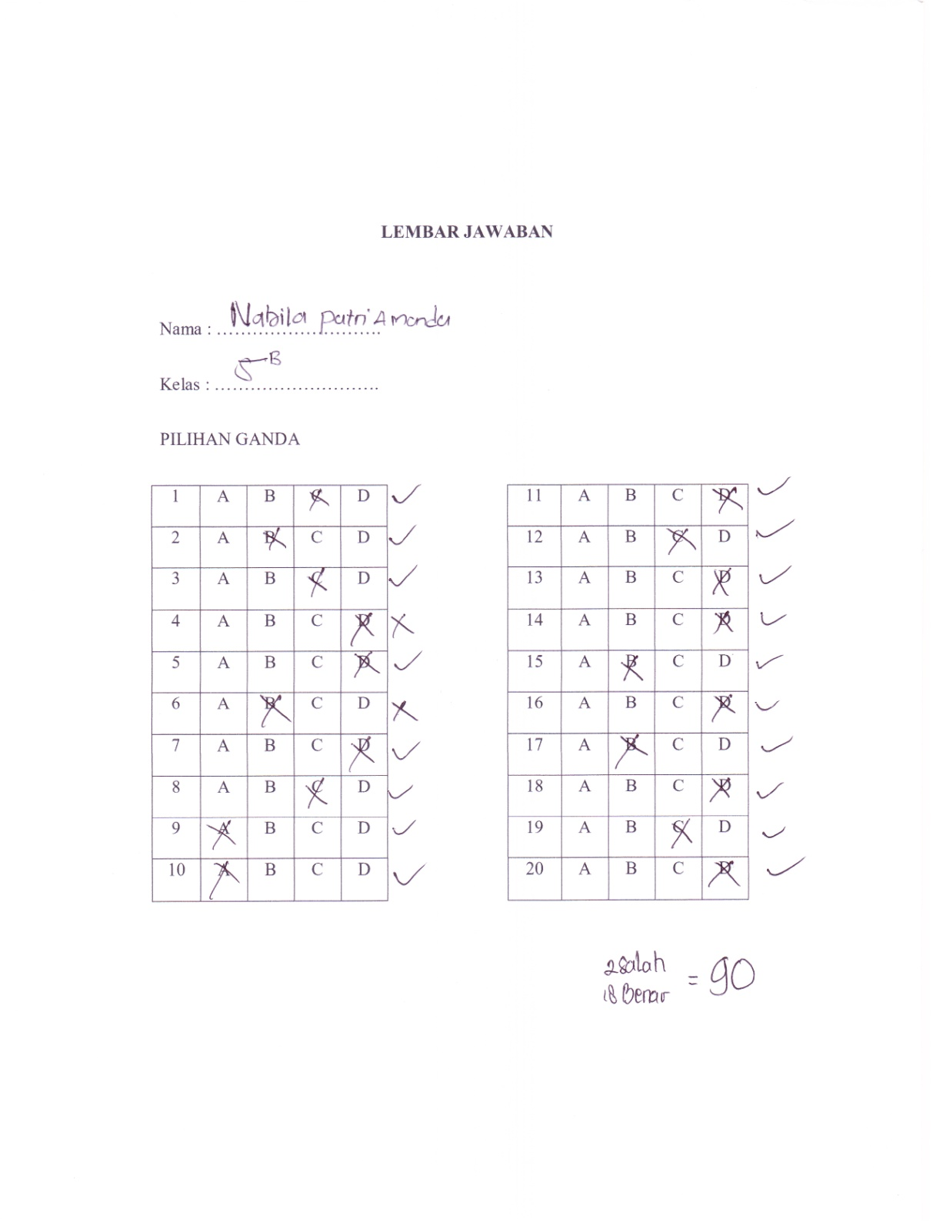

LAMPIRAN 10
HASIL ANALISIS DEKRIPTIF
Statistics
 |  | X | Y
N | Valid | 28 | 28
 | Missing | 0 | 0
Mean |  | 72,75 | 76,79
Median |  | 73,50 | 75,00
Mode |  | 75 | 70ª
Std. Deviation |  | 4,971 | 6,696
Variance |  | 24,713 | 44,841
Skewness |  | ,340 | ,778
Std. Error of Skewness |  | ,441 | ,441
Kurtosis |  | ,121 | -,494
Std. Error of Kurtosis |  | ,858 | ,858
Minimum |  | 65 | 70
Maximum |  | 85 | 90
Sum |  | 2037 | 2150
Percentiles | 25 | 70,00 | 70,00
 | 50 | 73,50 | 75,00
 | 75 | 75,00 | 80,00
a. Multiple modes exist. The smallest value is shown

LAMPIRAN 11
HASIL UJI NORMALITAS
One-Sample Kolmogorov-Smirnov Test
 |  | Y | X
N |  | 28 | 28
Normal Parameters^{a,b} | Mean | 76,79 | 72,75
 | Std. Deviation | 6,696 | 4,971
Most Extreme Differences | Absolute | ,248 | ,183
 | Positive | ,248 | ,183
 | Negative | -,155 | -,175
Kolmogorov-Smirnov Z |  | 1,312 | ,966
Asymp. Sig. (2-tailed) |  | ,064 | ,308
a. Test distribution is Normal.
b. Calculated from data.

LAMPIRAN 12
HASIL UJI LINEARITAS
ANOVA Table
 |  |  | Sum of Squares | df | Mean Square | F | Sig.
Hasil Belajar *  Gaya Belajar X | Between Groups | (Combined) | 915,992 | 5 | 183,198 | 13,675 | ,000
 |  | Linearity | 871,347 | 1 | 871,347 | 65,043 | ,000
 |  | Deviation from Linearity | 44,645 | 4 | 11,161 | ,833 | ,519
 | Within Groups |  | 294,722 | 22 | 13,396
 | Total |  | 1210,714 | 27

LAMPIRAN 13
HASIL ANALISIS UJI REGRESI LINEAR SEDERHANA

Model Summary
Model | R | R Square | Adjusted R Square | Std. Error of the Estimate
1 | ,848ª | ,720 | ,709 | 3,613
- Predictors: (Constant), Gaya Belajar

ANOVAª
Model |  | Sum of Squares | df | Mean Square | F | Sig.
1 | Regression | 871,347 | 1 | 871,347 | 66,757 | ,000^{b}
 | Residual | 339,367 | 26 | 13,053
 | Total | 1210,714 | 27
a. Dependent Variable: Hasil Belajar
- Predictors: (Constant), Gaya Belajar

Coefficientsª
Model |  | Unstandardized Coefficients |  | Standardized Coefficients | t | Sig.
 |  | B | Std. Error | Beta
1 | (Constant) | -6,349 | 10,198 |  | -,623 | ,539
 | Gaya Belajar | 1,143 | ,140 | ,848 | 8,170 | ,000
a. Dependent Variable: Hasil belajar

LAMPIRAN 14
DOKUMENTASI
- Pada saat penyebaran angket dan tes di kelas VB
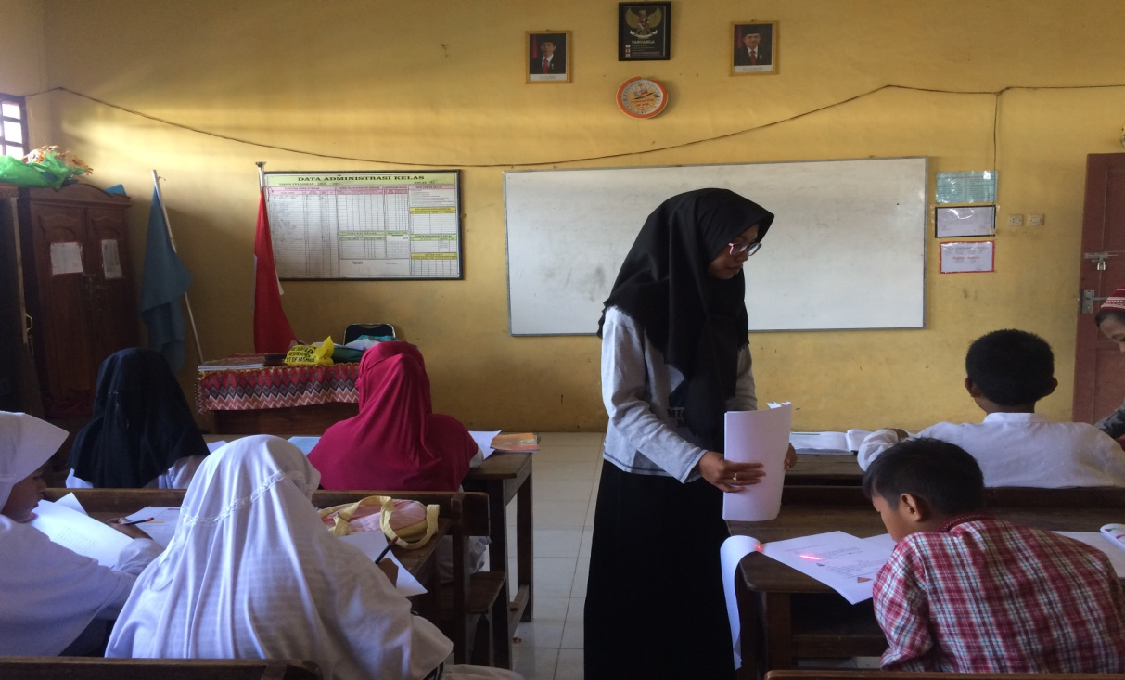

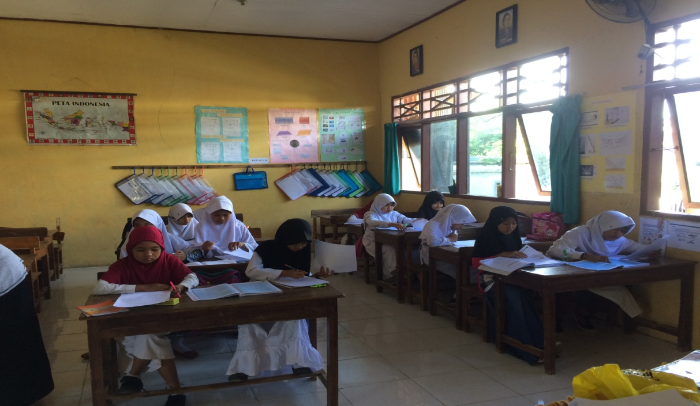
- Siswa mengerjakan angket dan tes yang telah dibagikan
