Lampiran 9 : Output Uji Normalitas
Output Uji Normalitas Kelas Kontrol
One-Sample Kolmogorov-Smirnov Test
 |  | Pretest_kontrol | Posttest_kontrol
N |  | 26 | 26
Normal Parameters^{a,b} | Mean | 17.6923 | 20.0000
 | Std. Deviation | 4.52344 | 3.66606
Most Extreme Differences | Absolute | .152 | .123
 | Positive | .146 | .091
 | Negative | -.152 | -.123
Kolmogorov-Smirnov Z |  | .777 | .629
Asymp. Sig. (2-tailed) |  | .583 | .824
a. Test distribution is Normal.
b. Calculated from data.

Output Uji Normalitas Kelas Eksperimen
One-Sample Kolmogorov-Smirnov Test
 |  | Pretest_eksperimen | Posttest_eksperimen
N |  | 22 | 22
Normal Parameters^{a,b} | Mean | 17.7727 | 20.9545
 | Std. Deviation | 5.55434 | 5.23247
Most Extreme Differences | Absolute | .201 | .261
 | Positive | .101 | .124
 | Negative | -.201 | -.261
Kolmogorov-Smirnov Z |  | .944 | 1.224
Asymp. Sig. (2-tailed) |  | .335 | .100
a. Test distribution is Normal.
b. Calculated from data.

Lampiran 10 : Uji Homogenitas

Test of Homogeneity of Variances
Pretest Kelas Kontrol
Levene Statistic | df1 | df2 | Sig.
1.632 | 6 | 15 | .206

Test of Homogeneity of Variances
Pretest Kelas Eksperimen
Levene Statistic | df1 | df2 | Sig.
1.854 | 4 | 10 | .195

Lampiran 11 : Uji Independent Sample T test

Group Statistics
 | Grup | N | Mean | Std. Deviation | Std. Error Mean
N-Gain Eksperimen  N-Gain Kontrol |  | 22 | .2723 | .16753 | .03572
 |  | 26 | .1546 | .20561 | .04032

Independent Samples Test
 | Levene's Test for Equality of Variances |  | t-test for Equality of Means
 | F | Sig. | t | df | Sig. (2-tailed) | Mean Difference | Std. Error Difference | 95% Confidence Interval of the Difference
 |  |  |  |  |  |  |  | Lower | Upper
Equal variances assumed  Equal variances not assumed | .471 | .496 | 2.147 | 46 | .037 | .11766 | .05480 | .00735 | .22797
 |  |  | 2.184 | 45.947 | .034 | .11766 | .05387 | .00923 | .22609

Lampiran 12 : Rekapitulasi Nilai Pretest, Posttest, dan N-Gain

Kelas Kontrol
Nomor Siswa | Pretest | Posttest | N-Gain
1. | 25 | 26 | 0.20
2. | 14 | 14 | 0.00
3. | 13 | 19 | 0.35
4. | 14 | 15 | 0.06
5. | 16 | 17 | 0.07
6. | 14 | 18 | 0.25
7. | 14 | 12 | -0.13
8. | 12 | 19 | 0.39
9. | 22 | 21 | -0.13
10. | 21 | 20 | -0.11
11. | 26 | 26 | 0.00
12. | 16 | 21 | 0.36
13. | 25 | 26 | 0.20
14. | 9 | 23 | 0.67
15. | 16 | 19 | 0.21
16. | 22 | 23 | 0.13
17. | 21 | 20 | -0.11
18. | 22 | 23 | 0.13
19. | 15 | 17 | 0.13
20. | 21 | 23 | 0.22
21. | 18 | 23 | 0.42
22. | 13 | 15 | 0.12
23. | 21 | 19 | -0.22
24. | 14 | 19 | 0.31
25. | 18 | 22 | 0.33
26. | 18 | 20 | 0.17
Rata-rata | 17.69 | 20.00 | 0.15

Kelas Eksperimen
Nomor Siswa | Pretest | Posttest | N-Gain
1. | 8 | 13 | 0.23
2. | 14 | 24 | 0.63
3. | 14 | 23 | 0.56
4. | 21 | 22 | 0.11
5. | 20 | 23 | 0.30
6. | 10 | 11 | 0.05
7. | 20 | 23 | 0.30
8. | 18 | 24 | 0.50
9. | 14 | 17 | 0.19
10. | 17 | 20 | 0.23
11. | 23 | 24 | 0.14
12. | 25 | 27 | 0.40
13. | 20 | 22 | 0.20
14. | 23 | 24 | 0.14
15. | 25 | 26 | 0.20
16. | 25 | 27 | 0.40
17. | 8 | 12 | 0.18
18. | 8 | 10 | 0.09
19. | 20 | 23 | 0.30
20. | 20 | 24 | 0.40
21. | 17 | 17 | 0.00
22. | 21 | 25 | 0.44
Rata-rata | 17.77 | 20.95 | 0.27

Lampiran 13 : Persentase Skor Nilai Pretest dan Posttest

 |  | Pretest_Kontrol | Posttets_Kontrol | Pretest_Eksperimen | Posttest_Eksperimen
N | Valid | 26 | 26 | 22 | 22
 | Missing | 0 | 0 | 4 | 4
Mean |  | 59.2692 | 67.0385 | 59.5909 | 70.1364
Median |  | 57.0000 | 67.0000 | 67.0000 | 77.0000
Mode |  | 47.00 | 77.00 | 67.00 | 80.00
Std. Deviation |  | 15.16986 | 12.26860 | 18.53609 | 17.34879
Variance |  | 230.125 | 150.518 | 343.587 | 300.981
Range |  | 57.00 | 47.00 | 57.00 | 56.00
Minimum |  | 30.00 | 40.00 | 27.00 | 34.00
Maximum |  | 87.00 | 87.00 | 84.00 | 90.00
Sum |  | 1541.00 | 1743.00 | 1311.00 | 1543.00

Frequency Table
Pretest_Kontrol
 |  | Frequency | Percent | Valid Percent | Cumulative Percent
Valid | 30.00 | 1 | 3.8 | 3.8 | 3.8
 | 40.00 | 1 | 3.8 | 3.8 | 7.7
 | 43.00 | 1 | 3.8 | 3.8 | 11.5
 | 44.00 | 1 | 3.8 | 3.8 | 15.4
 | 47.00 | 5 | 19.2 | 19.2 | 34.6
 | 50.00 | 1 | 3.8 | 3.8 | 38.5
 | 54.00 | 3 | 11.5 | 11.5 | 50.0
 | 60.00 | 3 | 11.5 | 11.5 | 61.5
 | 70.00 | 4 | 15.4 | 15.4 | 76.9
 | 74.00 | 3 | 11.5 | 11.5 | 88.5
 | 84.00 | 2 | 7.7 | 7.7 | 96.2
 | 87.00 | 1 | 3.8 | 3.8 | 100.0
 | Total | 26 | 100.0 | 100.0
Posttets_Kontrol
 |  | Frequency | Percent | Valid Percent |  | Cumulative Percent
Valid | 40.00 | 1 | 3.8 | 3.8 |  | 3.8
 | 47.00 | 1 | 3.8 | 3.8 |  | 7.7
 | 50.00 | 2 | 7.7 | 7.7 |  | 15.4
 | 57.00 | 2 | 7.7 | 7.7 |  | 23.1
 | 60.00 | 1 | 3.8 | 3.8 |  | 26.9
 | 64.00 | 4 | 15.4 | 15.4 |  | 42.3
 | 65.00 | 1 | 3.8 | 3.8 |  | 46.2
 | 67.00 | 3 | 11.5 | 11.5 |  | 57.7
 | 70.00 | 2 | 7.7 | 7.7 |  | 65.4
 | 74.00 | 1 | 3.8 | 3.8 |  | 69.2
 | 77.00 | 5 | 19.2 | 19.2 |  | 88.5
 | 87.00 | 3 | 11.5 | 11.5 |  | 100.0
 | Total | 26 | 100.0 | 100.0

Pretest_Eksperimen
 |  | Frequency | Percent | Valid Percent | Cumulative Percent
Valid | 27.00 | 3 | 11.5 | 13.6 | 13.6
 | 34.00 | 1 | 3.8 | 4.5 | 18.2
 | 47.00 | 3 | 11.5 | 13.6 | 31.8
 | 57.00 | 2 | 7.7 | 9.1 | 40.9
 | 60.00 | 1 | 3.8 | 4.5 | 45.5
 | 67.00 | 5 | 19.2 | 22.7 | 68.2
 | 70.00 | 2 | 7.7 | 9.1 | 77.3
 | 77.00 | 2 | 7.7 | 9.1 | 86.4
 | 84.00 | 3 | 11.5 | 13.6 | 100.0
 | Total | 22 | 84.6 | 100.0
Missing | System | 4 | 15.4
Total |  | 26 | 100.0

Posttest_Eksperimen
 |  | Frequency | Percent | Valid Percent | Cumulative Percent
Valid | 34.00 | 1 | 3.8 | 4.5 | 4.5
 | 37.00 | 1 | 3.8 | 4.5 | 9.1
 | 40.00 | 1 | 3.8 | 4.5 | 13.6
 | 44.00 | 1 | 3.8 | 4.5 | 18.2
 | 57.00 | 2 | 7.7 | 9.1 | 27.3
 | 67.00 | 1 | 3.8 | 4.5 | 31.8
 | 74.00 | 2 | 7.7 | 9.1 | 40.9
 | 77.00 | 4 | 15.4 | 18.2 | 59.1
 | 80.00 | 5 | 19.2 | 22.7 | 81.8
 | 84.00 | 1 | 3.8 | 4.5 | 86.4
 | 87.00 | 1 | 3.8 | 4.5 | 90.9
 | 90.00 | 2 | 7.7 | 9.1 | 100.0
 | Total | 22 | 84.6 | 100.0
Missing | System | 4 | 15.4
Total |  | 26 | 100.0

Lampiran 14 : Dokumentasi Kegiatan
Pretest Kelas Kontrol

Posttest Kelas Kontrol
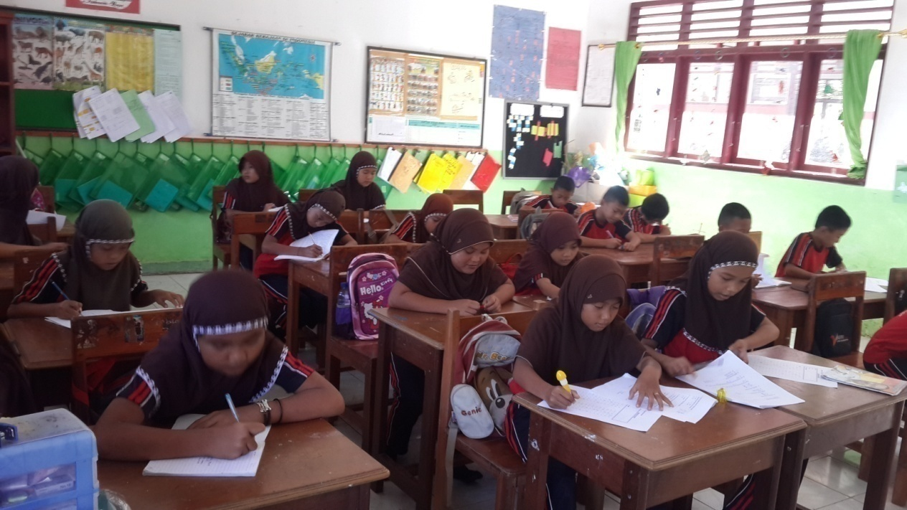

Proses pembelajaran

