**FOTO KEGIATAN PENELITIAN**

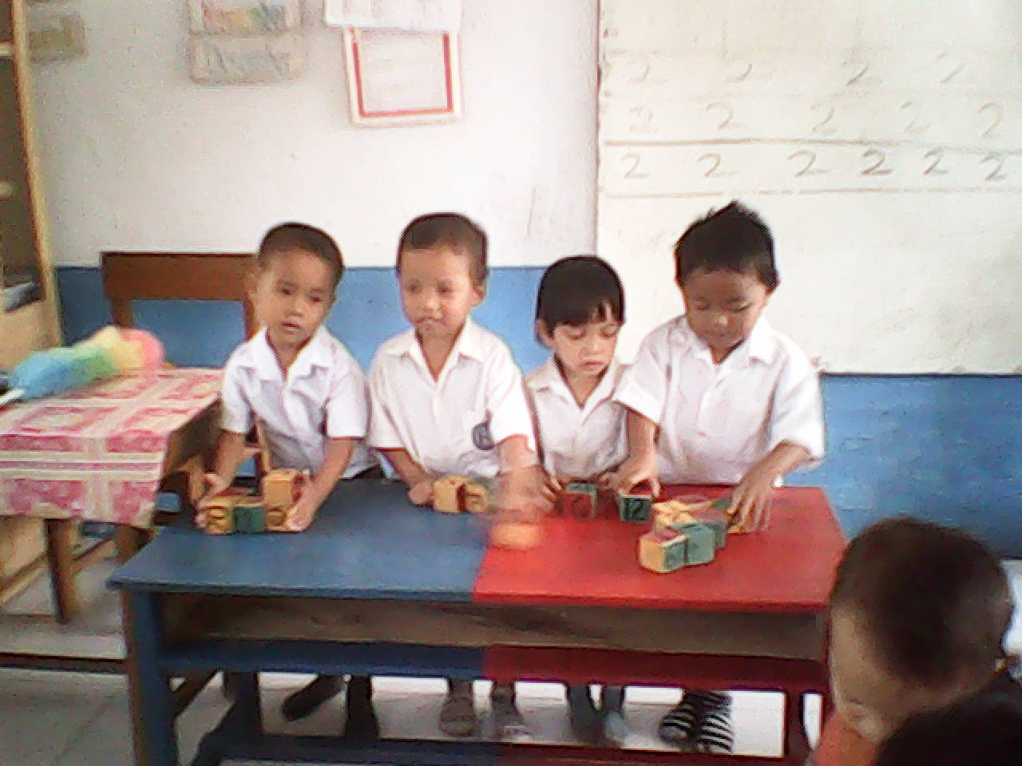

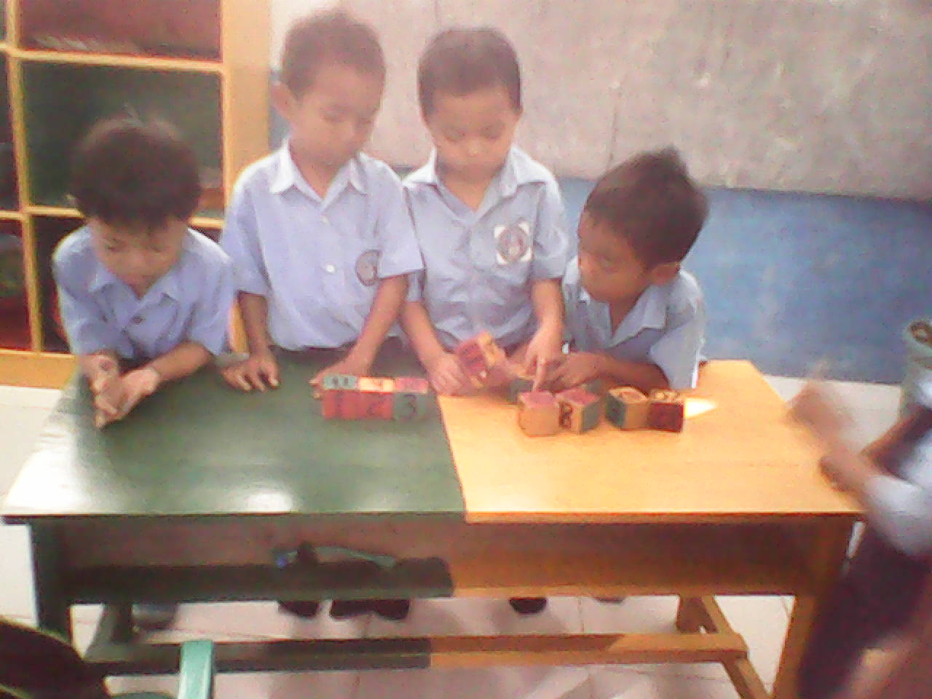

Lampiran 00