LAMPIRAN 14
ANALISIS STATISTIK DESKRIPTIF EKSPERIMEN

Frequencies
Statistics
 |  | pretest | posttest
N | Valid | 20 | 20
 | Missing | 0 | 0
Mean |  | 75.8000 | 1.1070E2
Std. Error of Mean |  | 2.31312 | 1.98958
Median |  | 76.5000 | 1.1150E2
Mode |  | 82.00 | 102.00ª
Std. Deviation |  | 1.03446E1 | 8.89766
Variance |  | 107.011 | 79.168
Range |  | 40.00 | 29.00
Minimum |  | 57.00 | 96.00
Maximum |  | 97.00 | 125.00
Sum |  | 1516.00 | 2214.00
Percentiles | 25 | 66.2500 | 1.0200E2
 | 50 | 76.5000 | 1.1150E2
 | 75 | 82.0000 | 1.1900E2
a. Multiple modes exist. The smallest value is shown

Frequency Table
pretest
 |  | Frequency | Percent | Valid Percent | Cumulative Percent
Valid | 57 | 1 | 5.0 | 5.0 | 5.0
 | 63 | 1 | 5.0 | 5.0 | 10.0
 | 64 | 2 | 10.0 | 10.0 | 20.0
 | 66 | 1 | 5.0 | 5.0 | 25.0
 | 67 | 1 | 5.0 | 5.0 | 30.0
 | 70 | 1 | 5.0 | 5.0 | 35.0
 | 75 | 2 | 10.0 | 10.0 | 45.0
 | 76 | 1 | 5.0 | 5.0 | 50.0
 | 77 | 2 | 10.0 | 10.0 | 60.0
 | 79 | 1 | 5.0 | 5.0 | 65.0
 | 82 | 3 | 15.0 | 15.0 | 80.0
 | 85 | 1 | 5.0 | 5.0 | 85.0
 | 86 | 1 | 5.0 | 5.0 | 90.0
 | 92 | 1 | 5.0 | 5.0 | 95.0
 | 97 | 1 | 5.0 | 5.0 | 100.0
 | Total | 20 | 100.0 | 100.0

posttest
 |  | Frequency | Percent | Valid Percent | Cumulative Percent
Valid | 96 | 1 | 5.0 | 5.0 | 5.0
 | 97 | 1 | 5.0 | 5.0 | 10.0
 | 101 | 1 | 5.0 | 5.0 | 15.0
 | 102 | 3 | 15.0 | 15.0 | 30.0
 | 103 | 1 | 5.0 | 5.0 | 35.0
 | 109 | 2 | 10.0 | 10.0 | 45.0
 | 110 | 1 | 5.0 | 5.0 | 50.0
 | 113 | 1 | 5.0 | 5.0 | 55.0
 | 115 | 2 | 10.0 | 10.0 | 65.0
 | 116 | 2 | 10.0 | 10.0 | 75.0
 | 120 | 3 | 15.0 | 15.0 | 90.0
 | 123 | 1 | 5.0 | 5.0 | 95.0
 | 125 | 1 | 5.0 | 5.0 | 100.0
 | Total | 20 | 100.0 | 100.0

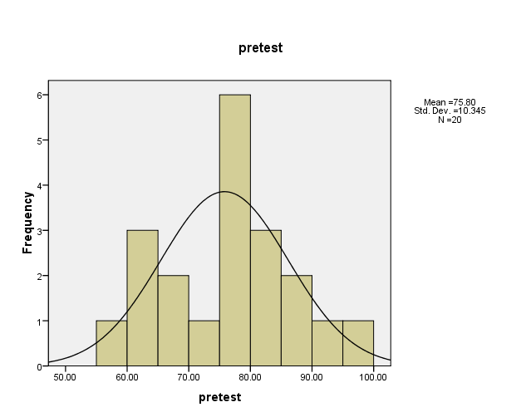
Histogram

