Lampiran 18
- Analisis Statistik
Frequencies
Statistics
 |  | VAR00001 | VAR00002
N | Valid | 10 | 10
 | Missing | 0 | 0
Mean |  | 35.3000 | 3.8000
Std. Error of Mean |  | 4.34626 | 2.43949
Median |  | 32.0000 | 2.0000
Mode |  | 31.00 | 2.00
Std. Deviation |  | 13.74409 | 7.71434
Variance |  | 188.900 | 59.511
Range |  | 49.00 | 24.00
Minimum |  | 16.00 | -5.00
Maximum |  | 65.00 | 19.00
Sum |  | 353.00 | 38.00
Frequency Table
VAR00001
 |  | Frequency | Percent | Valid Percent | Cumulative Percent
Valid | 16 | 1 | 10.0 | 10.0 | 10.0
 | 24 | 1 | 10.0 | 10.0 | 20.0
 | 27 | 1 | 10.0 | 10.0 | 30.0
 | 31 | 2 | 20.0 | 20.0 | 50.0
 | 33 | 1 | 10.0 | 10.0 | 60.0
 | 36 | 1 | 10.0 | 10.0 | 70.0
 | 42 | 1 | 10.0 | 10.0 | 80.0
 | 48 | 1 | 10.0 | 10.0 | 90.0
 | 65 | 1 | 10.0 | 10.0 | 100.0
 | Total | 10 | 100.0 | 100.0

VAR00002
 |  | Frequency | Percent | Valid Percent | Cumulative Percent
Valid | -5 | 1 | 10.0 | 10.0 | 10.0
 | -2 | 1 | 10.0 | 10.0 | 20.0
 | -1 | 1 | 10.0 | 10.0 | 30.0
 | 0 | 1 | 10.0 | 10.0 | 40.0
 | 2 | 2 | 20.0 | 20.0 | 60.0
 | 3 | 1 | 10.0 | 10.0 | 70.0
 | 4 | 1 | 10.0 | 10.0 | 80.0
 | 16 | 1 | 10.0 | 10.0 | 90.0
 | 19 | 1 | 10.0 | 10.0 | 100.0
 | Total | 10 | 100.0 | 100.0

Histogram
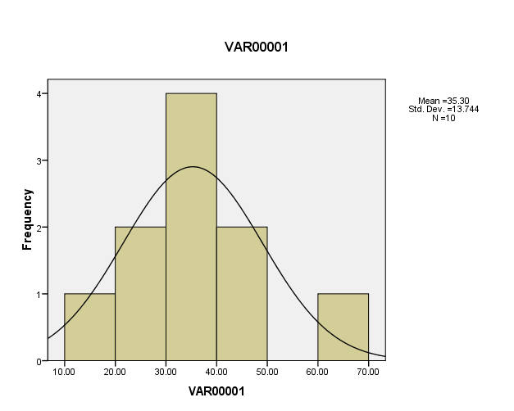

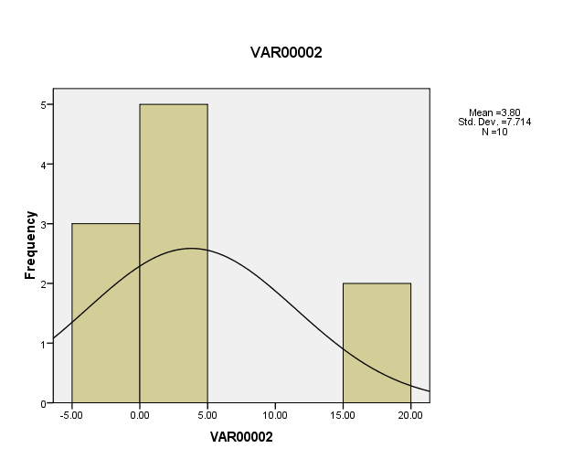

- Uji Hipotesis
- Uji Normalitas
Explore
Case Processing Summary
 | Cases
 | Valid |  | Missing |  | Total
 | N | Percent | N | Percent | N | Percent
VAR00001 | 10 | 100.0% | 0 | .0% | 10 | 100.0%
VAR00002 | 10 | 100.0% | 0 | .0% | 10 | 100.0%
Tests of Normality
 | Kolmogorov-Smirnovª |  |  | Shapiro-Wilk
 | Statistic | df | Sig. | Statistic | df | Sig.
VAR00001 | .180 | 10 | .200* | .937 | 10 | .522
VAR00002 | .290 | 10 | .017 | .834 | 10 | .037
a. Lilliefors Significance Correction
*. This is a lower bound of the true significance.
VAR00001
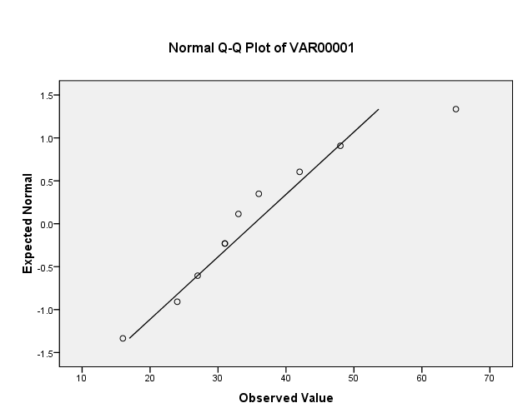

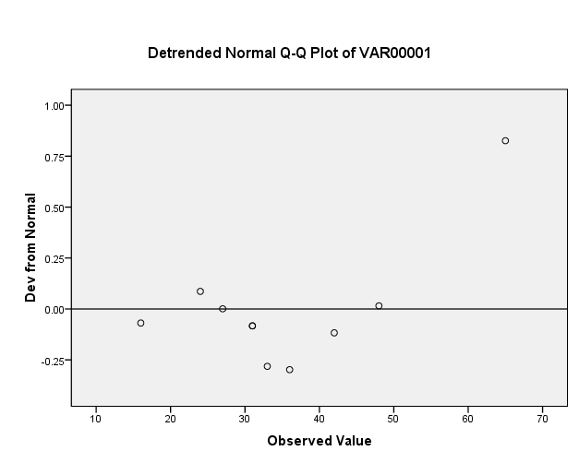
VAR00002
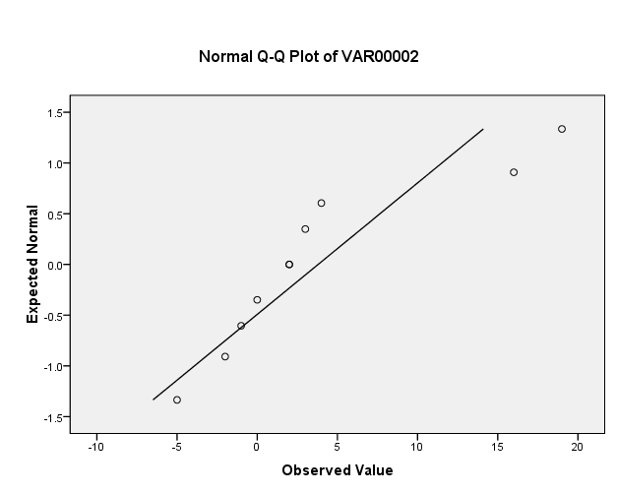

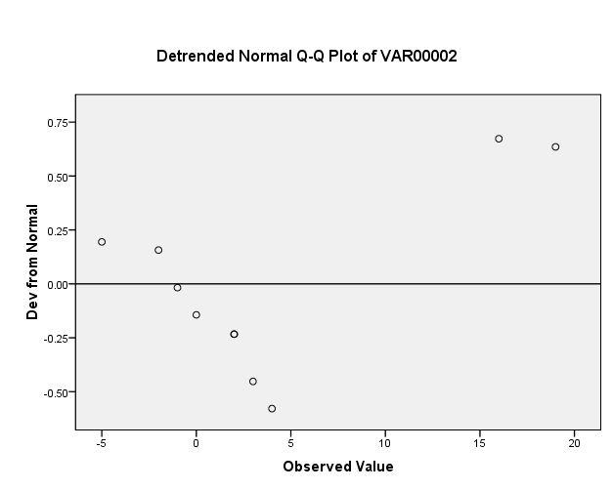

- Uji Homogenitas
ANOVA
VAR00002
 | Sum of Squares | df | Mean Square | F | Sig.
Between Groups | 391.100 | 8 | 48.888 | .338 | .876
Within Groups | 144.500 | 1 | 144.500
Total | 535.600 | 9

- Uji t
t-test
Paired Samples Statistics
 |  |  |  | Mean | N |  |  | Std. Deviation |  |  |  |  | Std. Error Mean
Pair 1 | VAR00001 |  |  | 35.3000 | 10 |  |  | 13.74409 |  |  |  |  | 4.34626
 | VAR00002 |  |  | 3.8000 | 10 |  |  | 7.71434 |  |  |  |  | 2.43949
Paired Samples Correlations
 |  |  |  |  |  |  | N |  |  | Correlation |  | Sig.
Pair 1 | VAR00001 & VAR00002 |  |  |  |  |  | 10 |  |  | .455 |  | .186
Paired Samples Test
 |  |  | Paired Differences |  |  |  |  |  |  |  |  |  |  |  |  |  | t | df | Sig. (2-tailed)
 |  |  | Mean |  |  | Std. Deviation |  |  | Std. Error Mean |  | 95% Confidence Interval of the Difference
 |  |  |  |  |  |  |  |  |  |  | Lower |  |  | Upper
Pair 1 |  | VAR00001 - VAR00002 | 3.15000E1 |  |  | 12.32207 |  |  | 3.89658 |  | 22.68532 |  |  | 40.31468 |  |  | 8.084 | 9 | .000

