DATA PENELITIAN
Lampiran 12
GAIN SKOR TEKNIK KONSELING KELOMPOK PENDEKATAN RATIONAL EMOTIVE BEHAVIOR THERAPY
DI SMA NEGERI 1 BONTONOMPO

RESPONDEN | PRETEST | POSTTEST | GAIN SKOR
NR | 141 | 83 | 58
ER | 123 | 86 | 37
ADR | 110 | 71 | 39
SND | 132 | 87 | 45
RA | 135 | 82 | 53
RSW | 130 | 84 | 46
SHR | 131 | 91 | 40
AH | 123 | 79 | 44
JL | 128 | 75 | 53
MTS | 123 | 77 | 46
ISL | 136 | 70 | 66
HS | 122 | 80 | 42
MF | 134 | 93 | 41
AN | 113 | 78 | 35
15 | 129 | 84 | 45
Jumlah | 1910 | 1220 | 690
Rata-rata | 127.33 | 81.33 | 46
Sumber : Hasil Angket Penelitian

DATA HASIL PENELITIAN
Lampiran 13
Analisis Statistik Deskriptif

Frequencies

Statistics
 |  | VAR00001 | VAR00002
N | Valid | 15 | 15
 | Missing | 0 | 0
Mean |  | 127.3333 | 81.3333
Std. Error of Mean |  | 2.18363 | 1.70899
Median |  | 129.0000ª | 82.0000ª
Mode |  | 123.00 | 84.00
Std. Deviation |  | 8.45718 | 6.61888
Variance |  | 71.524 | 43.810
Skewness |  | -.603 | -.037
Std. Error of Skewness |  | .580 | .580
Kurtosis |  | .119 | -.397
Std. Error of Kurtosis |  | 1.121 | 1.121
Range |  | 31.00 | 23.00
Minimum |  | 110.00 | 70.00
Maximum |  | 141.00 | 93.00
Sum |  | 1910.00 | 1220.00
Percentiles | 10 | 113.0000^{b} | 71.0000^{b}
 | 20 | 122.2500 | 76.0000
 | 25 | 122.6250 | 77.2500
 | 30 | 123.0000 | 78.0000
 | 40 | 126.7500 | 79.5000
 | 50 | 129.0000 | 82.0000
 | 60 | 130.5000 | 83.3333
 | 70 | 132.0000 | 84.6667
 | 75 | 133.5000 | 85.6667
 | 80 | 134.5000 | 86.5000
 | 90 | 136.0000 | 91.0000
a. Calculated from grouped data.
b. Percentiles are calculated from grouped data.

Frequency Table

VAR00001
 |  | Frequency | Percent | Valid Percent | Cumulative Percent
Valid | 110 | 1 | 6.7 | 6.7 | 6.7
 | 113 | 1 | 6.7 | 6.7 | 13.3
 | 122 | 1 | 6.7 | 6.7 | 20.0
 | 123 | 3 | 20.0 | 20.0 | 40.0
 | 128 | 1 | 6.7 | 6.7 | 46.7
 | 129 | 1 | 6.7 | 6.7 | 53.3
 | 130 | 1 | 6.7 | 6.7 | 60.0
 | 131 | 1 | 6.7 | 6.7 | 66.7
 | 132 | 1 | 6.7 | 6.7 | 73.3
 | 134 | 1 | 6.7 | 6.7 | 80.0
 | 135 | 1 | 6.7 | 6.7 | 86.7
 | 136 | 1 | 6.7 | 6.7 | 93.3
 | 141 | 1 | 6.7 | 6.7 | 100.0
 | Total | 15 | 100.0 | 100.0

VAR00002
 |  | Frequency | Percent | Valid Percent | Cumulative Percent
Valid | 70 | 1 | 6.7 | 6.7 | 6.7
 | 71 | 1 | 6.7 | 6.7 | 13.3
 | 75 | 1 | 6.7 | 6.7 | 20.0
 | 77 | 1 | 6.7 | 6.7 | 26.7
 | 78 | 1 | 6.7 | 6.7 | 33.3
 | 79 | 1 | 6.7 | 6.7 | 40.0
 | 80 | 1 | 6.7 | 6.7 | 46.7
 | 82 | 1 | 6.7 | 6.7 | 53.3
 | 83 | 1 | 6.7 | 6.7 | 60.0
 | 84 | 2 | 13.3 | 13.3 | 73.3
 | 86 | 1 | 6.7 | 6.7 | 80.0
 | 87 | 1 | 6.7 | 6.7 | 86.7
 | 91 | 1 | 6.7 | 6.7 | 93.3
 | 93 | 1 | 6.7 | 6.7 | 100.0
 | Total | 15 | 100.0 | 100.0

Histogram
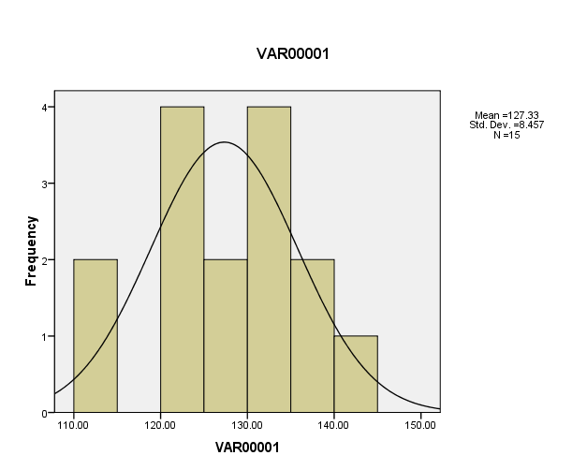

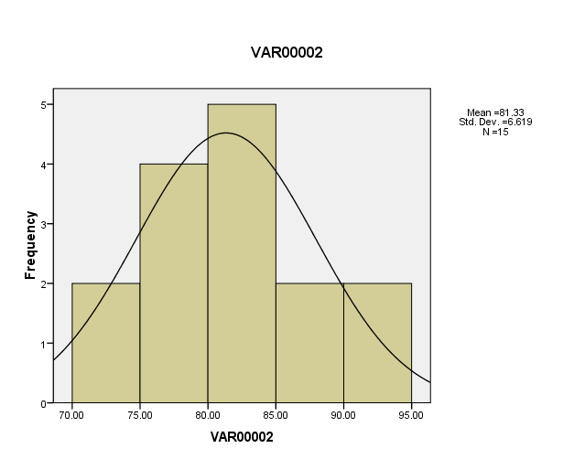

Wilcoxon Signed Ranks Test

Ranks
 |  |  |  | N | Mean Rank | Sum of Ranks
VAR00002 - VAR00001 |  | Negative Ranks |  | 15ª | 8.00 | 120.00
 |  | Positive Ranks |  | 0^{b} | .00 | .00
 |  | Ties |  | 0^{c}
 |  | Total |  | 15
a. VAR00002 < VAR00001
b. VAR00002 > VAR00001
c. VAR00002 = VAR00001
Test Statistics^{b}
 | VAR00002 - VAR00001
Z | -3.410ª
Asymp. Sig. (2-tailed) | .001
a. Based on positive ranks.
b. Wilcoxon Signed Ranks Test

