Lampiran 12

TABEL STATISTIK

Frequencies

[DataSet0]

Statistics
 |  | var0001 | var0002
N | Valid | 30 | 30
 | Missing | 0 | 0
Mean |  | 65.4333 | 92.6667
Std. Error of Mean |  | 1.05665 | 1.77488
Median |  | 66.0000 | 93.0000
Mode |  | 66.00ª | 101.00
Std. Deviation |  | 5.78752 | 9.72141
Variance |  | 33.495 | 94.506
Range |  | 19.00 | 35.00
Minimum |  | 57.00 | 68.00
Maximum |  | 76.00 | 103.00
Sum |  | 1963.00 | 2780.00
a. Multiple modes exist. The smallest value is shown

var0001
 |  | Frequency | Percent | Valid Percent | Cumulative Percent
Valid | 57 | 2 | 6.7 | 6.7 | 6.7
 | 58 | 3 | 10.0 | 10.0 | 16.7
 | 59 | 2 | 6.7 | 6.7 | 23.3
 | 60 | 2 | 6.7 | 6.7 | 30.0
 | 62 | 2 | 6.7 | 6.7 | 36.7
 | 63 | 1 | 3.3 | 3.3 | 40.0
 | 64 | 1 | 3.3 | 3.3 | 43.3
 | 65 | 1 | 3.3 | 3.3 | 46.7
 | 66 | 4 | 13.3 | 13.3 | 60.0
 | 67 | 1 | 3.3 | 3.3 | 63.3
 | 69 | 1 | 3.3 | 3.3 | 66.7
 | 70 | 1 | 3.3 | 3.3 | 70.0
 | 71 | 4 | 13.3 | 13.3 | 83.3
 | 72 | 2 | 6.7 | 6.7 | 90.0
 | 73 | 1 | 3.3 | 3.3 | 93.3
 | 74 | 1 | 3.3 | 3.3 | 96.7
 | 76 | 1 | 3.3 | 3.3 | 100.0
 | Total | 30 | 100.0 | 100.0

var0002
 |  | Frequency | Percent | Valid Percent | Cumulative Percent
Valid | 68 | 1 | 3.3 | 3.3 | 3.3
 | 72 | 1 | 3.3 | 3.3 | 6.7
 | 74 | 1 | 3.3 | 3.3 | 10.0
 | 83 | 1 | 3.3 | 3.3 | 13.3
 | 86 | 3 | 10.0 | 10.0 | 23.3
 | 87 | 2 | 6.7 | 6.7 | 30.0
 | 88 | 1 | 3.3 | 3.3 | 33.3
 | 90 | 2 | 6.7 | 6.7 | 40.0
 | 91 | 2 | 6.7 | 6.7 | 46.7
 | 92 | 1 | 3.3 | 3.3 | 50.0
 | 94 | 1 | 3.3 | 3.3 | 53.3
 | 97 | 1 | 3.3 | 3.3 | 56.7
 | 99 | 1 | 3.3 | 3.3 | 60.0
 | 100 | 1 | 3.3 | 3.3 | 63.3
 | 101 | 5 | 16.7 | 16.7 | 80.0
 | 102 | 4 | 13.3 | 13.3 | 93.3
 | 103 | 2 | 6.7 | 6.7 | 100.0
 | Total | 30 | 100.0 | 100.0

Graph

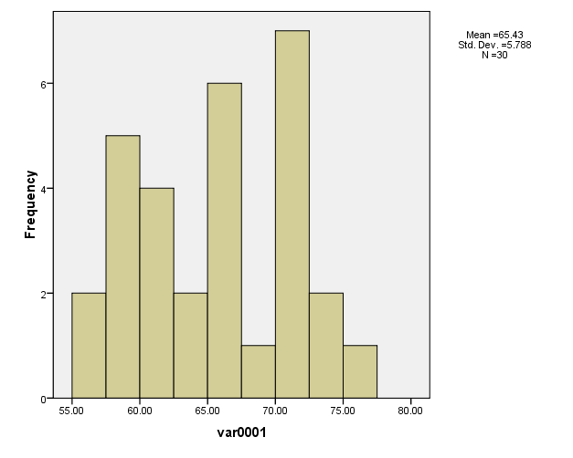

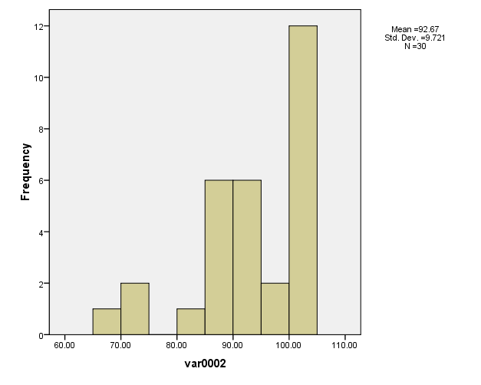

Uji normalitas

Explore

Case Processing Summary
 | Cases
 | Valid |  | Missing |  | Total
 | N | Percent | N | Percent | N | Percent
var0001 | 30 | 100.0% | 0 | .0% | 30 | 100.0%
var0002 | 30 | 100.0% | 0 | .0% | 30 | 100.0%

Tests of Normality
 | Kolmogorov-Smirnovª |  |  | Shapiro-Wilk
 | Statistic | Df | Sig. | Statistic | df | Sig.
var0001 | .132 | 30 | .193 | .936 | 30 | .069
var0002 | .176 | 30 | .019 | .873 | 30 | .002
a. Lilliefors Significance Correction

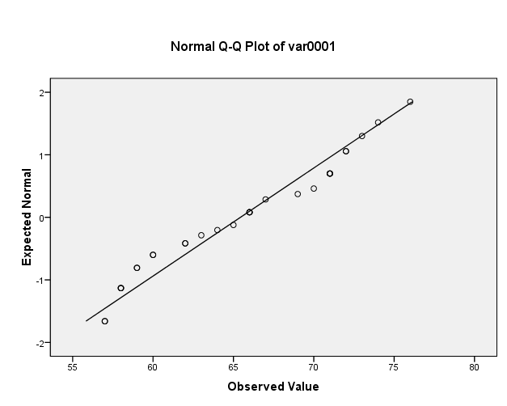
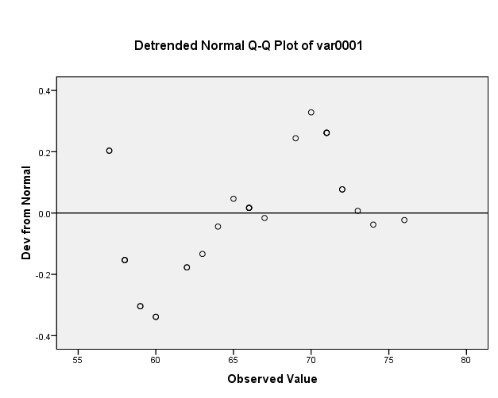

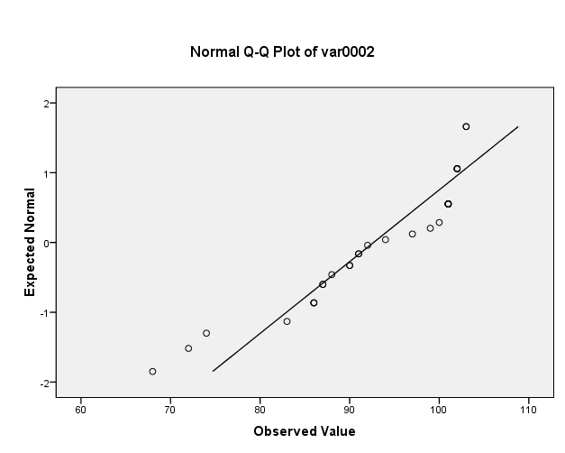

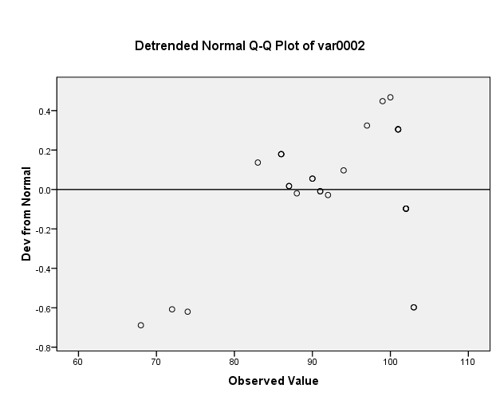

Uji homogenitas

Test of Homogeneity of Variances
nilai
Levene Statistic | df1 | df2 | Sig.
7.146 | 1 | 58 | .010

ANOVA
nilai
 | Sum of Squares | df | Mean Square | F | Sig.
Between Groups | 11124.817 | 1 | 11124.817 | 173.824 | .000
Within Groups | 3712.033 | 58 | 64.001
Total | 14836.850 | 59

T-Test

Paired Samples Statistics
 |  | Mean | N | Std. Deviation | Std. Error Mean
Pair 1 | VAR00001 | 65.4333 | 30 | 5.78752 | 1.05665
 | VAR00002 | 92.6667 | 30 | 9.72141 | 1.77488

Paired Samples Correlations
 |  | N | Correlation | Sig.
Pair 1 | VAR00001 & VAR00002 | 30 | .201 | .288

