Lampiran

GAIN SKOR PRETEST – POSTTEST MOTIVASI BELAJAR KELAS LOWES
SMA NEGERI 1 MARIORIWAWO KABUPATEN SOPPENG

Responden | Eksperimen
 | Pre Test | Post Test | Gain Skor
1 | 86 | 124 | 38
2 | 101 | 139 | 38
3 | 95 | 103 | 8
4 | 91 | 114 | 23
5 | 85 | 150 | 65
6 | 82 | 111 | 29
7 | 94 | 106 | 12
8 | 89 | 112 | 23
9 | 76 | 100 | 24
10 | 87 | 102 | 15
11 | 90 | 130 | 40
12 | 89 | 99 | 10
13 | 76 | 107 | 31
14 | 91 | 113 | 22
15 | 94 | 117 | 23
16 | 89 | 125 | 36
17 | 89 | 121 | 32
18 | 76 | 130 | 54
19 | 94 | 116 | 22
20 | 85 | 122 | 37
21 | 87 | 92 | 5
22 | 94 | 117 | 23
23 | 82 | 129 | 47
24 | 77 | 96 | 19
25 | 80 | 131 | 51
26 | 84 | 100 | 16
27 | 87 | 124 | 37
28 | 78 | 120 | 42
N = 28 | 2428 | 3250 | 822
Rata-rata | 86.71429 | 116.0714 | 29.35714
Lampiran
ANALISIS STATISTIK DESKRIPTIF EKSPERIMEN

Statistics
 |  | Pretest | Posstest
N | Valid | 28 | 28
 | Missing | 0 | 0
Mean |  | 86.7143 | 1.1607E2
Median |  | 87.0000 | 1.1650E2
Mode |  | 89.00ª | 100.00ª
Std. Deviation |  | 6.58763 | 1.37919E1
Sum |  | 2428.00 | 3250.00
Percentiles | 25 | 82.0000 | 1.0375E2
 | 50 | 87.0000 | 1.1650E2
 | 75 | 91.0000 | 1.2475E2

Pretest
 |  | Frequency | Percent | Valid Percent | Cumulative Percent
Valid | 76 | 3 | 10.7 | 10.7 | 10.7
 | 77 | 1 | 3.6 | 3.6 | 14.3
 | 78 | 1 | 3.6 | 3.6 | 17.9
 | 80 | 1 | 3.6 | 3.6 | 21.4
 | 82 | 2 | 7.1 | 7.1 | 28.6
 | 84 | 1 | 3.6 | 3.6 | 32.1
 | 85 | 2 | 7.1 | 7.1 | 39.3
 | 86 | 1 | 3.6 | 3.6 | 42.9
 | 87 | 3 | 10.7 | 10.7 | 53.6
 | 89 | 4 | 14.3 | 14.3 | 67.9
 | 90 | 1 | 3.6 | 3.6 | 71.4
 | 91 | 2 | 7.1 | 7.1 | 78.6
 | 94 | 4 | 14.3 | 14.3 | 92.9
 | 95 | 1 | 3.6 | 3.6 | 96.4
 | 101 | 1 | 3.6 | 3.6 | 100.0
 | Total | 28 | 100.0 | 100.0

Posstest
 |  | Frequency | Percent | Valid Percent | Cumulative Percent
Valid | 92 | 1 | 3.6 | 3.6 | 3.6
 | 96 | 1 | 3.6 | 3.6 | 7.1
 | 99 | 1 | 3.6 | 3.6 | 10.7
 | 100 | 2 | 7.1 | 7.1 | 17.9
 | 102 | 1 | 3.6 | 3.6 | 21.4
 | 103 | 1 | 3.6 | 3.6 | 25.0
 | 106 | 1 | 3.6 | 3.6 | 28.6
 | 107 | 1 | 3.6 | 3.6 | 32.1
 | 111 | 1 | 3.6 | 3.6 | 35.7
 | 112 | 1 | 3.6 | 3.6 | 39.3
 | 113 | 1 | 3.6 | 3.6 | 42.9
 | 114 | 1 | 3.6 | 3.6 | 46.4
 | 116 | 1 | 3.6 | 3.6 | 50.0
 | 117 | 2 | 7.1 | 7.1 | 57.1
 | 120 | 1 | 3.6 | 3.6 | 60.7
 | 121 | 1 | 3.6 | 3.6 | 64.3
 | 122 | 1 | 3.6 | 3.6 | 67.9
 | 124 | 2 | 7.1 | 7.1 | 75.0
 | 125 | 1 | 3.6 | 3.6 | 78.6
 | 129 | 1 | 3.6 | 3.6 | 82.1
 | 130 | 2 | 7.1 | 7.1 | 89.3
 | 131 | 1 | 3.6 | 3.6 | 92.9
 | 139 | 1 | 3.6 | 3.6 | 96.4
 | 150 | 1 | 3.6 | 3.6 | 100.0
 | Total | 28 | 100.0 | 100.0

Histogram
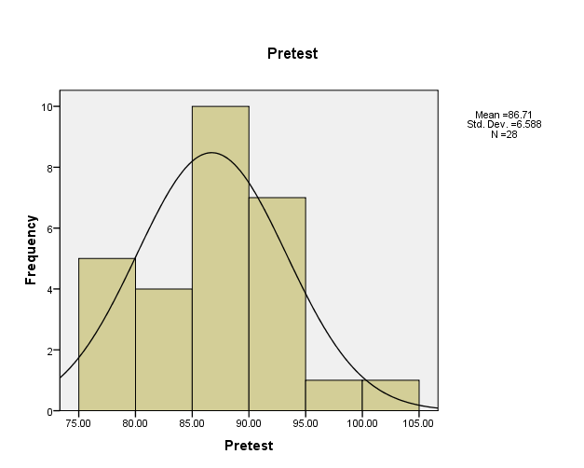

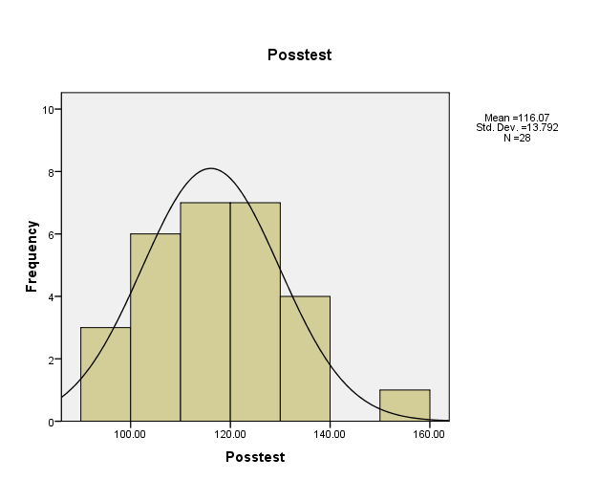

Lampiran
UJI WILCOXON DATA EKSPERIMEN

Ranks
 |  | N | Mean Rank | Sum of Ranks
Posstest - Pretest | Negative Ranks | 0ª | .00 | .00
 | Positive Ranks | 28^{b} | 14.50 | 406.00
 | Ties | 0^{c}
 | Total | 28
a. Posstest < Pretest
b. Posstest > Pretest
c. Posstest = Pretest

Test Statistics^{b}
 | Posstest - Pretest
Z | -4.625ª
Asymp. Sig. (2-tailed) | .000
a. Based on negative ranks.
b. Wilcoxon Signed Ranks Test

