

**DOKUMENTASI**

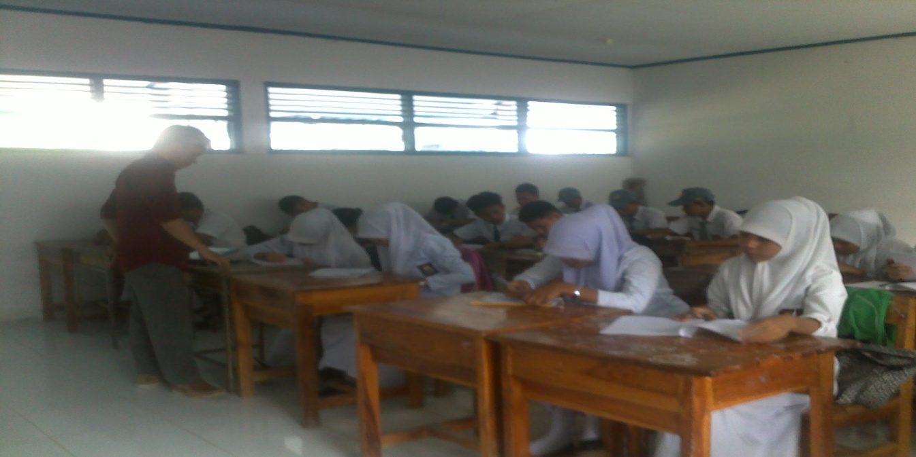

**Gambar Pemberian *Pretest***

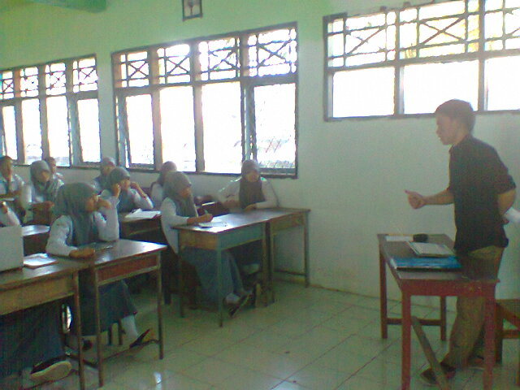

**Gambar Pemberian Teknik *PQRST***

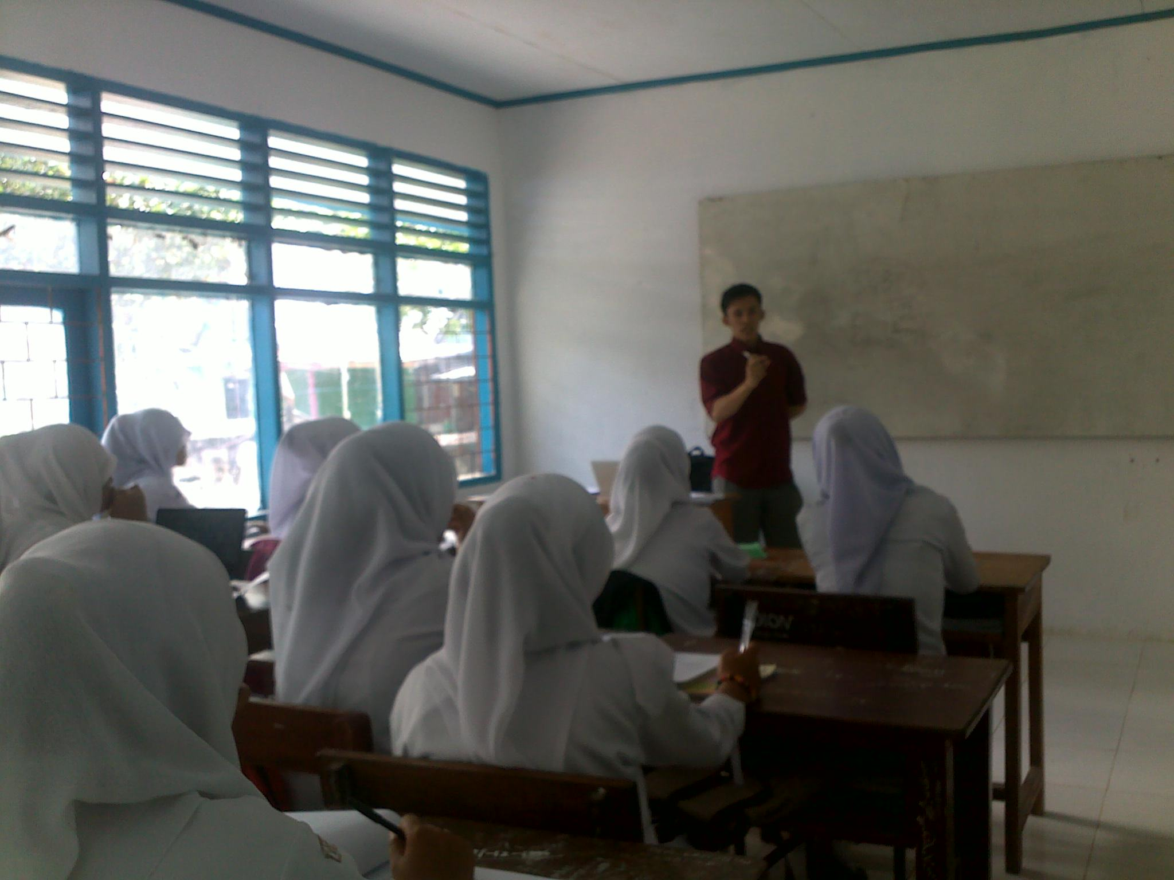

**Gambar Pemberian Teknik *PQRST***

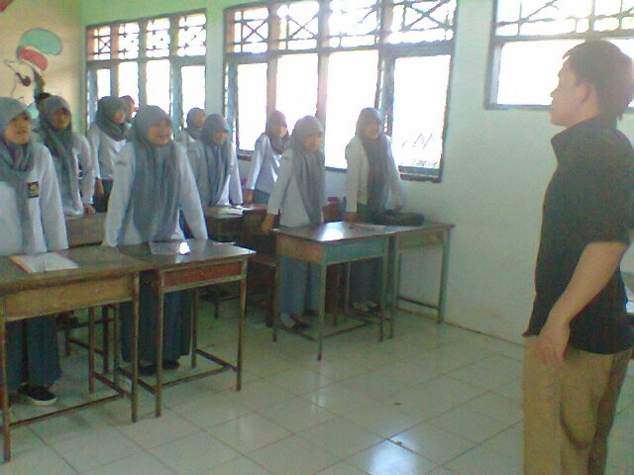

**Gambar Pemberian *Ice Breaking***

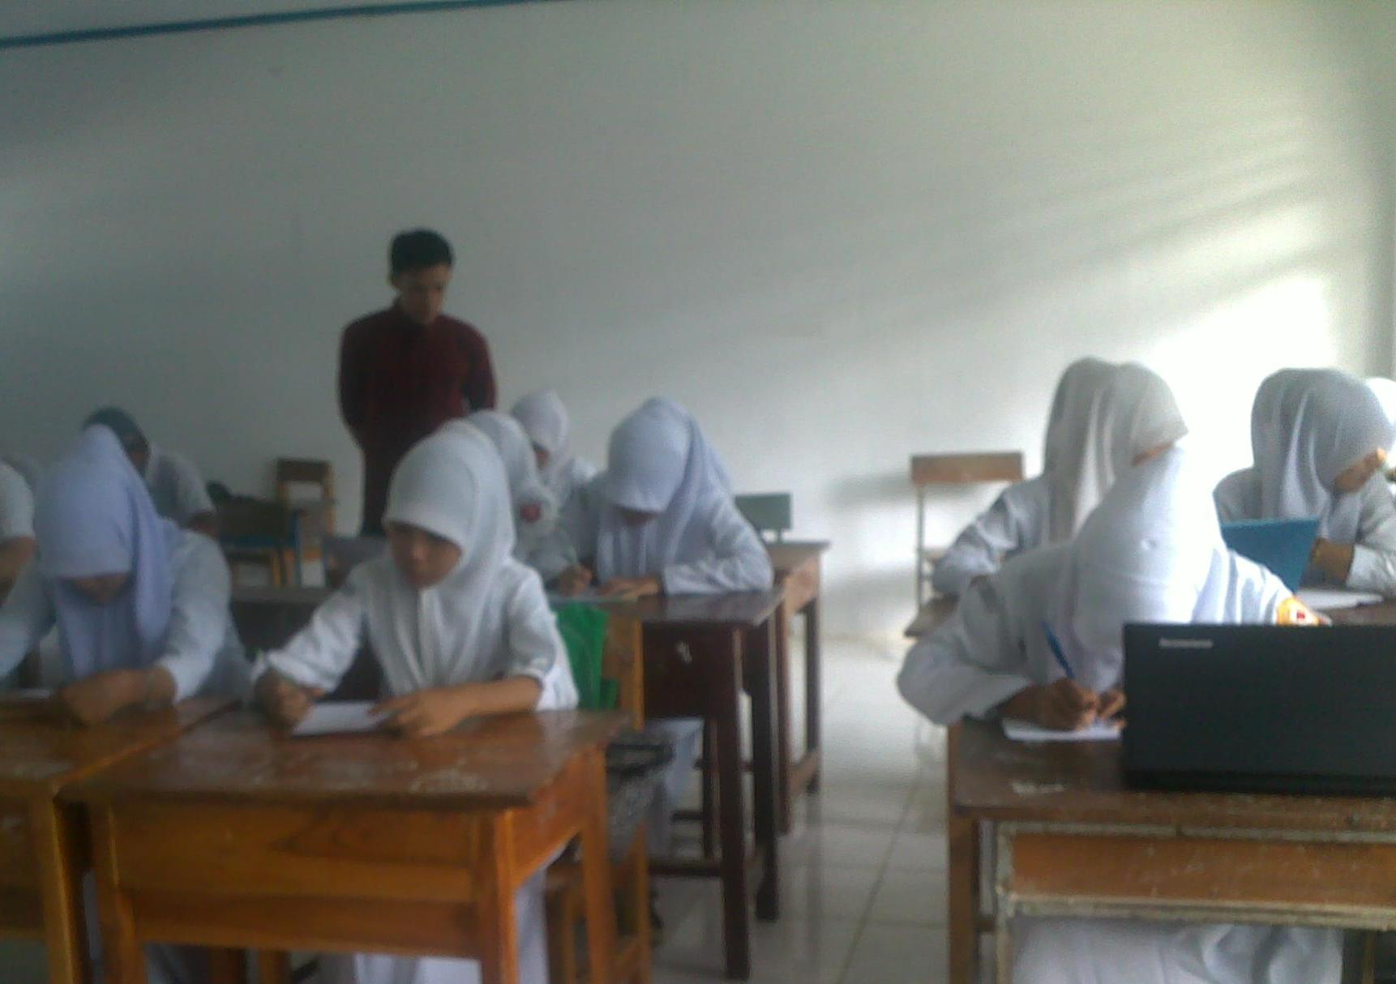

**Gambar Pemberian *Posttest***

**DATA HASIL ANALISIS OBSERVASI SETELAH PELAKSANAAN**

**Lampiran 17**

**TEKNIK *SQ3R***

* 1. Analisis Data Observasi Individu dalam Persen (%)

|  |  |  |  |  |  |
| --- | --- | --- | --- | --- | --- |
| **Responden** | **Pertemuan** | | | | |
| **I** | **II** | **III** | **IV** | **V** |
| 1 | 40% | 50% | 60% | 60% | 70% |
| 2 | 30% | 40% | 60% | 60% | 60% |
| 3 | 30% | 40% | 60% | 70% | 70% |
| 4 | 30% | 30% | 40% | 40% | 70% |
| 5 | 40% | 50% | 60% | 60% | 60% |
| 6 | 10% | 30% | 30% | 60% | 60% |
| 7 | 30% | 30% | 40% | 60% | 60% |
| 8 | 20% | 40% | 40% | 40% | 70% |
| 9 | 40% | 50% | 60% | 60% | 70% |
| 10 | 30% | 30% | 60% | 70% | 80% |
| 11 | 50% | 60% | 60% | 60% | 60% |
| 12 | 40% | 60% | 60% | 80% | 90% |
| 13 | 40% | 50% | 70% | 70% | 90% |
| 14 | 40% | 40% | 40% | 40% | 50% |
| 15 | 30% | 30% | 30% | 30% | 50% |

b.Analisis Data Observasi Kelompok dalam Persen **(**%)

|  |  |  |  |  |  |
| --- | --- | --- | --- | --- | --- |
| **Item** | **Pertemuan** | | | | |
| **I** | **II** | **III** | **IV** | **V** |
| 1 | 16,66% | 20% | 40% | 66.66% | 80% |
| 2 | 26,66% | 20% | 40% | 40% | 66,66% |
| 3 | 46,66% | 46,66% | 60% | 66,66% | 93,33% |
| 4 | 33,33% | 40% | 60% | 66,66% | 80% |
| 5 | 53,33% | 73,33% | 66,66% | 53,33% | 80% |
| 6 | 73,33% | 46,66% | 73,33% | 73,33% | 86,66% |
| 7 | 53,33% | 53,33% | 60% | 53,33% | 53,33% |
| 8 | 33,33% | 40% | 40% | 46,66% | 66,66% |
| 9 | 40% | 53,33% | 53,33% | 53,33% | 80% |
| 10 | 16,33% | 60% | 26,66% | 60% | 66,66% |

**Lampiran 18**

**Data Hasil Persentase Observasi Pelaksanaan Teknik *PQRST***

|  |  |  |  |  |  |  |  |
| --- | --- | --- | --- | --- | --- | --- | --- |
| **Persentase** | **Kriteria** | **Pertemuan** | | | | | |
|  | |  | | **I** | **II** | **III** | **IV** | **V** |
| 80% - 100% | | Sangat Tinggi | | 0 | 0 | 0 | 0 | 0 |
| 60% - 79% | | Tinggi | | 0 | 2 | 9 | 11 | 13 |
| 40% - 59% | | Sedang | | 7 | 8 | 4 | 3 | 2 |
| 20% - 39% | | Rendah | | 7 | 5 | 2 | 1 | 0 |
| 0% - 19% | | Sangat Rendah | | 1 | 0 | 0 | 0 | 0 |
| Jumlah | | | | 15 | 15 | 15 | 15 | 15 |

Sumber: Hasil Observasi