HASIL ANALISIS UJI LAPANGAN
Lampiran 10

Uji Validitas dan Realibilitas

Case Processing Summary
 |  | N | %
Cases | Valid | 30 | 100.0
 | Excludedª | 0 | .0
 | Total | 30 | 100.0
a. Listwise deletion based on all variables in the procedure.

Reliability Statistics
Cronbach's Alpha | N of Items
.896 | 36

Item Statistics
 | Mean | Std. Deviation | N
VAR00001 | 3.3333 | 1.09334 | 30
VAR00002 | 4.0000 | .98261 | 30
VAR00003 | 4.0667 | 1.01483 | 30
VAR00004 | 3.7667 | 1.25075 | 30
VAR00005 | 3.8000 | .80516 | 30
VAR00006 | 4.0333 | 1.09807 | 30
VAR00007 | 4.1667 | 1.14721 | 30
VAR00008 | 4.0333 | 1.06620 | 30
VAR00009 | 3.8000 | 1.18613 | 30
VAR00010 | 4.1333 | 1.07425 | 30
VAR00011 | 4.1667 | .98553 | 30
VAR00012 | 2.7000 | 1.26355 | 30
VAR00013 | 3.4667 | 1.38298 | 30
VAR00014 | 1.8000 | 1.29721 | 30
VAR00015 | 3.9333 | 1.17248 | 30
VAR00016 | 3.7667 | 1.19434 | 30
VAR00017 | 4.1667 | 1.14721 | 30
VAR00018 | 4.3667 | .76489 | 30
VAR00019 | 3.3333 | .95893 | 30
VAR00020 | 3.4000 | .89443 | 30
VAR00021 | 4.0000 | .98261 | 30
VAR00022 | 4.2000 | .96132 | 30
VAR00023 | 3.9333 | 1.04826 | 30
VAR00024 | 3.7667 | 1.25075 | 30
VAR00025 | 4.2000 | .96132 | 30
VAR00026 | 2.7000 | 1.26355 | 30
VAR00027 | 3.8333 | 1.01992 | 30
VAR00028 | 1.8000 | 1.29721 | 30
VAR00029 | 4.6667 | .71116 | 30
VAR00030 | 4.0000 | 1.57568 | 30
VAR00031 | 4.4000 | .85501 | 30
VAR00032 | 3.8667 | 1.30604 | 30
VAR00033 | 3.9667 | 1.24522 | 30
VAR00034 | 4.1333 | 1.07425 | 30
VAR00035 | 3.9333 | 1.04826 | 30
VAR00036 | 4.1667 | 1.11675 | 30

Item-Total Statistics
 | Scale Mean if Item Deleted | Scale Variance if Item Deleted | Corrected Item-Total Correlation | Cronbach's Alpha if Item Deleted
VAR00001 | 132.4667 | 328.671 | .359 | .894
VAR00002 | 131.8000 | 318.717 | .696 | .889
VAR00003 | 131.7333 | 316.133 | .746 | .888
VAR00004 | 132.0333 | 325.895 | .368 | .894
VAR00005 | 132.0000 | 335.448 | .271 | .895
VAR00006 | 131.7667 | 317.978 | .636 | .889
VAR00007 | 131.6333 | 326.654 | .389 | .893
VAR00008 | 131.7667 | 323.151 | .517 | .891
VAR00009 | 132.0000 | 326.069 | .388 | .893
VAR00010 | 131.6667 | 323.333 | .508 | .891
VAR00011 | 131.6333 | 325.068 | .508 | .892
VAR00012 | 133.1000 | 342.438 | .001 | .900
VAR00013 | 132.3333 | 317.195 | .507 | .891
VAR00014 | 134.0000 | 356.069 | -.279 | .906
VAR00015 | 131.8667 | 327.844 | .350 | .894
VAR00016 | 132.0333 | 312.999 | .702 | .888
VAR00017 | 131.6333 | 326.654 | .389 | .893
VAR00018 | 131.4333 | 323.013 | .746 | .890
VAR00019 | 132.4667 | 326.257 | .488 | .892
VAR00020 | 132.4000 | 327.559 | .486 | .892
VAR00021 | 131.8000 | 318.717 | .696 | .889
VAR00022 | 131.6000 | 317.214 | .758 | .888
VAR00023 | 131.8667 | 319.361 | .631 | .890
VAR00024 | 132.0333 | 325.895 | .368 | .894
VAR00025 | 131.6000 | 317.214 | .758 | .888
VAR00026 | 133.1000 | 342.438 | .001 | .900
VAR00027 | 131.9667 | 322.102 | .572 | .891
VAR00028 | 134.0000 | 356.069 | -.279 | .906
VAR00029 | 131.1333 | 330.464 | .508 | .892
VAR00030 | 131.8000 | 358.924 | -.290 | .909
VAR00031 | 131.4000 | 327.628 | .508 | .892
VAR00032 | 131.9333 | 310.892 | .684 | .888
VAR00033 | 131.8333 | 316.489 | .588 | .890
VAR00034 | 131.6667 | 315.540 | .718 | .888
VAR00035 | 131.8667 | 319.430 | .629 | .890
VAR00036 | 131.6333 | 318.240 | .618 | .890

Scale Statistics
Mean | Variance | Std. Deviation | N of Items
1.3580E2 | 344.097 | 18.54984 | 36

DATA PENELITIAN
Lampiran 11

GAIN SKOR KELOMPOK EKSPERIMEN DAN KELOMPOK KONTROL
TERHADAP KESULITAN MEMAHAMI ISI BACAAN TEKS DI SMAN 1 ANGGERAJA KAB. ENREKANG

Kelompok Eksperimen Kelompok Kontrol
Responden | Postest  (X₂) | Pretest  (X₁) | Gain score  (X) | Responden | Postest  (X₂) | Pretest  (X₁) | Gain score  (X)
1  2  3  4  5  6  7  8  9  10  11  12  13  14  15 | 81  91  88  93  93  93  89  92  77  73  80  73  83  77  70 | 125  121  127  116  122  126  123  104  129  126  128  102  130  118  129 | -44  -30  -39  -23  -29  -33  -24  -12  -53  -53  -48  -29  -47  -41  -59 | 1  2  3  4  5  6  7  8  9  10  11  12  13  14  15 | 123  119  126  120  124  120  127  104  131  128  125  135  137  103  127 | 122  104  120  123  122  121  122  116  130  127  124  130  130  118  126 | 1  15  6  -3  2  -1  5  -12  1  1  1  5  7  -15  1
Jumlah | 1253 | 1826 | -564 | Jumlah | 1849 | 1832 | 76
Rata-rata | 83,53 | 121,73 | 37,60 | Rata-rata | 123,26 | 122,13 | 5,06
Sumber : Hasil Angket Penelitian

Data Tingkat Kesulitan Memahami Isi Bacaan Teks Siswa Kelas XI SMAN 1 Anggeraja Sebelum (Pretest) Dan Sesudah (Posttest) Diberi Perlakuan Teknik SQ3R
Interval | Kategori | Pretest Ekperimen |  | Posttest Eksperimen
 |  | F | P (%) | F | P (%)
30 – 54 | Sangat Rendah | 0 | 0 | 0 | 0
55 – 79 | Rendah | 0 | 0 | 5 | 33,33%
80 – 104 | Sedang | 2 | 13,33% | 10 | 66,66%
105 – 129 | Tinggi | 12 | 80% | 0 | 0
130 – 154 | Sangat Tinggi | 1 | 6,66% | 0 | 0
Jumlah |  | 15 | 100 | 15 | 100

Interval | Kategori | Pretest Kontrol |  | Posttest Kontrol
 |  | F | P (%) | F | P (%)
30 – 54 | Sangat Rendah | 0 | 0 | 0 | 0
55 – 79 | Rendah | 0 | 0 | 0 | 0
80 – 104 | Sedang | 2 | 13,33% | 1 | 6,66%
105 – 129 | Tinggi | 10 | 66,66% | 11 | 73,33%
130 – 154 | Sangat Tinggi | 3 | 20% | 3 | 20%
Jumlah |  | 15 | 100 | 15 | 100
Sumber: Hasil Angket Penelitian
DATA HASIL PENELITIAN
Lampiran 12
Analisis Statistik Deskriptif Kelompok Eksperimen
Frequencies

Statistics
 |  | VAR00001 | VAR00002
N | Valid | 15 | 15
 | Missing | 0 | 0
Mean |  | 83.5333 | 121.7333
Std. Error of Mean |  | 2.13333 | 2.22639
Median |  | 83.0000 | 125.0000
Mode |  | 93.00 | 126.00ª
Std. Deviation |  | 8.26236 | 8.62278
Variance |  | 68.267 | 74.352
Skewness |  | -.236 | -1.489
Std. Error of Skewness |  | .580 | .580
Kurtosis |  | -1.514 | 1.501
Std. Error of Kurtosis |  | 1.121 | 1.121
Range |  | 23.00 | 28.00
Minimum |  | 70.00 | 102.00
Maximum |  | 93.00 | 130.00
Sum |  | 1253.00 | 1826.00
a. Multiple modes exist. The smallest value is shown

Frequency Table

VAR00001
 |  | Frequency | Percent | Valid Percent | Cumulative Percent
Valid | 70 | 1 | 6.7 | 6.7 | 6.7
 | 73 | 2 | 13.3 | 13.3 | 20.0
 | 77 | 2 | 13.3 | 13.3 | 33.3
 | 80 | 1 | 6.7 | 6.7 | 40.0
 | 81 | 1 | 6.7 | 6.7 | 46.7
 | 83 | 1 | 6.7 | 6.7 | 53.3
 | 88 | 1 | 6.7 | 6.7 | 60.0
 | 89 | 1 | 6.7 | 6.7 | 66.7
 | 91 | 1 | 6.7 | 6.7 | 73.3
 | 92 | 1 | 6.7 | 6.7 | 80.0
 | 93 | 3 | 20.0 | 20.0 | 100.0
 | Total | 15 | 100.0 | 100.0

VAR00002
 |  | Frequency | Percent | Valid Percent | Cumulative Percent
Valid | 102 | 1 | 6.7 | 6.7 | 6.7
 | 104 | 1 | 6.7 | 6.7 | 13.3
 | 116 | 1 | 6.7 | 6.7 | 20.0
 | 118 | 1 | 6.7 | 6.7 | 26.7
 | 121 | 1 | 6.7 | 6.7 | 33.3
 | 122 | 1 | 6.7 | 6.7 | 40.0
 | 123 | 1 | 6.7 | 6.7 | 46.7
 | 125 | 1 | 6.7 | 6.7 | 53.3
 | 126 | 2 | 13.3 | 13.3 | 66.7
 | 127 | 1 | 6.7 | 6.7 | 73.3
 | 128 | 1 | 6.7 | 6.7 | 80.0
 | 129 | 2 | 13.3 | 13.3 | 93.3
 | 130 | 1 | 6.7 | 6.7 | 100.0
 | Total | 15 | 100.0 | 100.0

Histogram
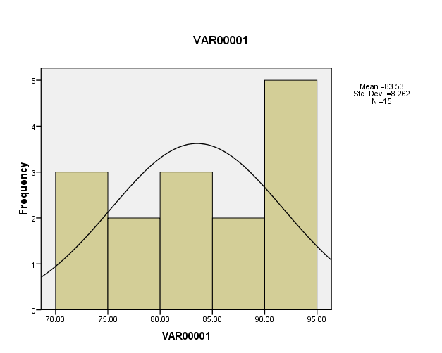

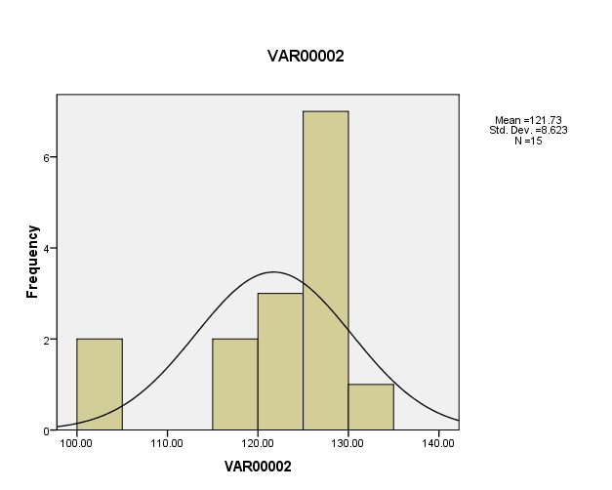

DATA HASIL PENELITIAN
Lampiran 13
Analisis Statistik Deskriptif Kelompok Kontrol
Frequencies

Statistics
 |  | VAR00001 | VAR00002
N | Valid | 15 | 15
 | Missing | 0 | 0
Mean |  | 123.2667 | 122.3333
Std. Error of Mean |  | 2.45816 | 1.71455
Median |  | 125.0000 | 122.0000
Mode |  | 120.00ª | 122.00ª
Std. Deviation |  | 9.52040 | 6.64042
Variance |  | 90.638 | 44.095
Skewness |  | -1.024 | -1.409
Std. Error of Skewness |  | .580 | .580
Kurtosis |  | 1.128 | 3.351
Std. Error of Kurtosis |  | 1.121 | 1.121
Range |  | 34.00 | 26.00
Minimum |  | 103.00 | 104.00
Maximum |  | 137.00 | 130.00
Sum |  | 1849.00 | 1835.00
a. Multiple modes exist. The smallest value is shown

Frequency Table

VAR00001
 |  | Frequency | Percent | Valid Percent | Cumulative Percent
Valid | 103 | 1 | 6.7 | 6.7 | 6.7
 | 104 | 1 | 6.7 | 6.7 | 13.3
 | 119 | 1 | 6.7 | 6.7 | 20.0
 | 120 | 2 | 13.3 | 13.3 | 33.3
 | 123 | 1 | 6.7 | 6.7 | 40.0
 | 124 | 1 | 6.7 | 6.7 | 46.7
 | 125 | 1 | 6.7 | 6.7 | 53.3
 | 126 | 1 | 6.7 | 6.7 | 60.0
 | 127 | 2 | 13.3 | 13.3 | 73.3
 | 128 | 1 | 6.7 | 6.7 | 80.0
 | 131 | 1 | 6.7 | 6.7 | 86.7
 | 135 | 1 | 6.7 | 6.7 | 93.3
 | 137 | 1 | 6.7 | 6.7 | 100.0
 | Total | 15 | 100.0 | 100.0

VAR00002
 |  | Frequency | Percent | Valid Percent | Cumulative Percent
Valid | 104 | 1 | 6.7 | 6.7 | 6.7
 | 116 | 1 | 6.7 | 6.7 | 13.3
 | 118 | 1 | 6.7 | 6.7 | 20.0
 | 120 | 1 | 6.7 | 6.7 | 26.7
 | 121 | 1 | 6.7 | 6.7 | 33.3
 | 122 | 3 | 20.0 | 20.0 | 53.3
 | 123 | 1 | 6.7 | 6.7 | 60.0
 | 124 | 1 | 6.7 | 6.7 | 66.7
 | 126 | 1 | 6.7 | 6.7 | 73.3
 | 127 | 1 | 6.7 | 6.7 | 80.0
 | 130 | 3 | 20.0 | 20.0 | 100.0
 | Total | 15 | 100.0 | 100.0

Histogram
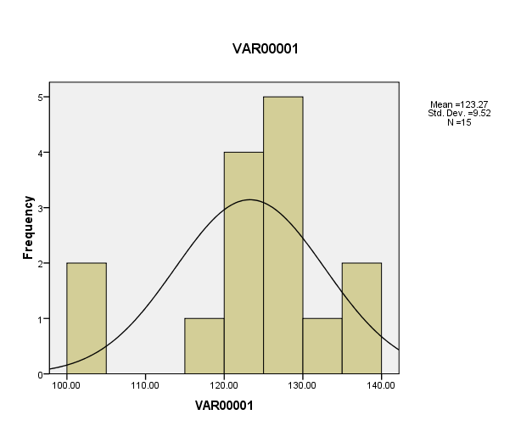

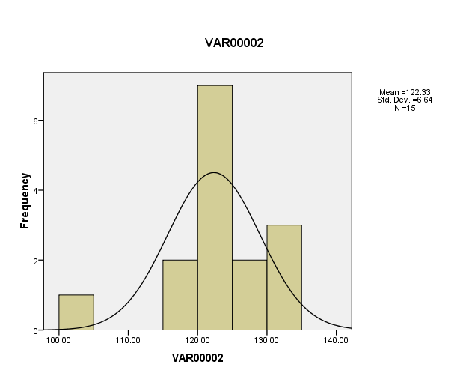

Wilcoxon Signed Ranks Test

Ranks
 |  | N | Mean Rank | Sum of Ranks
VAR00002 - VAR00001 | Negative Ranks | 0ª | .00 | .00
 | Positive Ranks | 15^{b} | 8.00 | 120.00
 | Ties | 0^{c}
 | Total | 15
a. VAR00002 < VAR00001
b. VAR00002 > VAR00001
c. VAR00002 = VAR00001

Test Statistics^{b}
 | VAR00002 - VAR00001
Z | -3.411ª
Asymp. Sig. (2-tailed) | .001
a. Based on negative ranks.
b. Wilcoxon Signed Ranks Test

