Lampiran 17

Analisis statistik deskriptif pada kelompok eksperimen

Frequencies
Statistics
 |  | VAR00001 | VAR00004
N | Valid | 10 | 10
 | Missing | 0 | 0
Mean |  | 83.0000 | 117.9000
Std. Error of Mean |  | 2.66667 | 3.70420
Median |  | 85.0000ª | 117.5000ª
Mode |  | 72.00^{b} | 128.00
Std. Deviation |  | 8.43274 | 11.71371
Variance |  | 71.111 | 137.211
Skewness |  | -.035 | -.216
Std. Error of Skewness |  | .687 | .687
Kurtosis |  | -.989 | -1.048
Std. Error of Kurtosis |  | 1.334 | 1.334
Range |  | 25.00 | 35.00
Minimum |  | 72.00 | 100.00
Maximum |  | 97.00 | 135.00
Sum |  | 830.00 | 1179.00
Percentiles | 10 | 72.0000^{c} | 101.0000^{c}
 | 20 | 73.3333 | 106.0000
 | 25 | 74.0000 | 110.0000
 | 30 | 76.5000 | 112.0000
 | 40 | 81.5000 | 115.0000
 | 50 | 85.0000 | 117.5000
 | 60 | 87.0000 | 123.0000
 | 70 | 88.0000 | 127.3333
 | 75 | 88.5000 | 127.6667
 | 80 | 89.0000 | 128.0000
 | 90 | 94.3333 | 132.6667
a. Calculated from grouped data.
b. Multiple modes exist. The smallest value is shown
c. Percentiles are calculated from grouped data.

Frequency Table

VAR00001
 |  | Frequency | Percent | Valid Percent | Cumulative Percent
Valid | 72 | 2 | 20.0 | 20.0 | 20.0
 | 74 | 1 | 10.0 | 10.0 | 30.0
 | 79 | 1 | 10.0 | 10.0 | 40.0
 | 84 | 1 | 10.0 | 10.0 | 50.0
 | 87 | 2 | 20.0 | 20.0 | 70.0
 | 89 | 2 | 20.0 | 20.0 | 90.0
 | 97 | 1 | 10.0 | 10.0 | 100.0
 | Total | 10 | 100.0 | 100.0

VAR00002
 |  | Frequency | Percent | Valid Percent | Cumulative Percent
Valid | 100 | 1 | 10.0 | 10.0 | 10.0
 | 102 | 1 | 10.0 | 10.0 | 20.0
 | 110 | 1 | 10.0 | 10.0 | 30.0
 | 114 | 1 | 10.0 | 10.0 | 40.0
 | 116 | 1 | 10.0 | 10.0 | 50.0
 | 119 | 1 | 10.0 | 10.0 | 60.0
 | 127 | 1 | 10.0 | 10.0 | 70.0
 | 128 | 2 | 20.0 | 20.0 | 90.0
 | 135 | 1 | 10.0 | 10.0 | 100.0
 | Total | 10 | 100.0 | 100.0

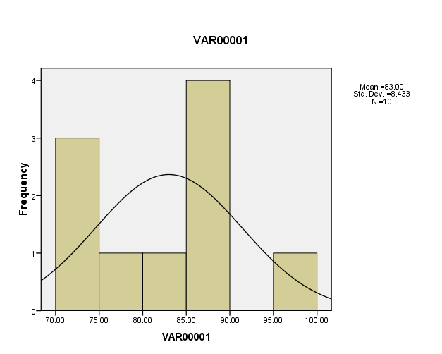
Histogram

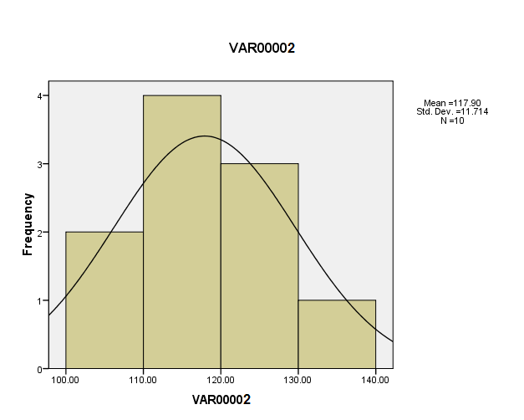

1
1
1

1

