Lampiran 16
Analisis statistik deskriptif pada kelompok kontrol
Frequencies

Statistics
 |  | VAR00001 | VAR00002
N | Valid | 10 | 10
 | Missing | 0 | 0
Mean |  | 83.3000 | 91.2000
Std. Error of Mean |  | 2.00028 | 3.62338
Median |  | 85.3333ª | 90.0000ª
Mode |  | 86.00 | 86.00^{b}
Std. Deviation |  | 6.32543 | 11.45814
Variance |  | 40.011 | 131.289
Skewness |  | -1.121 | .828
Std. Error of Skewness |  | .687 | .687
Kurtosis |  | .306 | .107
Std. Error of Kurtosis |  | 1.334 | 1.334
Range |  | 19.00 | 34.00
Minimum |  | 71.00 | 77.00
Maximum |  | 90.00 | 111.00
Sum |  | 833.00 | 912.00
Percentiles | 10 | 72.5000^{c} | 77.5000^{c}
 | 20 | 77.5000 | 80.6667
 | 25 | 81.0000 | 83.3333
 | 30 | 82.0000 | 86.0000
 | 40 | 84.0000 | 88.0000
 | 50 | 85.3333 | 90.0000
 | 60 | 86.0000 | 90.6667
 | 70 | 87.3333 | 92.0000
 | 75 | 88.0000 | 93.0000
 | 80 | 88.5000 | 101.5000
 | 90 | 89.5000 | 110.5000
a. Calculated from grouped data.
b. Multiple modes exist. The smallest value is shown
c. Percentiles are calculated from grouped data.
Frequency Table

VAR00001
 |  | Frequency | Percent | Valid Percent | Cumulative Percent
Valid | 71 | 1 | 10.0 | 10.0 | 10.0
 | 74 | 1 | 10.0 | 10.0 | 20.0
 | 81 | 1 | 10.0 | 10.0 | 30.0
 | 83 | 1 | 10.0 | 10.0 | 40.0
 | 85 | 1 | 10.0 | 10.0 | 50.0
 | 86 | 2 | 20.0 | 20.0 | 70.0
 | 88 | 1 | 10.0 | 10.0 | 80.0
 | 89 | 1 | 10.0 | 10.0 | 90.0
 | 90 | 1 | 10.0 | 10.0 | 100.0
 | Total | 10 | 100.0 | 100.0

VAR00002
 |  | Frequency | Percent | Valid Percent | Cumulative Percent
Valid | 77 | 1 | 10.0 | 10.0 | 10.0
 | 78 | 1 | 10.0 | 10.0 | 20.0
 | 86 | 2 | 20.0 | 20.0 | 40.0
 | 90 | 2 | 20.0 | 20.0 | 60.0
 | 91 | 1 | 10.0 | 10.0 | 70.0
 | 93 | 1 | 10.0 | 10.0 | 80.0
 | 110 | 1 | 10.0 | 10.0 | 90.0
 | 111 | 1 | 10.0 | 10.0 | 100.0
 | Total | 10 | 100.0 | 100.0
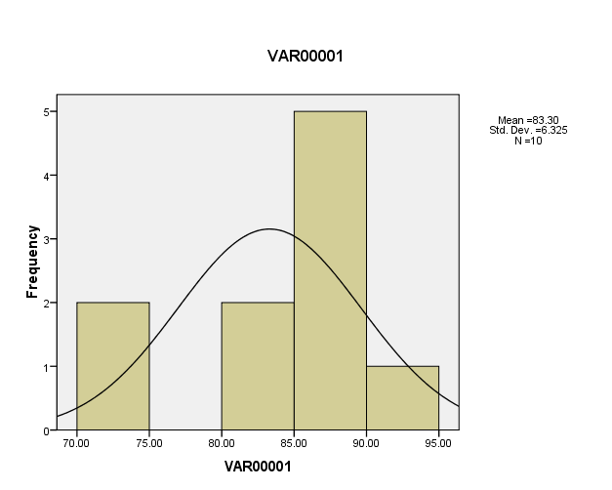
Histogram

