Lampiran 12

DATA ANALISIS STATISTIK DESKRIPTIF
Frequencies

Statistics
 |  | VAR00001 | VAR00002
N | Valid | 10 | 10
 | Missing | 0 | 0
Mean |  | 100.8000 | 64.3000
Median |  | 104.0000 | 62.5000
Mode |  | 86.00ª | 53.00ª
Std. Deviation |  | 9.70452 | 7.94495
Variance |  | 94.178 | 63.122
Range |  | 27.00 | 27.00
Minimum |  | 86.00 | 53.00
Maximum |  | 113.00 | 80.00
Sum |  | 1008.00 | 643.00
Percentiles | 25 | 90.5000 | 59.2500
 | 50 | 104.0000 | 62.5000
 | 75 | 108.0000 | 68.7500
a. Multiple modes exist. The smallest value is shown

VAR00001
 |  | Frequency | Percent | Valid Percent | Cumulative Percent
Valid | 86 | 2 | 20.0 | 20.0 | 20.0
 | 92 | 1 | 10.0 | 10.0 | 30.0
 | 100 | 1 | 10.0 | 10.0 | 40.0
 | 103 | 1 | 10.0 | 10.0 | 50.0
 | 105 | 2 | 20.0 | 20.0 | 70.0
 | 107 | 1 | 10.0 | 10.0 | 80.0
 | 111 | 1 | 10.0 | 10.0 | 90.0
 | 113 | 1 | 10.0 | 10.0 | 100.0
 | Total | 10 | 100.0 | 100.0

VAR00002
 |  | Frequency | Percent | Valid Percent | Cumulative Percent
Valid | 53 | 1 | 10.0 | 10.0 | 10.0
 | 57 | 1 | 10.0 | 10.0 | 20.0
 | 60 | 1 | 10.0 | 10.0 | 30.0
 | 61 | 1 | 10.0 | 10.0 | 40.0
 | 62 | 1 | 10.0 | 10.0 | 50.0
 | 63 | 1 | 10.0 | 10.0 | 60.0
 | 66 | 1 | 10.0 | 10.0 | 70.0
 | 67 | 1 | 10.0 | 10.0 | 80.0
 | 74 | 1 | 10.0 | 10.0 | 90.0
 | 80 | 1 | 10.0 | 10.0 | 100.0
 | Total | 10 | 100.0 | 100.0

Histogram
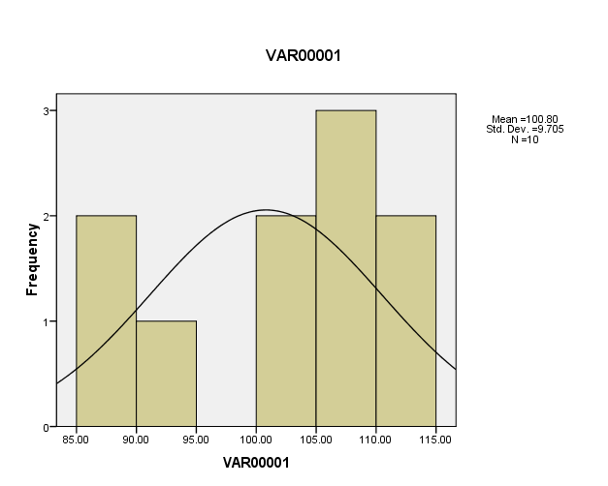

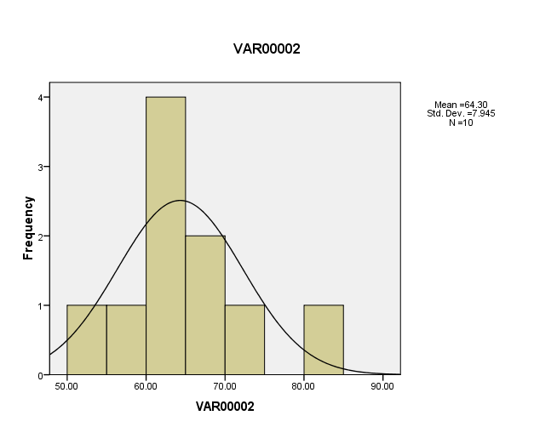

Wilcoxon Signed Ranks Test

Ranks
 |  | N | Mean Rank | Sum of Ranks
VAR00002 - VAR00001 | Negative Ranks | 10ª | 5.50 | 55.00
 | Positive Ranks | 0^{b} | .00 | .00
 | Ties | 0^{c}
 | Total | 10
a. VAR00002 < VAR00001
b. VAR00002 > VAR00001
c. VAR00002 = VAR00001

Test Statistics^{b}
 | VAR00002 - VAR00001
Z | -2.805ª
Asymp. Sig. (2-tailed) | .005
a. Based on positive ranks.
b. Wilcoxon Signed Ranks Test

