Lampiran 13

HASIL ANALISIS DATA OBSERVASI
- Analisis Data Observasi Individu dalam Persen (%)
RESPON |  | PERTEMUAN
 | I | II | III | IV
2 | 41, 66 % | 58,33 % | 66,67 | 83,33 %
3 | 25 % | 41,66 % | 58,33 | 75 %
4 | 33,33 % | 50 % | 75 % | 83,33 %
6 | 16,67 % | 41,67 % | 66,67 % | 75 %
7 | 25 % | 66,67 % | 75 % | 75 %
8 | 33,33 % | 50 % | 66,67 % | 66,67 %
9 | 41,66 % | 66,67 % | 66,67 % | 66,67 %
10 | 25 % | 50 % | 66,67 % | 75 %
11 | 25 % | 50 % | 58,33 % | 66,67 %
12 | 25 % | 66,67 % | 66,67 % | 66,67 %
13 | 25 % | 41,66 % | 58,33 % | 66,67 %
14 | 41,66 % | 50 % | 66,67 % | 75 %
15 | 25 % | 50 % | 66,67 % | 66,67 %
16 | 25 % | 41,66 % | 58,33 % | 83,33 %
17 | 41, 66 % | 50 % | 58,33 % | 75 %
18 | 25 % | 41,66 % | 58,33 % | 66,67 %
19 | 16, 67 | 50 % | 58,33 % | 66,67 %
20 | 25 % | 66,67 % | 75 % | 91,67 %

Persentase | Kriteria | Pertemuan
 |  | 1 | 2 | 3 | 4
80 % - 100% | Sangat tinggi | 0 | 1 | 0 | 4
60% - 79% | Tinggi | 0 | 4 | 11 | 14
40% - 59% | Sedang | 4 | 14 | 7 | 0
20% - 39% | Rendah | 12 | 0 | 0 | 0
0% - 19% | Sangat rendah | 2 | 0 | 0 | 0
Jumlah |  | 18 | 18 | 18 | 18
Data Hasil Persentase Observasi Saat Pelaksanaan
Bimbingan Kelompok Dengan Teknik Peer Group

Lampiran 14

Hasil Analisis Uji Lapangan

Uji Validitas Dan Reabilitas

Case Processing Summary
 |  | N | %
Cases | Valid | 20 | 100.0
 | Excludedª | 0 | .0
 | Total | 20 | 100.0
a. Listwise deletion based on all variables in the procedure.

Reliability Statistics
Cronbach's Alpha | N of Items
.737 | 33

Item Statistics
 | Mean | Std. Deviation | N
VAR00001 | 4.5500 | .82558 | 20
VAR00002 | 3.9500 | .82558 | 20
VAR00003 | 3.1000 | 1.29371 | 20
VAR00004 | 4.0000 | .91766 | 20
VAR00005 | 3.9000 | .96791 | 20
VAR00006 | 3.0000 | 1.25656 | 20
VAR00007 | 3.7000 | .92338 | 20
VAR00008 | 3.4500 | 1.27630 | 20
VAR00009 | 3.0000 | 1.25656 | 20
VAR00010 | 3.3500 | 1.46089 | 20
VAR00011 | 3.2000 | 1.32188 | 20
VAR00012 | 3.6000 | 1.14248 | 20
VAR00013 | 3.8500 | 1.46089 | 20
VAR00014 | 3.8000 | 1.00525 | 20
VAR00015 | 4.2000 | .95145 | 20
VAR00016 | 3.4000 | 1.23117 | 20
VAR00017 | 4.4000 | .75394 | 20
VAR00018 | 3.4500 | .99868 | 20
VAR00019 | 3.4500 | .94451 | 20
VAR00020 | 4.0000 | .79472 | 20
VAR00021 | 3.2500 | .71635 | 20
VAR00022 | 4.0000 | .97333 | 20
VAR00023 | 3.8000 | 1.10501 | 20
VAR00024 | 3.7500 | 1.16416 | 20
VAR00025 | 4.2000 | .76777 | 20
VAR00026 | 3.9500 | .99868 | 20
VAR00027 | 4.4000 | .68056 | 20
VAR00028 | 2.7000 | 1.08094 | 20
VAR00029 | 3.8000 | 1.19649 | 20
VAR00030 | 4.5000 | .88852 | 20
VAR00031 | 3.3000 | 1.12858 | 20
VAR00032 | 3.8000 | 1.10501 | 20
VAR00033 | 4.0500 | 1.09904 | 20

Item-Total Statistics
 | Scale Mean if Item Deleted | Scale Variance if Item Deleted | Corrected Item-Total Correlation | Cronbach's Alpha if Item Deleted
VAR00001 | 118.3000 | 122.432 | .453 | .722
VAR00002 | 118.9000 | 121.463 | .508 | .720
VAR00003 | 119.7500 | 121.145 | .301 | .727
VAR00004 | 118.8500 | 122.134 | .415 | .723
VAR00005 | 118.9500 | 119.945 | .496 | .718
VAR00006 | 119.8500 | 122.555 | .261 | .730
VAR00007 | 119.1500 | 121.713 | .433 | .722
VAR00008 | 119.4000 | 125.516 | .149 | .737
VAR00009 | 119.8500 | 126.239 | .127 | .739
VAR00010 | 119.5000 | 119.842 | .295 | .728
VAR00011 | 119.6500 | 117.818 | .412 | .719
VAR00012 | 119.2500 | 121.776 | .330 | .726
VAR00013 | 119.0000 | 137.158 | -.231 | .766
VAR00014 | 119.0500 | 117.418 | .595 | .712
VAR00015 | 118.6500 | 119.608 | .523 | .717
VAR00016 | 119.4500 | 120.261 | .356 | .724
VAR00017 | 118.4500 | 124.576 | .372 | .726
VAR00018 | 119.4000 | 116.568 | .641 | .709
VAR00019 | 119.4000 | 122.674 | .374 | .724
VAR00020 | 118.8500 | 130.134 | .035 | .740
VAR00021 | 119.6000 | 139.305 | -.498 | .758
VAR00022 | 118.8500 | 123.713 | .311 | .727
VAR00023 | 119.0500 | 129.313 | .034 | .743
VAR00024 | 119.1000 | 117.884 | .481 | .716
VAR00025 | 118.6500 | 124.029 | .396 | .725
VAR00026 | 118.9000 | 128.095 | .102 | .738
VAR00027 | 118.4500 | 125.839 | .334 | .729
VAR00028 | 120.1500 | 139.924 | -.379 | .764
VAR00029 | 119.0500 | 116.997 | .501 | .714
VAR00030 | 118.3500 | 122.661 | .404 | .724
VAR00031 | 119.5500 | 139.629 | -.356 | .765
VAR00032 | 119.0500 | 125.208 | .201 | .733
VAR00033 | 118.8000 | 127.221 | .120 | .738

Scale Statistics
Mean | Variance | Std. Deviation | N of Items
1.2285E2 | 131.397 | 11.46287 | 33

Lampiran 15
Hasil Analisis Statistik

Frequencies
Statistics
 |  | VAR00001 | VAR00002
N | Valid | 18 | 18
 | Missing | 0 | 0
Mean |  | 60.3333 | 85.4444
Std. Error of Mean |  | 2.33473 | 1.21058
Median |  | 63.5000 | 85.5000
Mode |  | 64.00ª | 89.00
Std. Deviation |  | 9.90544 | 5.13606
Variance |  | 98.118 | 26.379
Skewness |  | -.903 | -.093
Std. Error of Skewness |  | .536 | .536
Kurtosis |  | -.109 | -.403
Std. Error of Kurtosis |  | 1.038 | 1.038
Range |  | 33.00 | 18.00
Minimum |  | 40.00 | 76.00
Maximum |  | 73.00 | 94.00
Sum |  | 1086.00 | 1538.00
Percentiles | 10 | 40.9000 | 76.9000
 | 20 | 49.6000 | 80.8000
 | 25 | 53.7500 | 81.7500
 | 30 | 57.1000 | 82.7000
 | 40 | 60.8000 | 84.6000
 | 50 | 63.5000 | 85.5000
 | 60 | 64.4000 | 86.4000
 | 70 | 67.3000 | 89.0000
 | 75 | 68.2500 | 89.0000
 | 80 | 69.0000 | 89.4000
 | 90 | 71.2000 | 94.0000
a. Multiple modes exist. The smallest value is shown
Frequency Table
VAR00001
 |  | Frequency | Percent | Valid Percent | Cumulative Percent
Valid | 40 | 1 | 5.6 | 5.6 | 5.6
 | 41 | 1 | 5.6 | 5.6 | 11.1
 | 48 | 1 | 5.6 | 5.6 | 16.7
 | 50 | 1 | 5.6 | 5.6 | 22.2
 | 55 | 1 | 5.6 | 5.6 | 27.8
 | 58 | 1 | 5.6 | 5.6 | 33.3
 | 59 | 1 | 5.6 | 5.6 | 38.9
 | 62 | 1 | 5.6 | 5.6 | 44.4
 | 63 | 1 | 5.6 | 5.6 | 50.0
 | 64 | 2 | 11.1 | 11.1 | 61.1
 | 65 | 1 | 5.6 | 5.6 | 66.7
 | 67 | 1 | 5.6 | 5.6 | 72.2
 | 68 | 1 | 5.6 | 5.6 | 77.8
 | 69 | 2 | 11.1 | 11.1 | 88.9
 | 71 | 1 | 5.6 | 5.6 | 94.4
 | 73 | 1 | 5.6 | 5.6 | 100.0
 | Total | 18 | 100.0 | 100.0

VAR00002
 |  | Frequency | Percent | Valid Percent | Cumulative Percent
Valid | 76 | 1 | 5.6 | 5.6 | 5.6
 | 77 | 1 | 5.6 | 5.6 | 11.1
 | 80 | 1 | 5.6 | 5.6 | 16.7
 | 81 | 1 | 5.6 | 5.6 | 22.2
 | 82 | 1 | 5.6 | 5.6 | 27.8
 | 83 | 1 | 5.6 | 5.6 | 33.3
 | 84 | 1 | 5.6 | 5.6 | 38.9
 | 85 | 2 | 11.1 | 11.1 | 50.0
 | 86 | 2 | 11.1 | 11.1 | 61.1
 | 87 | 1 | 5.6 | 5.6 | 66.7
 | 89 | 3 | 16.7 | 16.7 | 83.3
 | 91 | 1 | 5.6 | 5.6 | 88.9
 | 94 | 2 | 11.1 | 11.1 | 100.0
 | Total | 18 | 100.0 | 100.0

Histogram
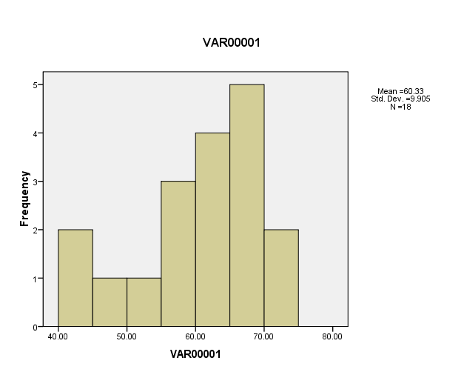

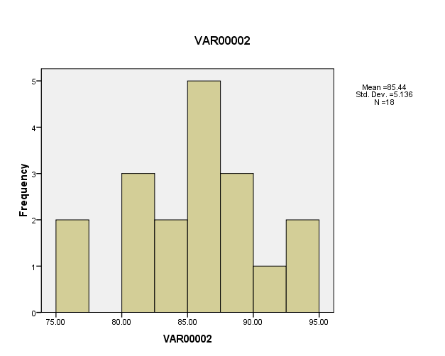

Lampiran 16

Uji Wilcoxon

NPar Tests

Descriptive Statistics
 | N | Mean | Std. Deviation | Minimum | Maximum
VAR00001 | 18 | 60.3333 | 9.90544 | 40.00 | 73.00
VAR00002 | 18 | 85.4444 | 5.13606 | 76.00 | 94.00

Wilcoxon Signed Ranks Test

Ranks
 |  | N | Mean Rank | Sum of Ranks
VAR00002 - VAR00001 | Negative Ranks | 0ª | .00 | .00
 | Positive Ranks | 18^{b} | 9.50 | 171.00
 | Ties | 0^{c}
 | Total | 18
a. VAR00002 < VAR00001
b. VAR00002 > VAR00001
c. VAR00002 = VAR00001

Test Statistics^{b}
 | VAR00002 - VAR00001
Z | -3.728ª
Asymp. Sig. (2-tailed) | .000
a. Based on negative ranks.
b. Wilcoxon Signed Ranks Test

