Lampiran 13
Hasil Analisis Data
- Statistik Deskriptif

Frequencies

Statistics
 |  | VAR00001 | VAR00002
N | Valid | 35 | 35
 | Missing | 0 | 0
Mean |  | 121.6857 | 83.2571
Median |  | 123.0000 | 83.0000
Mode |  | 115.00ª | 73.00ª
Std. Deviation |  | 15.70645 | 13.46311
Variance |  | 246.692 | 181.255
Range |  | 61.00 | 50.00
Minimum |  | 91.00 | 58.00
Maximum |  | 152.00 | 108.00
Sum |  | 4259.00 | 2914.00
Percentiles | 25 | 110.0000 | 73.0000
 | 50 | 123.0000 | 83.0000
 | 75 | 131.0000 | 94.0000
a. Multiple modes exist. The smallest value is shown

Frequency Table

VAR00001
 |  | Frequency | Percent | Valid Percent | Cumulative Percent
Valid | 91 | 1 | 2.9 | 2.9 | 2.9
 | 99 | 2 | 5.7 | 5.7 | 8.6
 | 102 | 1 | 2.9 | 2.9 | 11.4
 | 103 | 2 | 5.7 | 5.7 | 17.1
 | 107 | 2 | 5.7 | 5.7 | 22.9
 | 110 | 1 | 2.9 | 2.9 | 25.7
 | 113 | 1 | 2.9 | 2.9 | 28.6
 | 114 | 2 | 5.7 | 5.7 | 34.3
 | 115 | 3 | 8.6 | 8.6 | 42.9
 | 117 | 1 | 2.9 | 2.9 | 45.7
 | 121 | 1 | 2.9 | 2.9 | 48.6
 | 123 | 2 | 5.7 | 5.7 | 54.3
 | 125 | 3 | 8.6 | 8.6 | 62.9
 | 128 | 2 | 5.7 | 5.7 | 68.6
 | 130 | 1 | 2.9 | 2.9 | 71.4
 | 131 | 2 | 5.7 | 5.7 | 77.1
 | 134 | 2 | 5.7 | 5.7 | 82.9
 | 137 | 1 | 2.9 | 2.9 | 85.7
 | 142 | 1 | 2.9 | 2.9 | 88.6
 | 148 | 1 | 2.9 | 2.9 | 91.4
 | 149 | 2 | 5.7 | 5.7 | 97.1
 | 152 | 1 | 2.9 | 2.9 | 100.0
 | Total | 35 | 100.0 | 100.0

VAR00002
 |  | Frequency | Percent | Valid Percent | Cumulative Percent
Valid | 58 | 2 | 5.7 | 5.7 | 5.7
 | 61 | 1 | 2.9 | 2.9 | 8.6
 | 65 | 1 | 2.9 | 2.9 | 11.4
 | 66 | 1 | 2.9 | 2.9 | 14.3
 | 71 | 1 | 2.9 | 2.9 | 17.1
 | 72 | 1 | 2.9 | 2.9 | 20.0
 | 73 | 3 | 8.6 | 8.6 | 28.6
 | 76 | 1 | 2.9 | 2.9 | 31.4
 | 77 | 2 | 5.7 | 5.7 | 37.1
 | 80 | 3 | 8.6 | 8.6 | 45.7
 | 82 | 1 | 2.9 | 2.9 | 48.6
 | 83 | 1 | 2.9 | 2.9 | 51.4
 | 84 | 1 | 2.9 | 2.9 | 54.3
 | 85 | 1 | 2.9 | 2.9 | 57.1
 | 87 | 1 | 2.9 | 2.9 | 60.0
 | 88 | 1 | 2.9 | 2.9 | 62.9
 | 90 | 2 | 5.7 | 5.7 | 68.6
 | 91 | 1 | 2.9 | 2.9 | 71.4
 | 94 | 2 | 5.7 | 5.7 | 77.1
 | 95 | 1 | 2.9 | 2.9 | 80.0
 | 96 | 1 | 2.9 | 2.9 | 82.9
 | 99 | 1 | 2.9 | 2.9 | 85.7
 | 100 | 2 | 5.7 | 5.7 | 91.4
 | 104 | 2 | 5.7 | 5.7 | 97.1
 | 108 | 1 | 2.9 | 2.9 | 100.0
 | Total | 35 | 100.0 | 100.0

Histogram

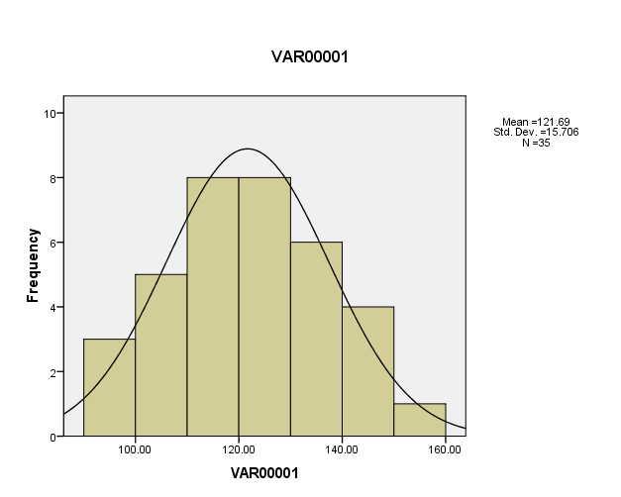

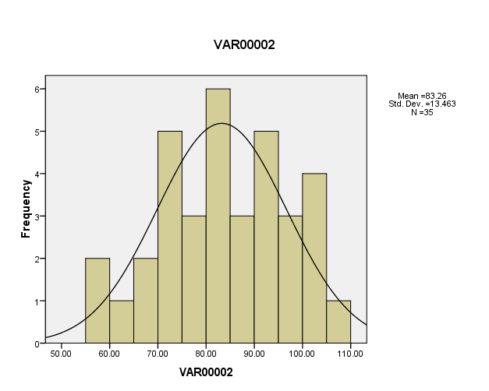

PENGUJIAN HIPOTESIS
- UJI NORMALITAS
Explore

Case Processing Summary
 | Cases
 | Valid |  | Missing |  | Total
 | N | Percent | N | Percent | N | Percent
VAR00001 | 35 | 100.0% | 0 | .0% | 35 | 100.0%
VAR00002 | 35 | 100.0% | 0 | .0% | 35 | 100.0%

Tests of Normality
 | Kolmogorov-Smirnovª |  |  | Shapiro-Wilk
 | Statistic | Df | Sig. | Statistic | df | Sig.
VAR00001 | .093 | 35 | .200* | .975 | 35 | .597
VAR00002 | .073 | 35 | .200* | .977 | 35 | .664
a. Lilliefors Significance Correction
*. This is a lower bound of the true significance.

VAR00001
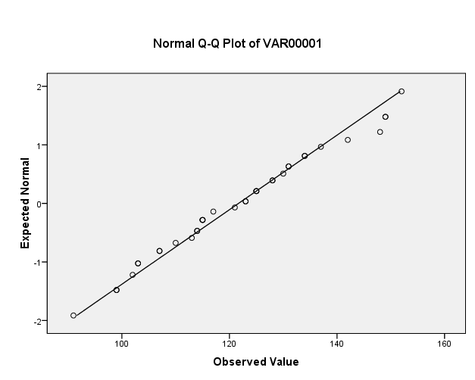
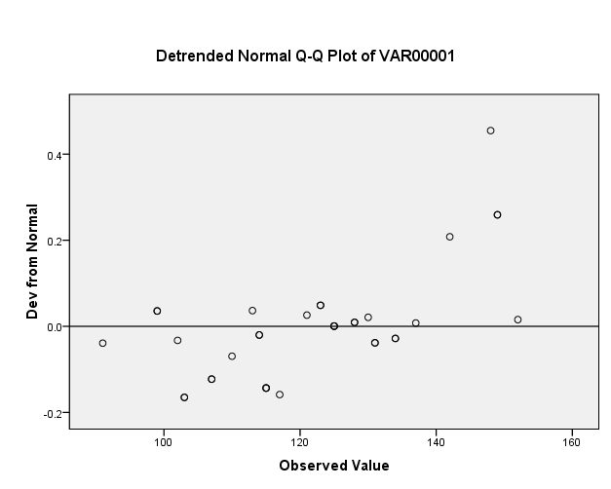

VAR00002

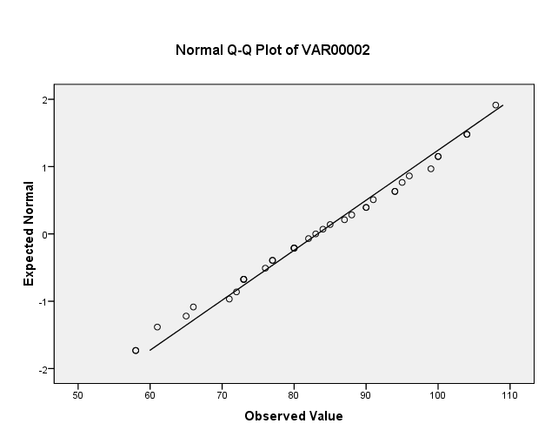
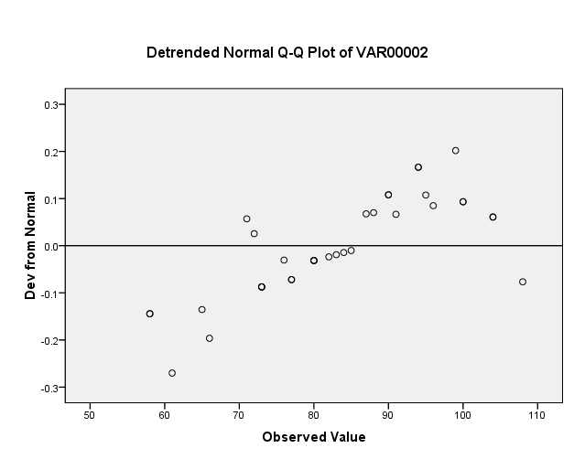

UJI HOMOGENITAS
Oneway

Test of Homogeneity of Variances
VAR00001
Levene Statistic | df1 | df2 | Sig.
.770 | 1 | 68 | .383

ANOVA
VAR00001
 | Sum of Squares | df | Mean Square | F | Sig.
Between Groups | 25843.214 | 1 | 25843.214 | 120.777 | .000
Within Groups | 14550.229 | 68 | 213.974
Total | 40393.443 | 69

T-Test

Paired Samples Statistics
 |  | Mean | N | Std. Deviation | Std. Error Mean
Pair 1 | VAR00001 | 1.2169E2 | 35 | 15.70645 | 2.65487
 | VAR00002 | 83.2571 | 35 | 13.46311 | 2.27568

Paired Samples Correlations
 |  | N | Correlation | Sig.
Pair 1 | VAR00001 & VAR00002 | 35 | -.225 | .194

Paired Samples Test
 |  | Paired Differences |  |  |  |  | t | df | Sig. (2-tailed)
 |  | Mean | Std. Deviation | Std. Error Mean | 95% Confidence Interval of the Difference
 |  |  |  |  | Lower | Upper
Pair 1 | VAR00001 - VAR00002 | 3.84286E1 | 22.86827 | 3.86544 | 30.57304 | 46.28410 | 9.942 | 34 | .000

