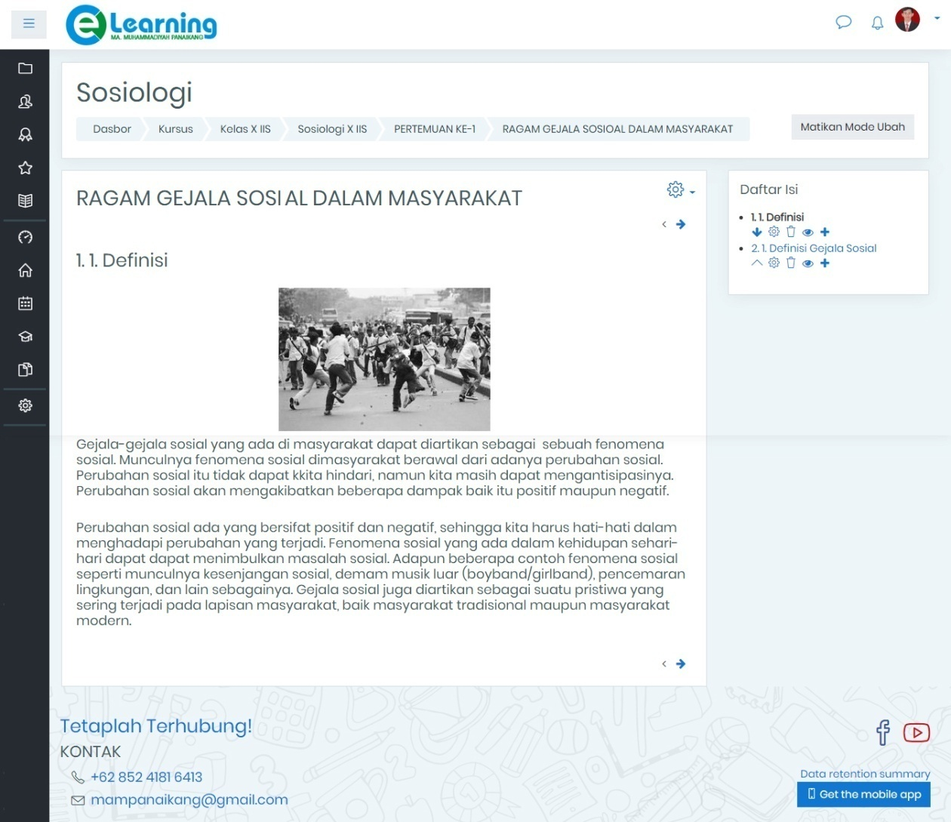
Media E-Learning Pasca Revisi
LAMPIRAN 17

Gambar 1 Materi E-Learning

