The Implementation of the Blended Learning Approach in Teaching English for Academic Purposes at Muhammadiyah University of Parepare
Nurul Sakinah Mutas
nsakinahm2107@gmail.com

ABSTRACT
This research aimed to find out: lecturer’s perceptions toward the implementation of Blended Learning (BL) approach in teaching English for Academic Purposes (writing). This research employed descriptive qualitative research. The participants of this research were an English lecturer who taught writing at Muhammadiyah University of Parepare which were taken through purposive sampling technique. The data of this research were collected by collecting documents, employing observation, and interview. The obtained data was analyzed in three major phases namely data collection, data reduction, data display, and draw conclusion. The study conlcudes that the implementation of BL was highly supported by the lecturer reviewed from her awereness to integrate technology and traditional teaching as a part of blended learning, the ability of the lecturer to survive among obstacles of employing BL, and the continuity of the implementation of BL in the classroom during one semester. The research showed that blended learning was fully implemented by the lecturer and it had positive impact to students’ writing achievement. It revealed that the practice of flipped learning as one of BL models improved pedagogy of lecturer in teaching as well as students’ achievement.

Key words: Blended learning, Flipped learning, English for Academic Purposes, Writing

INTRODUCTION

Blended Learning (BL) is an innovative teaching method that offers students with a flexible teaching environment. Blended learning is an approach to education that offers a learning environment to accompany the teaching process by adding more innovative modes of assessment (Reid-Young, 2003 in Addas & Bakir, 2013). It is defined that “blended learning is a hybrid of traditional face-to-face and online learning so that instruction occurs both in the classroom and online, and where the online component becomes a natural extension of traditional classroom learning” (Colis and Moonen, 2001 in Addas & Bakir, 2013).

Blended learning has continuously been employed excessively to high schools and universities as well as in many countries including in Indonesia. Most of these schools implied to get great result for students achievement particularly in academic purposes. To meet this goal, causal factors that involved in implementing this approach need to be studied further. This study concerns on finding educators perceptions in teaching English for Academic Purposes by implementing blended learning approach, observing the practice of blended learning in teaching EAP, and describing the effect of blended learning approah to students’ English performance.

With this increasing growth in the use of information and communication technology, schools, colleges and universities in the South Sulawesi region are gradually beginning to adopt and integrate information and communication tools to deliver course works. There are growing demands and discussions for innovative ways of delivering educational packages. This is precipitated by radical changes in the learning needs compounded by the growing computer/internet literacy of the population.

This study will be conducted at Univesitas Muhammadiyah Parepare (UMPAR) in South Sulawesi, Indonesia. Some lecturers in UMPAR have been trying to diversify its programs in order to meet the 21st century needs of the country. One of the programs in UMPAR is teaching English as an area of specialization within English Department and it aspired to renovate the teaching-learning of English for Academic Purposes thorugh the support of computer-based instructional process. In this context, examining the advantages of using computers and internet technology to extend face-to-face teaching in blended learning instruction seems to be a necessary innovation.

Blended learning in this study brings a shift from a solely conventional mode of teaching to student-based learning by combining the conventional face-to-face and e-learning in an appropriate mix. Blended learning has helped to transform education and has become associated with, and interpreted in a variety of context such as distance learning and networked learning. The obvious limitation that challenges the use of blended learning is that academic institutions may lag behind the need for setting up technology-based education insfratructure and culture in their instructional systems.

Blended courses provide the opportunity for teachers to mix the best of onsite and online to create a new learning environment for their students (Graham, 2005). Research suggests that blended courses can have a positive impact on efficiency, convenience, and learning outcomes (Graham, 2005).The involvement of teachers in designing the process of teaching becoming determinant to the sucessful of the implementation of blended learning approach. In relation to this, there are some aspects of teachers’ perceptions need to be investigated namely, their opinion, beliefs, and feelings as practioners of BL, it also crucial to discover their consideration in designing and choosing level, model, and tools used in blended learning classroom when teaching english for academic purposes. These information can be the most beneficial references to build strong foundation in establishing the basics things in blended learning classroom especially in teaching english for academic purposes.

Although some lecturers have been employed BL in English Foreign Language (EFL) education at UMPAR, it is unknown how EFL lecturers at this university perceive blended learning, whether they can recognise benefits and challenges of blended learning implementation, and what factors influence their perceptions and practices of teaching EAP in BL environments. Furthermore, it is intended to get evidence based in EFL classroom particularly in teaching EAP as a helpful reference to BL practitioners in South Sulawesi, Indonesia.
Based on the illustration above, the objectives of this study were to find out and describe:
- Lecturer’s perceptions towards the implementation of the Blended Learning approach in teaching EAP particularly Writing.

REVIEW OF LITERATURE
Maulan & Ibrahim (2012) in their study examined the students’ perception, engagement and performance in the blended learning environment.The study was both exploratory and experimental in nature. A set of questionnaire was used to gather students’ perception, examination of students and lecturers’ interaction in i-discussion was done to determine students’ engagement and t-tests were carried out to seek the difference of students’ performance between the blended learning group and the face-to-face group. Results of frequency count from the questionnaire showed that the students viewed blended learning positively. There were also signs of engagement in the learning environment from the examination of i-discussion.
A study conducted by Soliman (2016) aimed to investigate the efficiency of the application of the Flipped Classroom pedagogy, examining the benefits of the flipped classroom, demonstrating the author’s qualitative reflections based on personal pedagogical experience which suggested ways to implement the flipped classroom pedagogoy in an EAP module and examine the challenge faced and ways to overcome them.

Miyazoe & Anderson (2012) in their study reported on empirical research investigating the qualitative changes in writing proficiencies in response to using three online writing tools, i.e., discussion forums, blogs, and wikis, in an EFL blended-format course. The study combine three instrument to collect the data namely; questionnaire, interview, and text analysis. Results of this study showed that student enjoyed the blended course design composed of three different online writing activities, they acknowledge different utilities and skills associated with the different purposes of each online writing tool, and their abilities to write academic English showed qualitative improvement in writing styles.

The above mentioned viewpoints and discussion developing teaching approach to develop english skills and highlight the importance of blending various multi-media of blended learning application in the classroom. Those previous studies describe obviously that nearly all the studies which were conducted in various environments have examined the effectiveness of blended learning in the teaching learning process inside or outside the classroom. Nearly all the studies have displayed blended learning as significant method in sustaining students' achievement, attitudes and perceptions in various subjects where teachers employed it as an alternative for completely face-to-face or on-line learning.

METHOD

A qualitative case study method was employed for the present study. As for the use of case study, Creswell (2014) states that case studies are studies where a researcher attempts to provide an in-depth analysis of the studied case such as an event or a process which is constrained with respect to time, place and activity. This research uses the case study to analyze the implementation of Blended Learning to EFL students of UMPAR in terms of teachers’ perceptions, the practice of blended learning in teaching English for Academic Purposes, and the impact of blended learning to students’ achievement.

The classroom that was going to be studied was the English Department of UMPAR particularly Writing class. Participants of this research was an English lecturer who have been implemented blended learning as an approach in teaching english for academic purposes, and first year students who have been engaged in a blended learning environment in learning Writing during second semester.

FINDINGS AND DISCUSSIONS

The findings presented here deal with the result of the analysis of the lecturer’s perceptions towards the implementation of the Blended Learning approach in teaching Writing.

- Lecturer’s Perceptions towards the Implementation of Blended Learning
Exploring lecturer’s perceptions generated into three main viewpoints of the lecturer namely lecturer’s perceptions related to concept of BL, lecturer’s opinion and experienced regarding advantages and challenges on the implementations of BL in teaching writing. Generally, it was found that the lecturer was highly supporting on the implementation of BL reviewed from her awereness to integrate technology and traditional teaching as a part of blended learning, the ability of the lecturer to survive among obstacles of employing BL, and the continuity of the implementation of BL in the classroom during one semester.
Furthermore the the perceptions of lecturer towards BL in detail were demonstrated in this section will be analysed through three perspectives:

- Concept of Blended Learning

Excerpt 1
“Pak Badar has introduce blended learning before, what year was that.... 2015 maybe. So I just known that ah yaa when you applied technology outside the classroom then combined with teaching and learning in the class called blended learning. That was when Pak Badar presented his research I watched his seminar, I talked to my self ‘ouh that’s blended learning’. Later Bu Salasiah came .... this year introduce another terminology namely TPACK, finally I know oo.. oh this is included in TPACK, flipped classrom, ah about flipped classroom it has been a long time I applied it. After Pak Badar, Ibu Salasiah then I recognize it.”
(Interview on May 8th, 2018)

Reffering to the result of interview in excerpt 1, it was found that the lecturer was adequately comprehending in undesrtanding the concept of BL. The participating lecture was asked about her understanding of BL and reported that when the first time she utilized technology in teaching English, she had no idea about the term of Blended Learning until three years ago one of a senior lecturer in the university introduced Blended Learning. She then realized the method she applied in her class is called Blended Learning. The lecturer employed blended learning consciously since 2015 by creating her blended lesson plans. The fact that the lecturer applied flipped learning to her writing class showed her comprehension about the concept of blended learning.

- Benefits of Blended Learning

- Increased Access and Flexibility
Blended Learning offers flexibility in terms of availability anytime, anywhere. In other words, eLearning enables students to access the materials from anywhere at anytime. Besides, it allows access to global resources and materials that meet the students’ level of knowledge and interest.
Excerpt 2
firstly, it is facilitating, so it facilitates the lesson, so for example I can’t attend the class due to some urgent business yaah we can teach through internet or edomodo.”
(Interview on May 8th, 2018)

The findings in excerpt 2 illustrated that blended learning gives a number of advantages to a lecturer since she could compensate her absence through online class discussion.

Excerpt 3
“we use WA more for discussions and submitting assignments”
(Interview on May 8th, 2018)

Excerpt 3 shown that lecturer tend to utilized Whatsapp to employe online discussion and assignments submission.

Excerpt 4
so the discussion through WA, the rule is I note them present after three times give any comments or answer my questions, for example I ask some questions, answer the first oke, answer the second ok, answer for the third times, present.
(Interview on May 8th, 2018)

.

Excerpt 4 ahown that this online class was held by utilizing internet but mostly via Whatapp group. The lecturer also established some rules to be obeyed by the students during online class discussion. Students have to answer the questions or give any comment at least three times to be noticed present.
The advantages of this can be seen from the flexibility of the students to contribute to the discussion at the time and place that is most convenient to them so all of the students can participate to the online class or discussion group due to the time and place constraint were removed. Owing to this fact, the researcher was able to conclude that learners have opportunity to more carefully consider and provide evidence for their arguments and more thoughtfull reflections.

- Pedagogy Improvement

Pedagogy is the method and practice of teaching, especially as an academic subject or theoritical concept. It is the discipline that deals with theory and practice of education; it thus concerns the study and practice of the best way to teach (Nuruzzaman, 2013). Some examples of pedagogy are simulation, case study, assignment, modelling, video, role play, exercise, tutorial, audio, project, power point, quiz etc.

The findings in this study indicated two sort of pedagogy improvement discerned from variety of instructional method and increased creativity.
- Instructional Method

Excerpt 5
I give them the video first, like the first video in the class, that first video actually I’ve shared it on WA, I told them to learn it at home together with the book which has just come.
(Interview on May 8th, 2018)

It was also found that the use of technology in flipped learning model increased the variety of intstructional method used by lecturer as shown in Excerpt 5. She tend to use video in her flipped classroom.
Picture 1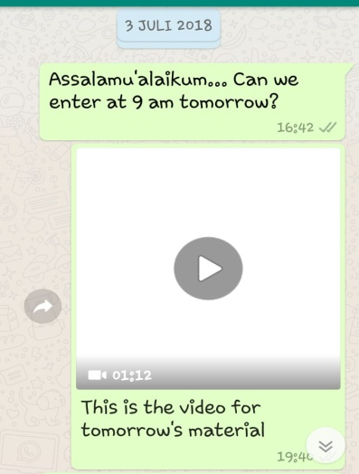

Picture 1 above revealed the instructional method employed by the lecturer. The lecturer share a video on whatsapp group then command her students to watch and learn the video to be discussed in the class. It showed how the lecturer instructed students to watch and learn through videos she shared earlier on whatsapp group. This sort of instructional method allowed students to get their additional material first at home before they attend the class for face-to-face section. It allowed them to learn and get their understanding to the material before involved in a discussion.

Picture 2
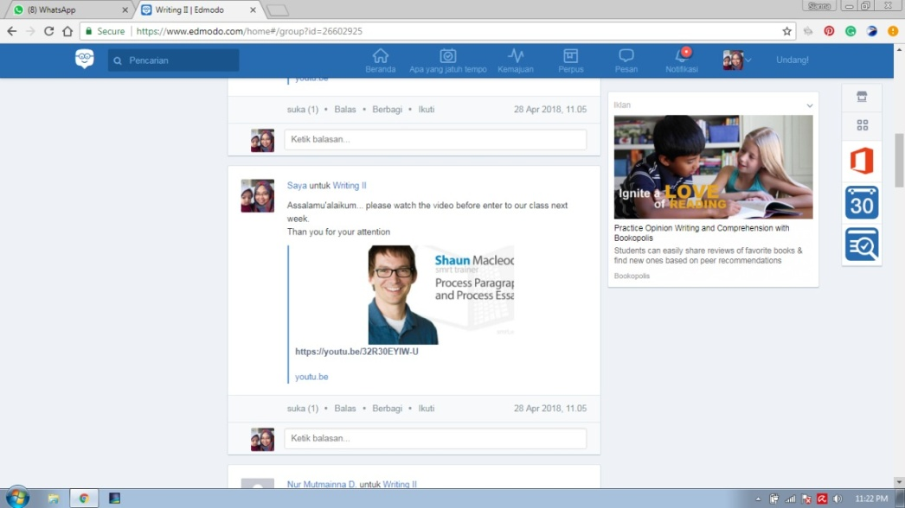

It was also found that the lecturer occasionally posted videos on Edmodo then direct her students to learn it as posted in picture 2.

Excerpt 6
so next week when come to the class, I will give them more video for them to write like what I’ve just done in the class.
(Interview on May 8th, 2018)

The other days, the lecturer provide the video on the classroom then ordered her students to make essay or paragraph related to the video they have watched as shown in excerpt 6.

Picture 2
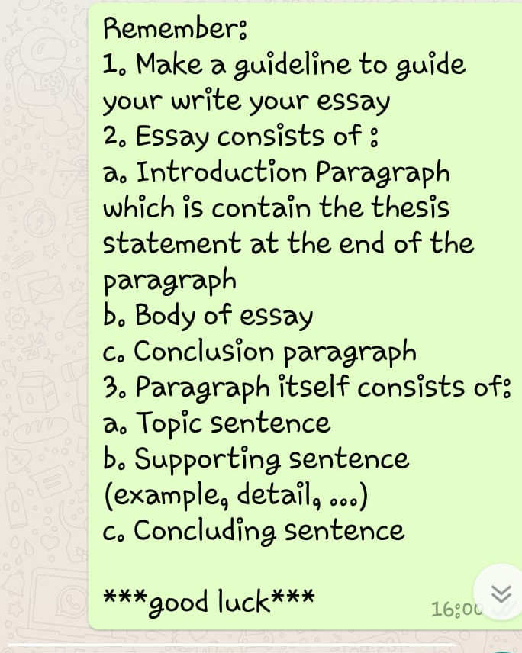

It was also found that the lecturer tend to give her instruction related to assignment as revealed on the picture 2 above. It was shown how the lecturer remind her students to create guidline and make essay by giving some detail instructions related to part of essay they should create. The use of application like whatsapp supported the instructional method performed by the lecturer. Apparently, the lecturer maximized the use of application like Edmodo and Whatsapp as an instructional method.

- Increase Creativity
Excerpt 7
R: How did you find software/learning media that is suit to your class?
L: youtube,, yeah it was from youtube, for example i was looking for interactive blackboard in the class, then I found screencase omatic. I also found the presentation on how to use it
(Interview on May 8th, 2018)

Excerpt 7 illustrated the process of lecturer to find new instructional media to be used in blended class. She found those information about instructional media from youtube then learn how to use it from youtube as well. As she became more familiar with using online activities in her teaching, she recognized the potential for creative teaching using these elements. Online activities, including online quizzes and online discussions, gave the lecturers an opportunity to use student-centred approaches which are not yet commonly applied in face-to-face teaching in UMPAR.

The implementation of flipped classroom allowed the lecturer to show her creativity to deliver subject course by utilizing some applications like edmodo and whatsapp to give quiz, assignment submission, and online discussons. It then led her to varied the instrucional method she may used. The lecturer reported that blended learning has the potential to imporve pedagogy and increase skills development which has helped her to be more creative.

- Students’ Engagement

The findings indicated that integrating technologies with traditional teaching and learning facilitates the engagement of the students in the learning process. This caused by the students’ effort to learn the video and other addtional lesson from lecturer by themselves. By watching the provided videos, the students felt more fun to begin their writing as they gained adequate ideas or sources to enrich their creativity and increase their concepts in writing.

Group discussion was also one of motives why flipped instructional method could encourage students’ engagement. It can be seen from the thread conversation captured by the lecturer, wherein the students participated actively there. Based on the class observation, after the lecturer conducted online discussion, the students have more things to say in the class, they could be actively perceived lecturer’s questions.

Based on the result of observing hundreds of conversation occured among students and lecturer, the researcher draw conclusion that students’ participations in the online discussions enhanced student learning as the lecturer inform the recent topic they were going to discuss whether in onlince class or face-to-face class. She instructed her students to learn the material from book and watch the video she already shared on whatsapp group, or edmodo. The lecturer appriciated that blended learning facilitated interaction with her students without a lack of feedback because of the rules maintained by all the members of group discussions.

- Challenges of Blended Learning Implementation

- Internet on-campus for lecturer
This campus has provided hotspot for all the employees to support their works but it could not be reached by the lecturers when they need it to their teaching in the class. There is no availability of internet in the college building. Therefore the lecturer had to prepared their teching materials, like offline videos before get in the classroom.
Excerpt 8
“connection and time, just those, about another difficulty I can solve it through youtube”
(Interview on May 8th, 2018)

As what the lecturer revealed in the interview section provided in excerpt 7 above, internet connection and time duration was her main diffuculty to prepare her teaching materials. It was expressed in the interview related to difficulty she faced.

Furthermore she stated in the interview sescton about her detailed problems that she struggled to prepare the materials from online site since she has a baby, or made her own material through application she used to use like screencaseomatic for another structure class. Nevertheles, she could overcome that problem in a such good way.
The network constraints she oftenly faced were revealed in the interview section. She gave her detailed information about that in the followings interview part:
Excerpt 9
“the constraints could be at home and campus. The internet connection was not really good or either my mobile data could not work at my home. While hotspot in campus could not be accessed through teaching process.”
(Interview on July 21st, 2018)

Excerpt 9 explained more about the lecturer difficulty on facing bad network connection. She emphasized that sometimes her mobile data could not work at home due to bad connection of network meanwhile she had to prepare all the materials needed like offline videos that must be downloaded from website first to be shown in the class.

System of Blended Learning approach relies much on the availability of internet in schools that if there is no internet connection would make their job getting harder. However this lecturer designed her flipped learning precisely appropriate so this challenge could be decrease by preparing all the material needed outside the class.

- Culture and the Internet

Providing hotspot internet at home would be rarely find in Parepare. Only some places like cafe, office, or campus made hotspot internet available. This one of the first and huge challenges for students when their lecturer introduced flipped learning.
Excerpt 10

“Mam, there is no connection in my house”, “you dont have to work in your house, you can find connection in other place”
(Interview on May 8th, 2018)

As shown in excerpt 10, many of them felt it was impossible to applied this learning method in their campus. However, the lecturer who came with high intention and motivation to keep utilizing technology in her teaching class did not give up. Infact she gave motivation to her students as revealed on the interview section above.

As time passed, writing class with flipped instructional method had run for almost one semester and still faced the same problem. The students might access the internet, logged in to their account learning like edmodo, joined group discussion, or downloaded video their lecturer shared, etc. but oftenly they struggled to finish their online tasks.

- Synchronous E-Learning

Synchronous e-learning involves online studies through chat and videoconferencing. This kind of learning tool is real-time. It is like a virtual classroom which allows students to ask, and teachers to answer questions instantly, through instant messaging, which is why it is called synchronous. Rather than taking lessons alone, students associating themselves with synchronous e-learning software or online courses can easily interact with fellow students and their teachers during the course.

Excerpt 11

“the difficulty of online class is just a matter of trusty, whether the students did their tasks or someone else.”
(Interview on July 21st, 2018)

In terms of synchronous learning, the researcher found some difficulties occured in group discussion as indicated in excerpt 10. Firstly, the lecturer implied in the interview section that she eventually had apprehension to students since she could not directly monitored the running of the online discussion.

Indeed, the lecturer should be aware of this issued before arranging online discussion so she could come with better preparation. She could begin with providing method to avoid this issue happened or probably came with solution when it is really occured since the vital part of online discussion is trusty and the ability of all member to get the point of what was being discussed.

Secondly, the lecturer again revealed in the interview section another problem she faced the most namely poor connection of network. This might be caused by the location of the city considered Parepare is categorized as a small city surrounded with villages, forests, and hills.

As a matter of those facts, online discussion kept going like it should be despite continously feeling concerned about the problems that might be appear.

- Models for Support and Training

There were several issues related to this challenge namely: increased demand on instructor, and providing learners with technological skills to succeed in both face-to-face and CM (computer mediated) environments.

When a teacher decided to combine their instructional method, employed technology in teaching and learning they should be ready for all the consequences might come. Since the lecturer applied blended learning based on her own will, she had to encourage herself to broaden her knowledge and deepen her ICT skill to survive and succeed in implementing blended learning.
Excerpt 12
“about another difficulty I can solve it through youtube”

(Interview on May 8th, 2018)

Regarding to one part of the interview in excerpt 12, the researcher found a fact of how was the lecturer trained herself to be more skillful and knowledgable one by utilizing technology in teaching and learning. She regularly looking for new method or media on how to teach in a flipped classroom through youtube as revealed above.

Above all, her high intention to persistently implemented what had planned on her lesson plan for one semester ahead proven to give good impact to students’ achievement. Therefore, her eagerness to enhanced the learning method as well as her ICT skill will be her long-term homework.

Another obstacles found was the responsibility of the lecturer to make sure their students at least had basic skill to operate computer and other software to support flipped instructional method. Flipped learning demands the learners to learn by themselves at home so they should have knowledge to access the internet and to operate learning media correctly.
Excerpt 13
I firstly introduced the technology we were going to use then showed them how to log in, create an account, how to do the assignment if there was any.. that so.”
(Interview on May 8th, 2018)

Thus, the result of interview in excerpt 13 showed that the lecturer played a significant role to introduce media and others learning software like edmodo to her students. Lecturer’s involvement to ensure the learners’ skill showed her huge intention to the successful of blended learning implementation.

- Digital Devide

The layout of traditional classroom was another obstacle to flipped learning. Collaboration, communication and creativity, are the heart of this methhod, but fostering these skills was almost impossible with poor classroom conditions, and lack of technology and technical support. It was one of the most prominent point to notice in mixing technology to teach. Consequently, as an independent practicioner of blended learning, this obstacle must be resolved by the lecturer herself.

By implementing flipped learning, the lecturer adjusted and designed her own lesson plan yet still follow the curriculum. It was obviously noticiable that the lecturer set her flipped classroom based on the situation in the campus. Furthermore, the lecturer asserted her outlook and expectancy related to future of blended learning in campus as revealed below:
Excerpt 14
I have many prospects about this blended learning, i wish they can facilitate for example each class is facilitated with like.... I personally want,, it’s not language lab, but I want there is laboratory, the class is transformed like laboratory where everyone can access internet at the time, want that so, but it should be improved slowly, so yaah first is improving hotspot then teaching media.”
(Interview on May 8th, 2018)

Excerpt 14 illustrated lecturer’s expectations towards support and facility provided by university. She wished to get a class with all computer devices and internet access but she realized it needed to improve slowly moreover the campus had not ordered the lecturer to teach by utilizing technology. Therefore, the lecturer may propose the authority of university to implement Blended Learning considering few lecturers of english department has continously employed Blemded Learning.

Dealing with those situations caused the lecturer utilize devices available to reach lesson purposes. Instead of using computer or accesss internet in the campus, they used their own digital device at home like computer and smartphone to access the internet.

CONCLUSION

The research showed that the lecturer response was highly supporting towards the implementation of blended learning. The lecturer perceptions (opinion, beliefes, feelings) was categorized into three points namely first, lecturer insight in understanding the concept of blended learning was found adequately comprehending since she implemented BL consciously for 3 years. Besides, it also revealed some advantages the lecturer and learnes exeperienced namely the improvement of lecturer’s pedagogy, increase of access and flexibility of internet and learning process thorugh online class, and the promotion of students’. This research also revealed some obstales faced by the lecturer and students in employing flipped learning. Those obstacles were unavailability of internet on campus, culture and unavailable internet for students, network and trusty difficulty of synchronous learning, problem of support and training, and digital devide to support learners.

REFERENCES

Adas, D., & Bakir, A. (2013). Writing Difficulties and New Solutions: Blended Learning as an Approach to Improve Writing Abilities. International Journal of Humanities and Social Science .

Reid-Young, A. (2003). The Key to E-Learning is B-Learning. HCi Journal of Information Development .
Colis, B., & Mooner, J. (2001). Flexible Learning in a Digital World: Experiences and Expectations. London: Kogan-Page.

Graham, C. R. (2005). Blended learning systems: Definition, current trends, and future directions. In C. J. Bonk & C. R. Graham, (Eds.), Handbook of blended learning: Global perspectives, local designs. San Francisco, CA: Pfeiffer Publishing.

Maulan. S & Ibrahim, R (2012). The Teaching and Learning of English for Academic Purposes in Blended Environment. The 3rd International Confrence on e-Learning. Universiti Teknologi MARA, Melaka, Malaysia.

Soliman, N. A. (2016). Teaching English for Academic Purposes via the Flipped Learning Approach. International Conference on Teaching and Learning English as an Additional Language, 122-129.

Miyazoe, T., & Anderson, T. (2012). Discuss, reflect, and collaborate: A qualitative analysis of forum, blog, and wiki use in an EFL blended learning course. Languages, Cultures and Virtual Communities , 146-152.

