THE PROBLEMS OF STUDENTS IN WRITING NARRATIVE ESSAYS OF THE EIGHT GRADE STUDENTS OF SMP NEGERI 4 BISSAPPU BANTAENG

Ratnawati R
State University of Makassar, Indonesia
email: fadhil.puam@gmail.com
Kisman Salija
State University of Makassar, Indonesia
email: kismansalija@unm.ac.id

Sahril
State University of Makassar, Indonesia
email: sahrilfbsunm@gmail.com

Abstract
The research explores EFL students’ problems in writing. Specifically, it seeks to discover are students’ problems in writing narrative essays and factors affecting the students’ problems. Employing qualitative method, it involves analyzing narrative essays written by 20 students of the eight grade students of SMP Negeri 4 Bissappu, Bantaeng, South Sulawesi, and interviewing them through semi-structured interview technique.
The findings show that the students have the three problems proposed by Byrne (1993) in writing a narrative essay; psychological, linguistic and cognitive problems because of their low level of English competence and low motivation. This implies that level of English competence and personal interest are two dominant factors affecting students’ problems in writing a narrative essay.

Keywords; Problems, Writing, Narrative Essays

- Introduction
In language learning, there are four skills that learners intend or are required to have; listening, speaking, reading and writing. Of the four language skills, writing seems so typical; it deals with the expression of language in the form of letters, symbol and words. Den (2013) proposed that there are four types of writing; narration, exposition, argumentation, description. Narration contains some true or fictitious event or connected sequence of events; exposition is a writing that presents reason, explanation or steps in a process; argumentation is defined as presentation of reasons and examples to influence action or thought; description is a clear description of people, place, object or event using appropriate details.
According to Oshima and Hogue (2007) narrative is story writing. When we write narrative text, we write about events in the order that happen in the past. In other word, the writer uses time order to tell what happened first, what happened next, what happened after that, and so on. Writing task is not a piece of cake to many learners (Abdulkareem, 2013). It seems that it is easier for many learners expressing their ideas orally than writing them down. This, according to Grenville (2001), is due the complexity of writing; this task requires high-level accuracy and imagination.
This paper explores several key questions for the design of intelligent composition support tools for novice writers is to find out the problems faced by the students in writing narrative essays and the factors affecting of the students’ problems in writing narrative essay.
This paper was focused on the problems faced by the students in writing narrative essays and the factors affecting of the students’ problems in writing narrative essay. This paper was employ the second year of SMP Negeri 4 Bissappu, Bantaeng

- Review Of Related Literatures

According Lana Nuzhatun (2016) in writing narrative text were in the use of sentence structure (tense) and vocabulary (article, preposition, and pronoun). In addition, the difficulty in determining the idea, difficulty in the selection of appropriate vocabulary, and difficulty in translating the writing from Indonesian language into English were also other problems for students in writing narrative text.
For this purpose, four research questions were posed and the answers to these questions were provided and discussed. The data for the study were collected via (face-to-face) interviews. The informants of this study were postgraduate students from the College of Business at Universiti Utara Malaysia for the Academic Year 2008-2009. The findings of the study revealed that the students faced problems in relation to vocabulary register, organization of ideas, grammar, spelling, and referencing (Abdulkareem,2015)
According Nguyen Thanh Huy (2015) It is one of the language skills students have to learn in their learning process. However, the result shows that many students are not aware of the importance of studying writing skill. They even spent a little investment in this skill. This leads to the low quality of studying writing skill in many high schools. Firstly, students are in shortage of vocabulary because their ways of learning is not reallyeffective. Secondly, students meet a lot of difficulties when facing with grammar structures because they spend a little time on studying as well as approaching necessary materials for grammar skill. Thirdly, students are not interested in writing’s topics. Fourthly, students do not have many chances for being corrected. Fifthly, students’ sources of materials are not various. Lastly, the time for writing skill in high school is not enough for students to practice.The results of research also reveal that many students made a lot of mistakes in writing English,especially in using preposition and verb tenses.

- Research Method
The research design applies descriptive qualitative method. It is designed to obtain information on the status of the phenomenon which is being investigated and the data is analyzed qualitatively in form of narration. Accordingly, it does not employ any treatment or control. It was undertaken at SMP Negeri 4 Bissappu, Bantaeng,the 8th-grade class of the school, that has 20 students. The researchers used two instruments to obtain the data; documentation students’ narrative essays and interview. Data analysis used in this research is descriptive qualitative data analysis technique, that is describing or submitting data using narrative or description description by using words.

- Findings and Discussion
- Findings
- Students’ Problems in Writing Narrative Essays
- Psychological Problem
According to Byrne (1993), the psychological problems in writing are due to the fact that it is a solitary activity; we are required to do it on our own without the possibility of interaction or the benefit of feedback.
The extract below presents some of the students’ works implying that they really have this problem.
Extract 1
Student 1
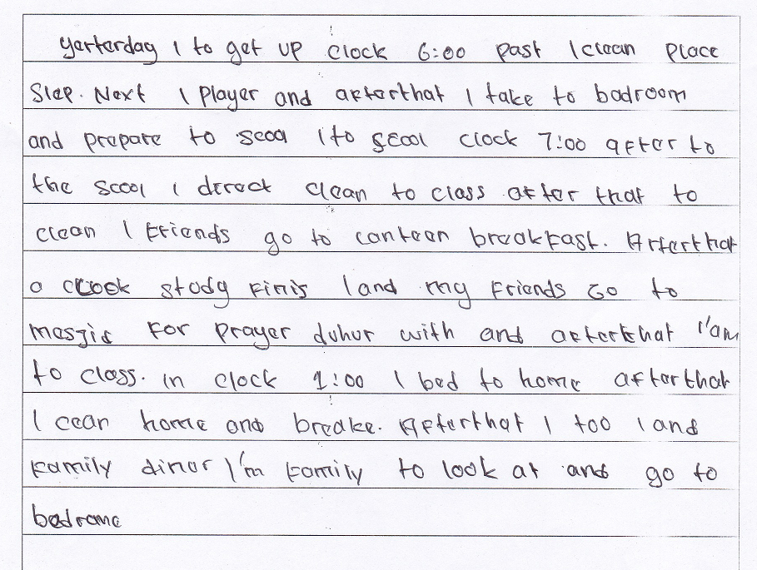
That there are too many basic mistakes in the students’ works clearly imply that they do have psychological problem in expressing their ideas in written language. The students’ very low competence in English may be the main cause of this, yet, it cannot be denied the students’ psychological problem also has contributed to their awful works. On average, it took them around 30 minutes to complete the very simple task, and this obviously implies that they had to work so hard for the accomplishment. The students had the ideas, but it was not easy for them to “cook” those ideas to be a good narrative essay since they had to do it on their own, without any support from interaction as they normally gain when doing speaking task in the class.
- Linguistic Problem
Byrne (1993) has stated that linguistic problem in writing deals with inability to use correct linguistic forms of written language. This means that whether or not one has this problem can simply be seen from his written work.
The extract below presents some of the students’ works convincing us that the students do have this problem.

Extract 2
Student 4
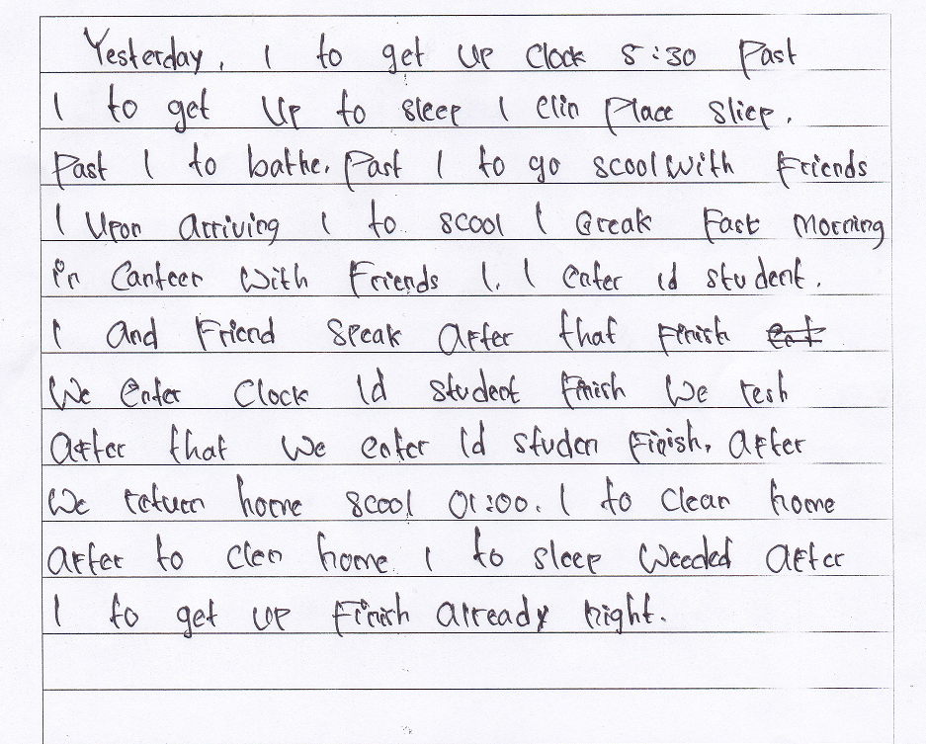
The grammatical mistakes in the students’ works are so distinct. It seems that those mistakes deal with so many topics in the discussion of English grammar, and the clearest ones are those dealing with words orderand tenses. For instance, instead of writing “Yesterday I got up at 5.30”,student 4 wrote “Yesterday, I to get up clock 5:30”. In short, the students’ works extracted above obviously imply that linguistically, they are still unable to write grammatically correct sentences.
The students’ works are also colored by mistakes in vocabulary. As we see, there are many words used improperly in the essays such as past, clock, than, place sleep, etc.This clearly indicates that vocabulary is one of their big problems in writing a narrative essay.
Mistakes in spelling can be seen in all the students’ works. Some of the incorrect spellings found in the works are clin (clean), sliep (sleep), scool (school), bed (back), leafe (leave) and luch (lunch). These basic mistakes absolutely imply that even in spelling very common and simple words, the students are still troubled.
The four poor works in the extract also indicate that the students are really bad at punctuation. As we see, the four works are full of sentences which do not end with full stop, and it seems that the students have not had the idea of when to use comma.

- Cognitive Problem
Cognitive problem in writing, according to Byrne (1993), is due to the fact that the task involves using certain structures which are less used in speaking, or perhaps not used at all, but which are important for effective communication in writing. This is what the extract below implies.

Extract 3
Student 7
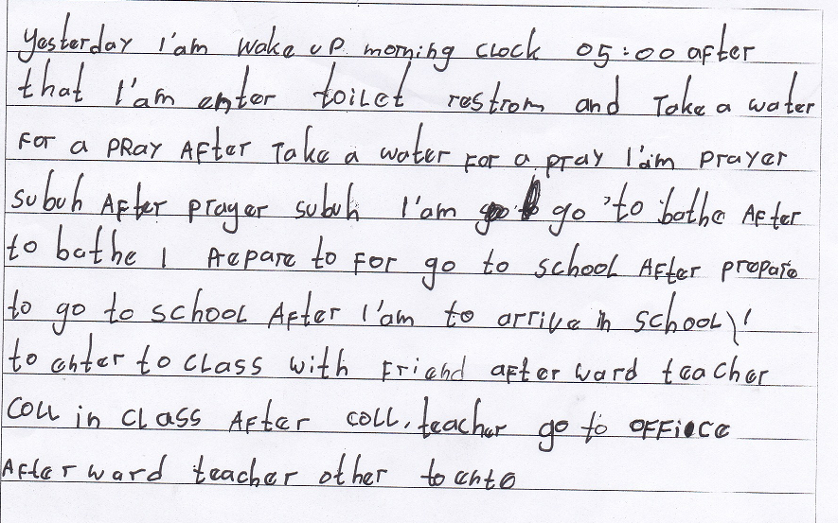
In the above extract do imply how the students are influenced by their knowledge of oral communication in bahasa Indonesia when writing narrative essays in English. Student 7, for instance, wrote “Yesterday, I am wake up morning clock 05.00” for “Yesterday I woke up at 5 o’clock in the morning. He seemed to just write such a confusing sentence based on what he had in his mind, which might be “Kemarin, saya bangun pagi jam 05.00”. From here, we can see that what the students have in their mind when writing a narrative essay is a speech in bahasa Indonesia which has to be translated literally into English. Thus, it can be said that their cognitive problem in writing a narrative essay is essentially the influence of two things; spoken language and bahasa Indonesia.
- Factors Affecting the Students’ Problems in Writing Narrative Essays
- Low Level of English Competence
When interviewed by the researcher, none of the junior high school students seemed happy about his or her writing in English. The extract below presents some of their statements indicating their low level of English that leads to the problems in writing a narrative essay.
Extract 4
R | : | Apa masalahmu dalam menulis narrative essay?  (What is your problem in writing a narrative essay?)
S1 | : | Dalam pelajaran bahasa Inggris, setiap ada tugas saya tidak pernah bisa mengartikan kedalam bahasa inggris kalau tidak menggunakan kamus, dan dalam penyusunan kalimat kadang juga terbalik-balik.  (In the English class, whenever we have a task, I can never do translation without dictionary, besides, my sentences are not well-ordered.)

R | : | Apa masalahmu dalam menulis narrative essay?  (What is your problem in writing a narrative essay?)
S3 | : | Pemasalahan yang kuhadapi dalam menulis narrative adalah kurang sekali kata-kata dalam bahasa Inggris yang kutau, harus selalu menggunakan kamus baru kutau bahasa Inggrisnya, anu juga cara penulisannya biasa salah-salahki.  (The problem I have in writing a narrative essay is my poor vocabulary; I don’t know many words, therefore, I always have to use dictionary, and the spellings as well.)

The students’ statements displayed in the above statement do signal their very low level of English competence which leads to the problems in writing a narrative essay. As we see, student 1 and 3 admitted that they greatly rely on dictionary when having a writing task, while student 4 tended to just admit his weakness in English in general. Despite using different expressions when answering the researcher’s question in the interview, those three students seem to agree that writing a narrative essay is never a simple task to them because of their poor English. Simply, their statements in the interview seem to mean how can we write a good narrative essay with our very poor English?.
- Low Motivation
It is so obvious that the problems faced by the students in writing a narrative essay is also due to some psychological matter; most of the students are not well-motivated. It is really disappointing that of the twelve students interviewed by the researcher, only one seemed to enjoy the writing task. The extract below displays some of the students’ statements implying their apathy in writing a narrative essay.
Extract 5
R | : | Ko suka ji kalau guru kasi tugas menulis narrative essay?  (Do you like narrative essay writing task from the teacher?)
S5 | : | Umm..nda’, ka susah sekali kurasa, jadi asal-asalan ji ku kerja.  (Umm..no, it is very difficult, so I do it carelessly.)

R | : | Ko suka tugas menulis?  (Do you like writing task?)
S6 | : | Tidak ka tidak kutau apa mo kutulis.  (No, because I don’t know what to write.)

R | : | Suka ko menulis?  (Do you like writing?)
S7 | : | Aih tidak. Mengarang dalam bahasa Indonesia saja na susah mi.  (No. Even writing in bahasa Indonesia is so difficult for me.)

The students’ answers extracted above obviously imply that they never enjoy writing a narrative essay. The task is so difficult to them that they just take it as a burden. As we see, none of the students’ statements in the above extract sounds optimistic; all the answers indicate pessimism. It seems that the students already know that their writings can never be good no matter how hard they try, therefore, they are not well-motivated. This is how we can infer that the big problems which the students have in writing a narrative essay to some extent are due to their low motivation.

- Discussions
- Students’ Problems in Writing Narrative Essays
- Psychological Problem
This seems to merely confirm Byrne’s (1993) proposal that writing is a difficult activity for most people, both in the mother tongue and in a foreign language, since it is a solitary task; we have to do it on our own, without feedback from another interlocutor like what we usually gain when conducting oral communication.
The researcher found two facts which firmly support the claim that the students have the psychological problem in writing a narrative essay; (1) the students’ very poor works and (2) the relatively long duration they spent just to finish the simple task.
Considering Byrne’s (1993) proposal, it can be inferred that the task would not have been so tough for the students had it been just an oral task. While in doing an oral the students gain the benefits from audience’s responses, in writing they have to work on their own. This is exactly how the psychological problem troubles them when writing a narrative essay.
There are similarities with the findings made by researchers in this study that students only use a few ideas and are simple in writing their stories. The story only contains an outline of the story with only a few elaborations from each section. A very small and simple idea causes the writing made by students to be very short.

- Linguistic Problem
Linguistic problem in writing, according to Byrne (1993), deals with inability to use correct forms of written language. That the students’ narrative essays are full of linguistic mistakes do signal that they totally have this problem. Their linguistic problem in writing a narrative essay is so big that it is very difficult to find linguistically correct sentences in their written works.
None of the students’ written works seems to fulfill the most basic definition of narrative essay. Almost all the sentences in the works are too awful to be called “a sentence”, which indirectly means that structurally, all the works are too poor to be called “a narrative essay”. There are too many linguistic mistakes in the works that it would take so many pages to detail them. After checking and analyzed all the mistakes, which are actually so elementary, there are three main mistakes leading to all the linguistic mistakes in the students’ narrative essays; mistakes in grammar, vocabulary, spelling and punctuation.
It seems that in composing a sentence, they are still influenced by their mother tongue, which is bahasa Indonesia. Meanwhile, in tenses, the students seem to have no idea at all about how to make a simple past sentence; despite the use of “yesterday” as the opening word, they hardly ever used verb2 in their sentences.
The students’ poor works do signal that they have a big linguistic problem in writing a narrative essay. The problem may be as big as confusion experienced by anyone who reads the works. From here, we can learn that linguistic problem in writing is so fundamental since it greatly determines readability of a written work.

- Cognitive Problem
Cognitive problem in writing rises as the task involves using certain structures which are less used in speaking (Byrne, 1993).
It is no doubt that empirically, the students are much more familiar with spoken than written language. Like most people all over the world, they have grown up with spoken language; the first language they heard and learnt naturally was spoken. They began to learn written language at school, when they were already used to communicating their ideas orally. Thus, whenever those students have a writing task, they are still under the control of their spoken language.
That none of the students’ narrative essays can be considered as a writing yet to some extent is caused by this problem. There are many sentences in the works which reflect that all they can do to produce a narrative essay is “transform” their spoken into written language (at least this is indicated by their weakness in punctuation). Besides, when writing, the students seem to just try to transfer their ideas in spoken bahasa Indonesia into written English. Overwhelmingly, we can say that they are totally not able to write a narrative essay yet; all they can do is write in their spoken language style.

- Factors Affecting the Students’ Problems in Writing Narrative Essays
- Low Level of English Competence
The students’ low level of English competence seems to be such a technical factor; it directly, and greatly as well, impacts the students’ written works quality. That there are so many linguistic mistakes in the students’ works obviously indicate that they have very low English competence.
When interviewed by the researcher, most of them admitted that they usually produce a narrative essay through two main steps; (1) just write their ideas in bahasa Indonesia and (2) translate those written ideas into English using dictionary. From here, we can learn that EFL learners with low level of English usually write a narrative essay through translation technique.

- Low Motivation
That the students face all the problems in writing proposed by Byrne (1993) to some extent is due to their low motivation. When interviewed by the researcher, none of the participants’ statements seemed to imply optimism, indicating their low motivation.
It seems that the students’ low motivation, which contributes towards the rise of the problems in writing a narrative essay, is due to their own mindset of English and tendency for language use. As mentioned previously, English is a difficult subject to them, which implies that writing an English narrative essay is a very difficult task to them. Thus, they are not confident that can make a good essay, and this is what makes them less motivated. Besides, most of the students seem to dislike writing, hence, whenever they have a writing task, they just do it carelessly.
Conclusion
- Conclusion
The following are conclusions which can be drawn based on the findings and discussions.
- The students’ narrative essays are so full of basic mistakes, indicating that they really have the three main problems proposed by Byrne (1993); psychological, linguistic and cognitive problems. The psychological problem occurs as they have to do the writing task on their own, without the opportunity of gaining feedback or response from an interlocutor. The linguistic problem deals with their inability to use correct forms of written language. The cognitive problem comes up since when writing, they are still greatly influenced by their spoken language.
- The factors affecting the students’ problems in writing narrative essays are their low level of English competence and low motivation. The first factor deals with the fact that they are still beginner learners of English, while the second deals with their own mindset of English and personal tendencies for language use; most of them perceive English as a very difficult subject and prefer speaking to writing.

- Suggestion
Considering the above conclusions, the researcher kindly invites both EFL teachers and other researchers to contemplate the suggestions below.
- To EFL Teachers
The research findings clearly imply that writing a narrative essay is not an easy task to junior high school students. Thus, EFL teachers are expected to start the teaching from the smallest units of a discourse called narrative essay, such as words, phrases and sentences. Besides, since the findings also indicate that the task is not enjoyable to many students, the teachers are supposed to provide the task in more interesting way, such as using attractive pictures to boost students’ interest.
- To Next Researchers
Essentially, the research findings are just to reveal the problems faced by beginner learners of English in writing a narrative essay and the factors affecting them. Hence, next researchers are expected to focus on the solutions to those problems.

REFERENCES
Abdulkareem, Mustafa N. (2013). An Investigation Study of Academic Writing Problems Faced by Arab Postgraduate Students at Universiti Teknologi Malaysia (UTM). Academy Publisher Manufactured in Finland. , Vol. 3, No. 9, (Theory and Practice in Language Studies), pp. 1552-1557.
Al-Khasawneh, Fadi Maher Saleh. (2010). Writing For Academic Purposes: Problems Faced By Arab Postgraduate Students Of The College Of Business, UUM. ESP World, Issue 2 (28), http://www.esp-world.info , Volume 9, 2010.
Anderson, K., & Anderson, M. (2003). Text types in English 2. Malaysia: The Modern Art Production Group.
Byrne,D. (1993). Teaching Writing Skill (6th Ed.). Longman: London
Chakravarthy, Dr. (Mrs.) Rini S Dwivedi & Ranganath VNallan. (2015). Problems Encountered By Rural Students in Writing English – Role of English Teacher - Some Solutions. International Journal on Studies in English Language and Literature (IJSELL) , Volume 3 (Issue 7), PP 27-38.
Emelia, E. (2010). Teaching Writing: Developing Critical Learners. Bandung: RIZQI Press.
Graham, J & Kelly, A. (1997). Reading Under Control, Teaching Reading In The Primary School. London: David Fulton publishers.
Grenville, Kate;. (2001). Writing from Start to Finish : A Six-Step Guide. Australia: Crow Nest-Australia: National Library of Australia.
Harmer, Jeremy;. (2001). The Practice of English Language Teaching. Harlow: Essex: Pearson Education Limited.
Huy, Nguyen Thanh. (2015). Problems Affecting Learning Writing Skill of Grade 11. Asian Journal of Educational Research,Vol. 3, No. 2, 2015 .
Hylan, Ken. (2003). Second Language Writing. London: Cambridge University Press.
Hyland, K. (2004). Genre and second language writing. Michigan: The University of Michigan Press.
Kadir, Mukhlis;. (2015). Error Analysis on Narrative Text Written by Students of SMA Neg 1 Baranti. Makassar: English Study Graduate Program, State University Of Makassar.
Karim, Irkah Taswirah;. (2013). The Implementation of Task-Based Language Teaching (TBLT) to Improve Students' Ability in Writing. Makassar: English Study Graduate Program, State University Of Makassar.
Knapp, Peter and Megan Watkin. (2005). Genre,Text,Grammar:Technologies for Teaching and Assessing Writing. Sydney: University of New South Wales Press Ltd.
Langan, John. (2003). College Writing Skill (5th ed.). Boston: The McGwaw-Hill Companies.
Lubis, Rayendriani Fahmei;. (2014). Writing Narrative Text. English Education , Vol. 02 No. 01.
Mulyaningsih, Dini Utami. (2013). An Analysis of Students’ Ability In Writing Narrative Texts: A Case study at One Public Junior High Schools in Bandung. Journal of English and Education 2013, 1(2) , 16-22.
Myles, Johanne. (2001). Second Language Writing and Research: The writing Process and Error Analysis in Students’ Text. Queen’s University.
Nunan, David. (2003). Practical English Language Teaching. New York: McGwaw Hill.
Nurhasanah. (2014). Improving Students’ Ability In Writing A Narrative Text By Using Round Table Strategy At Grade Viii C Of Smp Negeri 11 Kota Bengkulu. In Thesis. Bengkulu: English Education Study Program Language And Arts Department,Education And Teachers Training Faculty, Bengkulu University.
Nuzhatun, Lana. (2016). An Analysis of Students’ Problems in Writing Narrative Text: A Case Study at Second Grade Students of SMKN 1 Praya Tengah in Academic Year 2015/2016. In Thesis. English Department Faculty of Teacher Training and Education, University of Mataram.
Ogano, J. A. (2012). Teaching Learners with Reading and Writing Problems in the Classroom: An Interview Study with teachers in Norwegian schools. Master’s Dissertation,Department of Special Needs Education,Faculty of Educational Sciences,University Of Oslo.
Oshima, Alice; Hogne, Ann. (1991). Writing Academic English. (3rd ed.). New York: Addison Wesley Longman.
Pardiyono. (2007). Pasti Bisa! Teaching Genre-Based Writing. Jogjakarta: Andi Offset.
Schmidt, Siegfried J;. (1980). Receptional Problems With Contemporary Narrative Texts And Some Of Their Reasons. Poetics 9 , 119-146.
Tarigan, G. (1986). Menulis Sebagai Suatu Keterampilan Berbahasa. Bandung: Angkasa.
Tika , Noviani; Sri Imelwaty; Herfyna Asty;. (2015). Students’ Problems in Writing Generic Structure of Narrative Text at Second Grade SMAN 1 Sungai Rumbai Dharmasraya. Education Journal .
Ur, Penny. (1996). A Course in Language Teaching. Melbourne: Cambridge University Press.
Wardiman, A. (2008). English In Focus For Grade Viii Junior High School. Jakarta: Pusat Perbukuan Departemen Nasional.
Yenti, Irisna. (1999). Using the Appropriate Reading Text in Teaching Reading to Improve the students‟s reading Interest. Padang:UBH: Unpublished Thesis.

