CONSTRUCTING AN INTERACTIVE MULTIMEDIA USING LECTORA INSPIRE 17 FOR LEARNING READING TO THE ELEVENTH GRADERS OF
SMAN 1 ENREKANG

Masyhud Zainuddin
zmasyhud@gmail.com

Baso Jabu
basojabu@gmail.com

Kisman Salija
kismansalija@unm.ac.id

ABSTRACT

The objectives of this research are: to develop and to know the appropriateness of an interactive multimedia using lectora inspire 17 for learning reading to the eleventh graders of SMAN 1 Enrekang. The type of this research is a Research and Development (R&D). There were 31 of eleventh graders as the subject of the research. The research procedure was adapted from ADDIE design model proposed by Molenda (2003). It comprised carrying out needs analysis, designing a course grid and a flowchart, developing the media, validating, testing, revising, evaluating, and completing the final draft. The data collection instruments were needs analysis, expert judgment, and students’ assessment in the form of questionnaire. The data from needs analysis were analysed quantitatively using frequency and percentage. The results were used to construct the first draft. The quantitative data from the expert judgment were converted to descriptive analysis. Furthermore, the suggestions and comments were used to revise the first draft to be the final draft of the product. The results of this research showed that the students want to be able to use English as a means of communication both in the spoken and written form and to study abroad. Concerning on reading skill, the students want to enrich English vocabulary, to be accustomed to English spelling, and to understand the text. The difficulties in reading English text are unfamiliar vocabulary and uninteresting topic or theme. The final draft of the product is an interactive multimedia for learning reading to the eleventh graders which comprises three units. Each unit covers contents and designs related to the students’ needs. The research findings showed that the mean score for the interactive multimedia was 4.49. It was categorized as “Appropriate”. Thus, the developed interactive multimedia can be used by the eleventh graders to learn reading.

Keywords: develop, interactive multimedia, lectora inspire 17, reading

INTRODUCTION

In this modern age, technology and information are growing rapidly and inevitably by human. Technological advancements are increasingly evolving, globalizing, and affecting the way of communicating, lifestyle, and even human behaviour itself. Marshall McLuhan (1962) stated that technology shapes the way of thinking, behaving, and moving from one century of technology to the next century of technology in human life.
Technology has effect on the aspects of human life in various fields, both politics, social, economy, culture, and more so in the field of education. In the field of education, technology has its own role in teaching and learning process. One of the technologies that can be used to support the process is multimedia learning. Learning supported by the use of multimedia will have posit ive impacts on students such as improving learning outcomes and student’s motivation in the learning. As stated by Munir (2012) the use of multimedia learning to improve student learning interest, motivate students to follow the learning process and can make it easier for students to understand the lesson. Using multimedia learning will be a good decision for teachers in teaching their students.
English is one of the main subjects taught at schools on many levels. It contains a variety of themes and topics. In this regard, a teacher is required to be able to choose the learning materials that are appropriate to the students’ needs. In the process of teaching and learning, learning materials take a very fundamental role to achieve learning outcomes. There are many learning materials that can be obtained from textbooks, newspapers, magazines, internet, and many others. A teacher just collects teaching materials that they produce according to the students’ need. Teaching materials that have been prepared will certainly lead to better learning lessons where students will more easily understand every material that is taught.
SMAN 1 Enrekang is the oldest senior high school that is located in Enrekang District, South Sulawesi. In teaching English, teachers apply curriculum 2013 with new revisions of 2017. One of basic competence (KD) taught to eleventh graders in Curriculum 2013 is learning English as a medium of introduction to international communication embodied in the spirit of learning. In other words, students must be eager in learning English so that they can use it at least in transactional communication with teachers and fellow students.
An effort to improve interesting and fun learning English to students is required various breakthrough in developing innovation of learning. Teachers are required to always innovate in teaching, master the material taught and skilled to teach it. Teachers had better teach in creative way. For instance, they can deliver learning materials in the form of visual and combine it with audio because it will be easier to understand and to remember rather than merely relying on a speech. Cohen, et al. (2009) pointed out that auditory memory proved to be systematically inferior to visual memory. Subsequently, it is required to apply a delivery of learning materials in teaching English through the learning paradigm by hearing, seeing, and doing. It can be reached by utilizing interactive multimedia learning technology.
Factually, most teachers rely solely on textbooks, printed materials such as student worksheets, and other materials produced from various sources as main materials in the teaching of students. The textbooks generally used by teachers include four English skills: speaking, listening, writing, and reading. Teachers play an important role in developing these four skills for students. Teachers become model in speaking activities such as discussing and questioning using English, and mentors in the activities of writing, reading, and listening. But then, for the reading skill itself, textbooks and some printed material will certainly be very tedious and make less interesting lessons for students. Teachers need teaching other materials or more interesting than books and delivering it in various ways. According to Rakhmat, et al. (2006) the teacher must be able to make changes, from tedious to pleasant classes. He continues that the teacher can restore the learning spirit of the students by changing the methods and approaches in teaching so that they are enthusiastic about taking lessons.
Interactive multimedia will be a good learning media for students as well as for teachers. Interactive multimedia technology can provide convenience for teachers in terms of preparation of teaching materials. Practically the learning media has benefits such as concreting concepts which are abstract, thus reducing verbalism. Through the media of learning, abstract things can be concretized, complex things can be simplified (Nana Sudjana and Ahmad Rivai, 2005). For students themselves, the teaching material will feel real because it is presented with the invisible eye, can create various senses to interact, visualization with the form of text, images, audio, video and animation will be easier to catch (Munir, 2012). With various advantages of interactive multimedia, the process of language teaching and learning should be fun and away from tediousness circumstance. Although there are various available sources of interactive multimedia learning, but most of them do not match with the competencies of national standards as taught in schools.
Based on the research carried out by Dwi (2017) in his research, he applied ADDIE design model to develop learning media using Lectora Inspire for Asmaul Husna material to the seventh graders of MTs Negeri 1 Bantul. The research result showed that the mean score of media expert was 3.02 categorized as worthy, the mean score of materials expert was 3.41 categorized as very worthy. Then, the mean score of field test I was 3.61 categorized as very worthy and field test II was 3.59 categorized as very worthy. Based on the scores, the researcher conclude that the interactive learning media Lectora Inspire-based for Asmaul Husna material was very worthy to be applied in learning. Then, Kusumaningtias (2016) developed an interactive multimedia for learning reading for ten grade students. This media was designed to be self-study sources. It is integrated in a CD so students can use it at school and at home as well. It is examined and validated by expert judgment and the result proved that the interactive multimedia was appropriate. Hence, the developed interactive multimedia can be used as learning materials to the students. From the explained researches previously, both of them were categorized as appropriate. It can be said that Lectora Inspire program has been proven to be able to create interactive multimedia learning that is appropriate to use in learning. Furthermore, Halimah (2015) in her research, developed an interactive multimedia for teaching descriptive text for Grade VII students of junior high school. It was developed using software authoring tools namely Lectora Inspire. The result of the research found that the interactive multimedia was considered appropriate to be used in the teaching descriptive text.
The objectives of this research are to construct and to find out the appropriateness of an interactive multimedia for learning reading to the eleventh graders of SMAN 2 Enrekang using Lectora Inspire 17.

METHOD

This research was classified as an educational Research and Development (R&D) which means it was product-oriented. Borg and Gall (1983) stated that Research and Development is a process used to develop educational products and validate by testing those products. The product developed in this research was called interactive multimedia learning. The design model used by the researcher to develop the product was ADDIE design model proposed by Molenda (2003). The following figure is the development stages of interactive multimedia for learning reading using ADDIE design model:
Analysis
Design
Development
Implementation
Evaluation
Students’ Needs
Literature
Flow Chart
Course Grid
Developing the First Draft of
Interactive Multimedia
Using Lectora Inspire 17
Revision
Field Test
Validation
Final Draft of Interactive Multimedia for Learning Reading
Revision

Figure 1. The Development Stages of Interactive Multimedia Using ADDIE Design Model

This research was carried out at SMAN 1 Enrekang. The subjects of the research were thirty one students from Grade XI IPS 2 class of SMAN 1 Enrekang. They were chosen by using purposive sampling technique (Arikunto, 2010). Instruments used in this research were needs analysis (Nunan, 2004), expert judgment, and students’ assessment. Needs analysis was used to find out the students’ needs in terms of target needs and learning needs (Hutchinson and Waters, 1987). Then, expert judgment was used to validate the quality of the developed product. The experts were materials expert and media expert. Lastly, students’ assessment was used to find out their response in field-test against the validated product.
The collected data of this research was in the form of quantitative descriptive data which was obtained from two questionnaires. Qualitative data were comments and suggestions for revising the product from materials and media expert. Thus, quantitative data was obtained from the score of media and material expert and students’ assessment. The data was in the form of frequency percentages from needs analysis questionnaires. The students’ answers were calculated and the results were in the form of percentages. The two highest percentages was considered representing the students’ needs. The percentage was calculated by using the following formula:
f
P = X 100
N

P : percentage (%)
f : frequency
N : number of respondents
100 : fixed number

In the meantime, he researcher used numerical scale as the type of the second questionnaire; they were expert judgment and students’ assessment. Each indication of the responses to the statement was measured by numbers. The obtained scores from the questionnaire were analyzed using Likert Scale (Sugiyono in Karunia, 2017) consisting of several categories as follows:

Table 1. Likert Scale Guidance
No | Score | Descriptions
1 | Score 5 | Strongly agree/always/very positive/very appropriate/very good/very useful/very motivating
2 | Score 4 | Agree/good//positive/appropriate/easy/feasible/useful/quite motivating
3 | Score 3 | Hesitant/sometimes/neutral/quite agree/pretty good/quite appropriate/quite easy/quite interesting/quite feasible/quite useful/quite motivating
4 | Score 2 | Disagree/rarely/negative/poor/less appropriate/less interesting/less understanding/less feasible/less useful/less motivating
5 | Score 1 | Strongly disagree/very poor/very less interesting/ very less feasible/very less useful/very less motivating

Quantitative data coming from the media and material expert as well as from the students were counted the mean score with formula adapted from Sukarjo in Santoso (2017) as follow:
∑x
X =
n

Descriptions:
X_{i} : Mean score
∑x : Total score
n : Appraisal number

For quantitative data, it was analysed descriptively by using quantitative data conversion proposed by Sukarjo in Santoso (2017). The result of the conversion whether the product was already appropriate or not. The following table showed the quantitative data conversion.

Table 2. Table of Quantitative Data to Qualitative Data Conversion
No | Interval of Quantitative Score |  | Qualitative Category
1 | (X_{i} + 1.80 SB_{i}) < X | 4.8 < X | Very Appropriate
2 | (X_{i} + 0.60 SB_{i}) < X < (X_{i} + 1.80 SB_{i}) | 3.6 < X < 4.8 | Appropriate
3 | (X_{i} - 0.60 SB_{i}) < X < (X_{i} + 0.60 SB_{i}) | 2.4 < X < 3.6 | Quite Appropriate
4 | (X_{i} - 1.80 SB_{i}) < X < (X_{i} - 0.60 SB_{i}) | 1.2 < X < 2.4 | Less Appropriate
5 | X < (X_{i} - 1.80 SB_{i}) | X < 1.2 | Very Less Appropriate

FINDINGS AND DISCUSSIONS

In the process of doing the research, the researcher carried out three main stages: needs analysis, development, and evaluation.
- Needs Analysis
This stage comprises two parts namely: analysing the students’ needs and the literature review. Analysing students’ needs was carried out to find out the target needs and learning needs of the students. While analysing literature review was carried out to come across references related to the English materials in terms of reading skill for the first semester of the eleventh graders of senior high school.
Based on the research findings, the results of the needs analysis are explained as follows.
- Target Needs
The researcher found from the research that the motivation of the students to learn English are to be able to use English as a means of communication both in spoken and written form and to study abroad. Regarding on what motivate them to read English text, the students want to enrich English vocabulary, to be accustomed to English spelling as well as to understand the text. In keeping their motivation to read English text, they find themselves facing some difficulties such as unfamiliar vocabulary and uninteresting topic or theme. Based on the research findings, they dominantly prefer themes or topic like social life and daily life.
- Learning Needs
The models of English input text that the most of students’ preference are text with some pictures and also text followed by questions. From the length of the text, there are three findings: they were 200 - 250, 250 – 300, and 300 – 350 words. In enriching vocabulary, the students prefer to do the reading activities by reading a text then answering some questions related to the text as well as completing sentences or paragraph with provided words. A half of the total number of the students like reading activities by arranging words into meaningful sentence and completing sentence with available words. Both of them are the way that they like most to enrich their knowledge about English sentence structure.
In doing the task, their preferences are dominantly individual and in pairs. Then, the students tend to prefer technique of teaching done by the teacher using media such as laptop, computer, and so on to explain the materials as well as giving them tasks and doing them together. Furthermore, the roles of the teachers in teaching reading are explaining and giving example on how to do the task and going around the class to monitor students’ activity. About their roles in learning reading, they state that they have to engage in the reading activities actively and doing the teacher’s instruction. They realize that not only teacher have roles in the classroom but also students have it. Interactive multimedia and textbooks become the dominant choice of the sources of reading materials that they like most. More than a half of total number of the students want that the contents of the interactive multimedia material should be in accordance with core competencies and basic competencies as well as clear instructions and explanations.
Regarding on the content and design of the interactive multimedia learning, the students want additional items such as quizzes or exercises. The dominant options to be the colours of the background are blue and white. Then, the font types are comic sans MS and times new roman. They expect that the used navigation button had better simple, easy, and also matched with its function. In addition, they prefer if the key word of the exercise is available.
- Development
This stage comprises three parts as follows:
- Drafting the first design
The data collected from observation and needs analysis were used to arrange the first draft of the product in which consist of three steps, they are:
- Arrangement of materials, flow chart, and course grid. The arrangement of materials was referred to the English syllabus of Curriculum 2013 used at SMAN 1 Enrekang.
- Determining the size of the screen as well as creating the layout in which they encompassed background color, font types, and navigation button styles.
- Designing the product used software authoring tool namely Lectora Inspire 17. In the process of designing, the researcher used supporting software such Corel Draw X7 to edit some pictures and to design some buttons.

- Expert Judgment (Validation)
The validity of judgment in this research referred to Sugiyono (2013). He stated that the measuring tool used to obtain data (measure) is valid. Valid means the instrument can be used to measure what should be measured. The assessment of interactive multimedia for learning reading to the eleventh graders of senior high school was carried out by experts through assessment instruments based on the existing theories and then used as indicators in assessment. There were two experts: materials expert and media expert.
Material expert assessing the appropriateness of the interactive multimedia was the English teacher of SMAN 1 Enrekang. There were two kinds of materials assessment: content quality and instructional quality. Each obtained mean score 4.62 and 4.46. Furthermore, media expert assessing the appropriateness of the media was a multimedia lecturer at Makassar State University. It was assessed by considering two aspects namely technical quality and programming quality. Each obtained mean score 4.37 and 4.8. Finally, the validated product acquiring appropriate predicate were tested to the students to elicit their response.

- Arrangement field-test assessment
Field-test assessment was validation assessment carried out by the users of the media in terms of students. The assessment sheet was arranged based on the media selection indicators.
Field-test was conducted on 31 students of grade XI IPS 2 to assess the interactive multimedia who have been constructed and validated. They gave their response after the researcher first let them try and learn the materials contained in the media for six meetings. Thus, the obtained mean score of the quality of the program assessed by the students was 4.36. It was categorized as appropriate.

- Evaluation
The final draft was the evaluation stage after the product was validated by experts and tested to the students.
The developed interactive multimedia for learning reading was not separated from the advantages of multimedia. It provides information such as pictures, audio, video, animation, and graphic so the role of multimedia is very essential and helpful in delivering information.
Phillips (1997) stated that interactive multimedia as a phrase that describes a new wave of computer software primarily related to the information section. This multimedia component is characterized by the presence of text, images, audios, animations and videos. Some or all of the components are arranged in several coherent programs. Interactive component refers to the process of user empowerment to control the environment usually with a computer.
Ariani & Haryanto (2010) distinguished multimedia into two category; they are linier multimedia and interactive multimedia. Linier multimedia is a multimedia that is not equipped with any controller that can be operated by the user. This multimedia runs sequentially. Then, Interactive multimedia is a multimedia that is equipped with a controller that can be operated by the user so that the user can choose what is desired for the next process.
Development of learning media in English lesson in this case reading skill referred to the interactive multimedia category in which the learning media equipped with controller can be used by user. The developed learning media was designed by combining pictures, audios, and animation in a single unit.
Some interfaces of the final draft of the developed interactive multimedia are presented below:
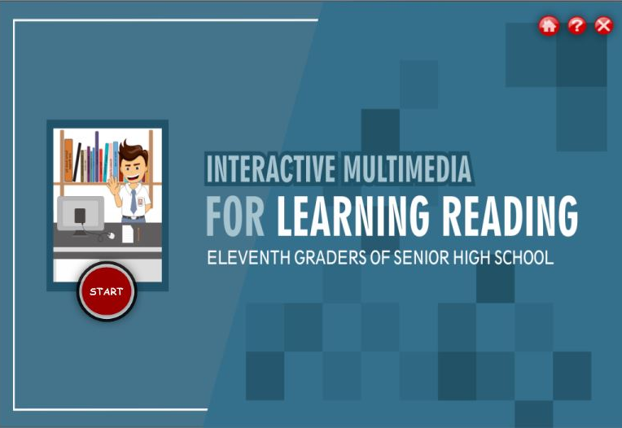
Figure 2. Welcoming Page

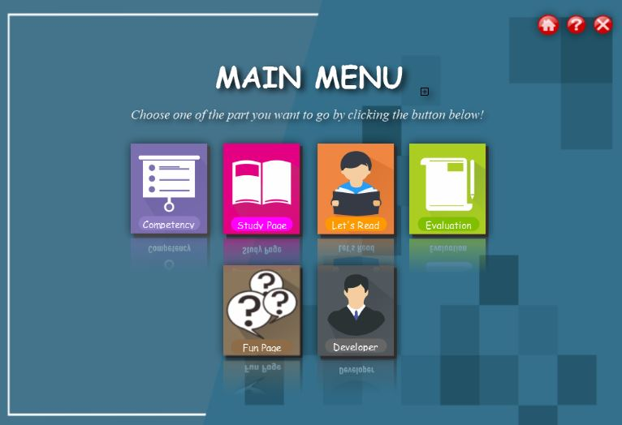
Figure 3. Main Menu

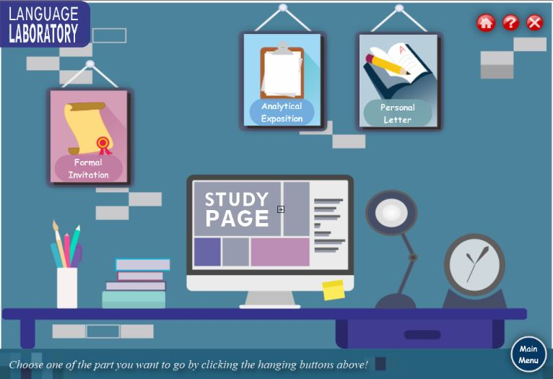
Figure 4. Study Page
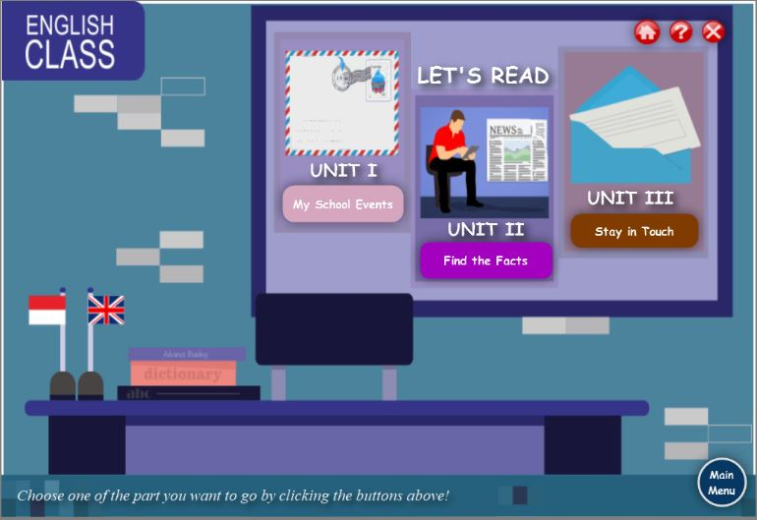
Figure 5. Let’s Read

CONCLUSION

Based on data from the results of the research and discussion previously explained, conclusions can be drawn as follows:
- Developed an interactive multimedia for learning reading to the eleventh graders of SMAN 1 Enrekang.
- Appropriateness of the interactive multimedia is known based on the validation of materials expert, media expert, and students’ response. The mean score obtained from all assessments is 4.49. Based on the table of qualitative data to quantitative data conversion, it is categorized as appropriate which means the interactive multimedia can be used by the eleventh graders to learn reading.

SUGGESTION

- Teachers should be always innovating and optimizing the use of technology in delivering materials to students. It aims to minimize the tediousness circumstance happened in the classroom. The use of interactive multimedia can help to enhance the students’ motivation to following the teaching and learning process.
- Other researcher may develop interactive multimedia, but they should consider things such as content and design. In terms of content, they should develop it in accordance with students’ needs. They may develop their own learning materials or take from authentic materials that can give advantages to the students. Yet, they should pay attention to the learning objectives in order to create consistent materials.
Other researchers who want to develop an interactive multimedia can use other software such Adobe Flash Software in order to make the learning media more interactive.

REFERENCE

Ariani & Haryanto. (2010). Pembelajaran Multimedia di Sekolah. Jakarta: PT. Prestasi Pustakarya.

Arikunto, S. (2010). Prosedur Penelitian Suatu Pendekatan Praktik. Jakarta: Rineka Cipta.

Borg & Gall. (2003). Educational Research: An Introduction (4th Ed.). New York: Longman.

Cohen, M. A., Horowitz, T., & Wolfe, J.M. (2009). Auditory recognition memory is inferior to visual recognition memory. Proceedings of the National Academy of Sciences of the United States of America, 106 14, 6008-10.

Halimah, R. (2015). Developing Interactive Multimedia for Teaching Descriptive Text Reading to Grade VII Students at SMPN 6 Yogyakarta.

Hutchinson and Waters. (1987). English for Specific Purpose. A Learning-Centered Approach. Cambridge: Cambridge University Press.
Karunia. (2017). Pengembangan Media Pembelajaran Berbasis Macromedia Flash 8 Pelajaran IPA Materi Energi Listrik Kelas VI di SD.

Kusumaningtias, A. (2016). Developing Interactive Multimedia for Learning Reading for Tenth Grade Students of SMAN 1 Cangkringan.

McLuhan, Marshall. (1962). The Gutenberg Galaxy: The Making of Typographic Man. Copyright, Canada: University of Toronto Press.

Molenda, M. (2003). In Search of the Elusive ADDIE Model. Performance Improvement, 42 (5), 34-36. Submitted for publication in A. Kovalchick & K. Dawson, Ed’s, Educational Technology: An Encyclopedia. Copyright by ABC-Clio, Santa Barbara, CA.

Munir. (2012). Multimedia dan Konsep Aplikasi dalam Pendidikan. Bandung: Penerbit Alfabeta.

Nunan, D. (2004). Task-Based Language Teaching: Teacher’s Text Book a Course in English Language Teaching. McGraw-Hill.

Phillips, R. (1997). The Developer’s Handbook to Interactive Multimedia: A Practical Guide for Educational Applications. London: Kogan Page.

Rakhmat, et al. (2006). Psikologi Pendidikan. Bandung: UPI Press.

Santoso. (2017). Pengembangan Media Pembelajaran Berbasis Lectora Inspire Materi Asmaul Husna Pada Siswa Kelas VII di MTs Negeri 1 Bantul.
Sudjana, Nana and Rivai, Ahmad. (2005). Media Pengajaran. Bandung: Sinar Baru Algendidndo.

Sugiyono. (2013). Metode Penelitian Kuantitatif Kualitatif dan R&D. Bandung: Alfabeta.

